LSP - Applicant User manual

To file a new LSP (Large and Special Project) application, go to Electronic Construction Permitting System Portal using the URL https://ecps.gov.bd/ and then click on “Login” button. Applicant then can login to the system using applicant’s username and password. After logging into the system successfully click on the “New Application” button as shown in the Figure: 1 & 1.1

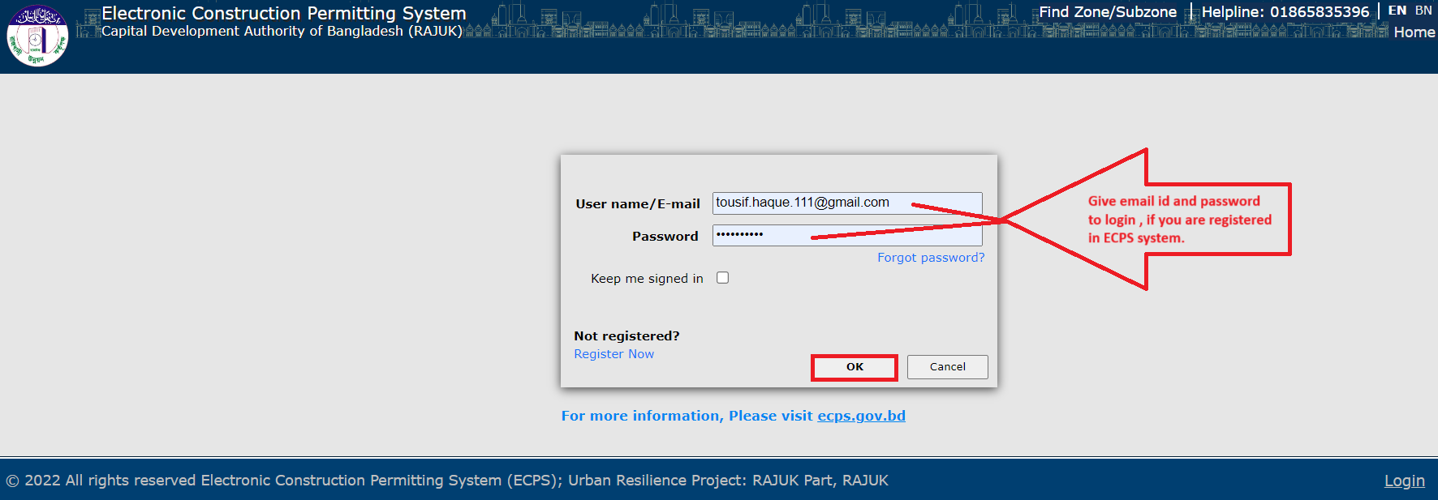
Figure: 1. Login as an Applicant

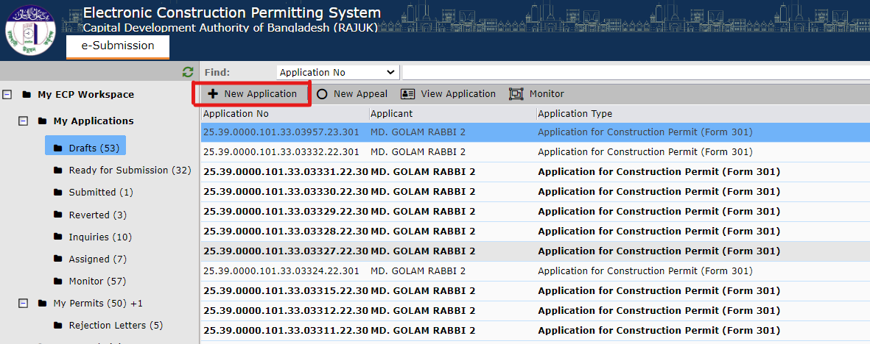

Figure: 1.1 New Application
After clicking on “New Application” the following window will pop-up with the drop-down selection bar for “Application type” and some other information (Ownership Type, RS Dag No) as shown in Figure: 2, 2.1 & 2.2
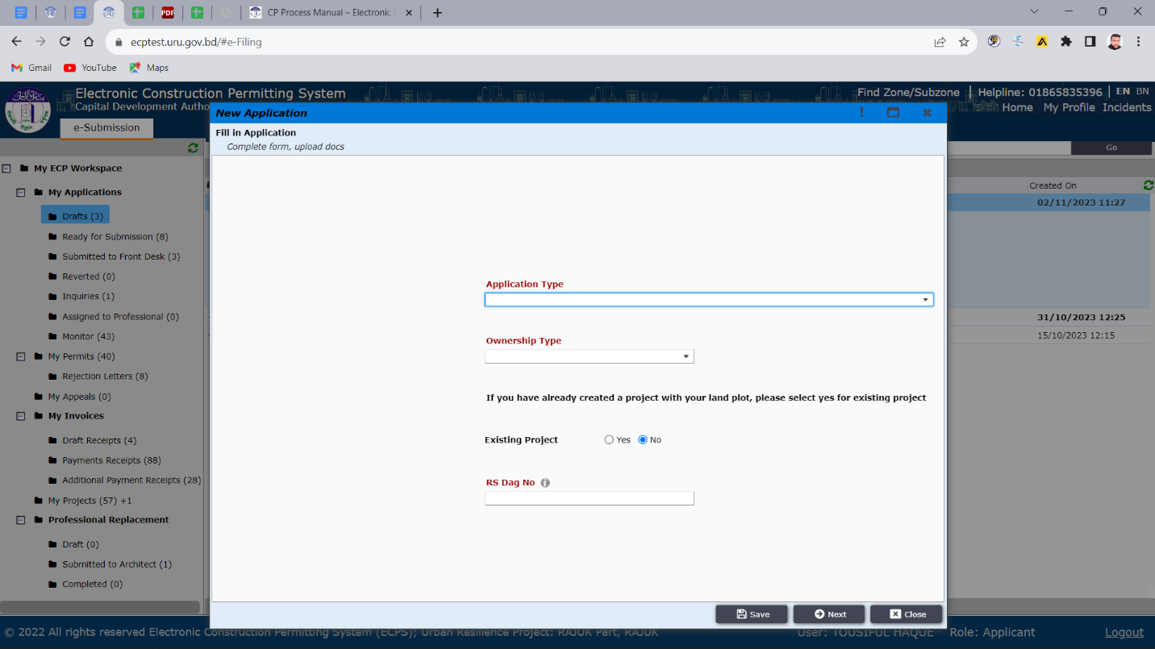
Figure: 2. New Application Form
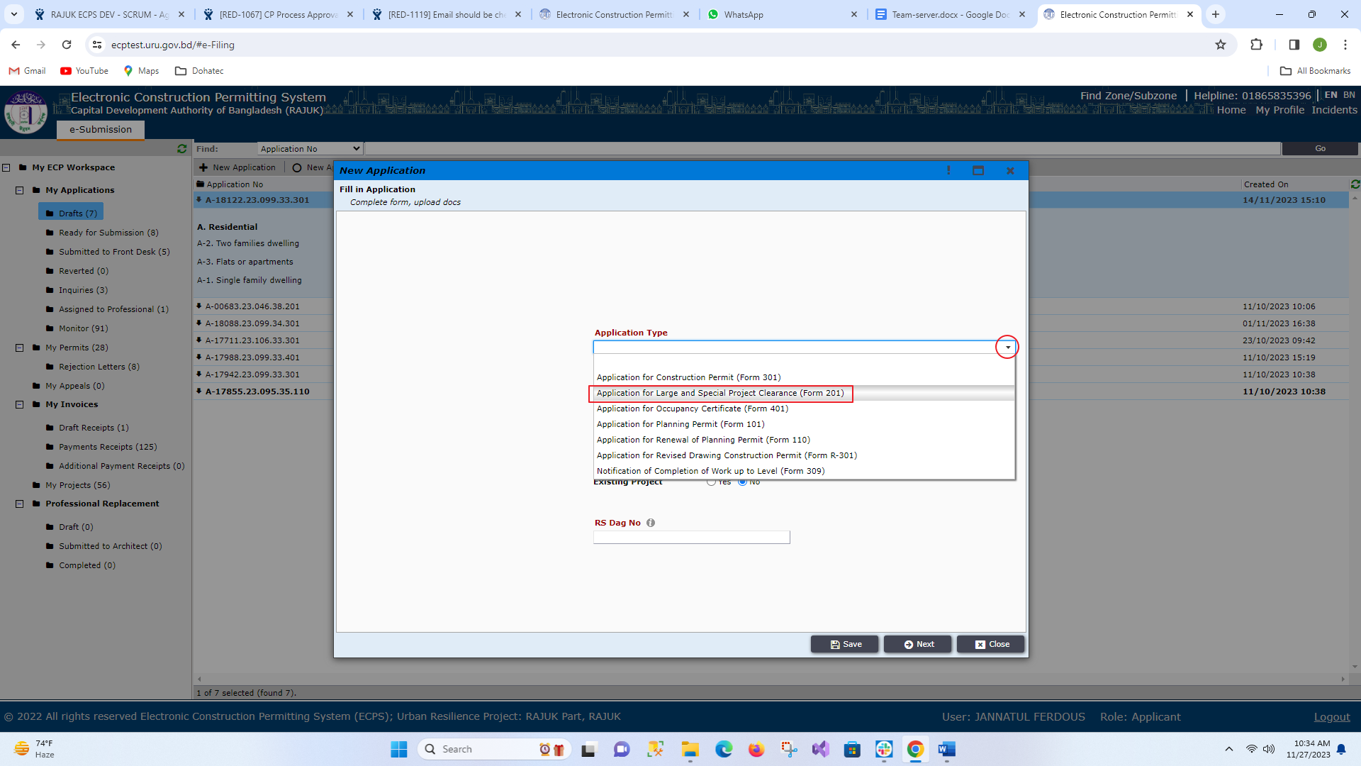
Figure: 2.1 Application Type

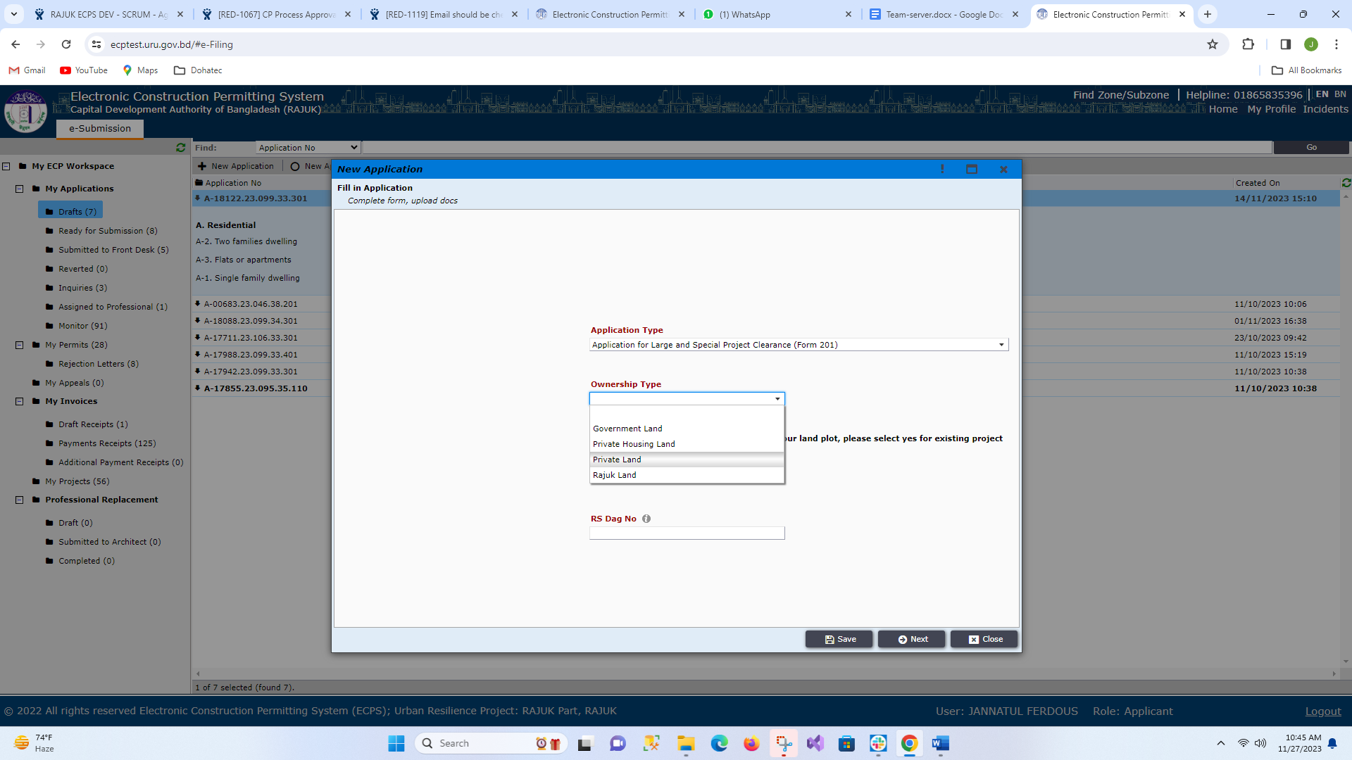
Figure: 2.2 Ownership Type
Now applicant needs to select the type of application which he would like to file (Ex. Large and Special Project), provide “Ownership Type”, “RS Dag No” and click on the “Next” button as shown in Figure 3

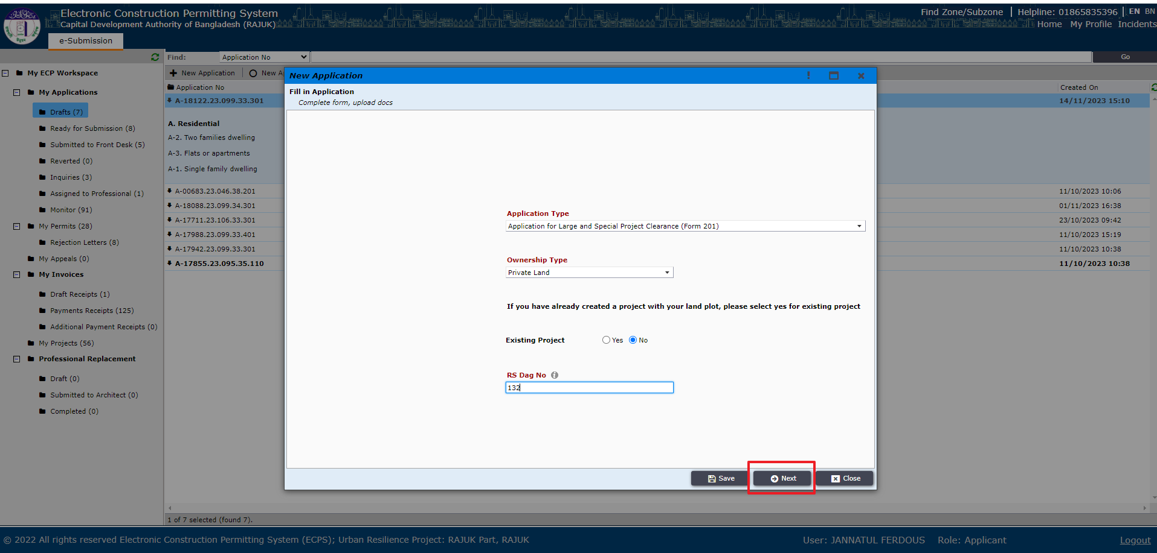

Figure: 3. Selecting application type, ownership type, RS Dag no and clicking on “Next”
After clicking “Next” the applicant will go to another window containing land details as shown in Figure 4. Applicant needs to fill up accordingly and then click “Next”.
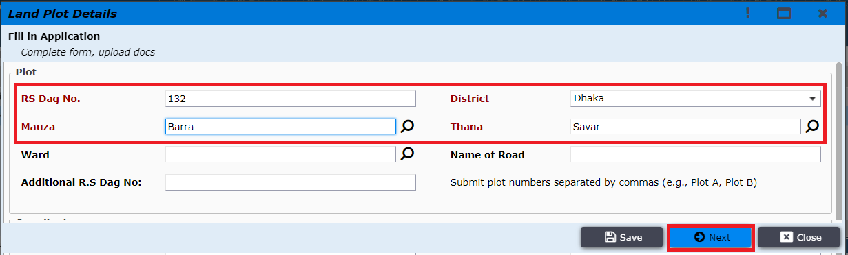
Figure: 4. Land plot details
Note: If the ownership type is “Government Land” then select only “Application type and Ownership Type” and click on “Next” Button. Figure: 4.1 shows the information.
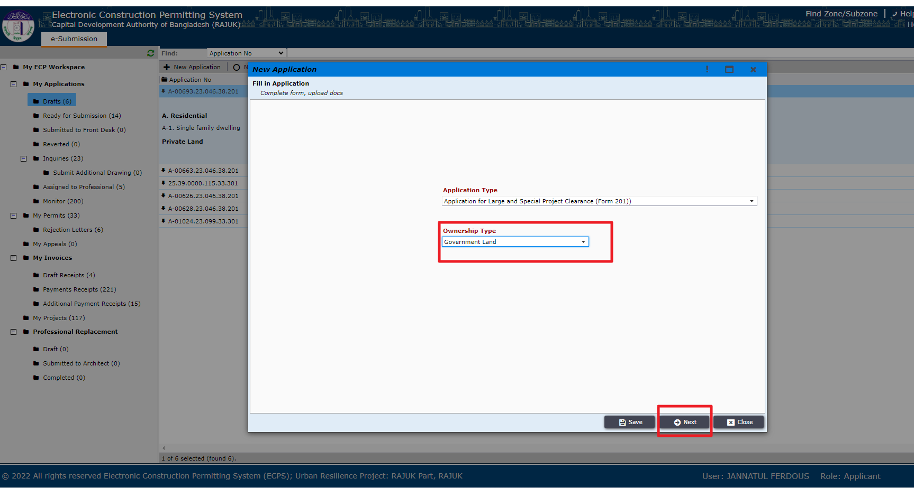
Figure 4.1 Application Type and Ownership Type for Government land
After clicking “Next” the applicant is prompted to another window containing land details as shown in Figure 4.2. Applicant needs to fill up accordingly and then click “Next”.
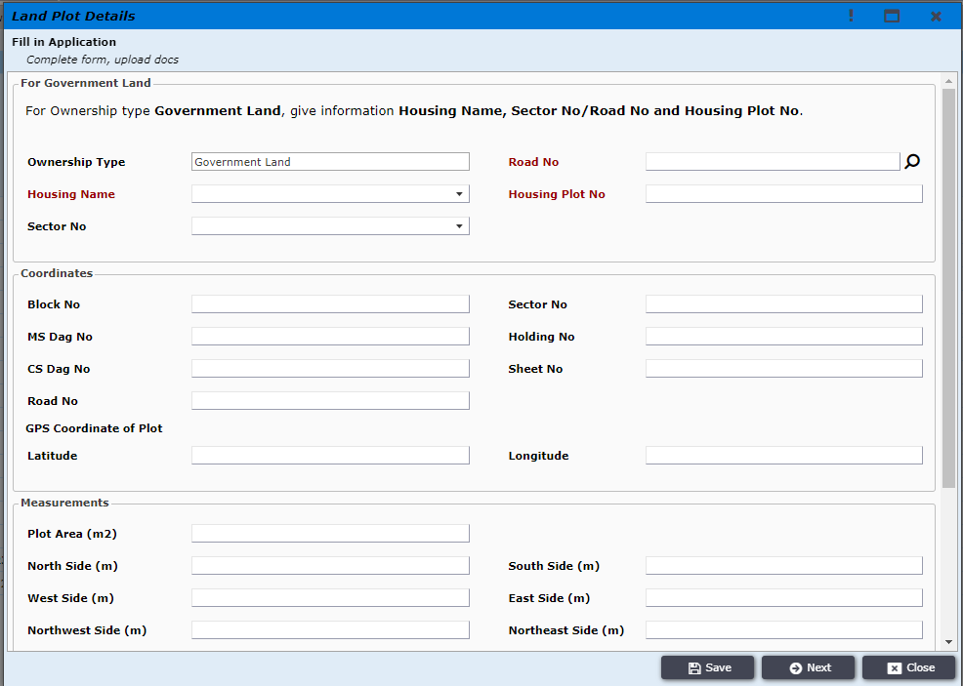
Figure 4.2
After providing the Land plot details applicant is prompted to “Next” window containing project information (Figure 5). Applicant needs to give a Project name and click “Next”.
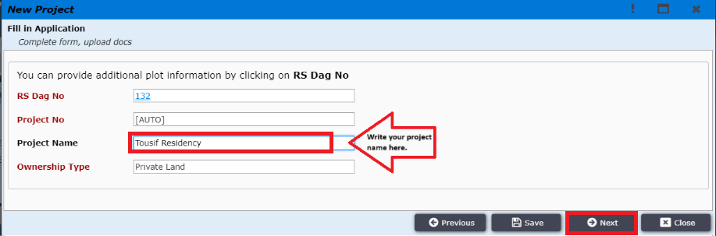
Figure: 5. New Project
After giving project name applicant must click on next button to choose Land Use Type & Occupancy Type as shown in Figure: 6, 6.1, 6.2, 6.3, 6.4
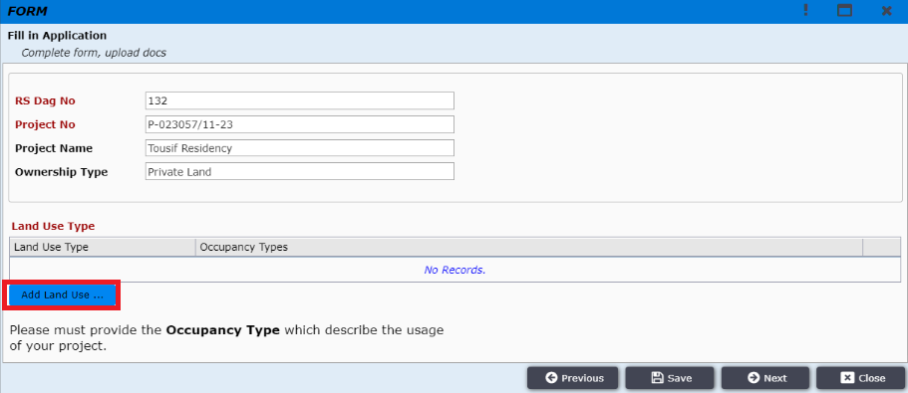
Figure: 6. Land Use Type
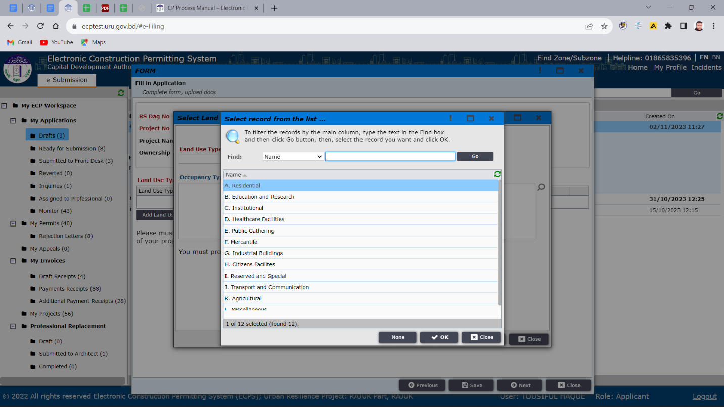
Figure: 6.1 Land Use Type
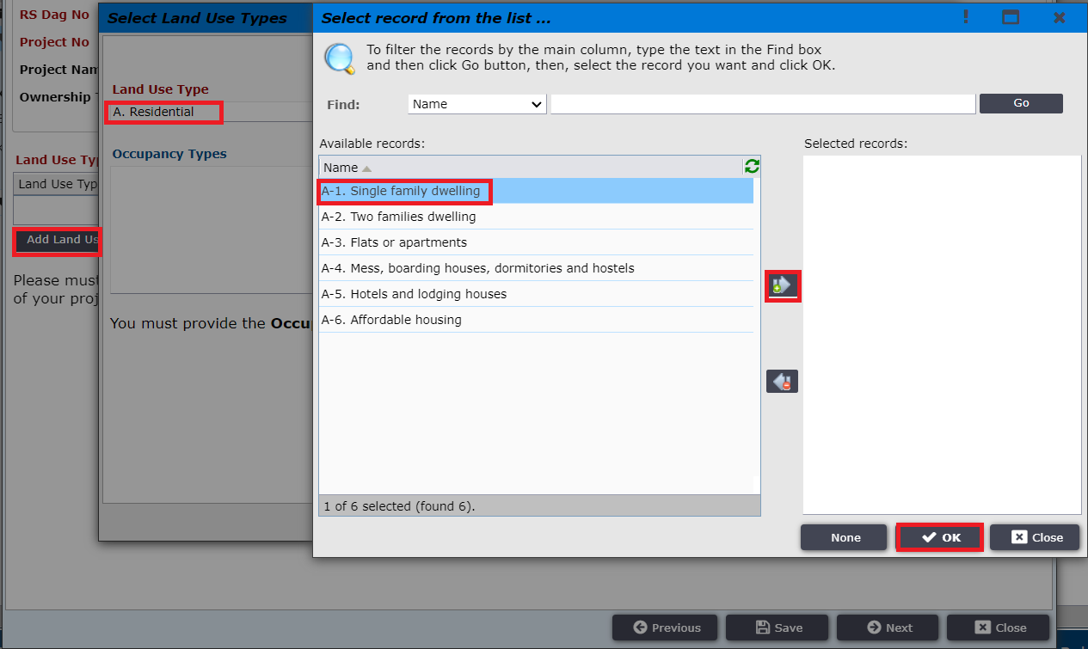
Figure: 6.3 Land Use Type
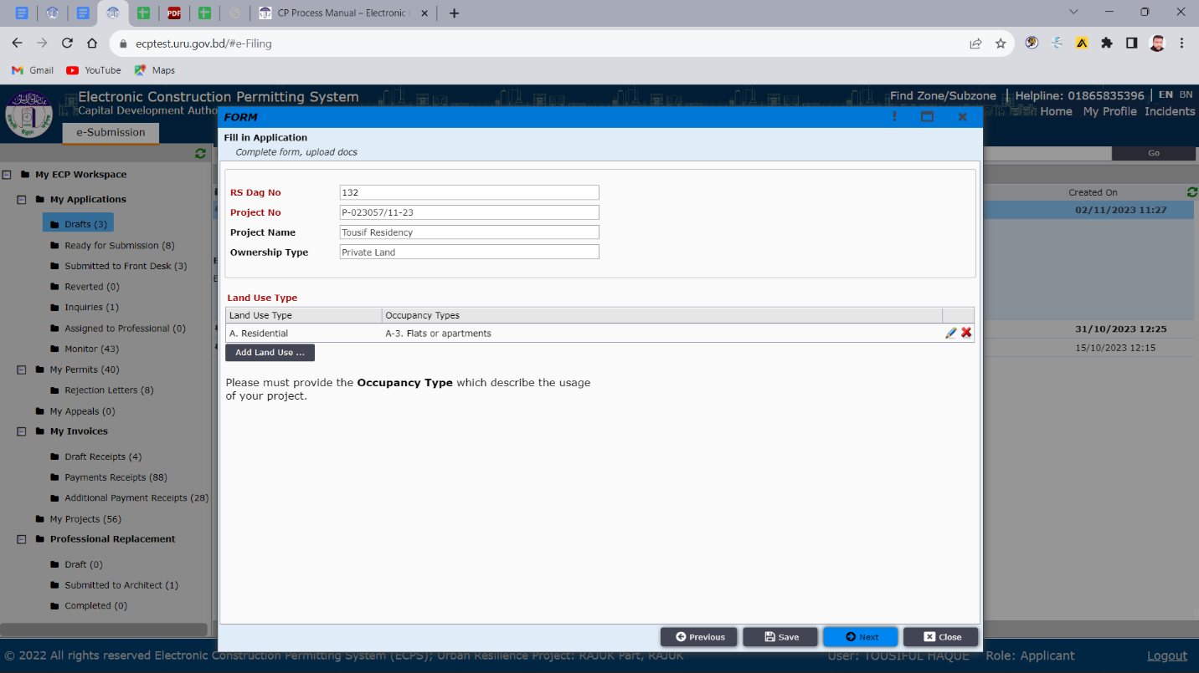
Figure: 6.4 Land Use Type

After selecting Land Use Type applicant must click on “Next” to add team members. Applicant needs to invite team member by clicking on ‘Invite Team Member’ option as shown in Figure 7.
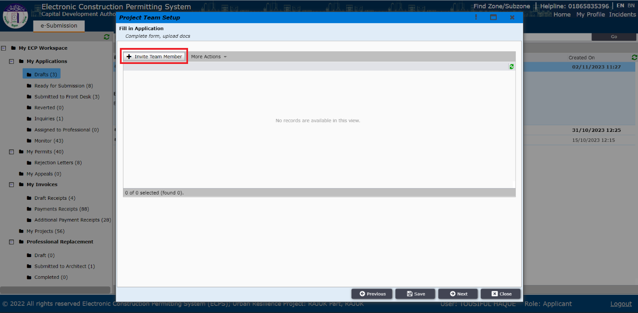
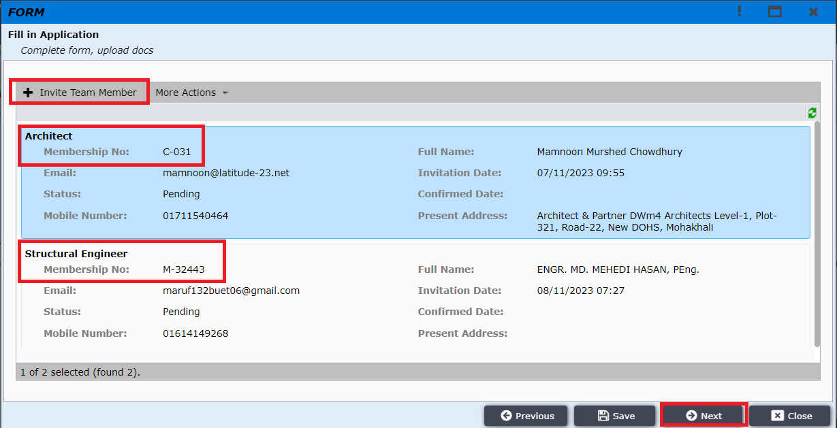
Figure 7: Invite Team Member
Applicant will be taken to a window to provide information about the particular professional such as Role and Membership number of IEB as shown in Figure 7.1 & 7.2
Note: As Architect is the focal point, so applicant must add an Architect.
Applicant can add multiple professionals here such as: Electrical Engineer, Fire Safety Specialist, Mechanical Engineer, Plumbing Engineer and Structural Engineer.
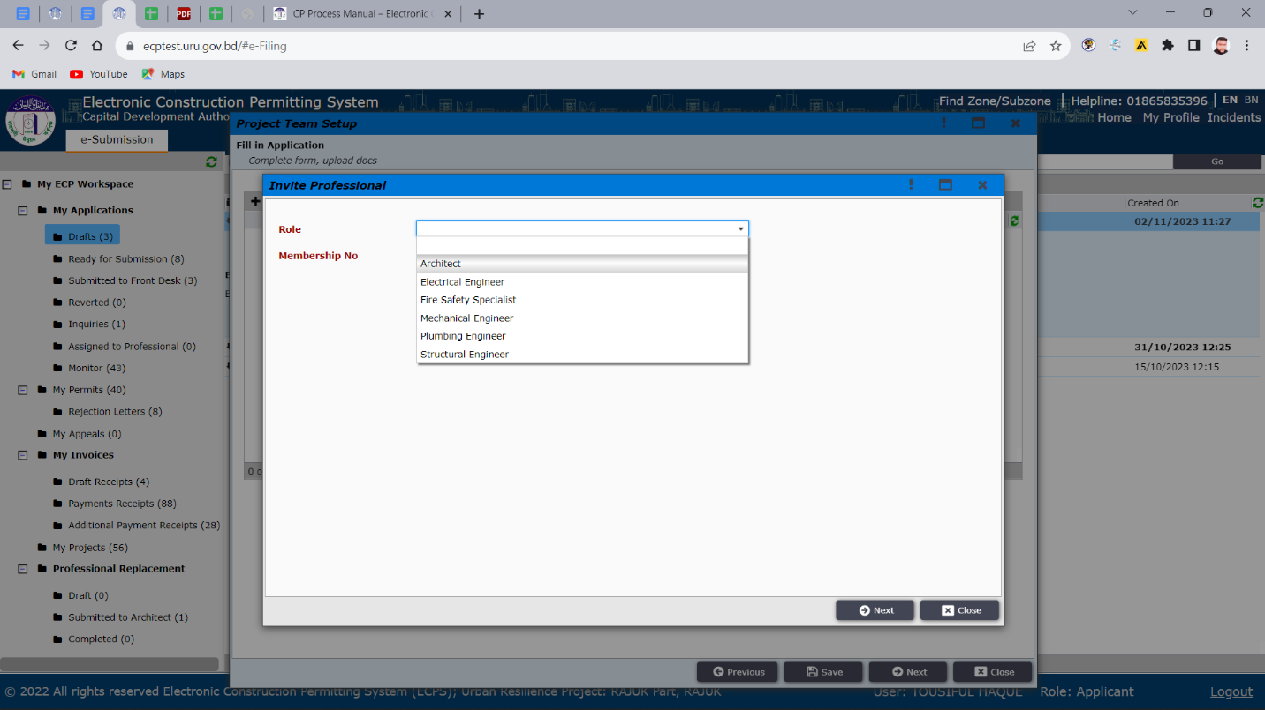
Figure 7.1 Inviting Professional

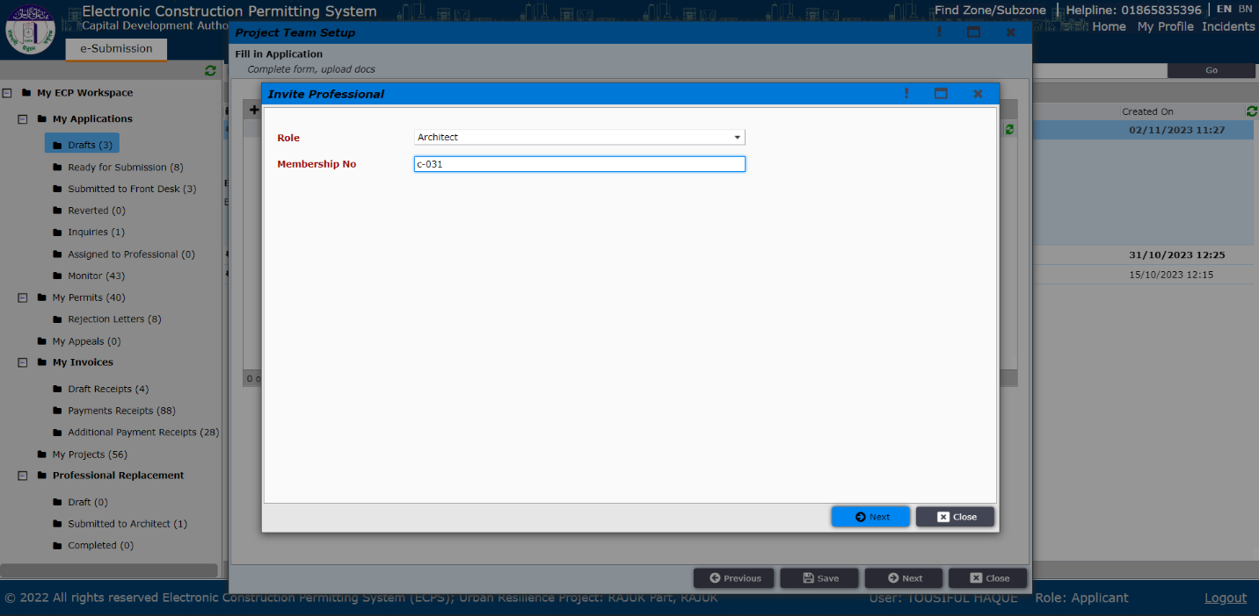
Figure 7.2 Inviting Professional
After providing correct membership number applicant will view the professional’s details with picture as shown in (Figure 8) and then applicant needs to click “Next” and window of Figure 8.1 will appear.

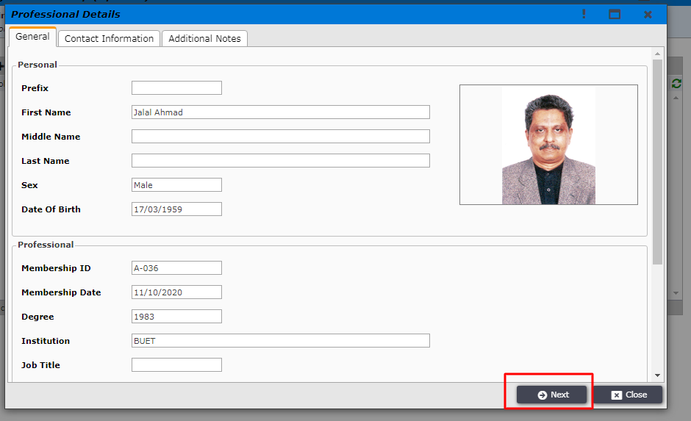
Figure 8. Professional Details
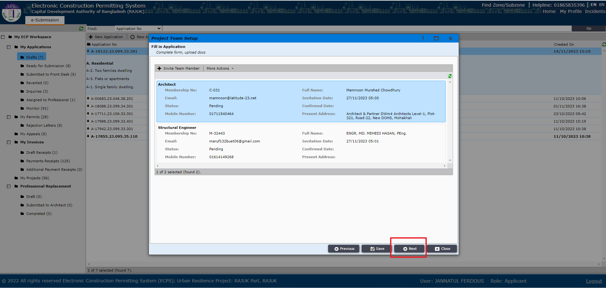
Figure 8.1 Project Team Setup
Applicant is then taken to the next window as shown in the Figure 9 after clicking on “Next”. In this window, Applicant will get “Application No” and need to remember this Application No.
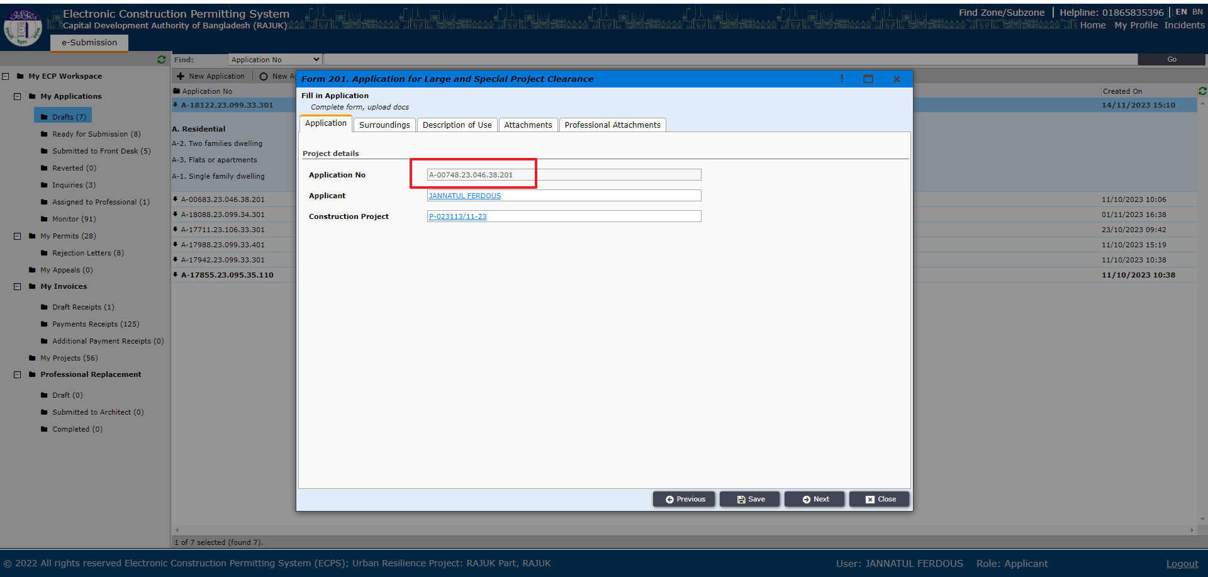
Figure 9
If Applicant need to provide some other Information of plot, s/he can give that information from “Surroundings”, “Description of Use”, “Attachments” tab like Figure 9.1
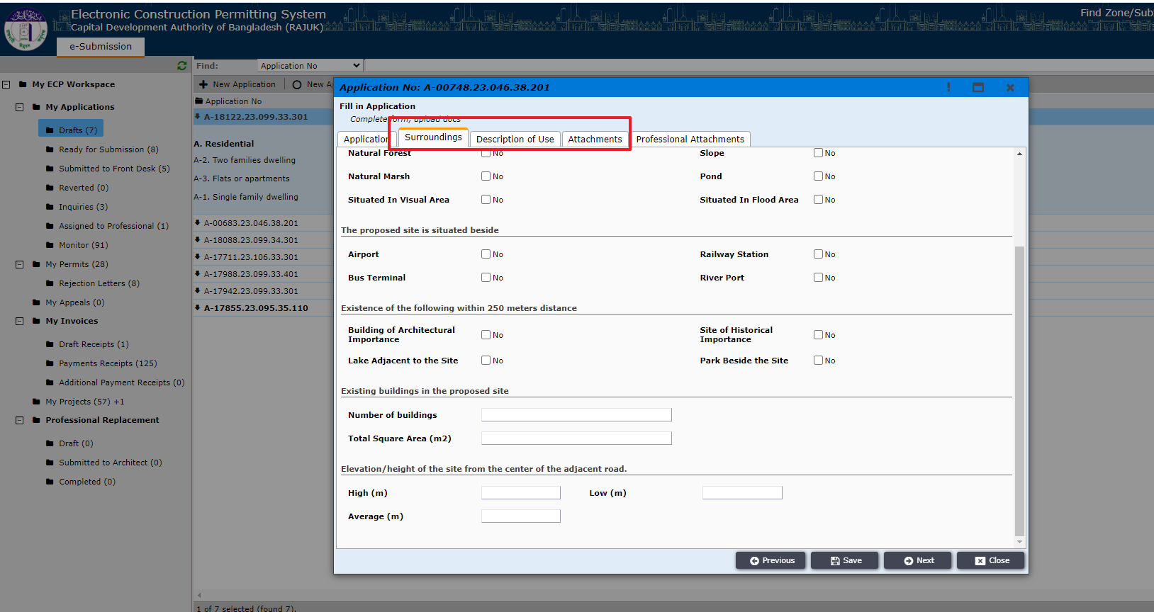
Figure 9.1
Then, by clicking on the next button, a new window will appear, and from this window, the applicant can add more attachments. Click on Add New, and then a new pop-up will appear. From this pop-up, attachment type can be seen after clicking on the drop-down button. Selecting the required attachment (according to RAJUK), like Figure 10.1, you need to provide a title for that attachment and add that attachment, like Figure 10.2.
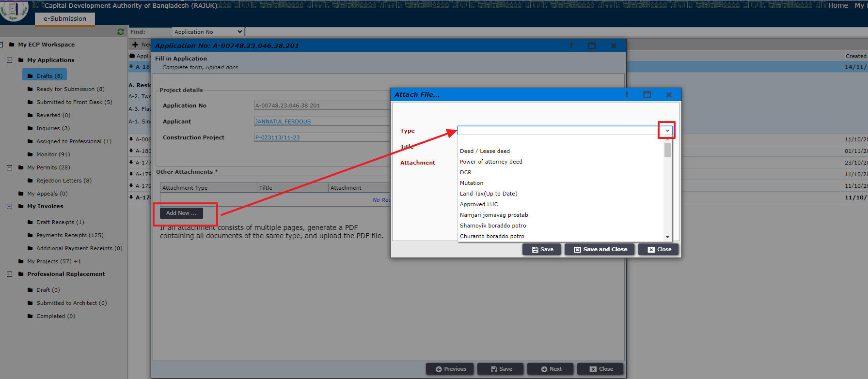
Figure 10.1 Select Other Attachment Type

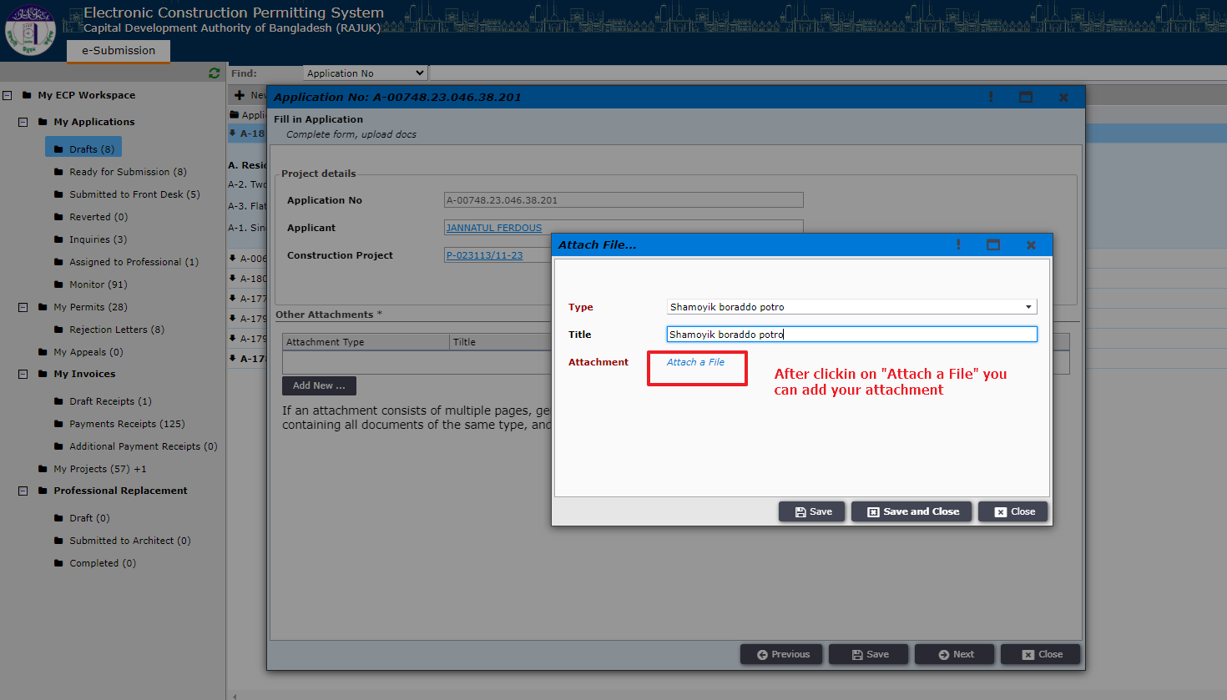
Figure 10.2 Upload Other Attachment
After uploading attachments, click on “Save and Close” button like Figure 10.3. Then click on “Next” button like Figure 10.4 and the applicant will be shown a message as shown in Figure 11 and will need to wait for Professional’s acceptance.

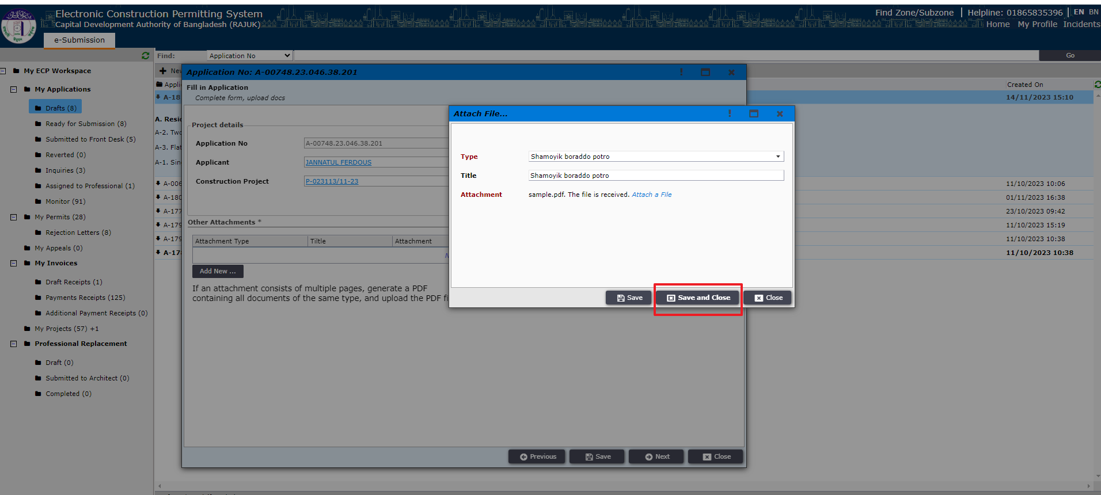
Figure 10.3

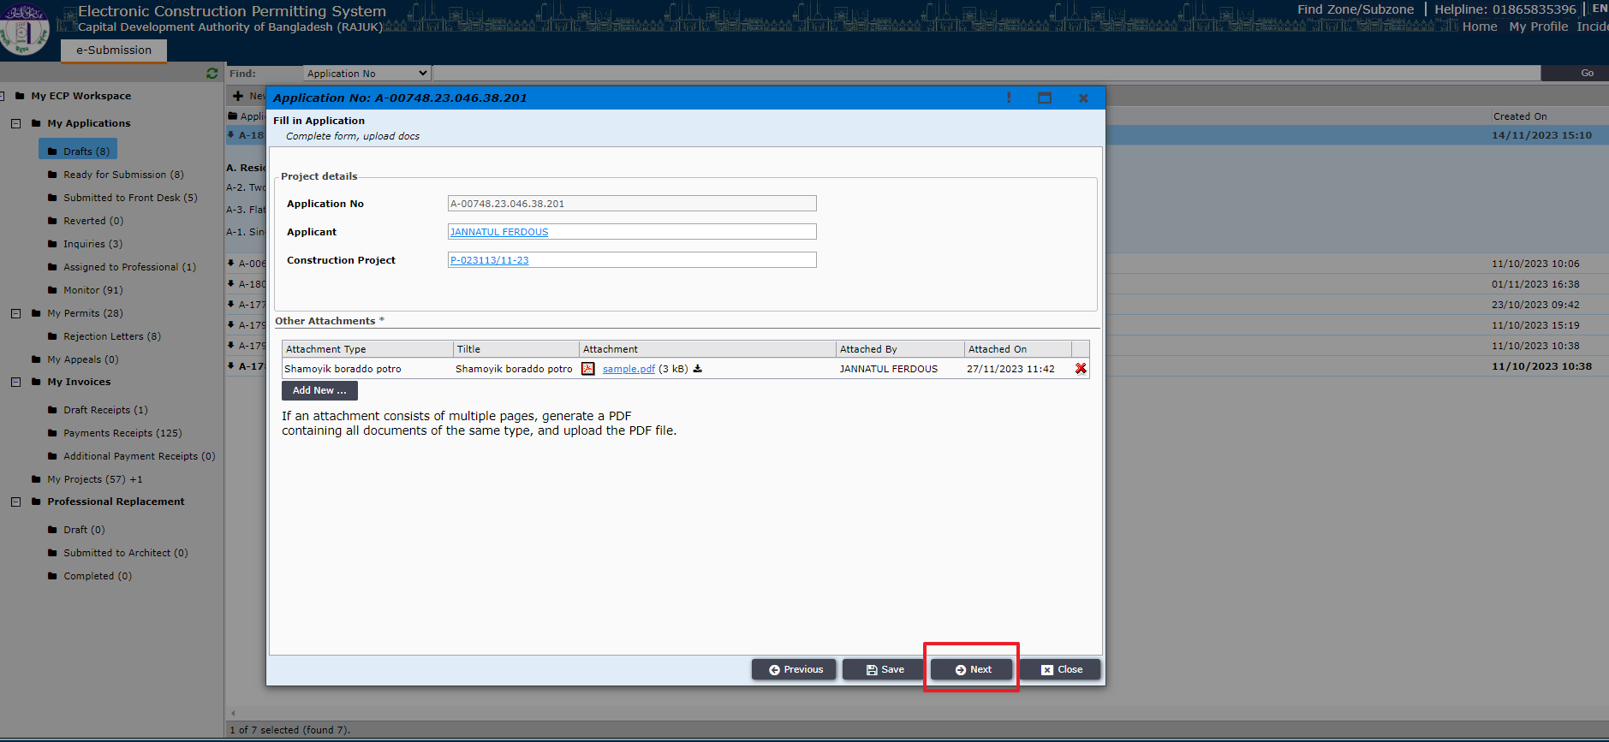
Figure 10.4
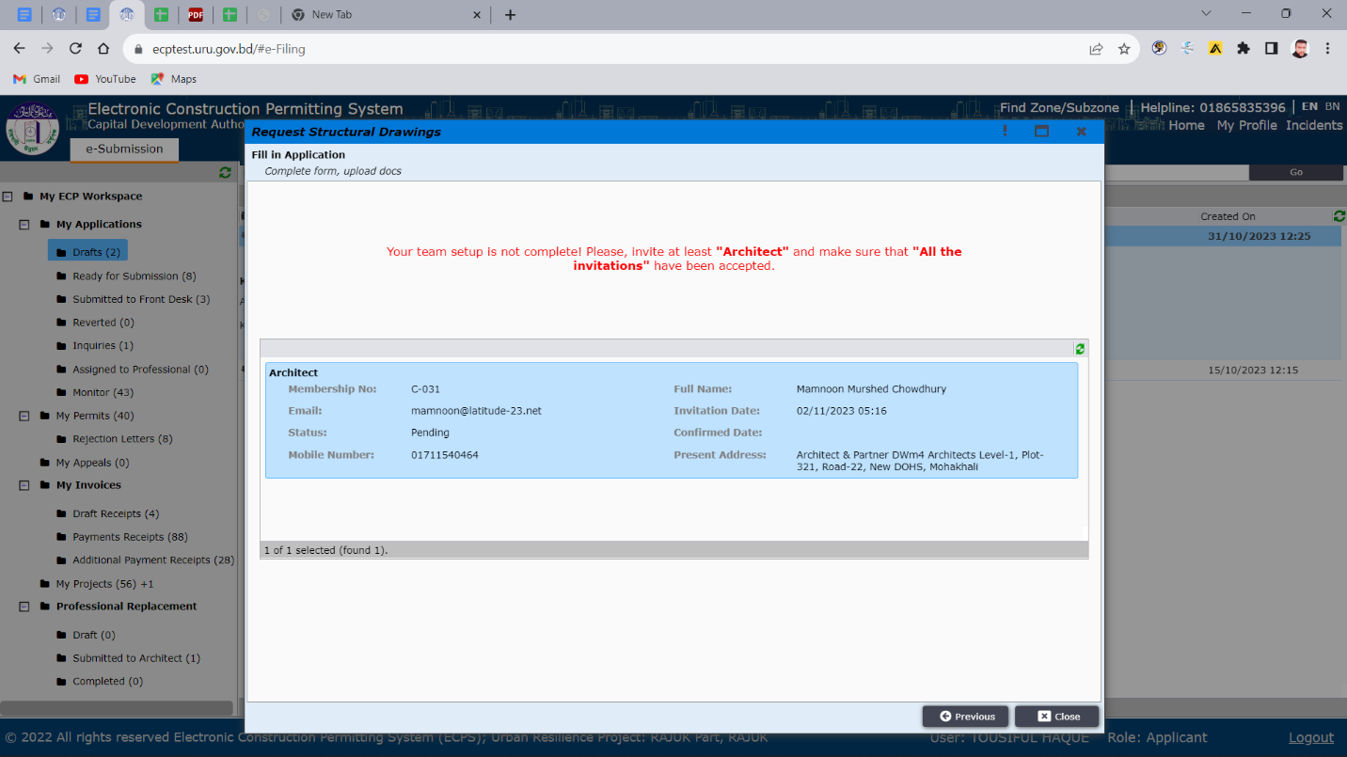
Figure 11. Professional’s acceptance
Now the professional (ex. architect) will find the invitation in his incoming section of “My invitation” workspace and click “Next” as shown in Figure 12.
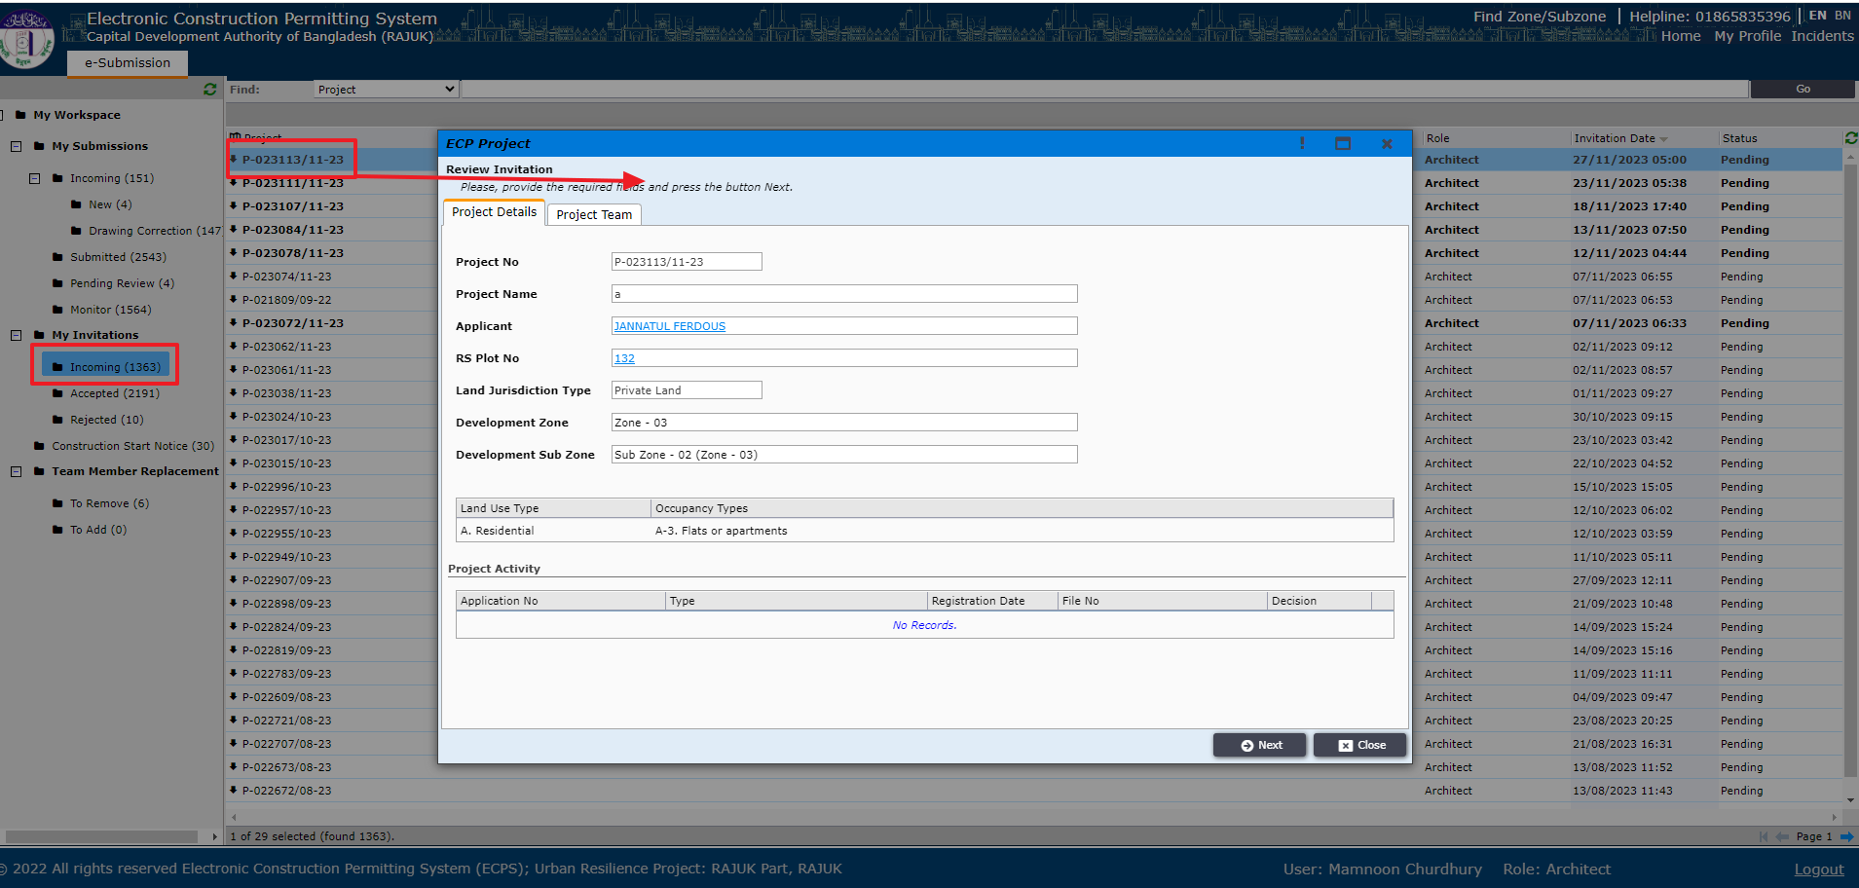
Figure 12. Professional’s acceptance

The Architect will get the option to accept or reject the invitation as shown in Figure 13. If Architect accepts then applicant can move forward to “Next” step but if the architect rejects then applicant needs to add another professional again by using the same steps mentioned above.
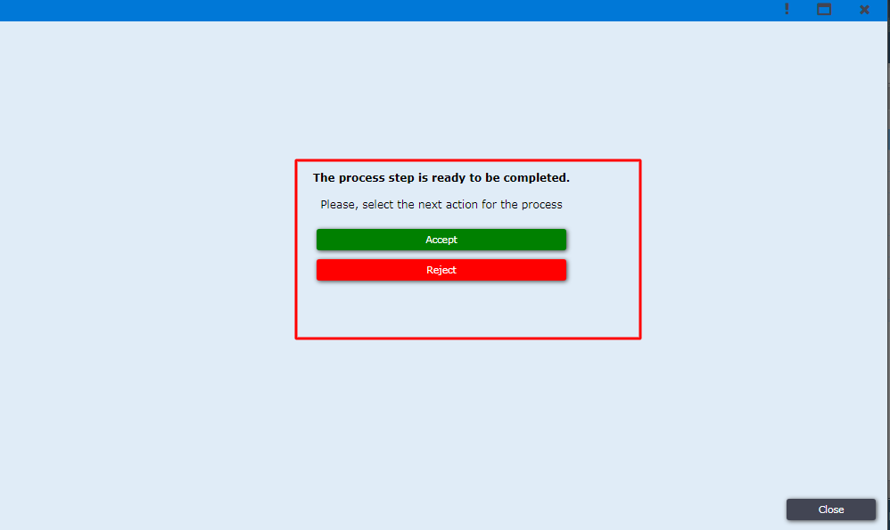
Figure 13. accept / reject

After the professional has accepted the invitation, the applicant can now send the application to focal point by opening the application from draft workspace (Figure 14.). The applicant needs to click “Next”. If the professional has rejected the invitation, then the applicant needs to invite another professional.
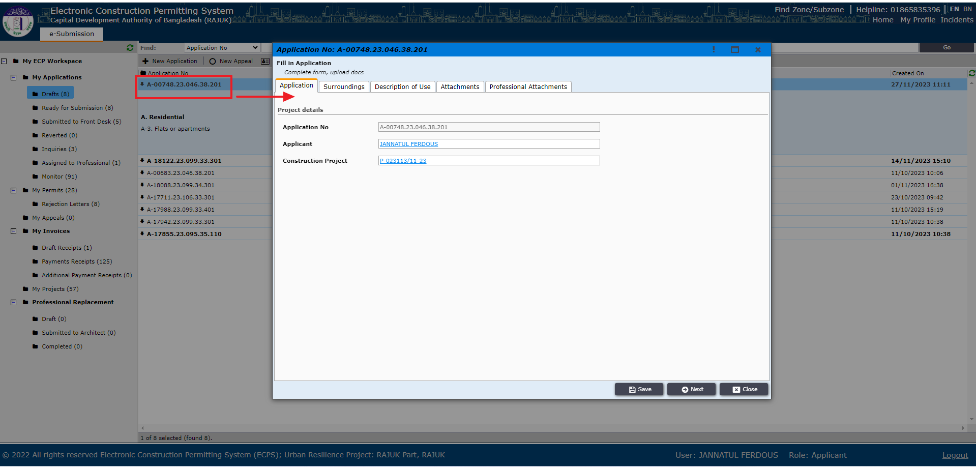
Figure 14. Application in draft

Applicant is then prompted to “Next” window to send the application to a focal point (Architect) by clicking on the button (Figure 15).
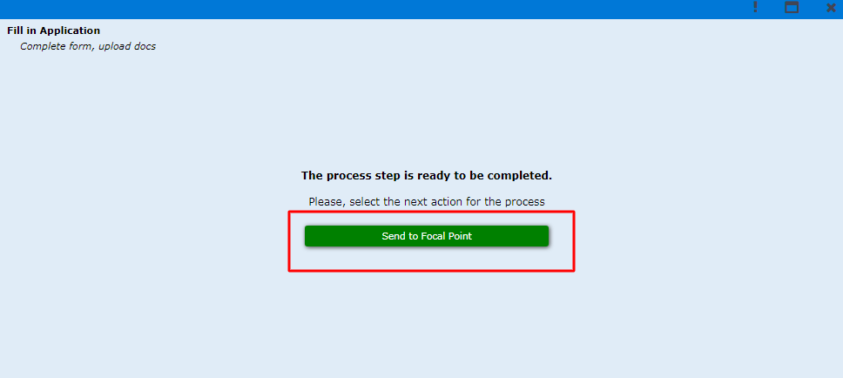
Figure 15. Send to Focal Point.

Now, the focal point can find the application under “My Submissions” workspace and can open the application details. (Figure 16)
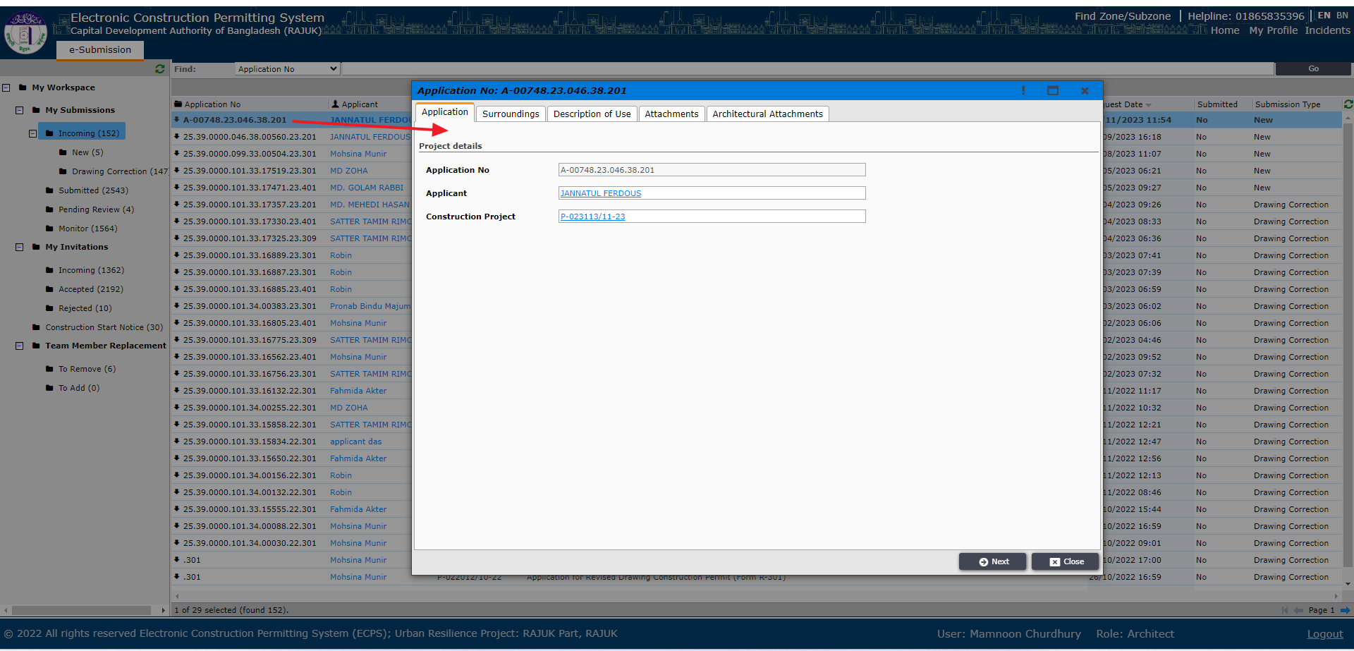
Figure 16. Focal Point’s workspace

Then, Architect will go to “Architectural Attachments” tab and click on “Add New” as shown in Figure 17, 17.1, 17.2, 17.3, 17.4 and 17.5.
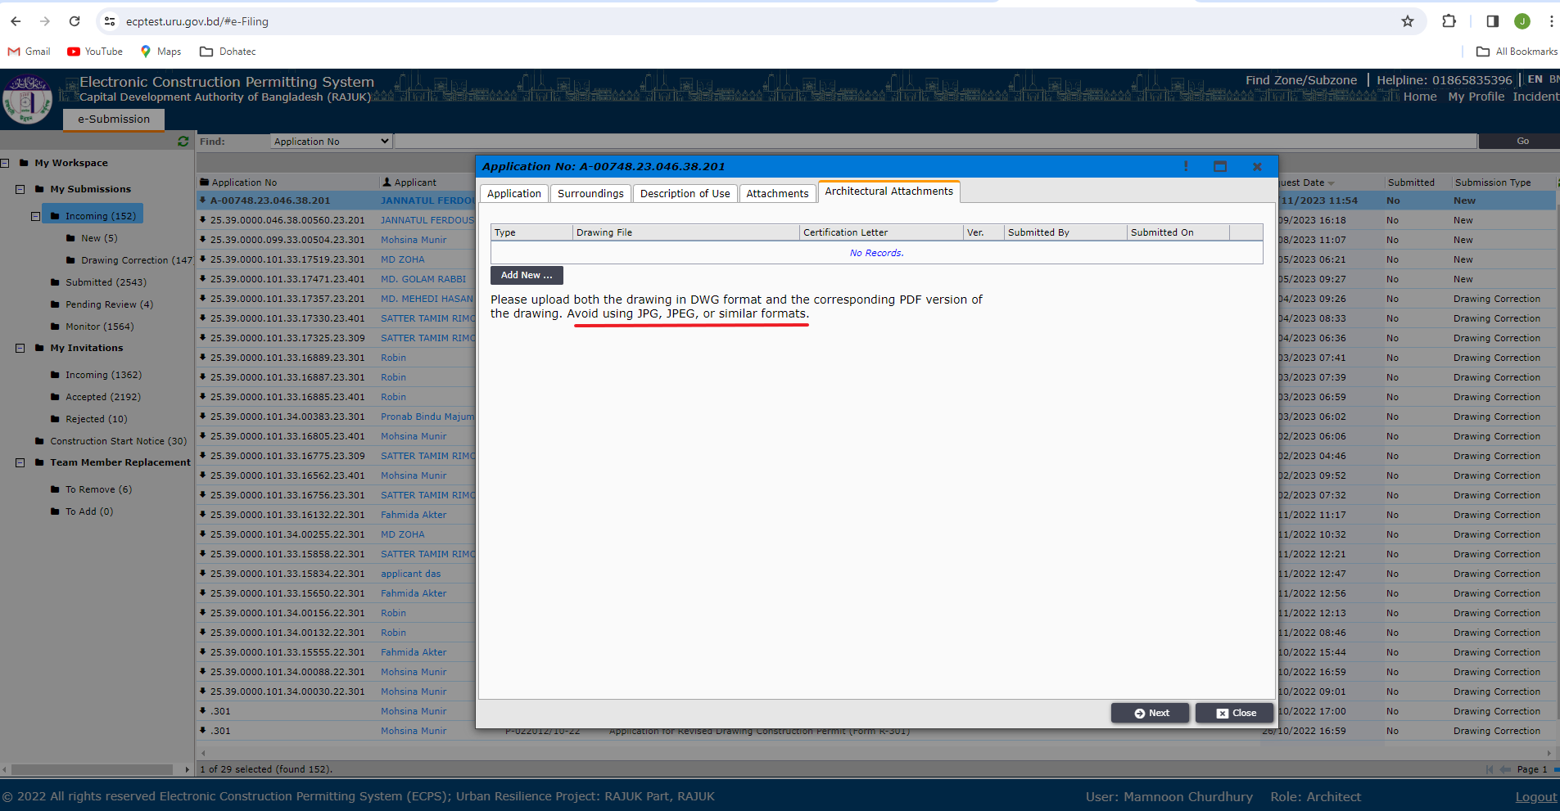
Figure 17. Architectural Attachments tab
Architect will then select drawing type and attach different drawings.
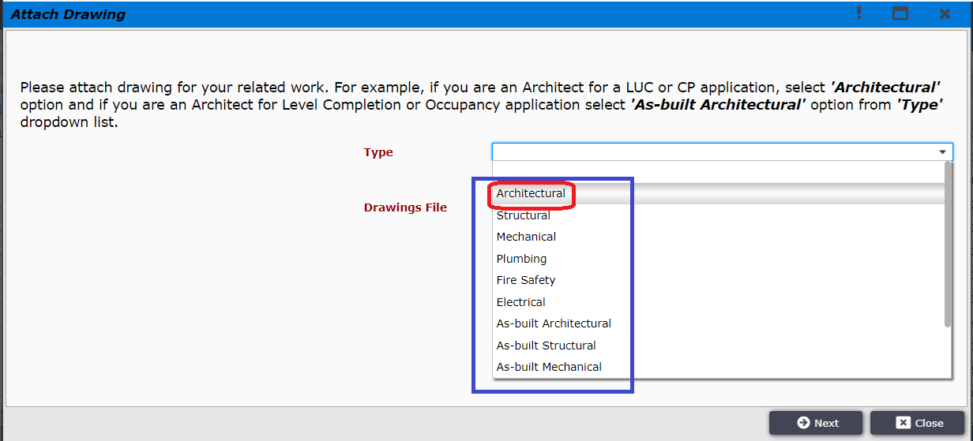
Figure 17.1 Architectural Attachments tab
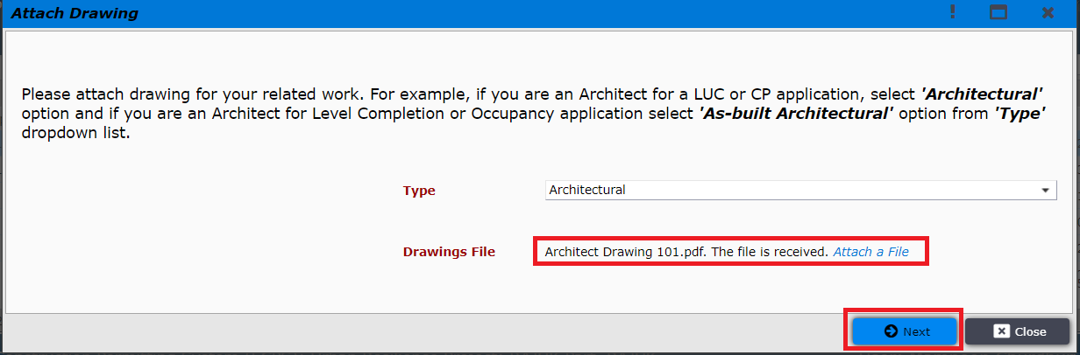
Figure 17.2. Drawing Attachment types
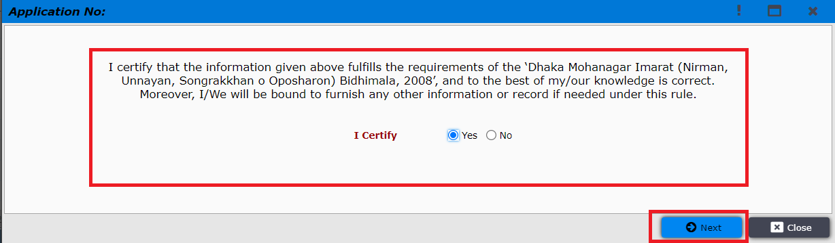
Figure 17.3. Drawing Attachment types

After agreeing with Rajuk Bidhimala Architect must sign the document and attach to “Signed Technical person Certificate Letter” (Digital signature) as shown in Figure 17.4
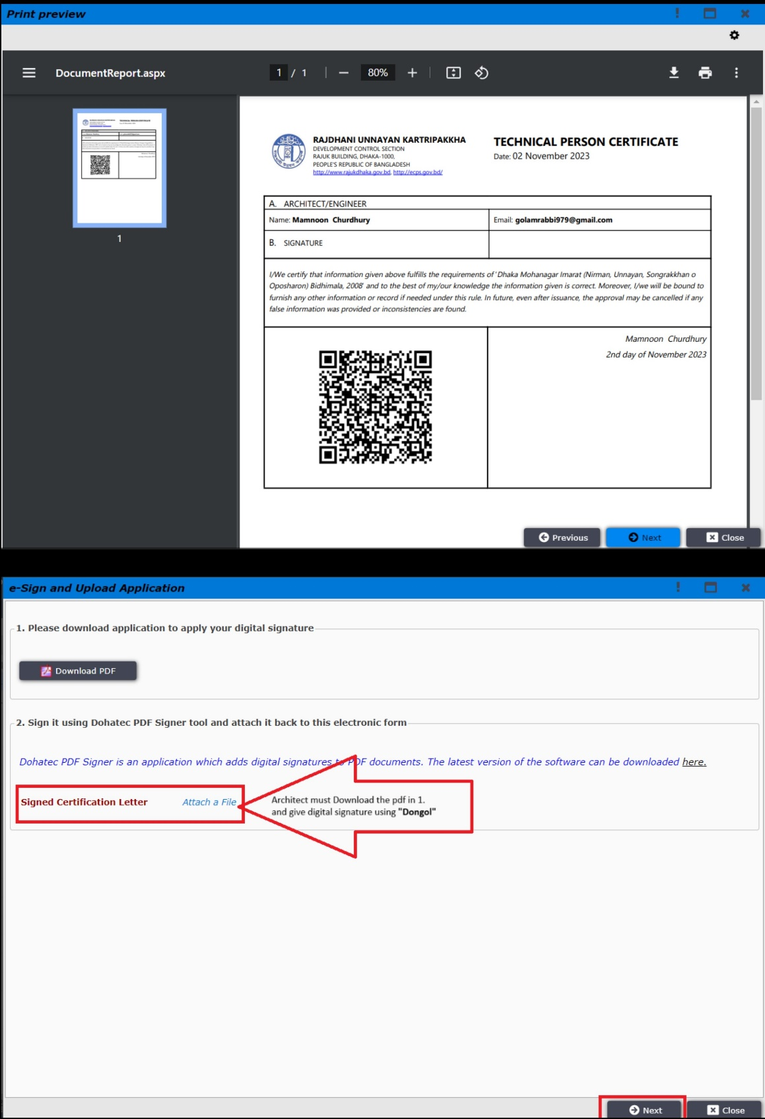
Figure 17.4 Architectural Attachments tab

After clicking on “Next” Architect will send the file to applicant as shown in Figure: 17.5

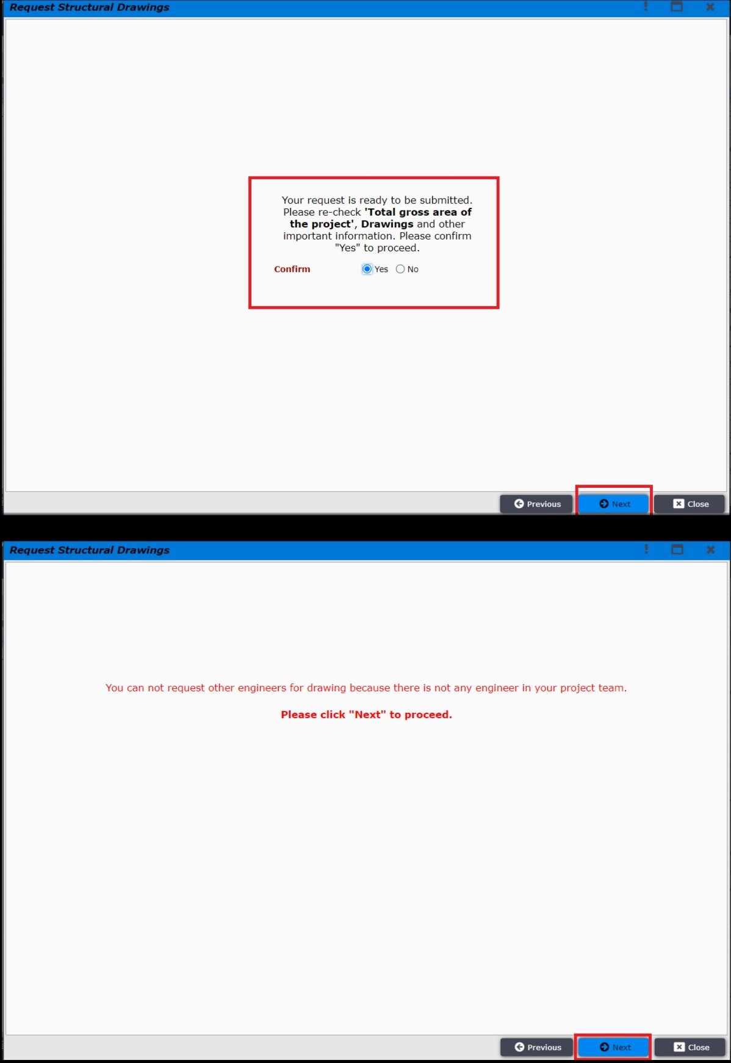
Figure 17.5 Architectural Attachments tab

If other professionals add their attachment, then the file will go to pending review folder. Here, the focal point “Architect” will decide whether he need other engineers or not to fulfill the applicants file demand as shown in the figure: 17.6, 17.7, 17.8 and 17.9

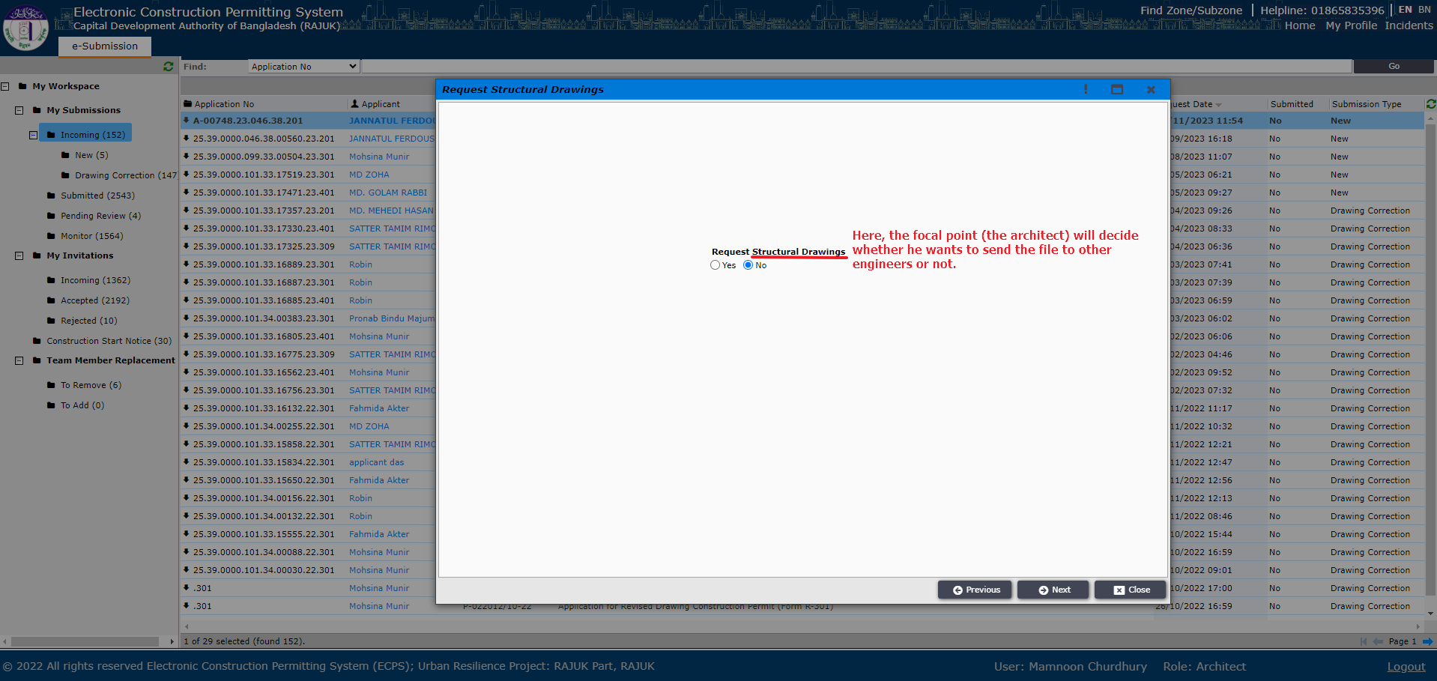
Figure: 17.6

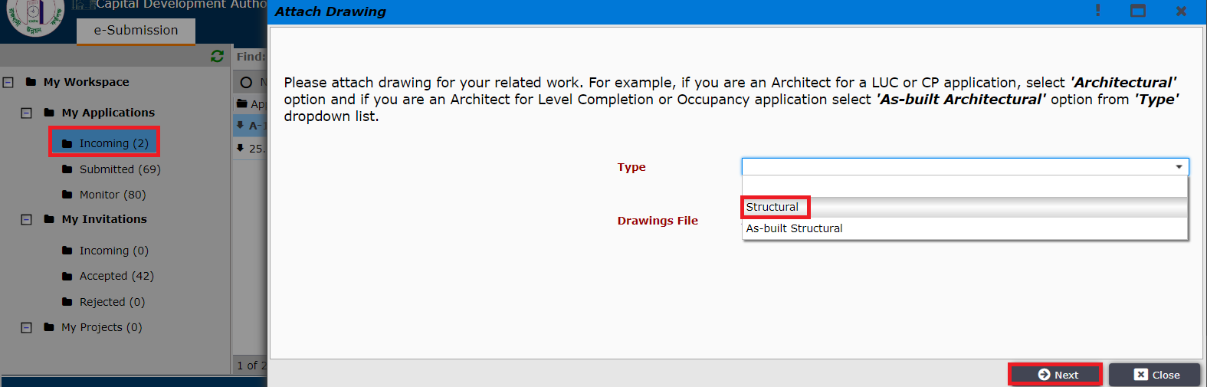
Figure: 17.7

Here, Other engineers, (Electrical Engineer, Fire Safety Specialist, Mechanical Engineer, Plumbing Engineer, Structural Engineer) such as Structural Engineer is attaching drawing as shown in Figure 17.8. After attaching drawing other engineers need to follow the same process as shown in Figure 17.3 & 17.4

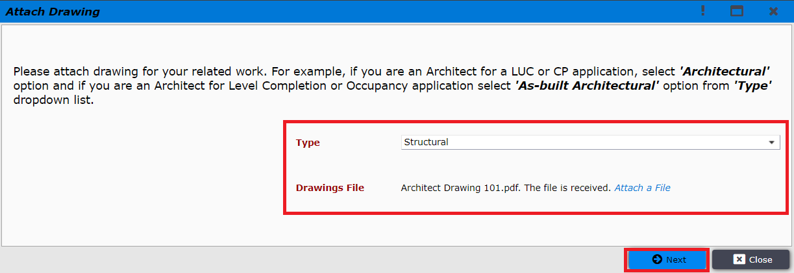
Figure: 17.8
Here, Structural engineer added structural drawing and the file will go to Architects dashboard in “Pending Review” folder as shown in figure: 17.9
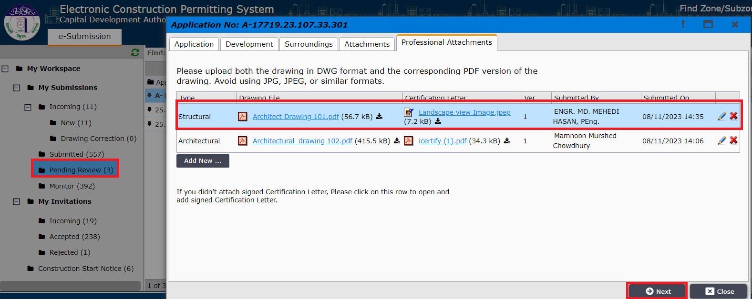
Figure: 17.9
After the focal point has submitted the drawings, the applicant will get the application under his ‘Ready for Submission’ tab as shown in Figure 18
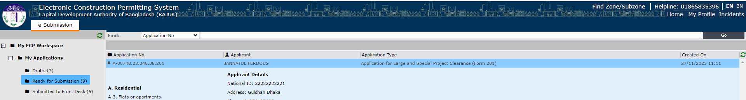
Figure 18. Ready for Submissions
Applicant now can open the application and after clicking “Next”, he will be prompted to the window to pay application fees. Applicant needs to click on “Pay Online” button. It is shown in Figure 19.
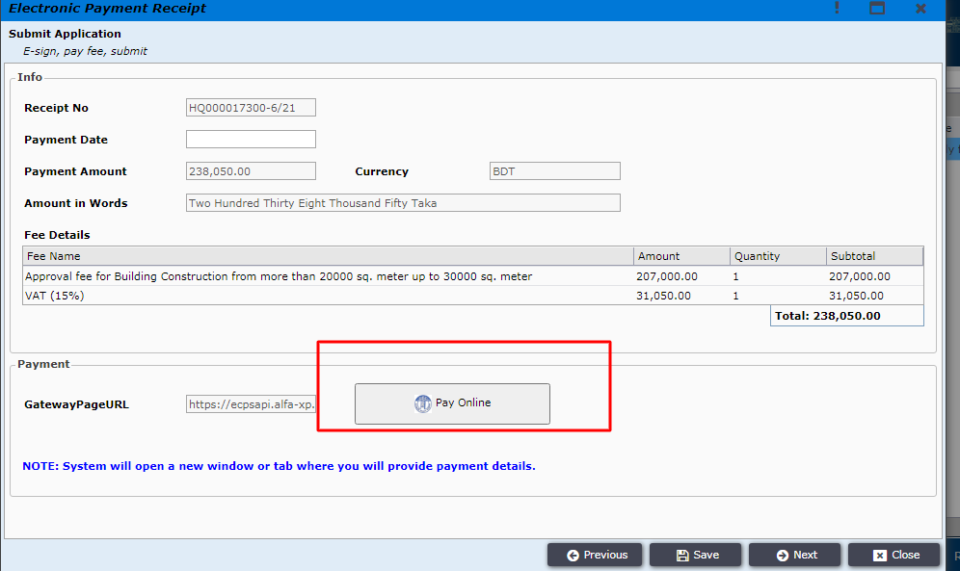
Figure 19. Pay online
After clicking pay online applicant will find different types payment options and can select the preferred option from those. (Figure 20)
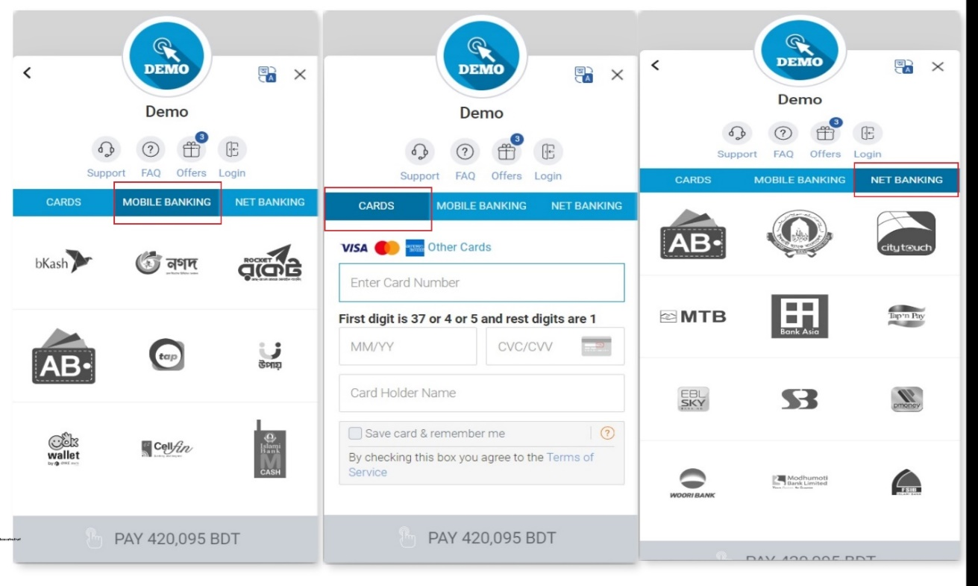
Figure 20. Different types of Payment options
After providing all correct payment information applicant will be able to pay the application fees successfully and a message will be shown confirming it as shown in Figure 21.
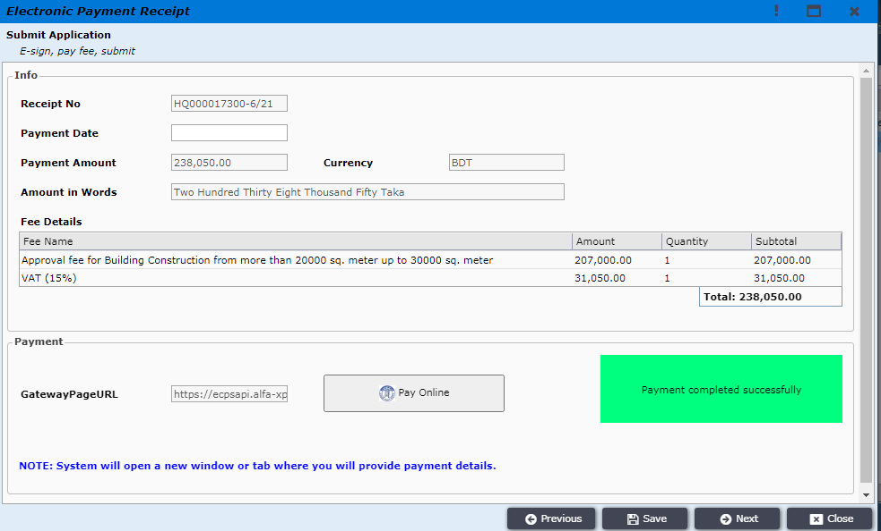
Figure 21. Payment is confirmed
Now applicant needs to click on “Next” and the payment details will be shown along with payment receipt printable PDF file as shown in Figure 22 and Figure 22.1.
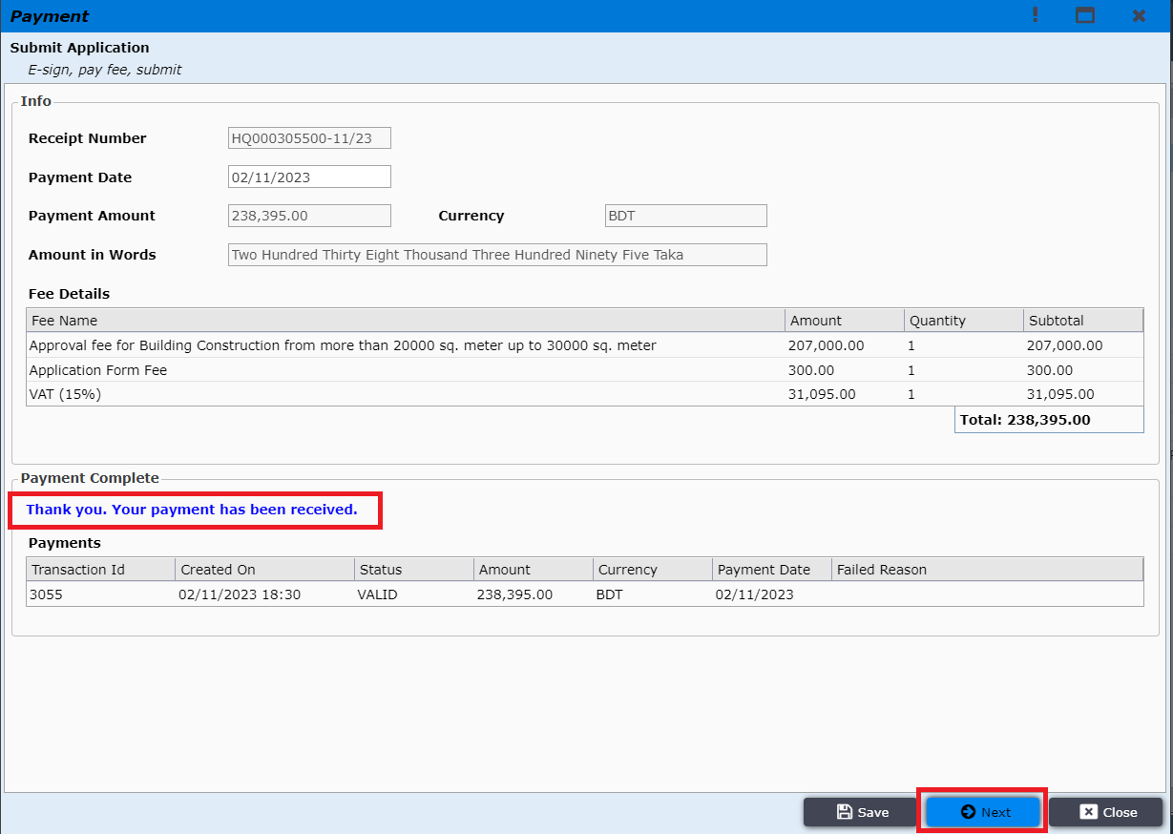
Figure 22. Payment details
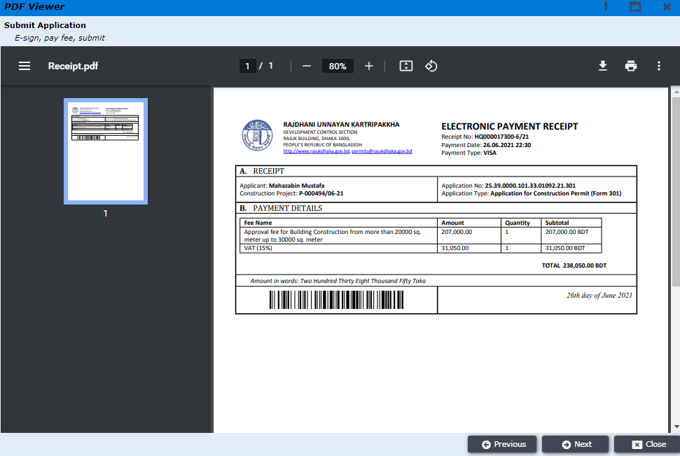
Figure 22.1 Printable PDF receipt
Applicant now needs to certify that the given information is correct by clicking on “Yes” as shown in Figure 23.
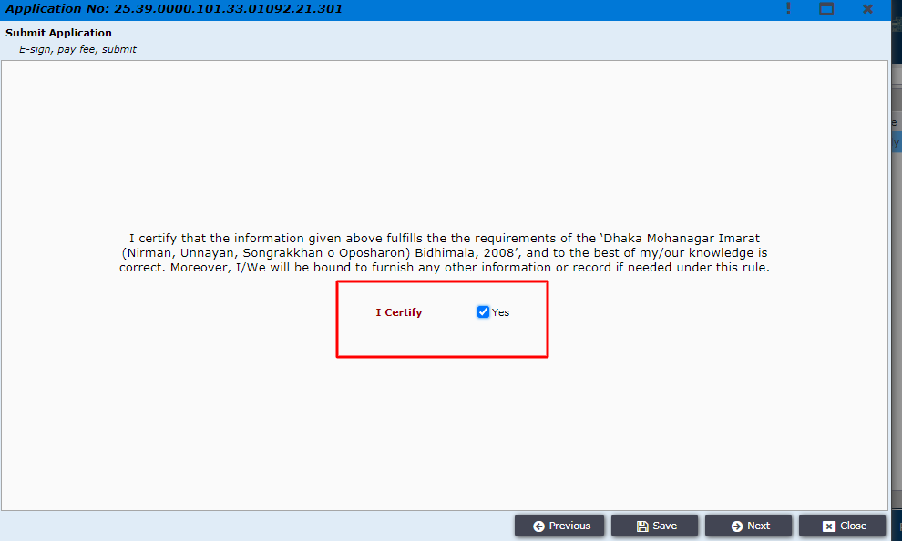
Figure 23. Certify
After certifying, the application printable preview is shown as Figure 24.
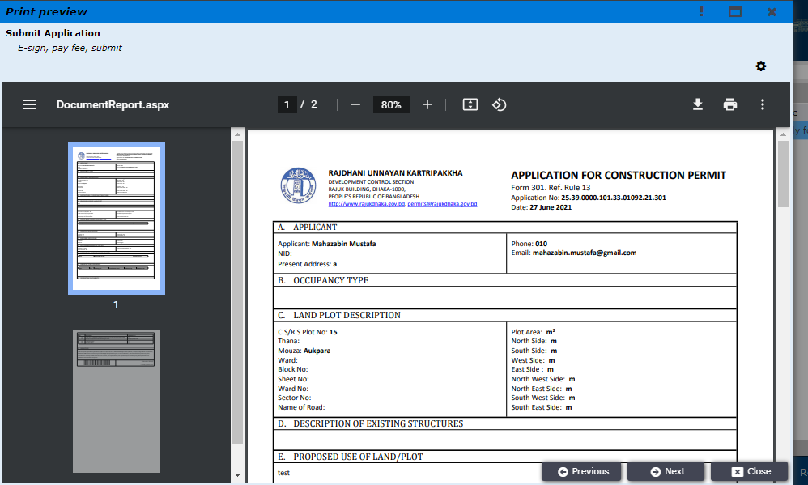
Figure 24. Printable application

Applicant needs to click “Next” and will be prompted to the window to download application and then need to e-sign the document. The e-signed documents need to be uploaded in the “Signed Application”
Section successfully and then the applicant can move “Next”.
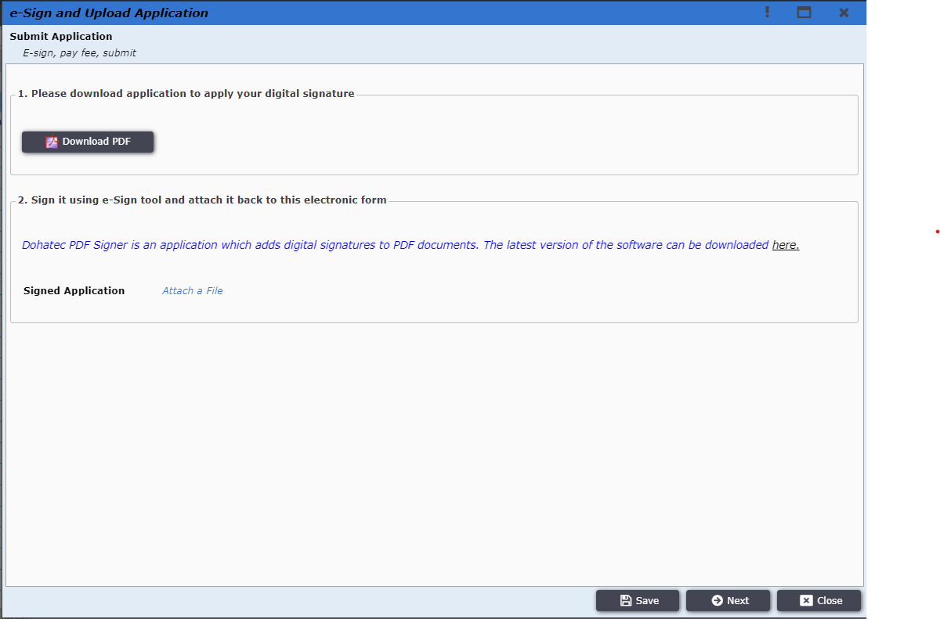
Figure 25. Sign and Validate
After the signed document is uploaded successfully, applicant will be provided the option to submit application as shown in Figure 26. By clicking on the button, the application will be submitted successfully and will be sent to the front desk officer.
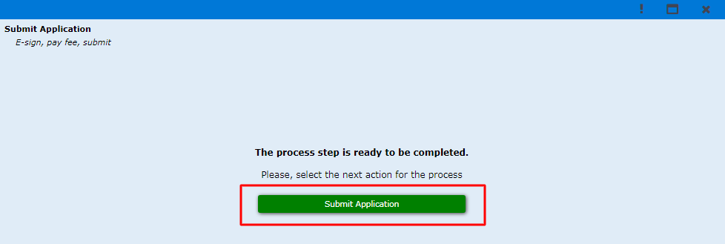
Figure 26. Submit Application
Front desk officer will be able to find the submitted application from E-filings workspace as shown in Figure 27.
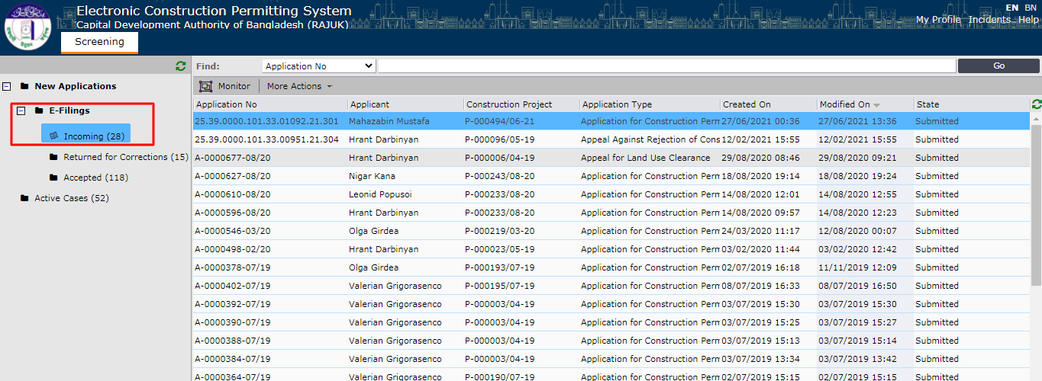
Figure 27. Incoming E-fillings
Now, front desk officer will be able to review the application as shown in Figure 28.
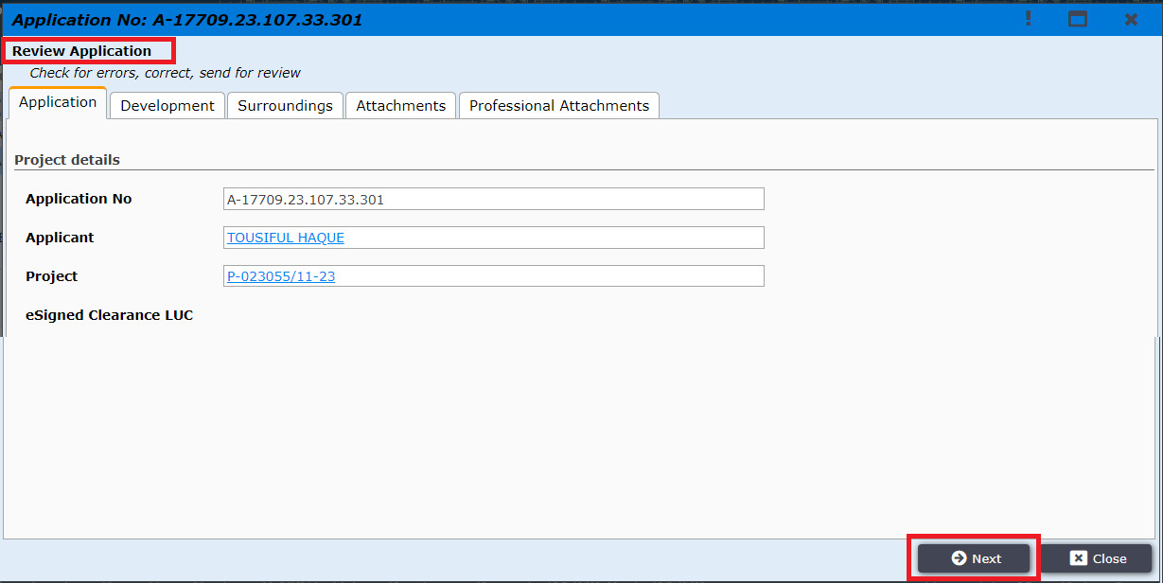
Figure 28. Review Application
After clicking “Next”, the front desk officer is given options to “Accept Application” or “Request Corrections”. If request correction is selected then front desk officer will need to mention the required corrections and send it back to the applicant and then applicant will be doing the required corrections before sending it back to the front desk officer. (Figure 29)
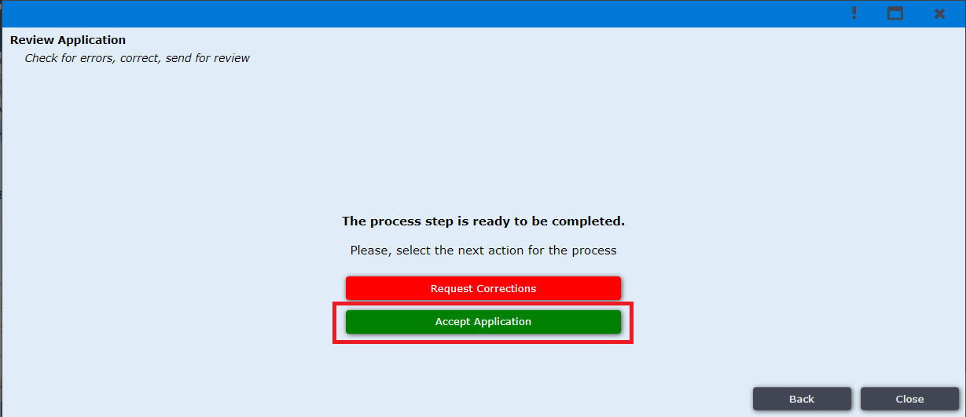
Figure 29. Front Desk Officer Application Processing options

If the front desk officer accepts the application, then he will be prompted to the window shown in Figure 30. And after clicking “Next” the application will be accepted successfully and is sent to the designated authority.
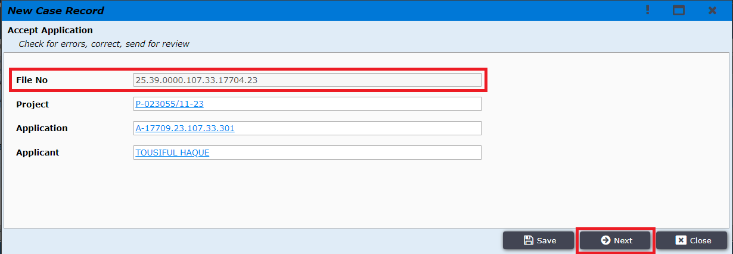
Figure 30. Accept Application
The Application Filing process is successfully completed after front desk officer accepts the application.
Front Desk Assistant can request for correction to applicant by clicking “Request Corrections” button in Figure 31
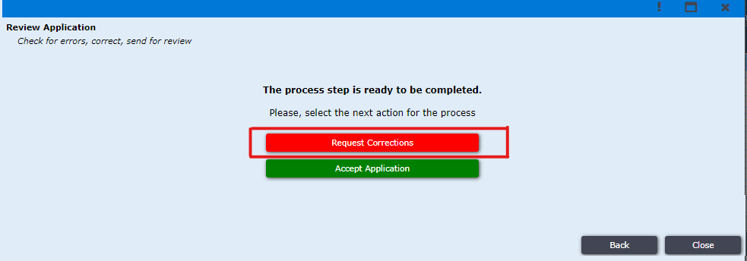
Figure 31. Request Corrections
After clicking Button “Request Corrections” he prompted to the window shown in Figure 32. Here first field for comment for whole application if there is anything for corrections. Other field is for every attachment if any correction needed for respective attachment.
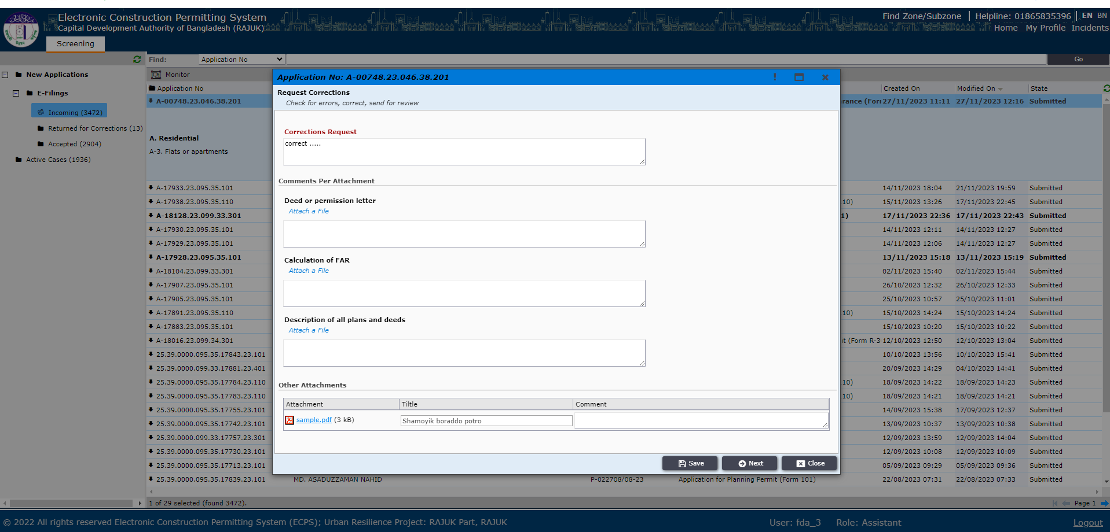
Figure 32. Field for correction
After clicking “Next” the file will go to the applicant Reverted tab section in “My Applications”.
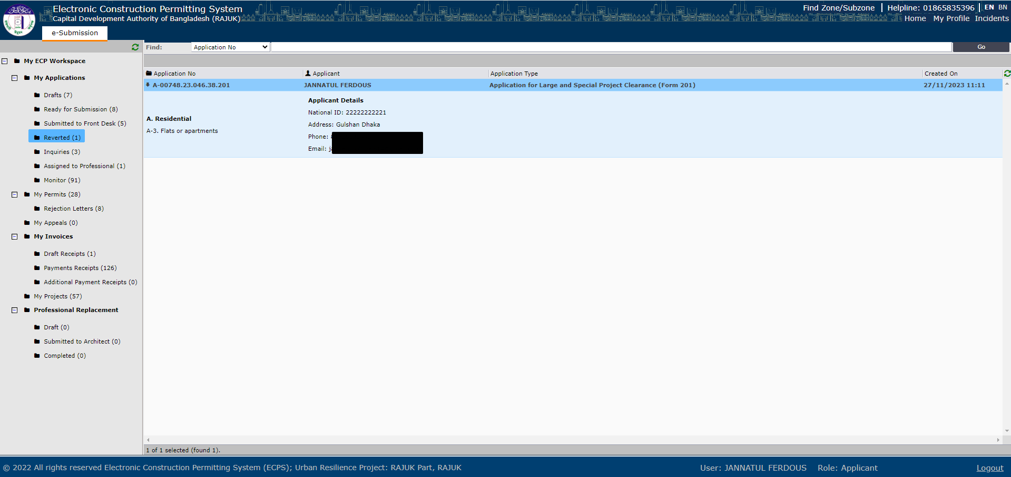
Figure 33. Application come to Applicant for correction
After clicking “Reverted” Figure 33, reverted applications from front desk assistant show as list. After clicking on file, Applicant can see the comment for correction as Figure 34.
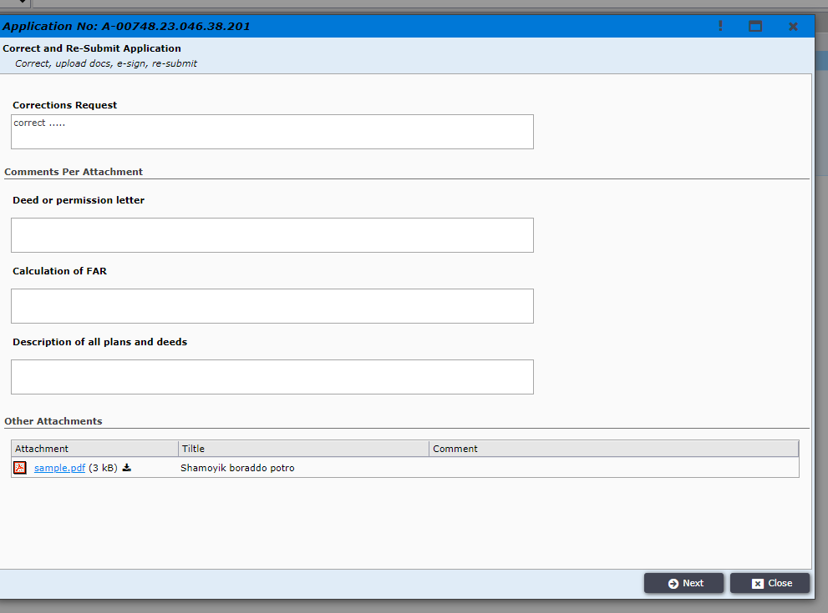
Figure 34. Comment for Correction
After clicking “Next” Applicant can see all data he fills during application in read-only mode Figure 35. He can check out where is the problem.
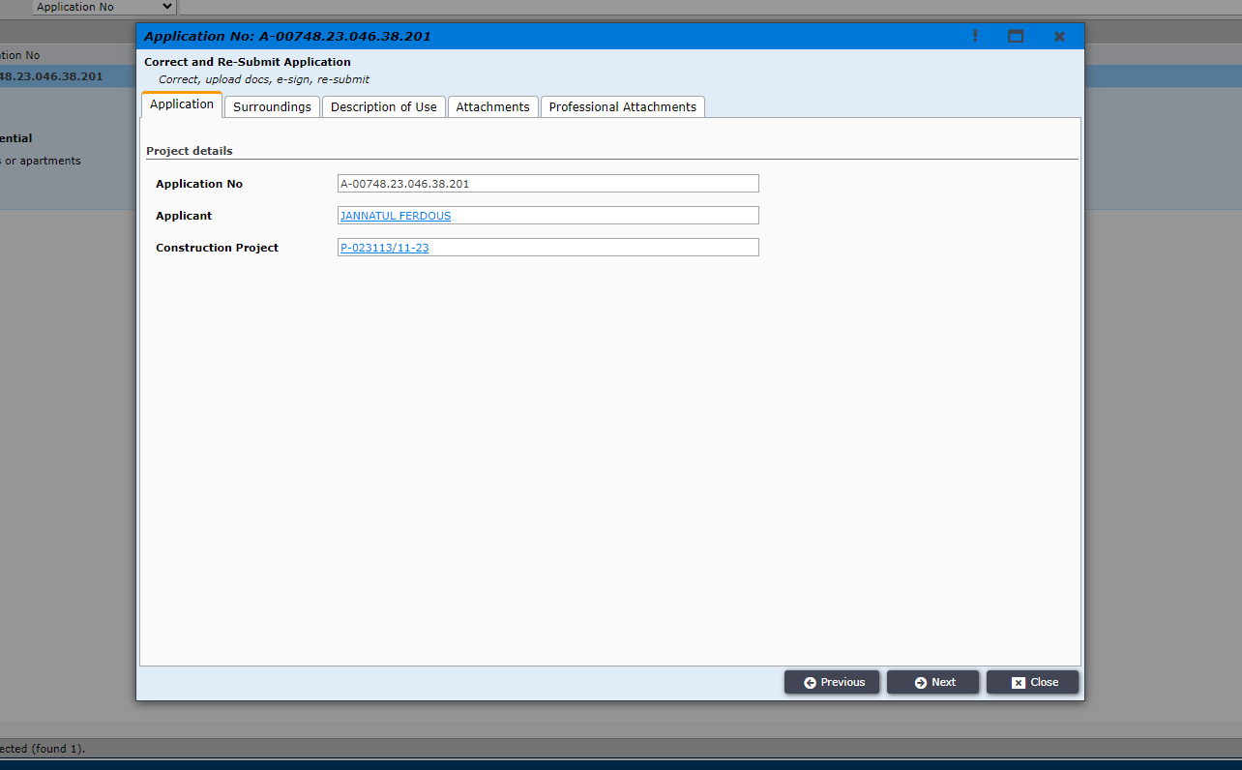
Figure 35. What applicant filled during application
After clicking “Next” he will find two options. For “Re-Submit” his application solving the issue mentioned in correction request comment he have to click “Re-Submit” button Figure 36.
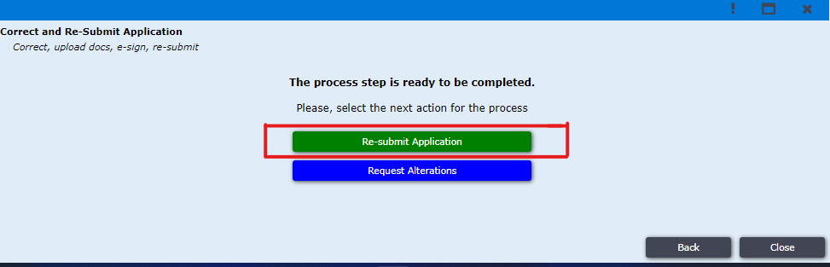
Figure 36. Re-submit Application
After clicking on “Re-Submit” button applicant can see request correction comment for whole application Figure 37.
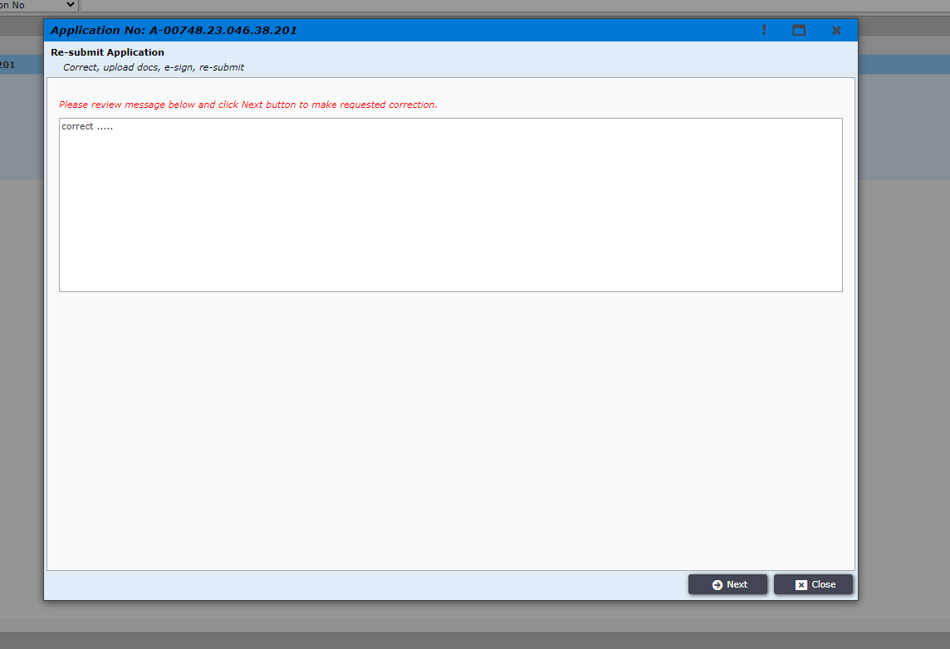
Figure 37. Request Correction Comment for whole application

After clicking “Next” applicant can see the window of Figure 38 where applicant can edit his information and re-upload attachment and submit as before.
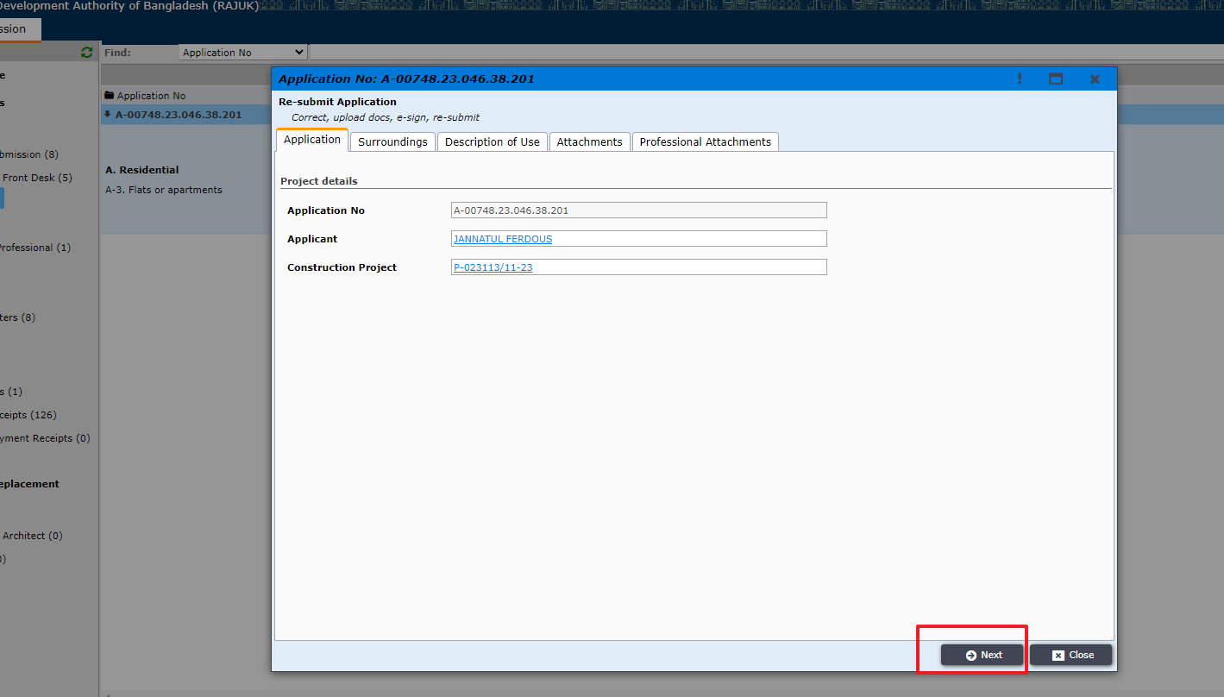
Figure 38. Editable window for re-upload and re-submit

If correction is needed for architect, then applicant have to click on “Request Alternations” Figure 39. Then file will go to the Architect who added with this application during application filing.
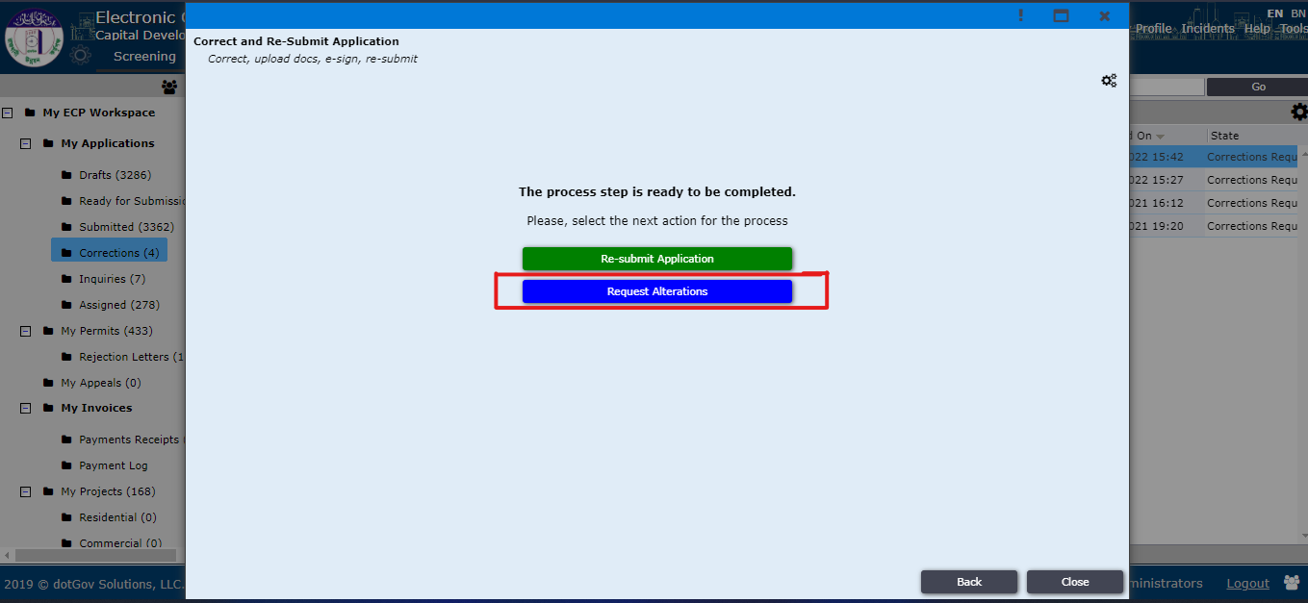
Figure 39. Request Alterations
Then the file will go to architect for giving Drawing correction as Architect is the focal point, only he has the ability to edit information Figure 40. After clicking “Next” and providing required data, the file will return back to applicant.
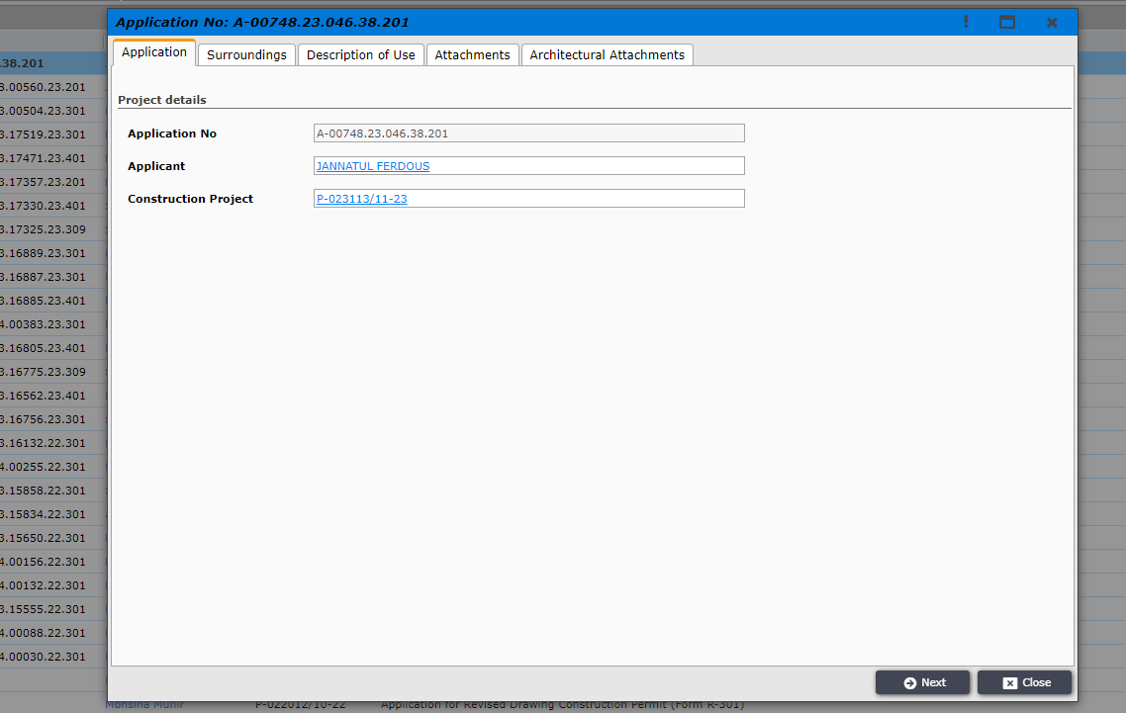
Figure 40. Architect Information
After Architect send the file to the applicant, that file will be in the “Ready for Submission” folder. Then applicant can click on next button and provide information if required and submit the application shown in Figure 41, Figure 42.
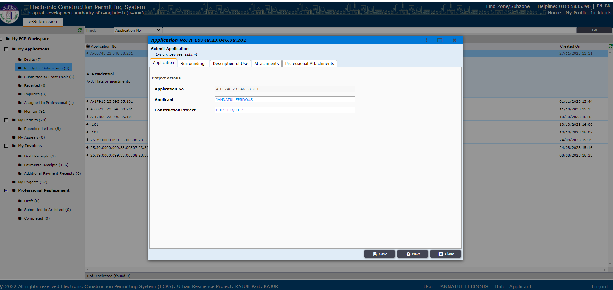
Figure 41
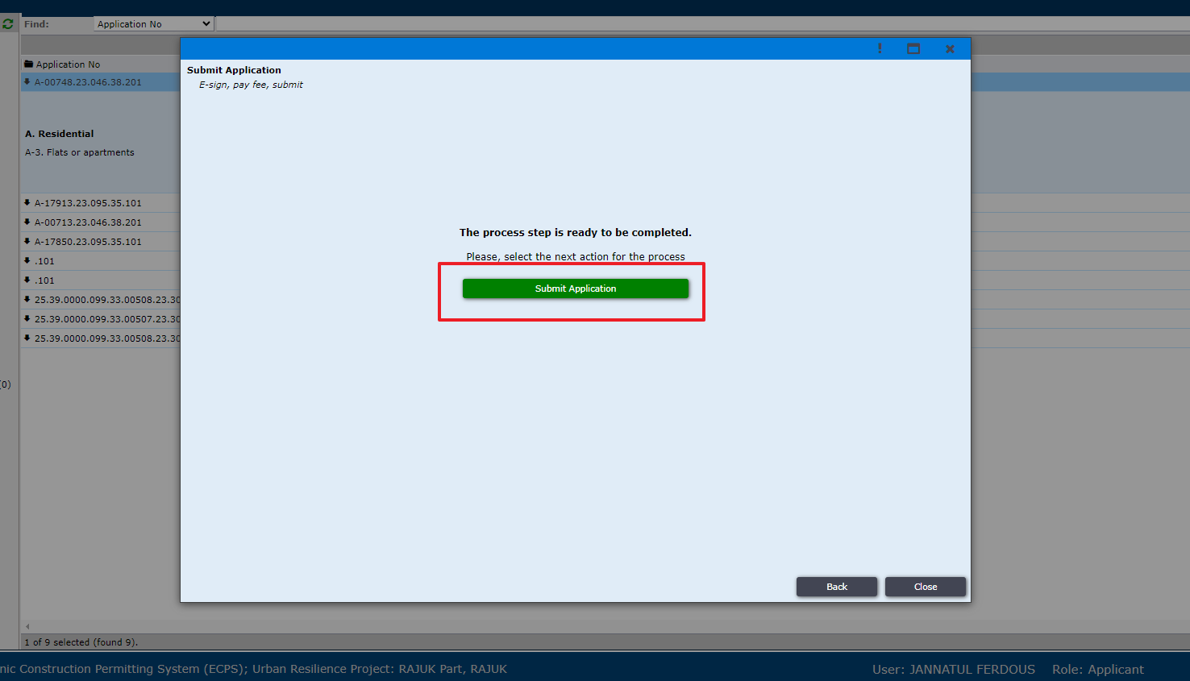 Figure 42

When the file is accepted by Front Desk Officer then it will go to DDC (For zone 1to4, ddc1to4. For zone 5to8, ddc5to8). Applicant can monitor the files status by clicking on the “Monitor”. By clicking on a file, a window will pop up, here applicant can see files current status. shown in Figure: 43.
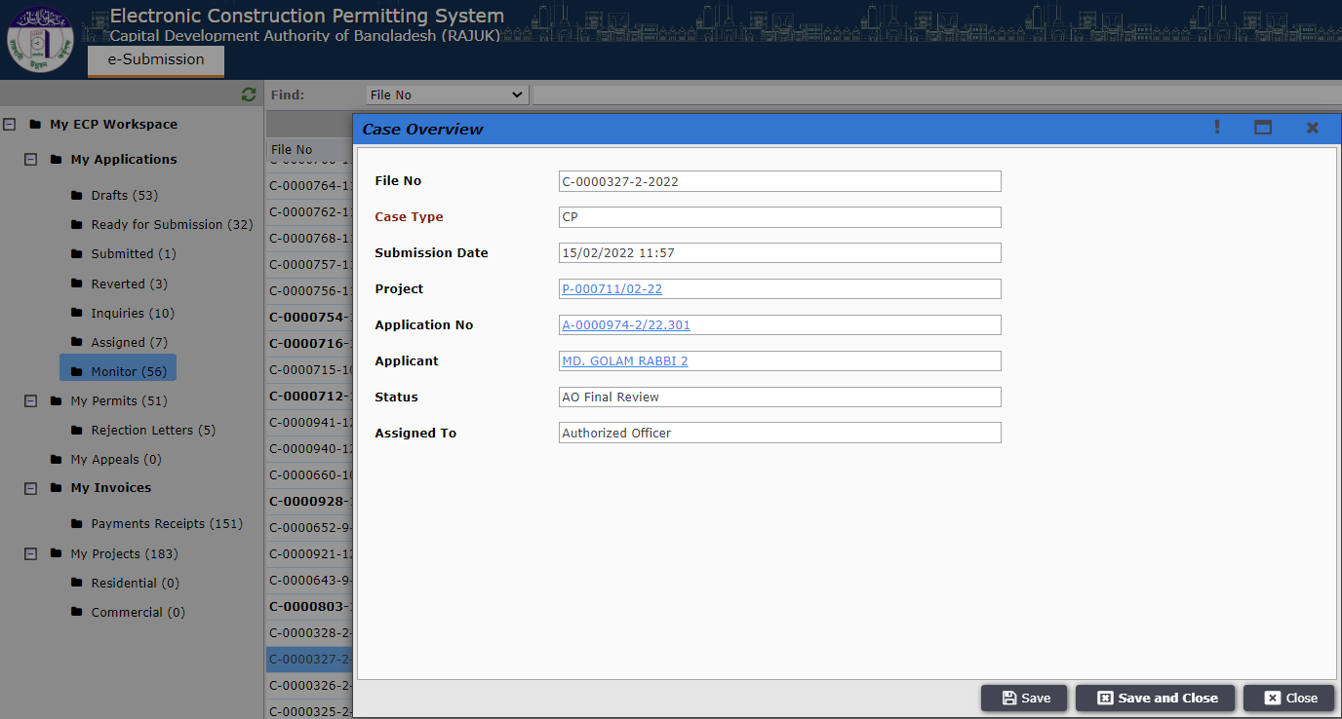
Figure 43. Monitor Files.

At initial stage the DDC can send the file to applicant for “Request Clarifications to Applicant”. It will come in “Inquiries” as Shown in Figure: 44 and Figure 44.1. It may require payment; the payment process is same as shown before in Figure: 19 to 22.1
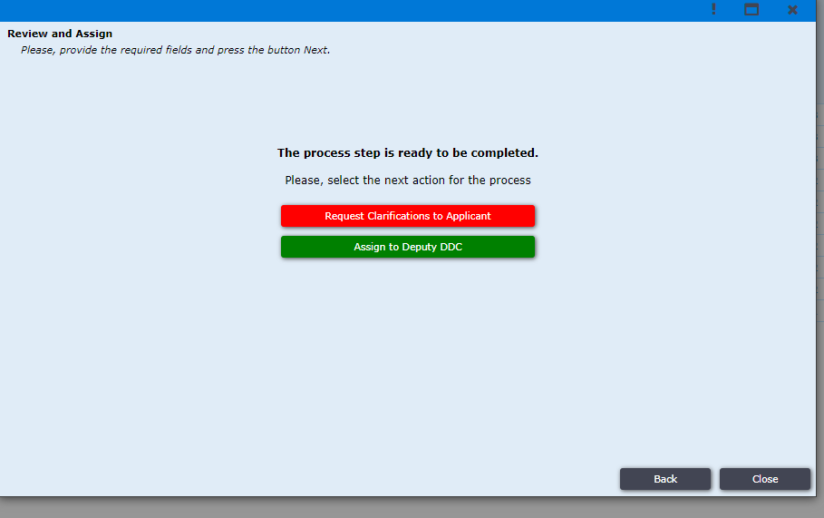
Figure 44. Request Clarifications to Applicant.
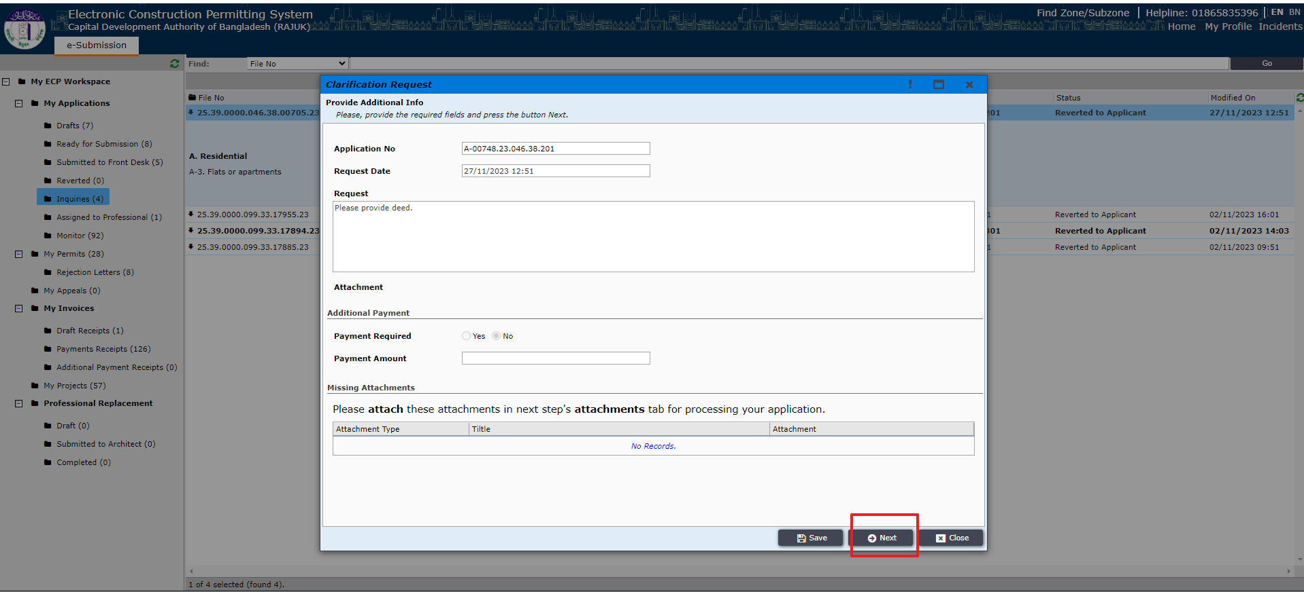
Figure 44.1

After completing payment process if needed applicant will have to go next and click on “Send Clarifications” button. Shown in Figure: 45.
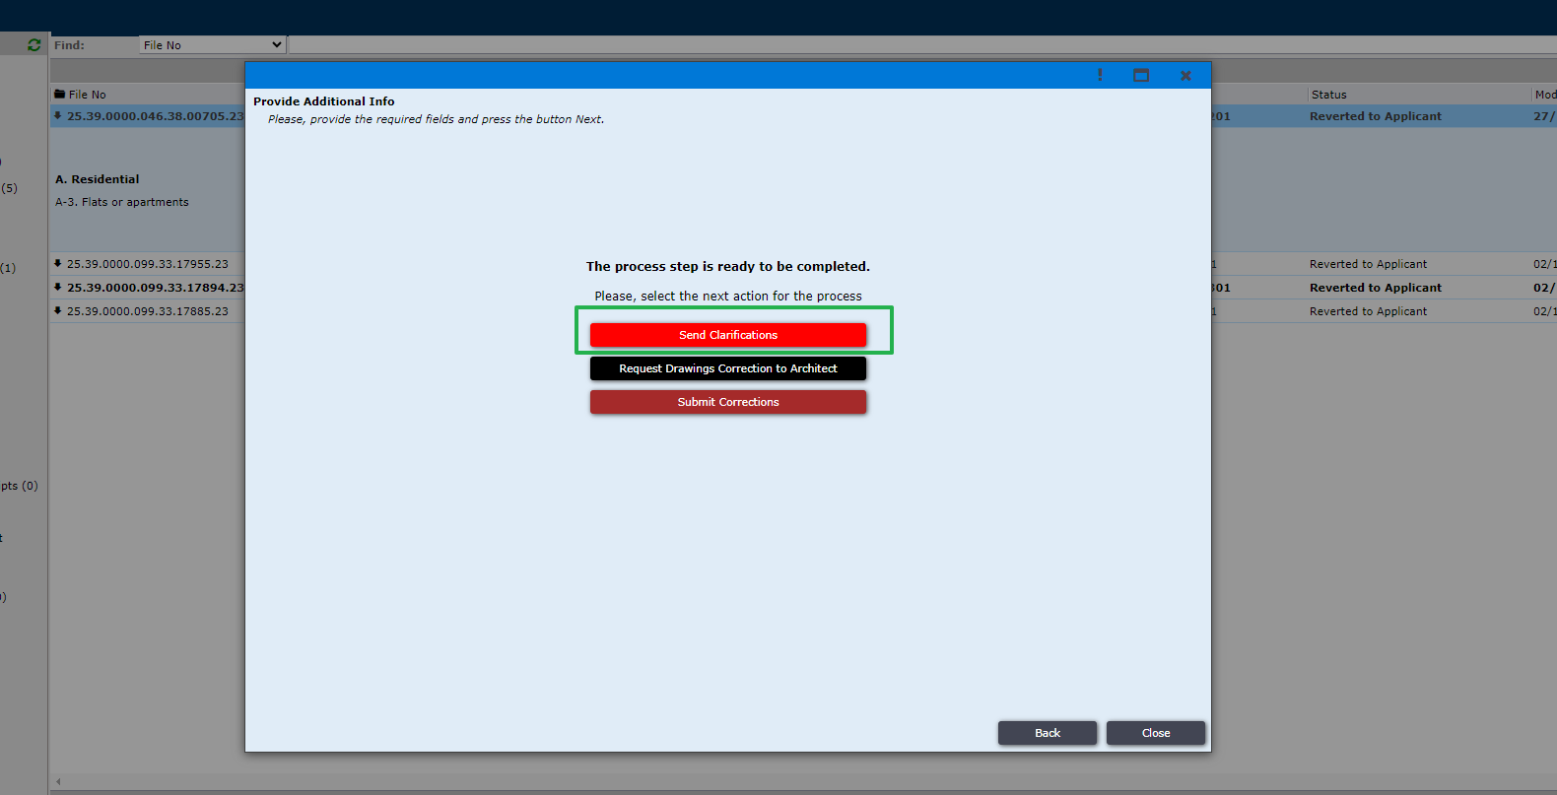
Figure 45: Send Clarification.
In the next step DDC can send the file to the applicant for “Request Additional Clarifications to Applicant”. It will come in “Inquiries”. Shown in Figure: 46. It may require payment too as shown before.
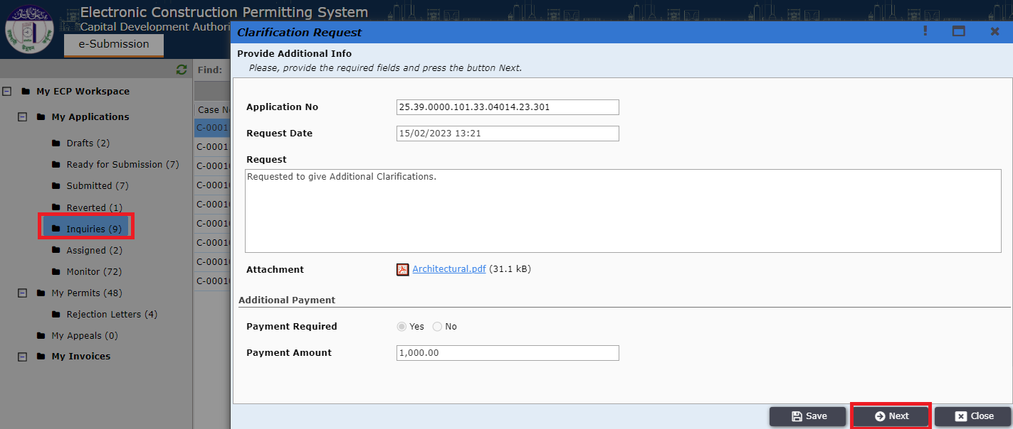
Figure 46: Additional Clarification.
After completing all corrections and payment process Applicant will click on the “Submit Corrections” button as shown in Figure: 47.
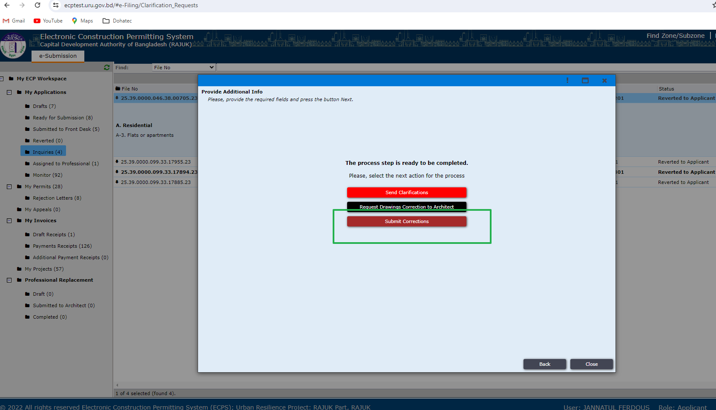
Figure 47: Submit Corrections.
After ‘committee review’ and before ‘collect signature’ DDC can send the file to the Applicant for drawing correction. This process is same as before. It may require payment too. Then the Applicant will have to click on the “Submit Corrections” button. Shown in Figure: 47.
After completing all the steps if the DDC accepts then a response will be sent to the applicant, it can be seen in “My Permits” as Shown in Figure: 48.
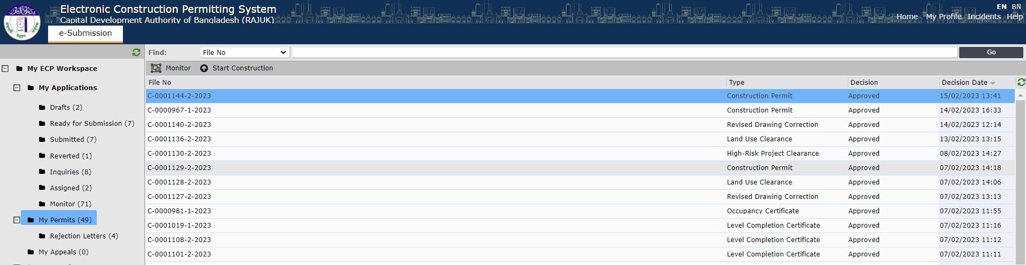
Figure 48: My Permits.

If the file is rejected it can be found in “Rejected Letters” as Shown in Figure: 49.
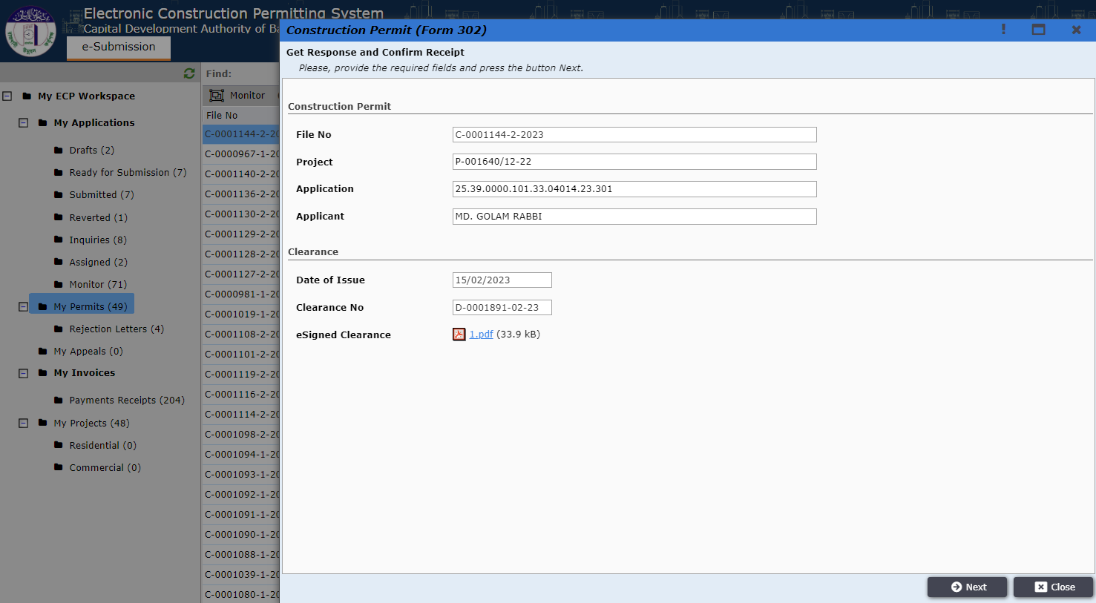
Figure 50: File details in My Permits.

Next Applicant will have to click on the button “Confirm Receipt”. Shown In Figure: 50.

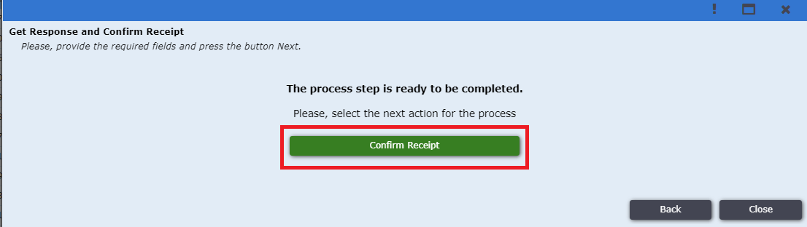
Figure 50: Confirm Receipt.

Then the process of Large and Special Project Clearance has been completed successfully. “Figure: 51”.
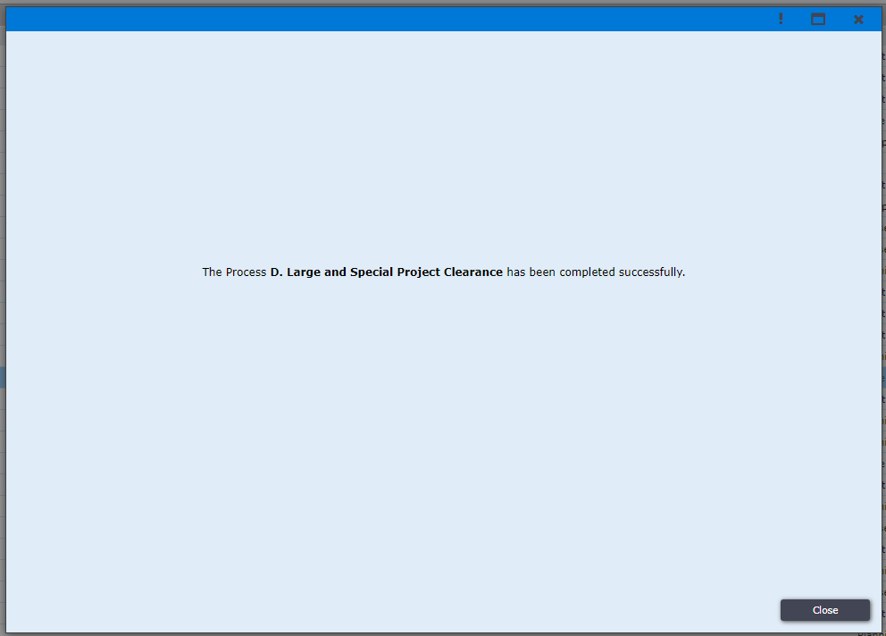
Figure 51: Large and Special Project Clearance completed successfully.

