To file an application, go to Electronic Construction Permitting System Portal using the URL
https://ecps.gov.bd/ and then click on “Login” button. Applicant then can login to the system using applicant’s username and password. After logging into the system successfully click on the “New Application” button as shown in the Figure: 1.
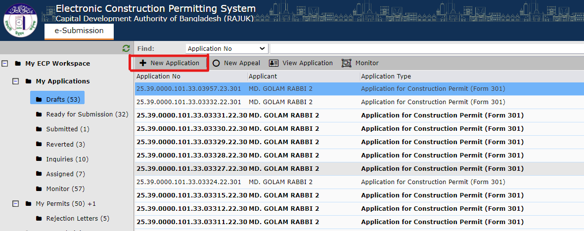
Figure: 1. New Application
After clicking on “New Application” the following window will pop-up with the drop-down selection bar for “Application type, Ownership Type” and enter some other information (RS Dag No, Existing Project). Figure: 2 shows the information.
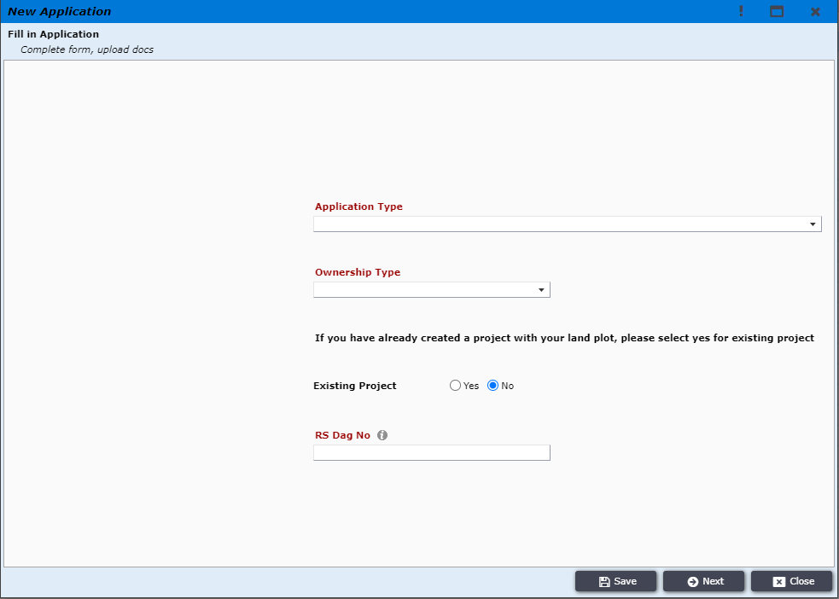
Figure: 2. Application Type
If the ownership type is not “Government Land”, then Applicant needs to select the type of application which he would like to file (e.g., Application for Planning Permit) and enter RS Dag No, select Existing Project “No” and then click on the “Next” button as shown in Figure 3.
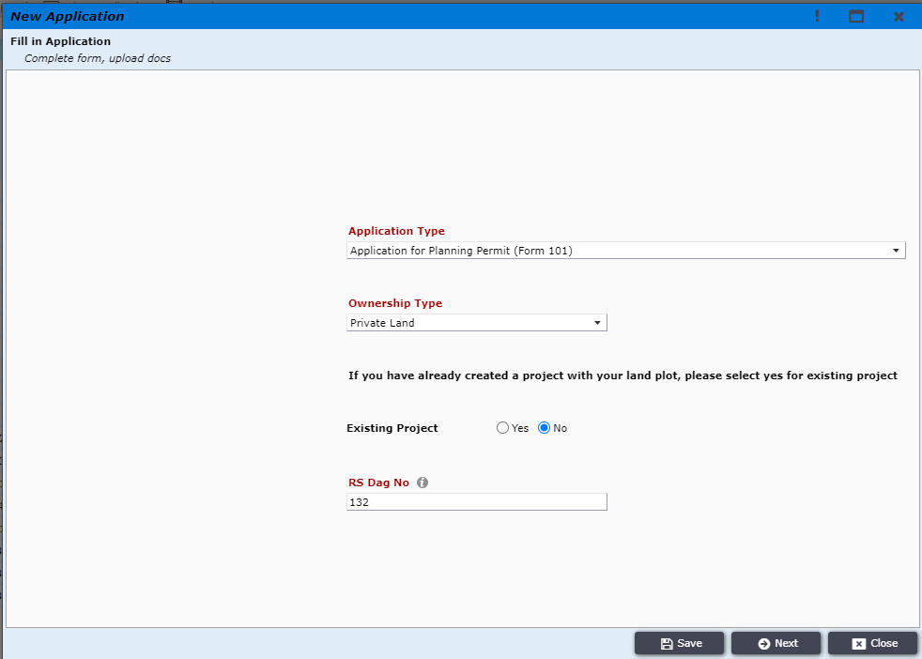
Figure: 3. selecting application type and clicking on “Next”

If the ownership type is “Government Land” then select only “Application type and Ownership Type” and click on “Next” Button. Figure: 3.1 shows the information.
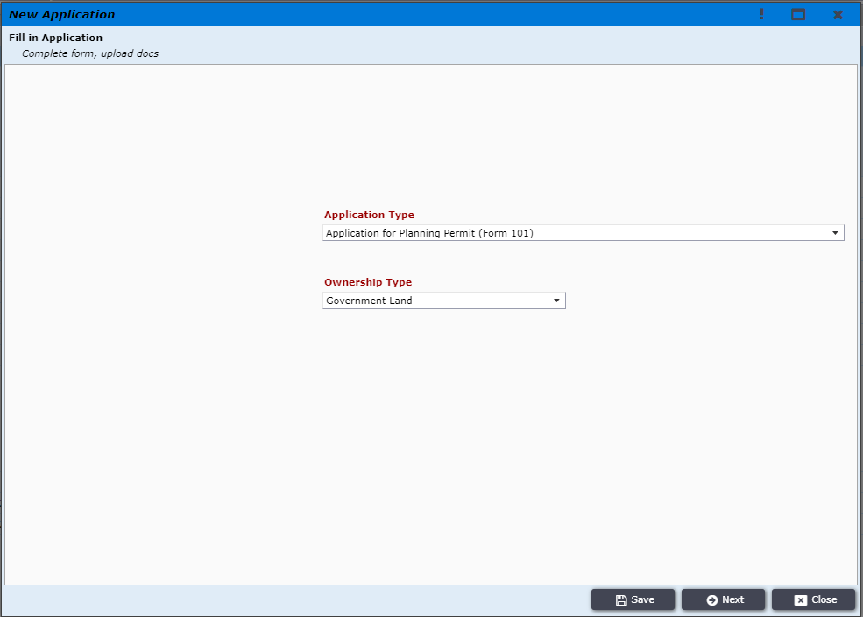
Figure 3.1

If the ownership type is not “Government Land”, then applicant is prompted to another window containing land details as shown in Figure 4. Applicant needs to fill up accordingly and then click “Next”.
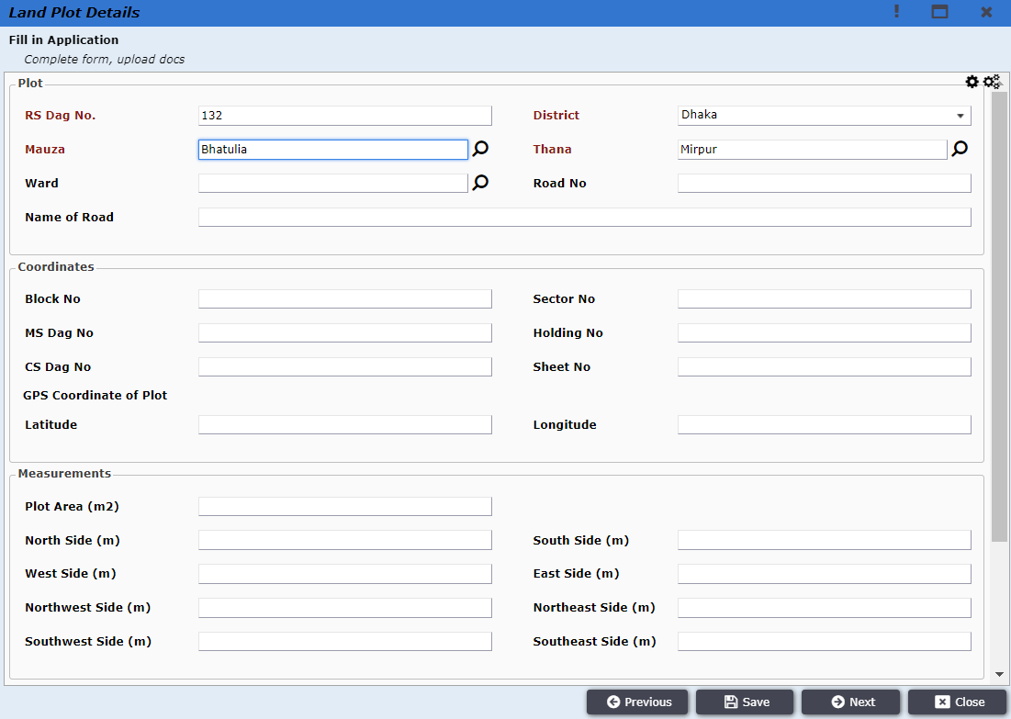
Figure 4. Land plot details

If the ownership type is “Government Land”, then the applicant is prompted to another window containing land details as shown in Figure 4.1. Applicant needs to fill up accordingly and then click “Next”.
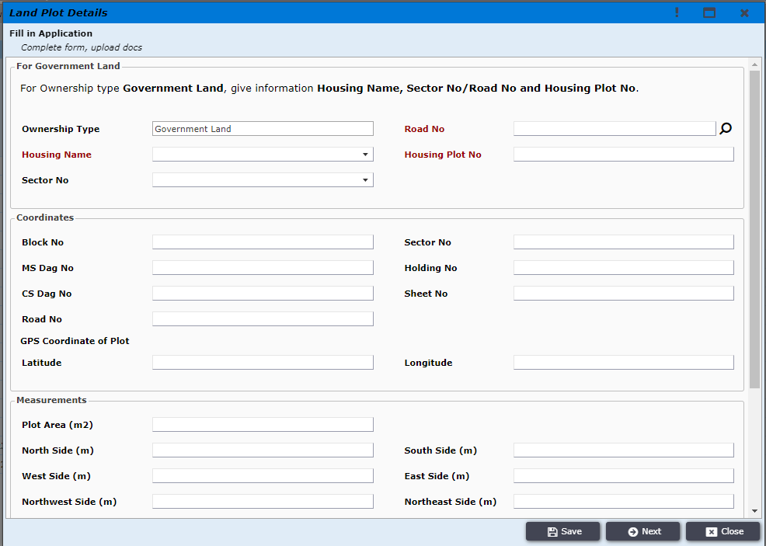
Figure 4.1

After providing the Land plot details applicant is prompted to “Next” window containing the PP information (Figure 5). Applicant needs to fill the information accordingly and click “Next”.
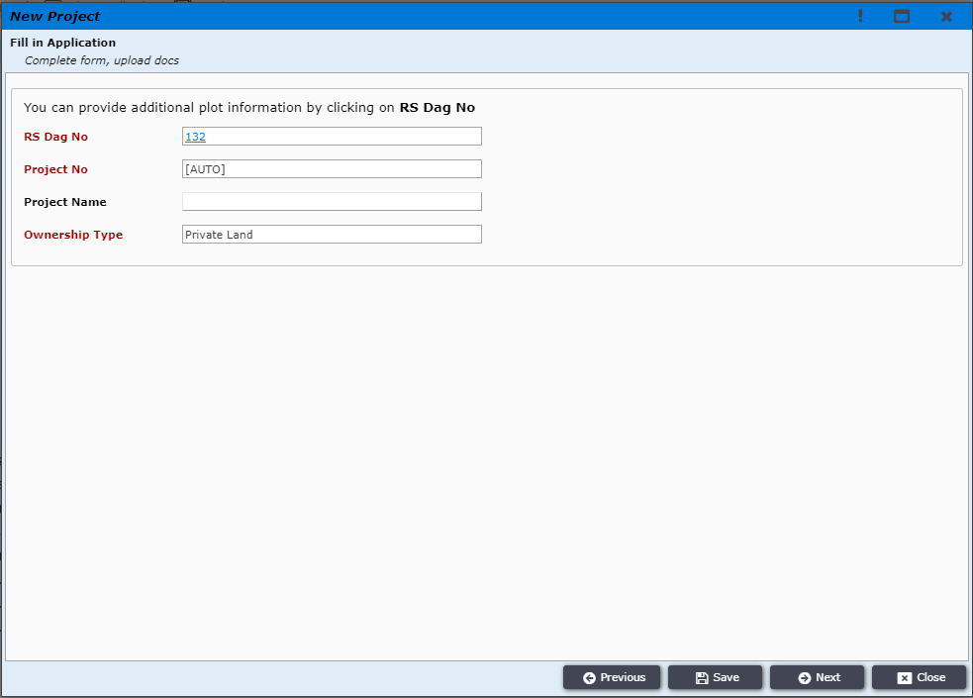Figure: 5.

After providing information such as ownership type and clicking “Next” the applicant will be taken to “Next” window containing information of land use type as shown in Figure 6.
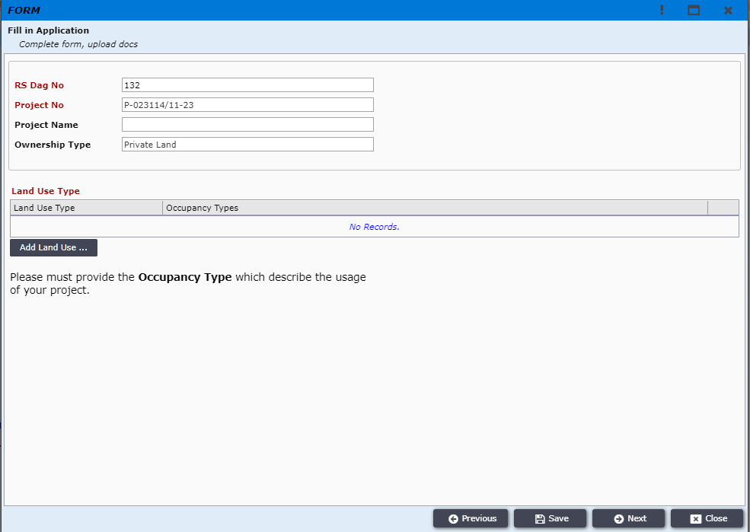
Figure 6. Land Use Type

Applicant will choose land use type and occupancy type as shown in Figure 7.
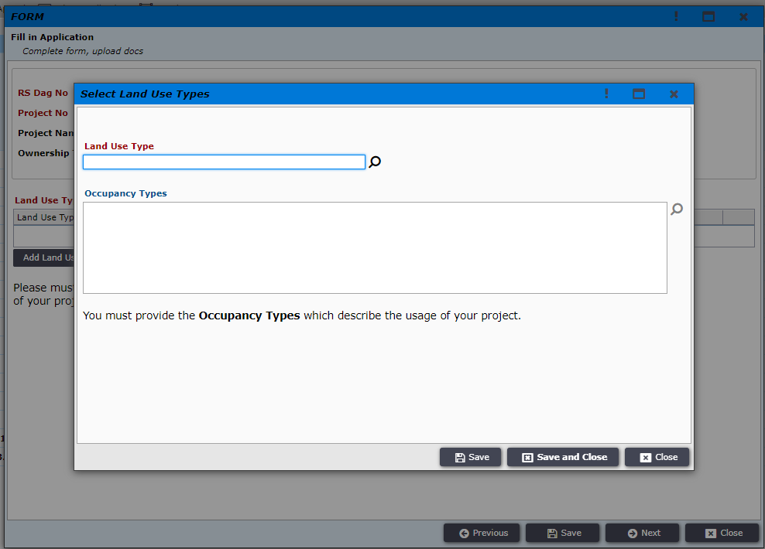
Figure 7. Land use and occupancy type

After providing correct land use type and occupancy type option, then applicant needs to click “Save And Close”.

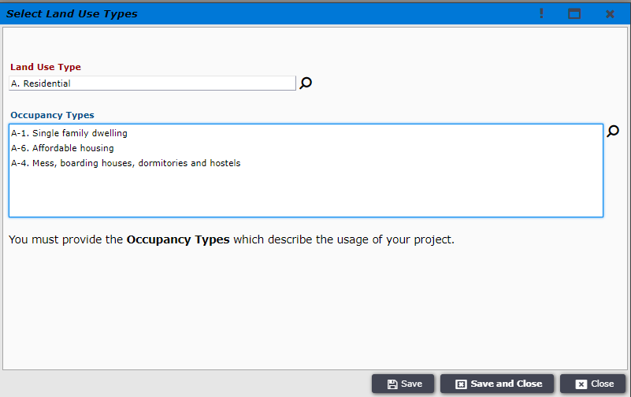
Figure 8. Selected type

Now you can see this window. Now click on “Next”. Figure: 8.1 shows the information.
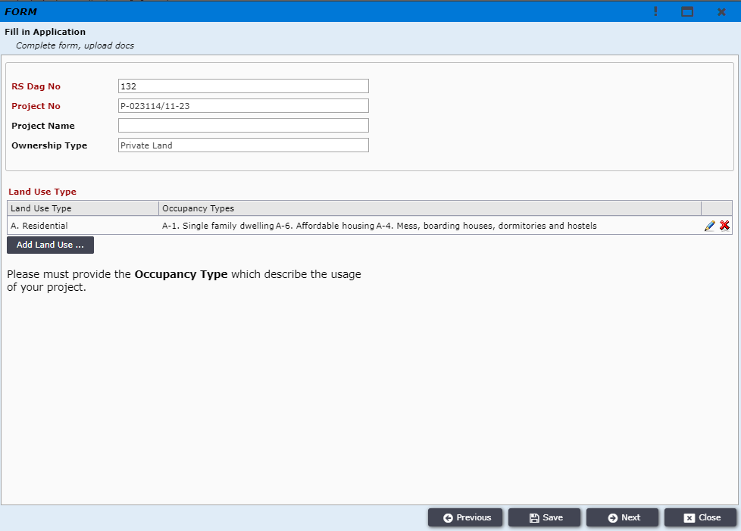

Figure 8.1.
Applicant will see this window (Figure 9.)
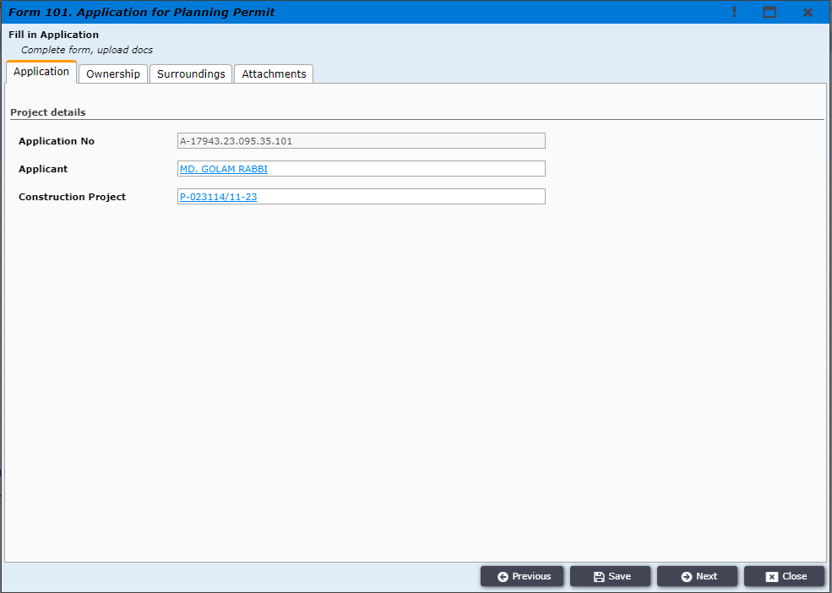
Figure 9
Then applicant will go to “Next” tab and applicant will see the interface containing Application, Ownership, Surroundings and Attachment tabs as in Figure 10.
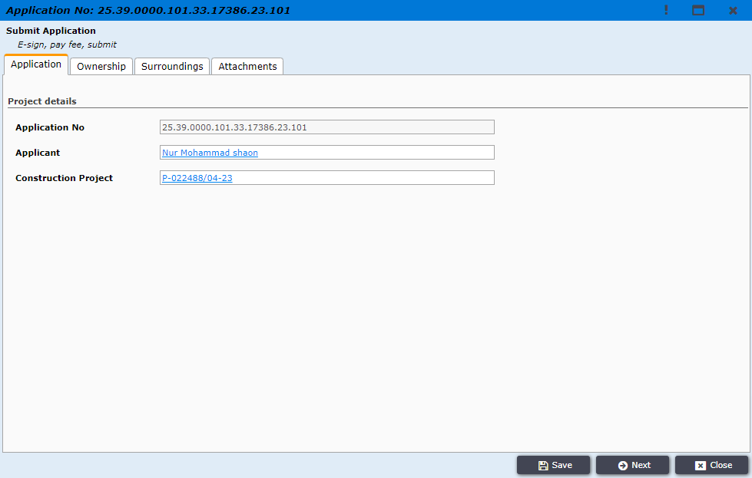
Figure 10.
In the Ownership tab, the applicant can fill-up the ownership details information.

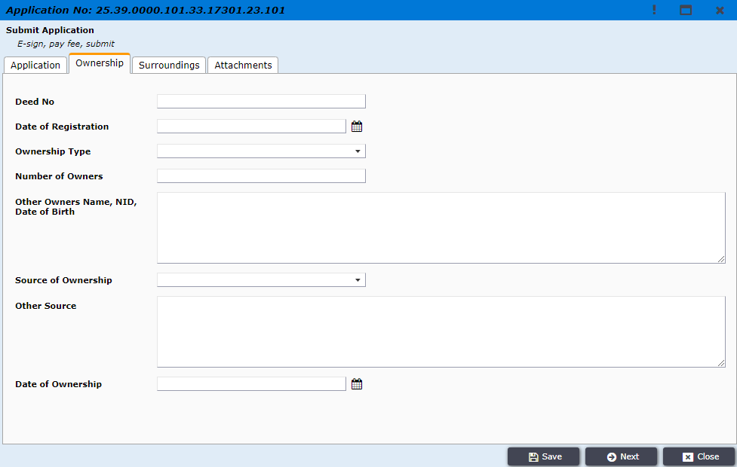
Figure 11 Ownership

In the Surroundings tab, the applicant can fill-up all the surroundings information of the land.
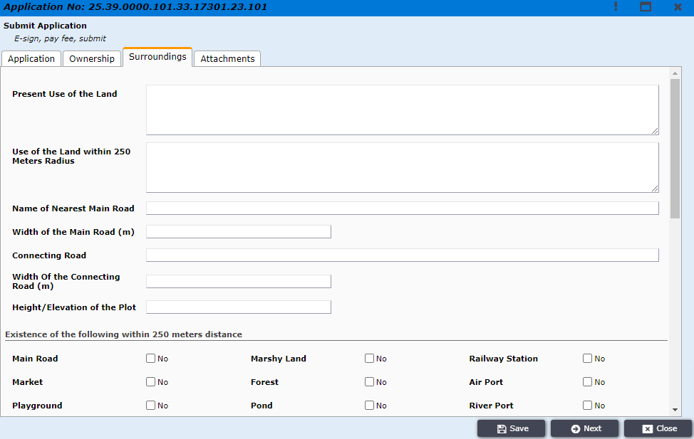

Figure 12. Surroundings

In the Attachments tab, the applicant will attach all the recommended attachment by RAJUK. EX. RS Mouza Map, MS Mouza Map, Digital Survey Map and many other options. Now, Click on Add new in Other Attachments Section. Figure 13.

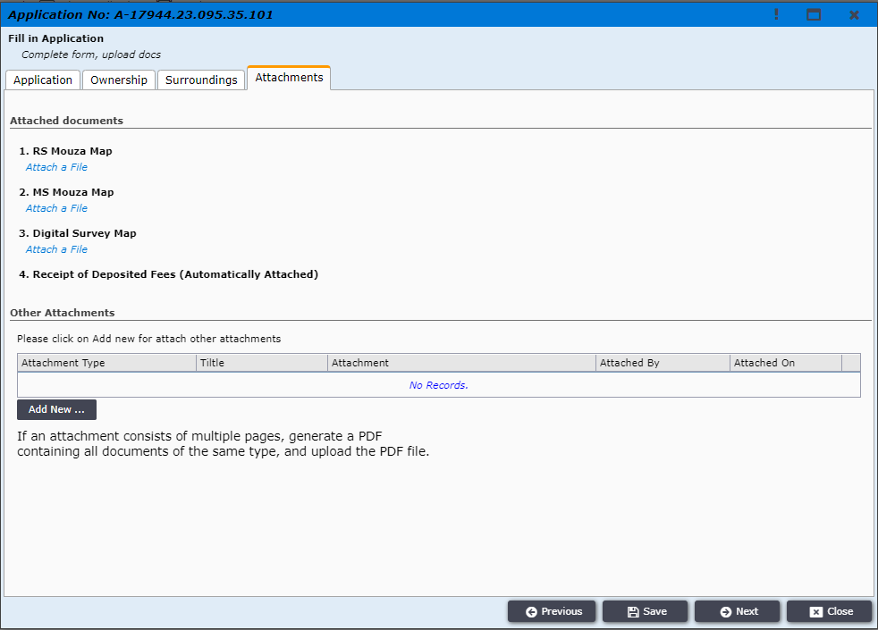
Figure 13. Attachments

Now Select “Type” and attach your attachment. Then click on “Save and Close”. For Another attachment click again “Add New” (Figure 13) then Now Select “Type” and attach your attachment. Then click on “Save and Close” (Figure 13.1)

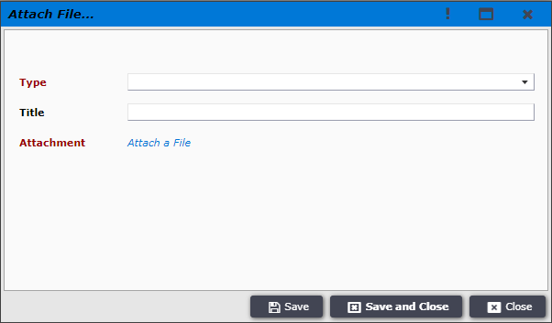
Figure 13.1. Attachments

Then the applicant will go to “Next” tab and applicant will see the interface as in Figure 14.
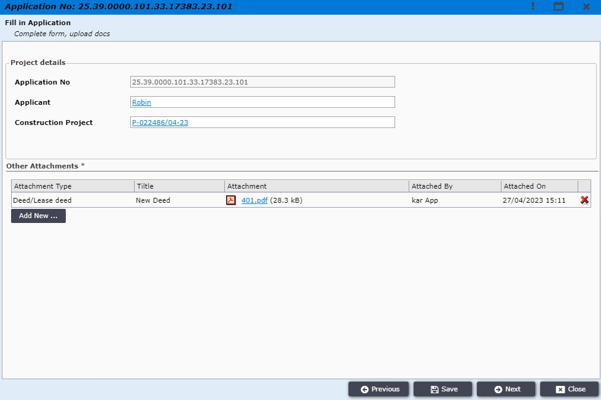
Figure 14.
After Clicking on “Next” button, Applicant will see this interface as in Figure 15.

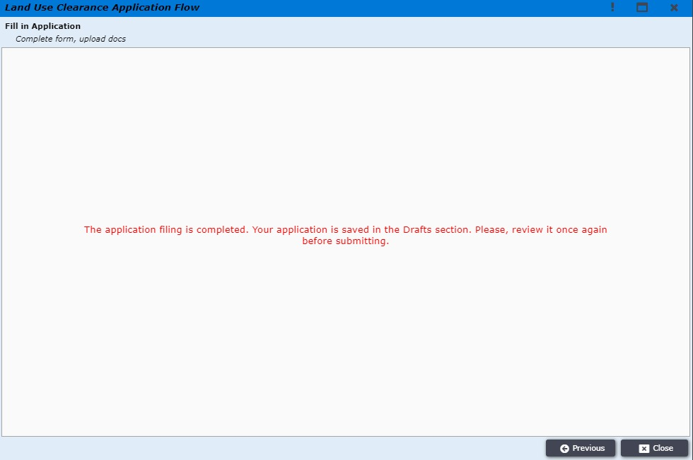
Figure 15.

After clicking “Close” the applicant will be shown message as shown in Figure 16 and will need to double click on the new highlighted LUC file for payment and further process.
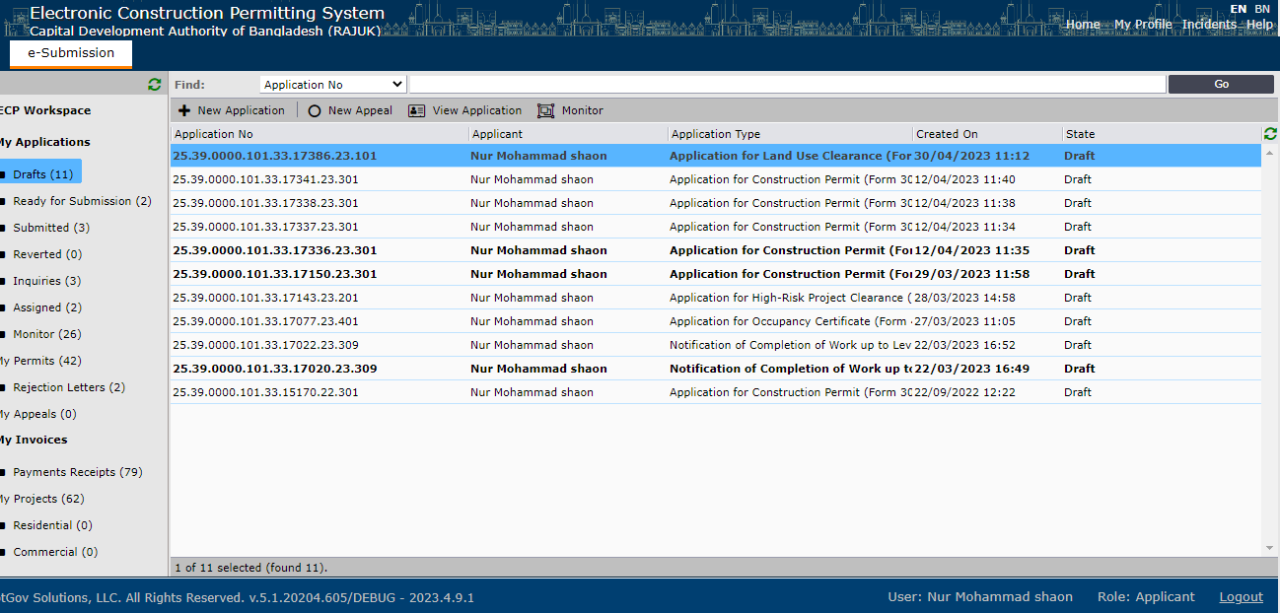
Figure 16.

Now after double clicking on the application, the applicant will see the previous interface containing Application, Ownership, Surroundings and Attachment tabs as in Figure 17. Here, he can also check and update information in all those tabs.
Figure 17.

The applicant will recheck the attached file and click “Next” tab to review the full project before final payment as shown in Figure 18.
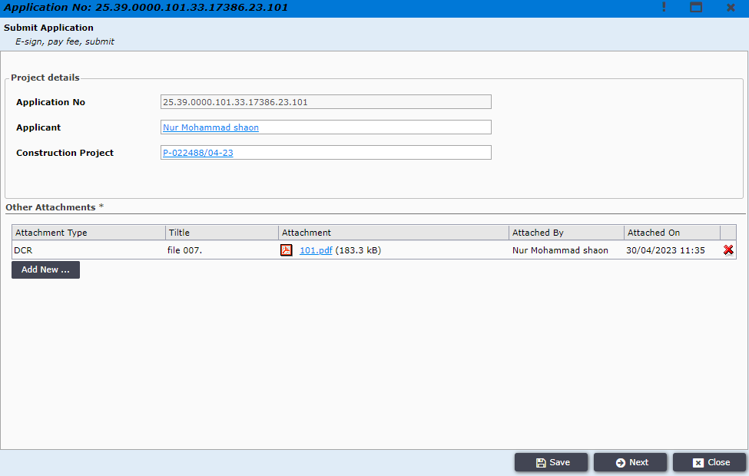
Figure 18. Attachments
After clicking the “Next” tab we can see the full project in a PDF form with all information what applicant inserted in both Bangla and English format and also able to download the application as shown in Figure 19.

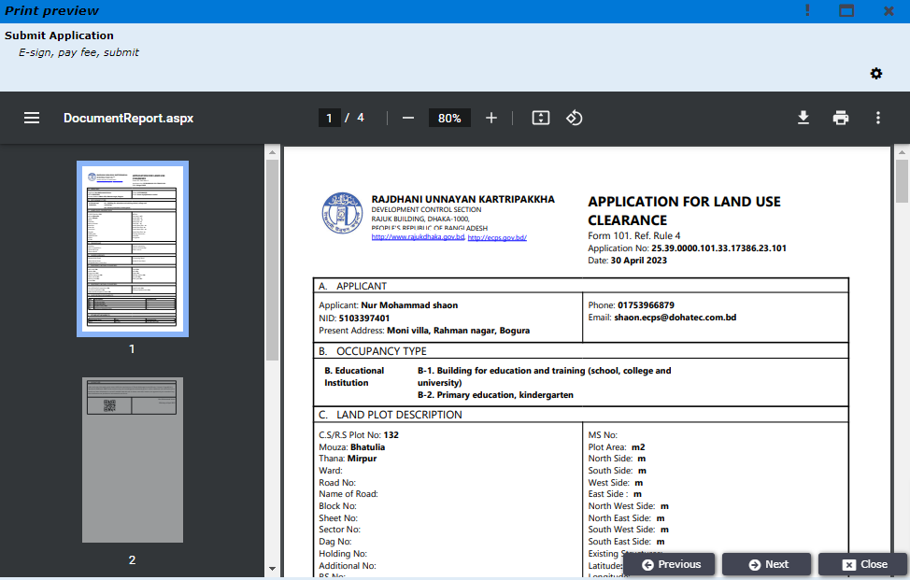
Figure 19. Document Report
Applicant is then prompted to “Next” window to see the payment option (Figure 20).
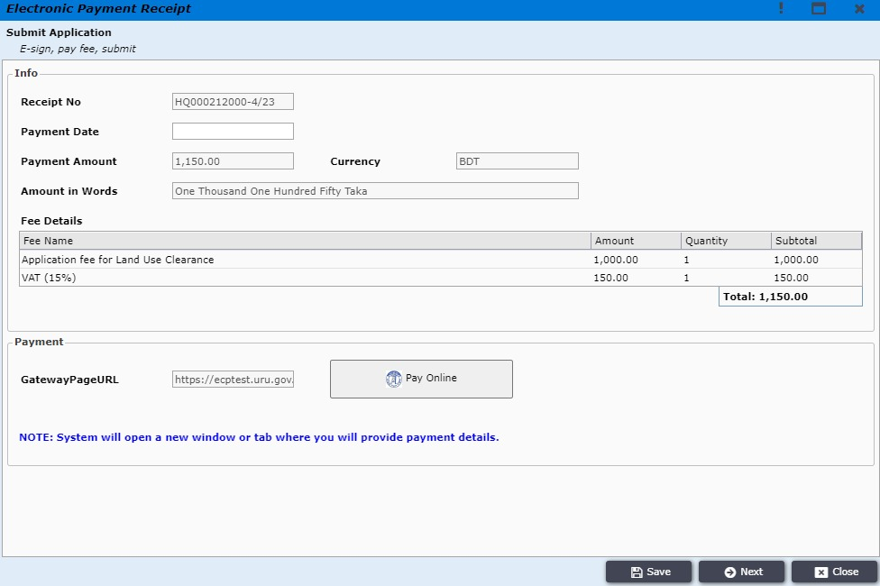
Figure 20. Payment.

After clicking “Pay Online” option, the applicant can pay the amount in any platform as he wishes and complete the payment process. (Figure 21)

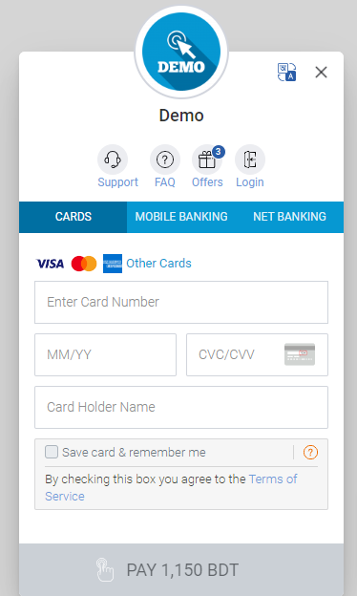
Figure 21. sslcommerz payment.

Using OTP verification, after completing the payment successfully the applicant clicks the “Next” button and can see the payment information and also see the recipient payment pdf file.

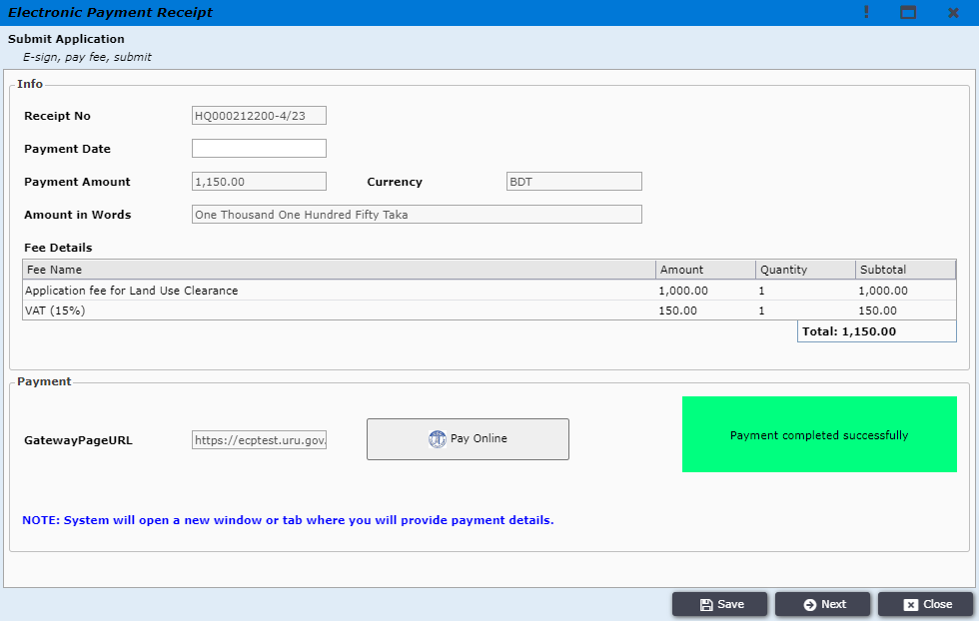
Figure 22. Payment successful

Then the applicant can see the certify option by “Dhaka Mohanagar Imarat , Bidhimala’ 2008” and will choose his option . After that the applicant will click the “Next” bar for reviewing the full project again in the PDF format.

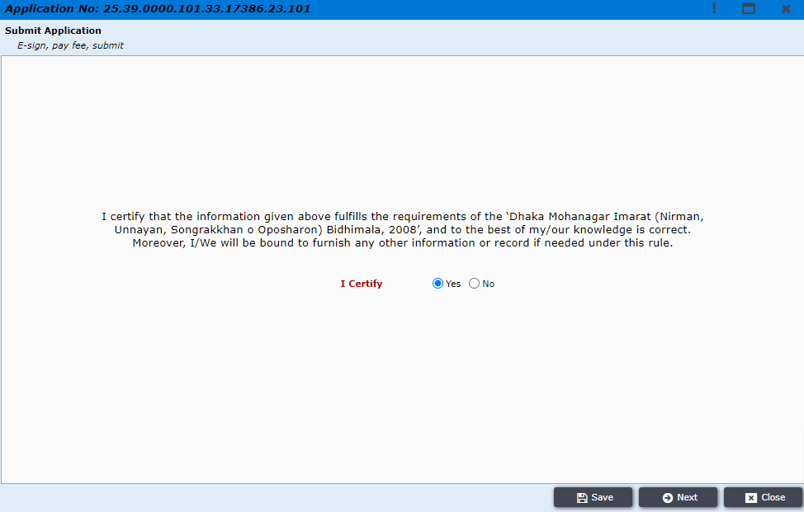
Figure 23. Certification

By clicking “Next” bar the applicant can see the e-sign page. Applicant will then add his / her digital signature in the downloaded application form and attach it in the Signed Application option as shown in figure 24. (You can skip this step because this is not mandatory now)
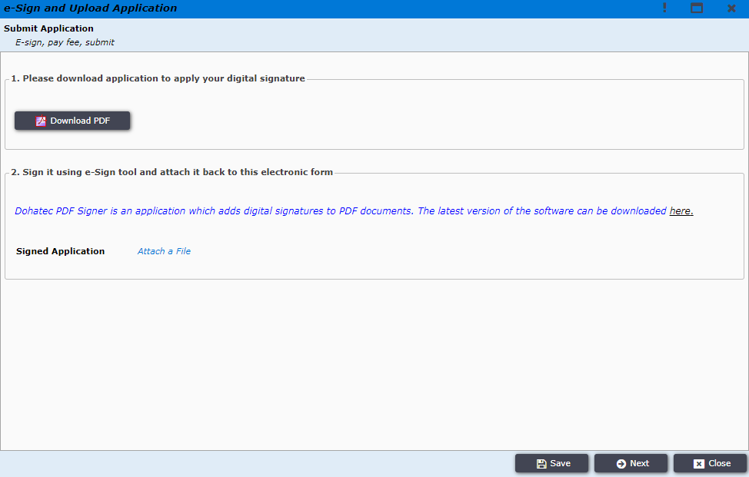
Figure 24. e-Sign and Upload Application pages

After uploading the Signed Application, the applicant clink on “Next” button to get the submission page as shown in figure 25.
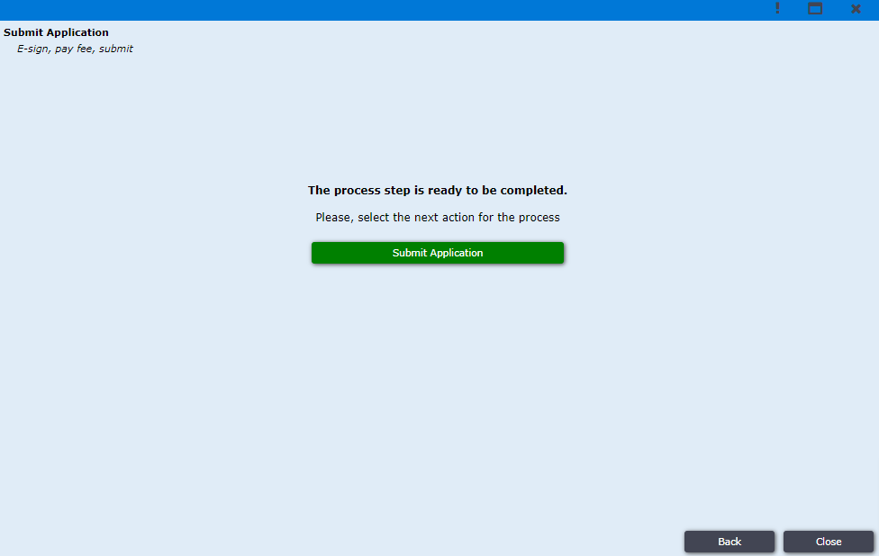
Figure 25. Submit

At last, the applicant will click on “Submit Application” button to submit the project from applicant end finally as shown in figure 26.

Figure 26. Final Submissions

