CP - Applicant User manual

To file an application, go to Electronic Construction Permitting System Portal using the URL
https://ecps.gov.bd/ and then click on “Login” button. Applicant then can login to the system using applicant’s username and password. After logging into the system successfully click on the “New Application” button as shown in the Figure: 1.1

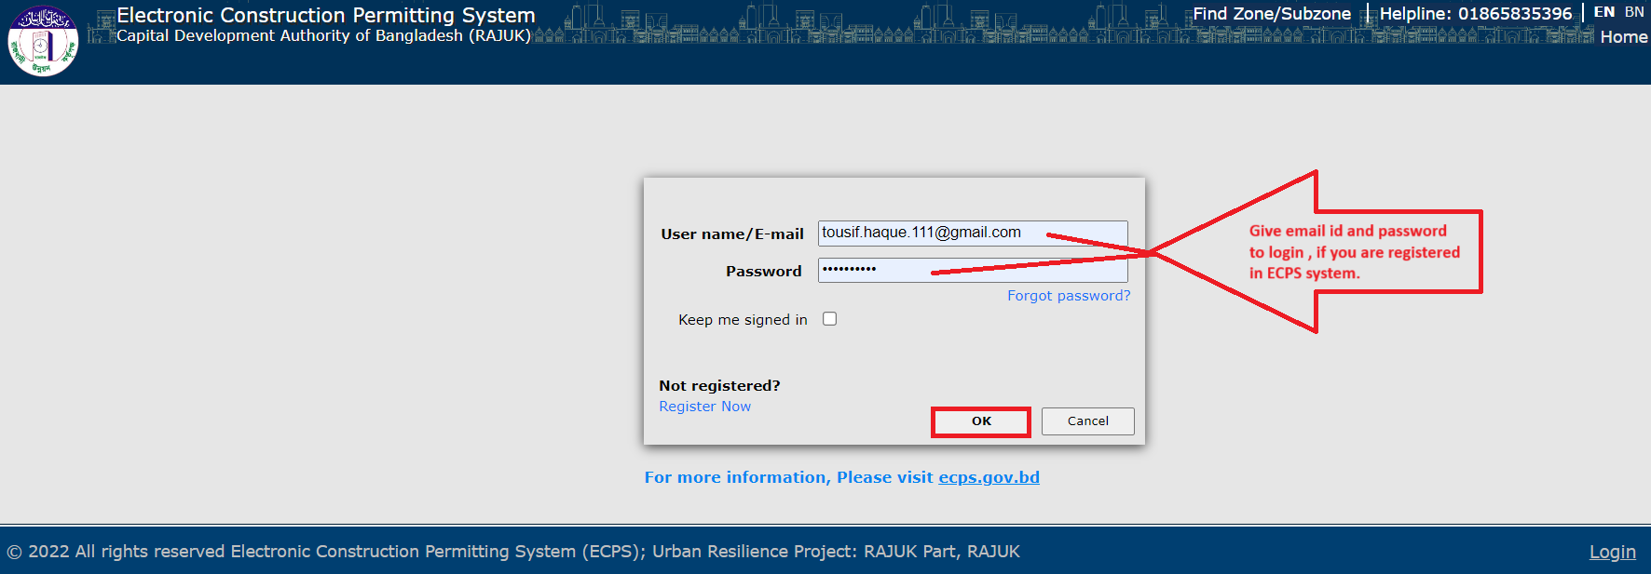
Figure: 1. Login

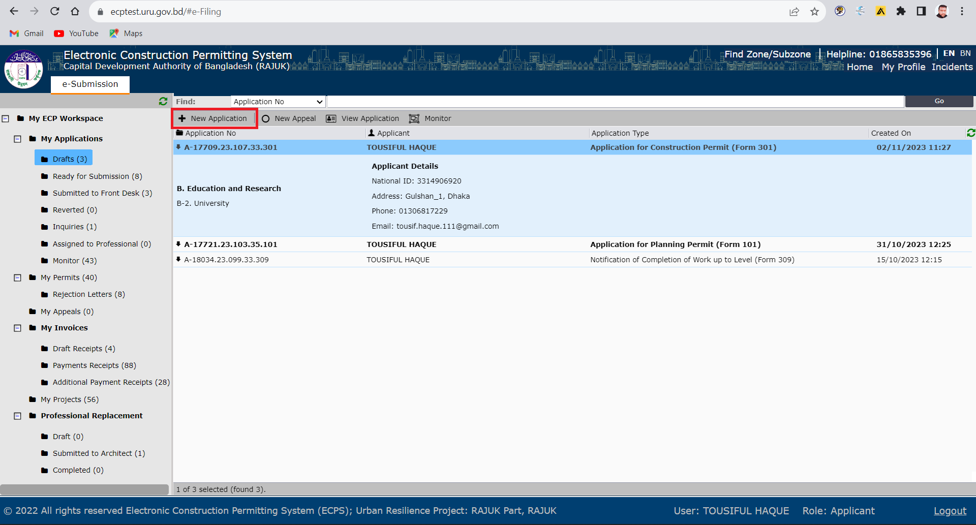

Figure: 1.1 New Application
Scenario 1: If PP (Planning Permit) or LSP (Large and Special Project) Approval is taken in ECPS system and applicant want to take CP (Construction Permit) from ECPS system, then they have to select “Existing Project = YES”
Scenario 2: If PP (Planning Permit) or LSP (Large and Special Project) Approval is taken by old/previous CP system and applicant want to take CP (Construction Permit) from ECPS system, then they have to select “Existing Project = NO”

Scenario 1 (DESCRIPTION): If PP (Planning Permit) or LSP (Large and Special Project) Approval is taken in ECPS system and applicant want to take CP (Construction Permit) from ECPS system, then they have to select “Existing Project = YES” during CP Application in ECPS as shown in the figure below.
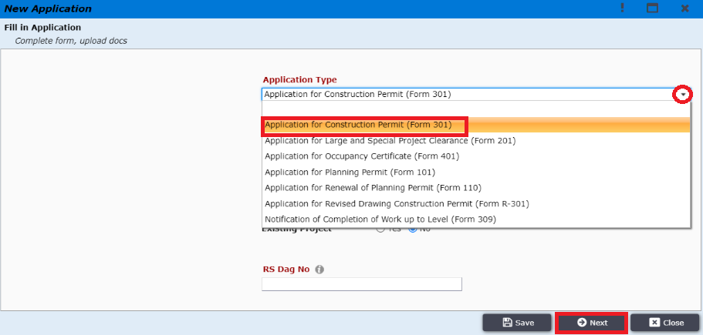
Figure: 1.2 Application Type Selection

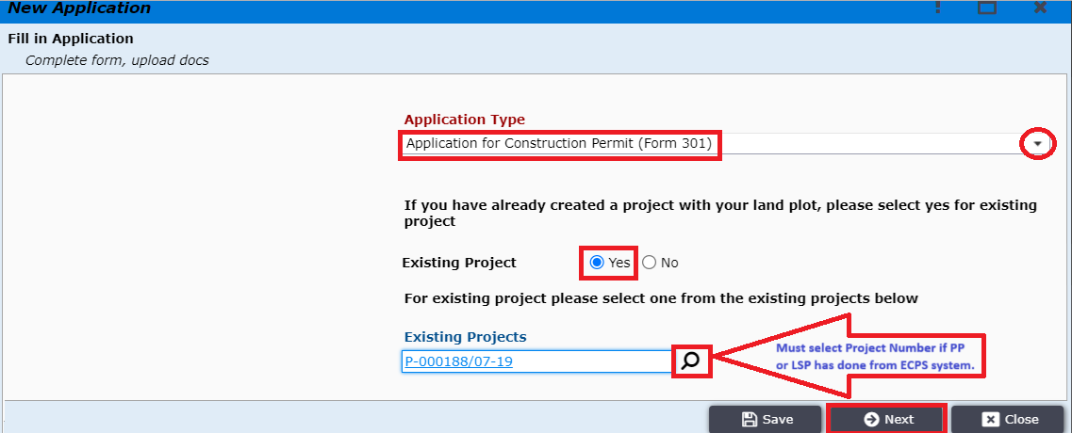
Figure: 1.3 Existing Project = ‘Yes’

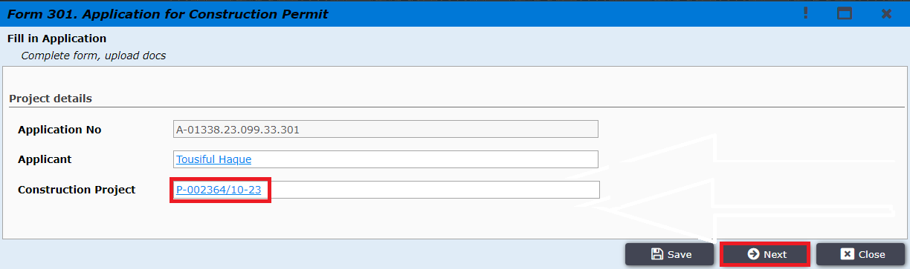
Figure: 1.4 Application Fill-up

After selecting Land Use Type applicant must click on “Next” to add team members. Applicant needs to invite team member by clicking on ‘Invite Team Member’ option as shown in Figure 2.
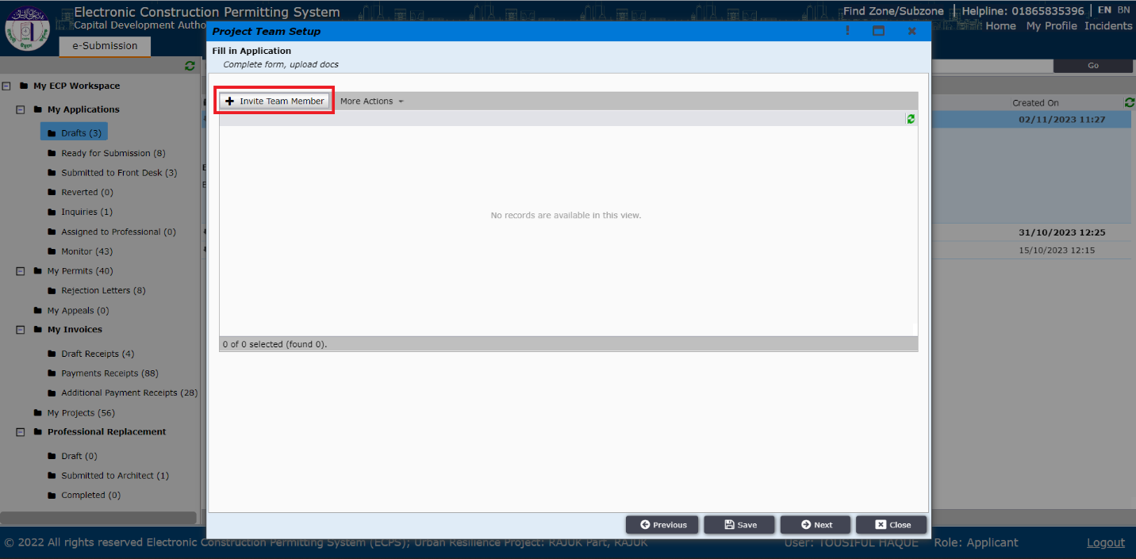
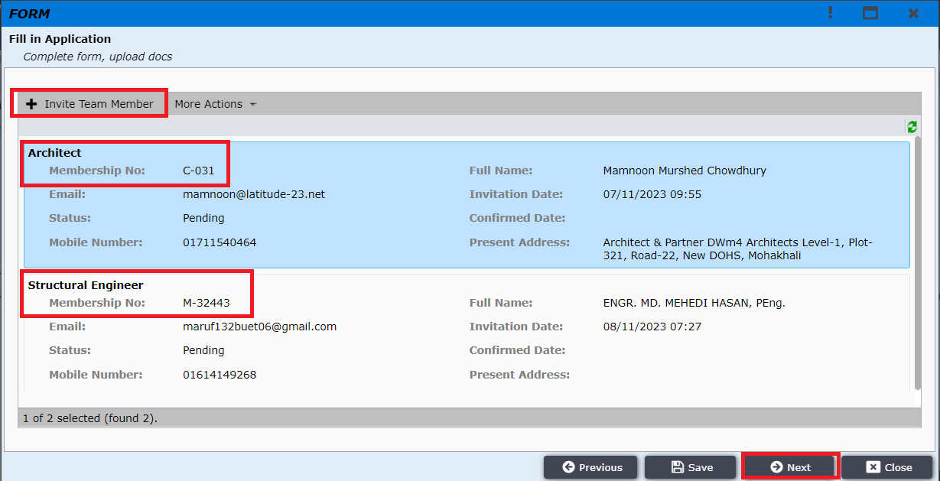
Figure 2: Invite Team Member
Applicant will be taken to a window to provide information about the particular professional such as Role and Membership number as shown in Figure 2.1 & 2.2
(Note: As Architect is the focal point, so applicant must add an Architect.)
Applicant can add multiple professionals here Such as: Electrical Engineer, Fire Safety Specialist, Mechanical Engineer, Plumbing Engineer and Structural Engineer.
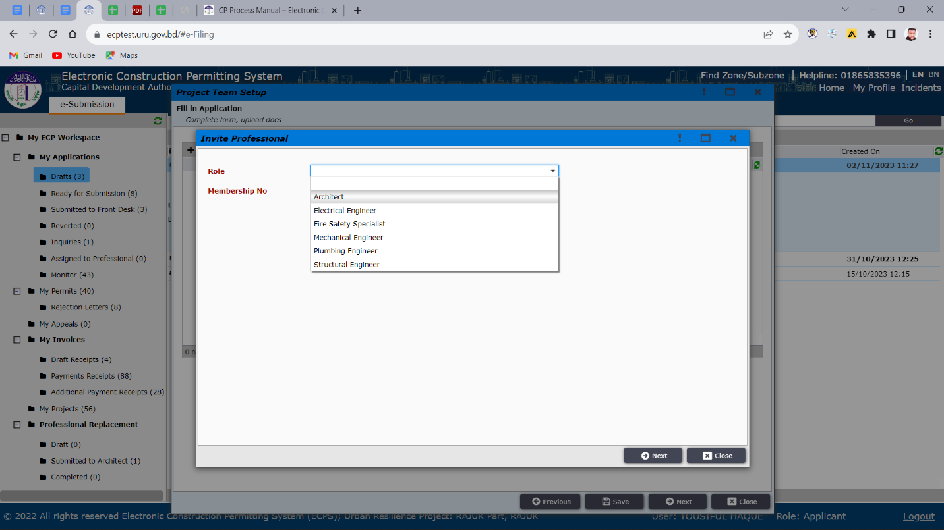
Figure 2.1 Inviting Professional

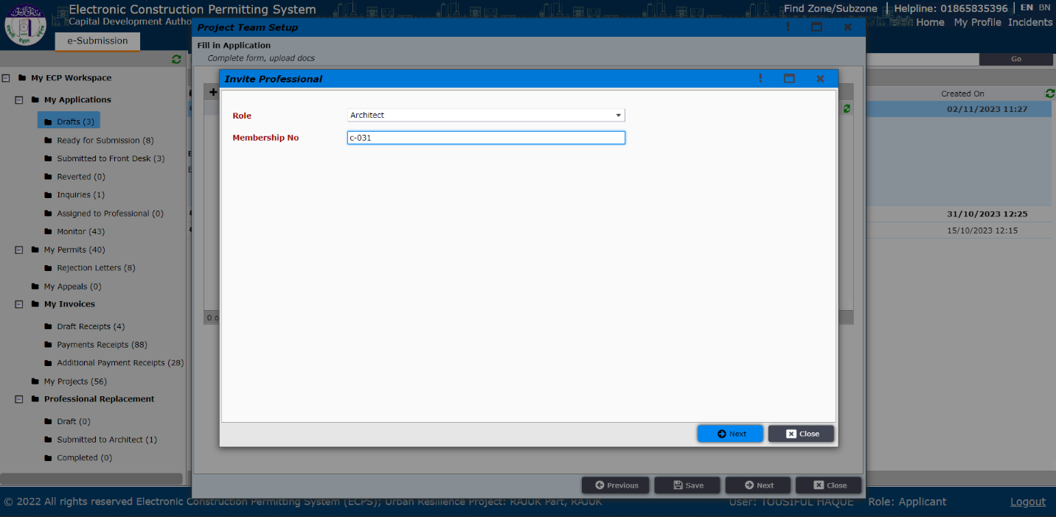
Figure 2.2 Inviting Professional

After providing correct membership number applicant will view the professional’s details with picture as shown in (Figure 3) and then applicant needs to click “Next”.
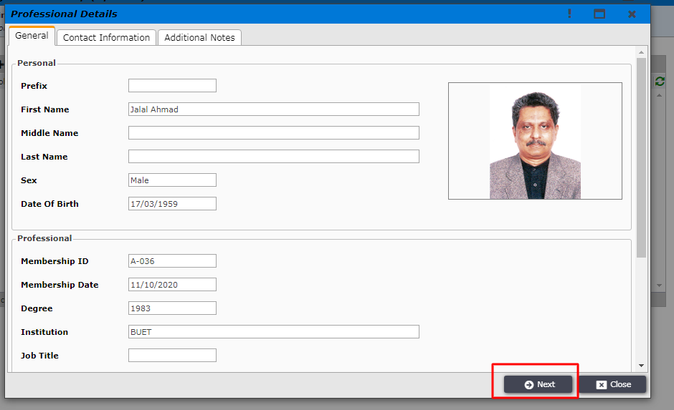
Figure 3. Professional Details

Applicant is then taken to the next window as shown in the Figure 4.
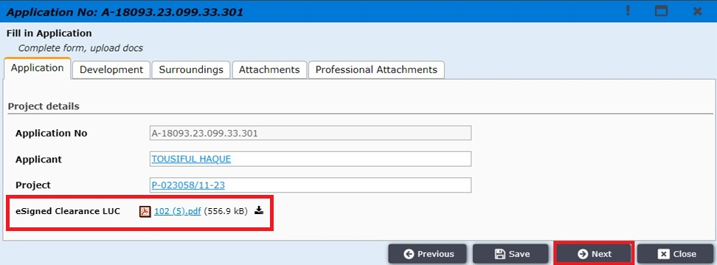
Figure 4
The Approved Planning Permit is being attached automatically from the ECPS system
Then applicant click on “Development” tab and needs to fill another mandatory field as shown in Figure 5, here ‘Total gross area of the project (Fees will be calculated by this field) (m2)’ field will be filled by the Architect added by applicant.
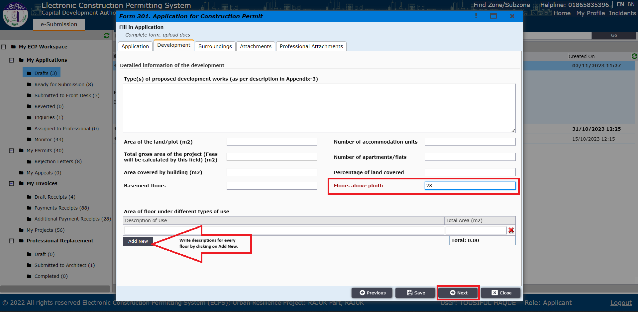
Figure 5. Floors above plinth
Then applicant click on “Attachments” tab and needs to Attach some mandatory Attachments which must be Scanned copy of original documents and merged as pdf file as shown in Figure: 5.1

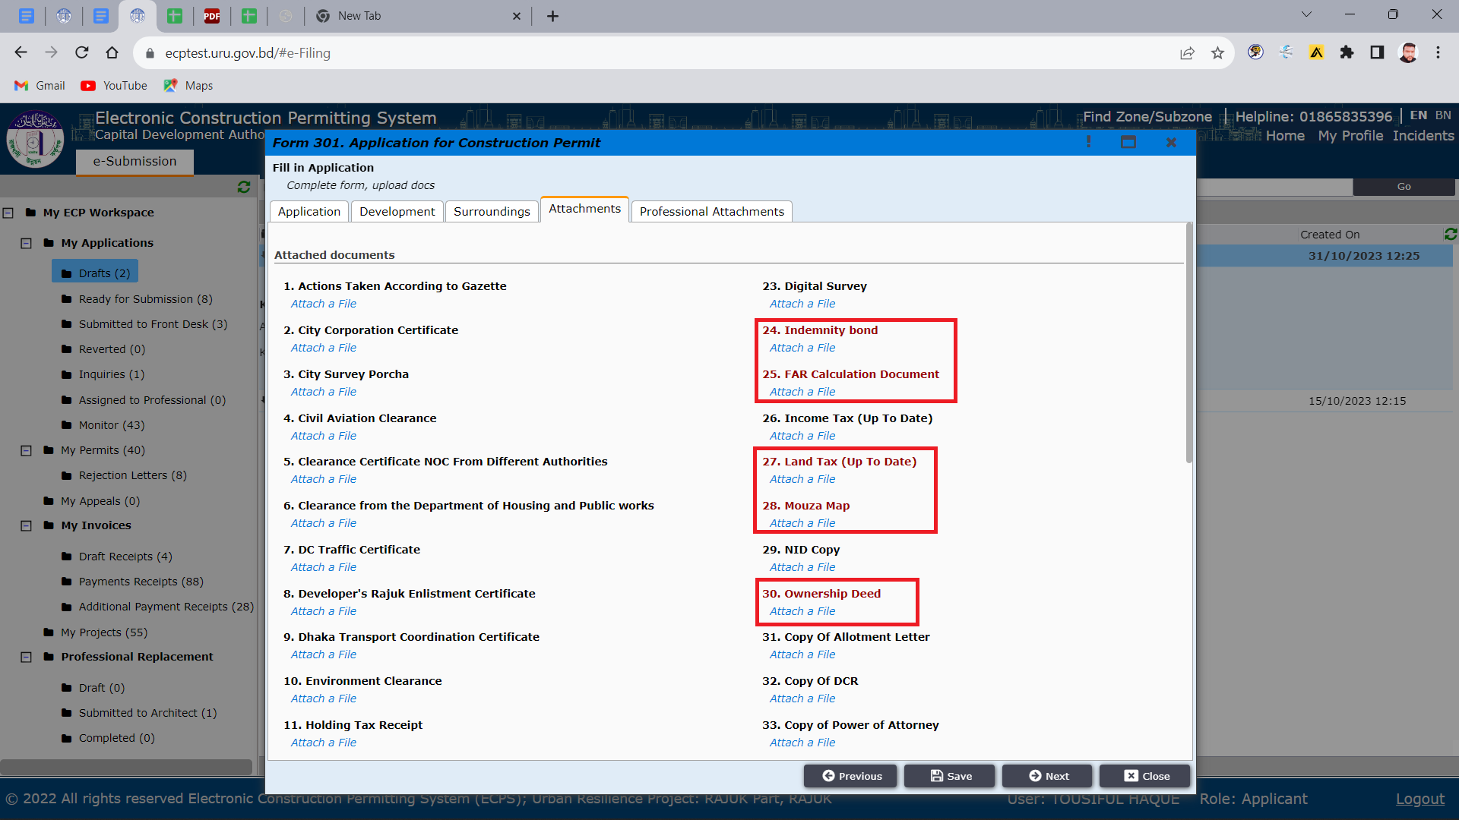
Figure 5.1 Floors above plinth
After clicking “Next” the applicant will be shown message as shown in Figure 6 and will need to wait for Professional’s acceptance. Now click on “Close” button. Now you can see this Application in “Drafts” section.
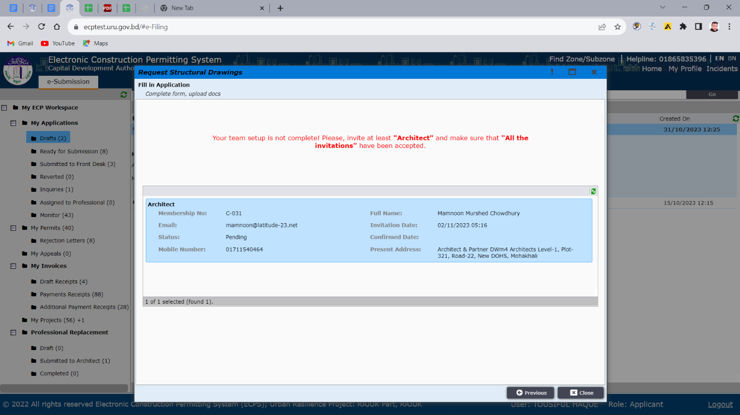
Figure 6. Professional’s acceptance
Scenario 2(Description): If PP (Planning Permit) or LSP (Large and Special Project) Approval is taken by old/previous CP system and applicant want to take CP (Construction Permit) from ECPS system, then they have to select “Existing Project = NO”
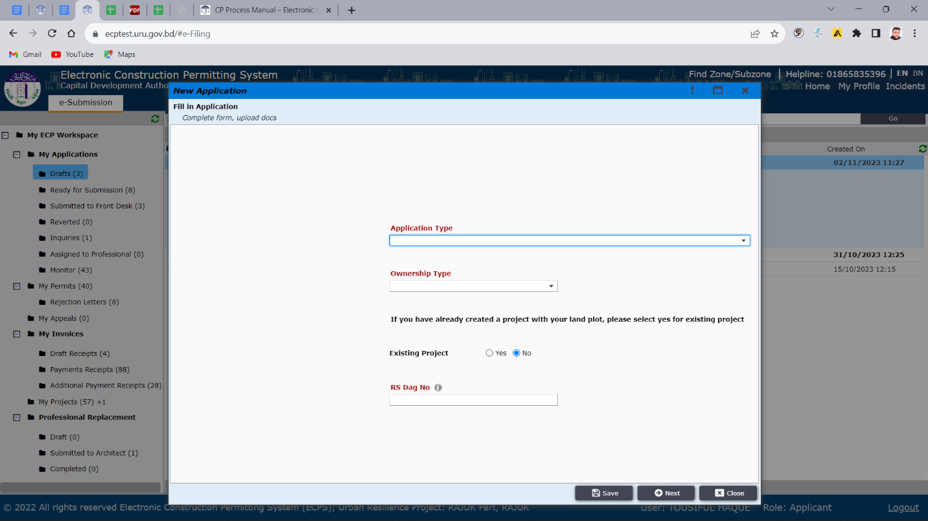
Figure: 6.1. Existing Project = ‘No’
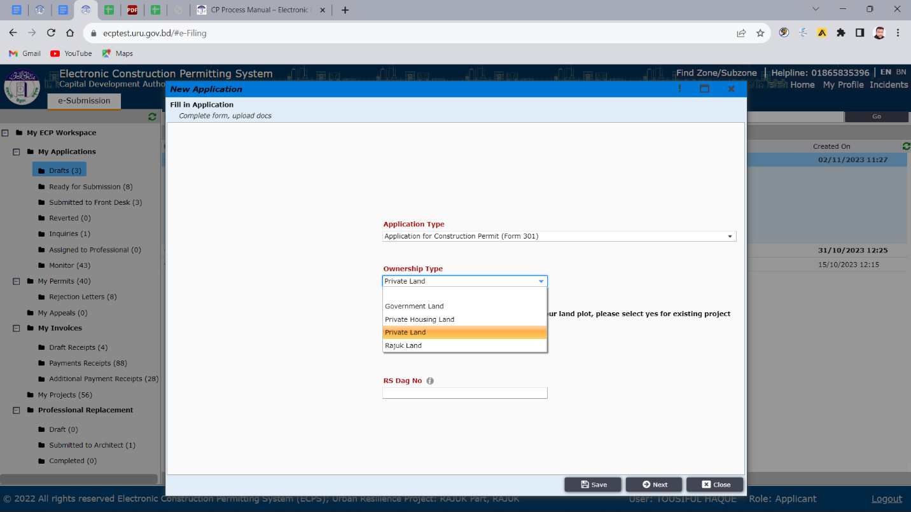
Figure: 6.2 Ownership Type Selection
Now applicant needs to enter RS Dag No.

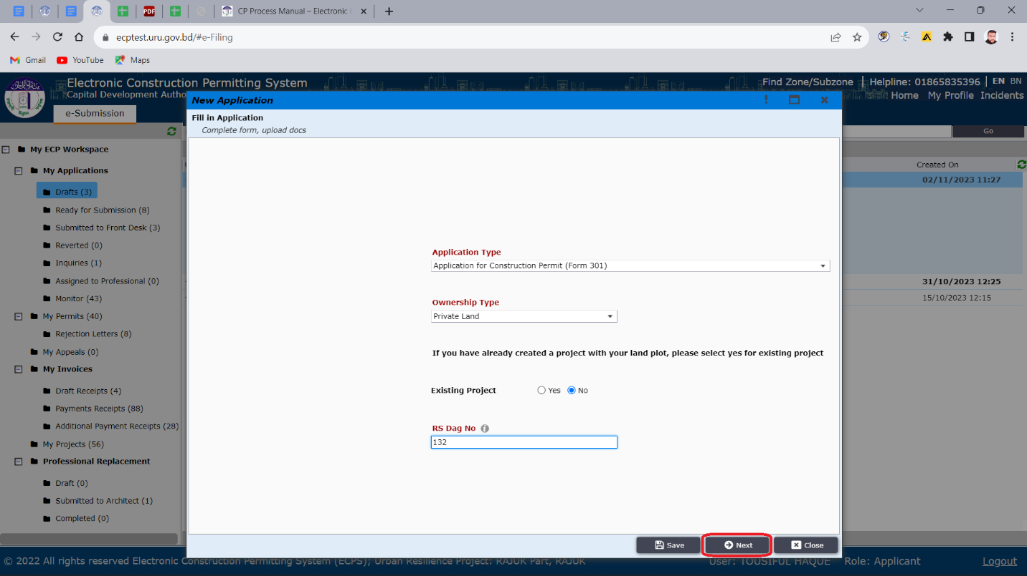
Figure: 6.3. Application Fill-up
After clicking “Next” the applicant will go to another window containing land details as shown in Figure 6.4. Applicant needs to fill up accordingly and then click “Next”.

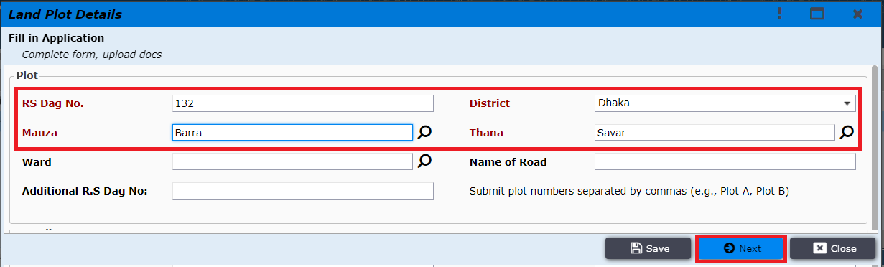
Figure: 6.4. Land plot details

After providing the Land plot details applicant is prompted to “Next” window containing construction project information (Figure 6.5). Applicant needs to give a Project name and click “Next”.
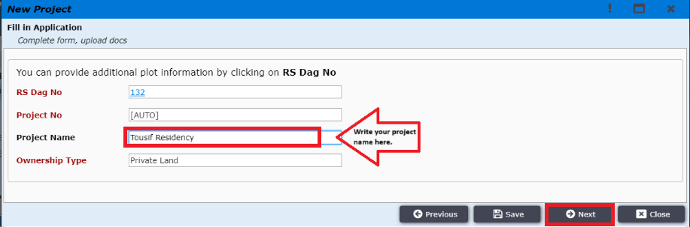
Figure: 6.5. New Construction Project

After giving project name applicant must click on next button to choose Land Use Type & Occupancy Type as shown in Figure: 6.6, 6.7, 6.8, 6.9, 6.10
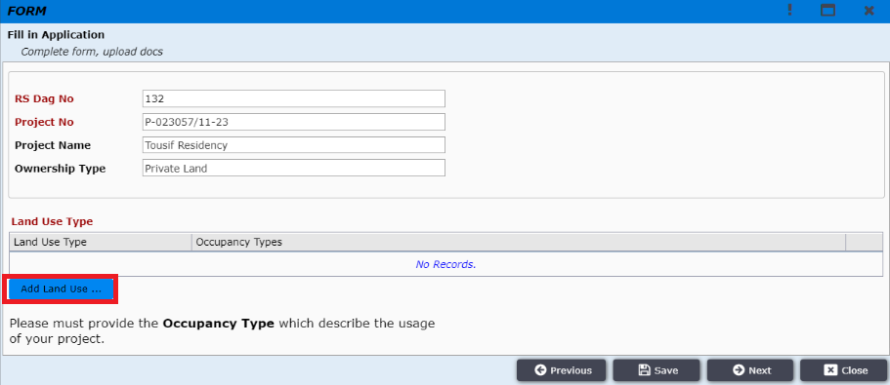
Figure: 6.6. Land Use Type
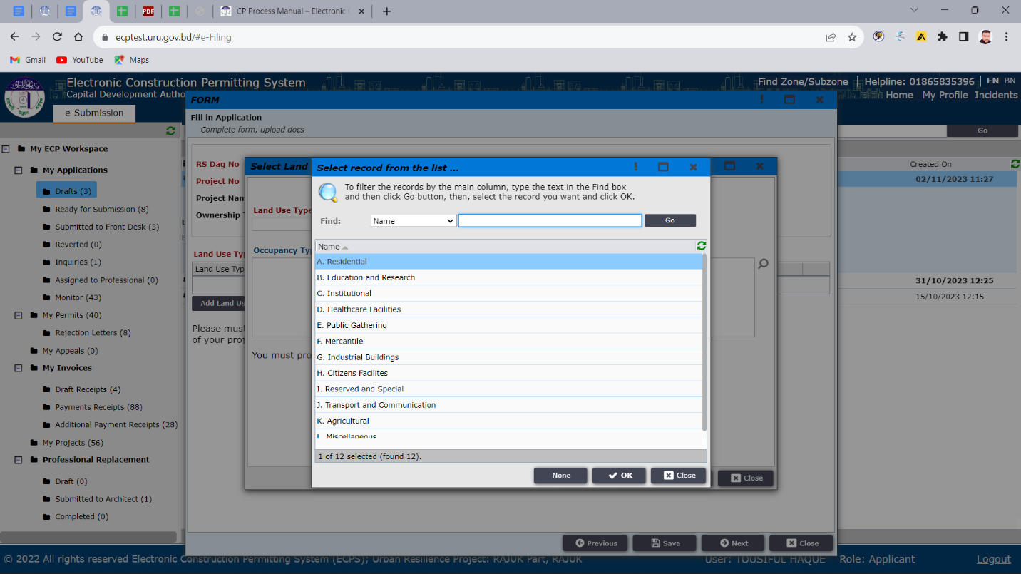
Figure: 6.7 Land Use Type
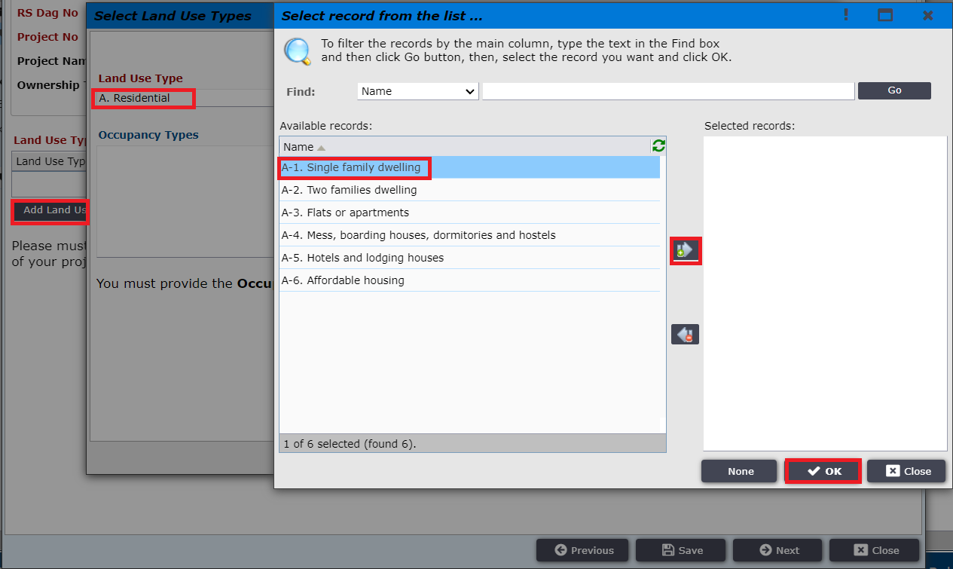
Figure: 6.8 Land Use Type
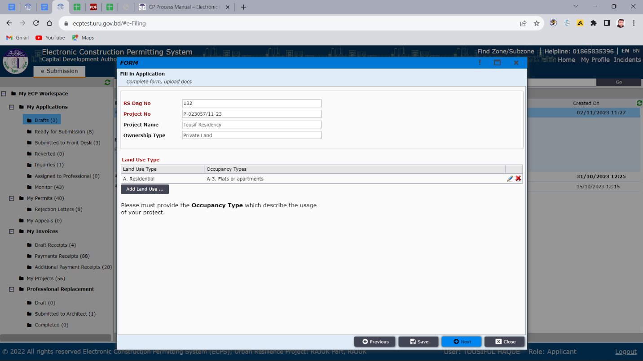
Figure: 6.9 Land Use Type

After selecting Land Use Type applicant must click on “Next” to add team members. Applicant needs to invite team member by clicking on ‘Invite Team Member’ option as shown in Figure 7.
Figure: 7 Land Use Type

Figure: 7.1 Invite Team Member
Applicant will be taken to a window to provide information about the particular professional such as Role and Membership number as shown in Figure 7.2 & 7.3
(Note: As Architect is the focal point, so applicant must add an Architect.)
Applicant can add multiple professionals here Such as: Electrical Engineer, Fire Safety Specialist, Mechanical Engineer, Plumbing Engineer and Structural Engineer.
Figure 7.2 Inviting Professional

Figure 7.3 Inviting Professional

After providing correct membership number applicant will view the professional’s details with picture as shown in (Figure 8) and then applicant needs to click “Next”.
Figure 8. Professional Details

Applicant is then taken to the next window as shown in the Figure 9.
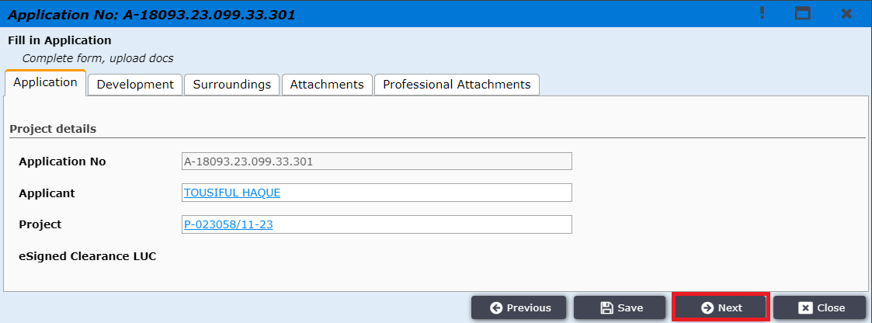
Figure 9

Then applicant click on “Development” tab and needs to fill another mandatory field as shown in Figure 10, here ‘Total gross area of the project (Fees will be calculated by this field) (m2)’ field will be filled by the Architect added by applicant.
Figure 10. Floors above plinth
Then applicant click on “Attachments” tab and needs to Attach some mandatory Attachments which must be Scanned copy of original documents and merged as pdf file as shown in Figure: 10.1
Figure 10.1
Now Click on “Next” button then “Add New”, You have to attach previous scanned copy of Approval letter of PP (Planning Permit) or LSP (Large and Special Project) during CP Application in ECPS as shown in the figure below. And you have to attach others necessary document in this window.

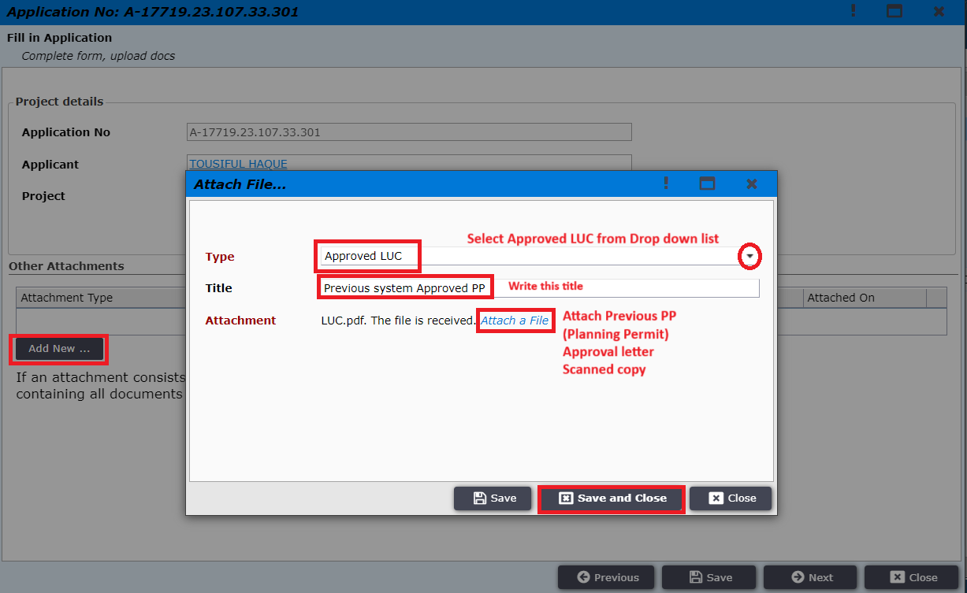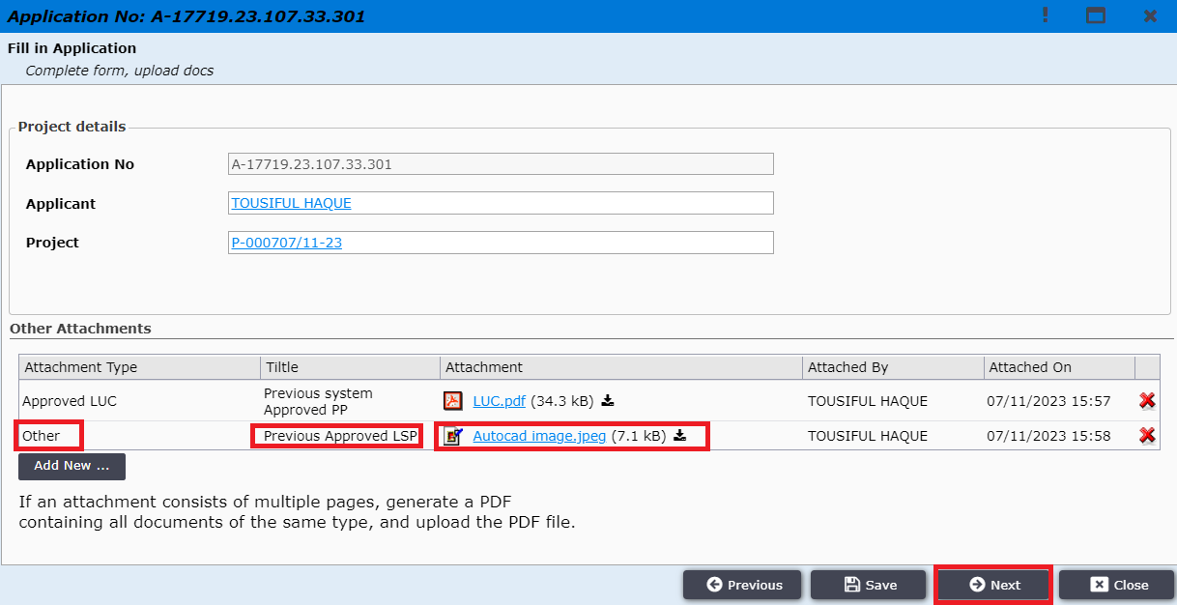
Figure 10.2

After clicking “Next” the applicant will be shown message as shown in Figure 11 and will need to wait for Professional’s acceptance.
Figure 11
Now the professional (ex. architect) will find the invitation in his incoming section of “My invitation” workspace and click “Next” as shown in Figure 12.

Now Process is same for “Existing Project = YES” or “Existing Project = NO”

*** Now the professional (ex. architect) will find the invitation in his incoming section of “My invitation” workspace and click “Next” as shown in Figure 12.
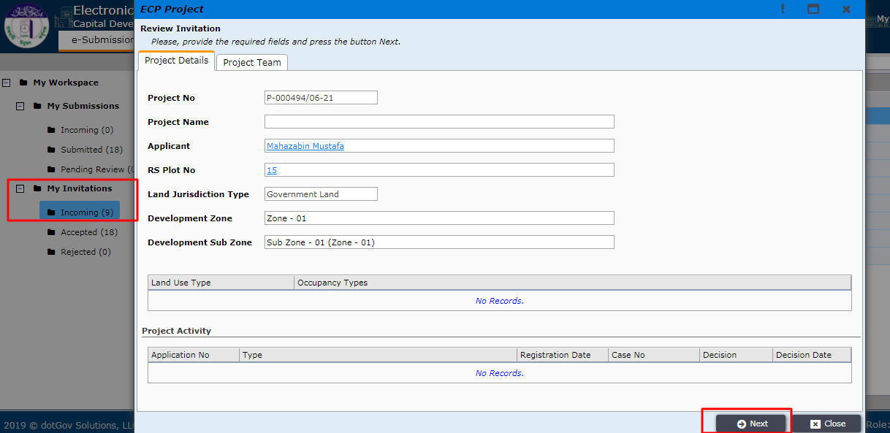
Figure 12. Professional’s acceptance

The Architect will get the option to accept or reject the invitation as shown in Figure 13. If Architect accepts then applicant can move forward to “Next” step but if the architect rejects then applicant needs to add another professional again by using the same steps mentioned above.
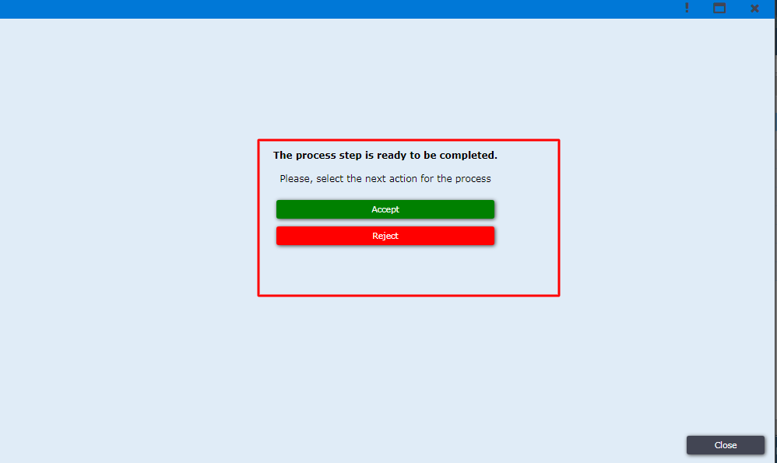
Figure 13. accept / reject

After the professional has accepted the invitation, the applicant can now send the application to focal point by opening the application from draft workspace (Figure 14.). The applicant needs to click “Next”. If the professional has rejected the invitation, then the applicant needs to invite another professional.
Figure 14. Application in draft

Applicant is then prompted to “Next” window to send the application to a focal point by clicking on the button (Figure 15).
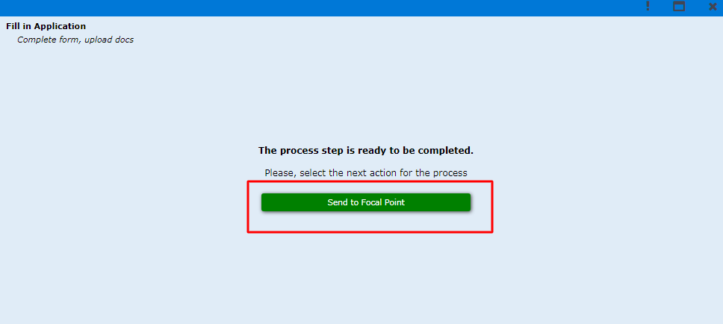
Figure 15. Send to Focal Point.

Now, the focal point can find the application under “My Submissions” workspace and can open the application details. (Figure 16)

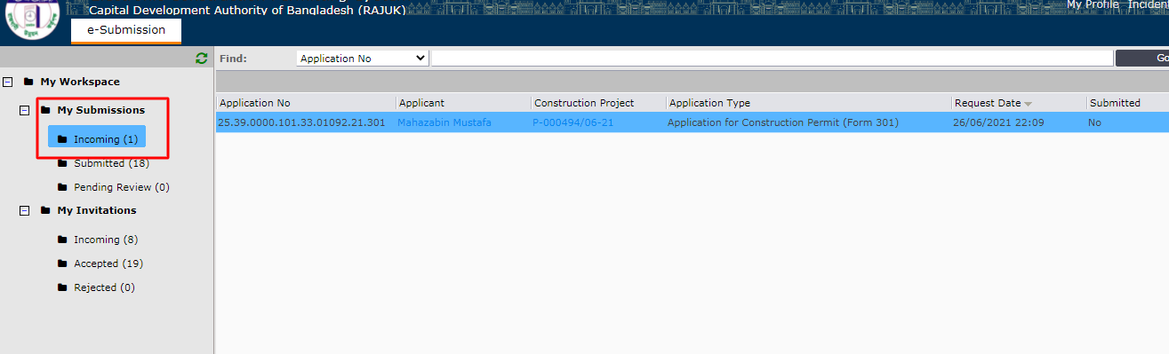
Figure 16. Focal Point’s workspace

The focal point Architect will then go to “Development” tab and fill total gross area and Description of use section as shown in Figure 17.

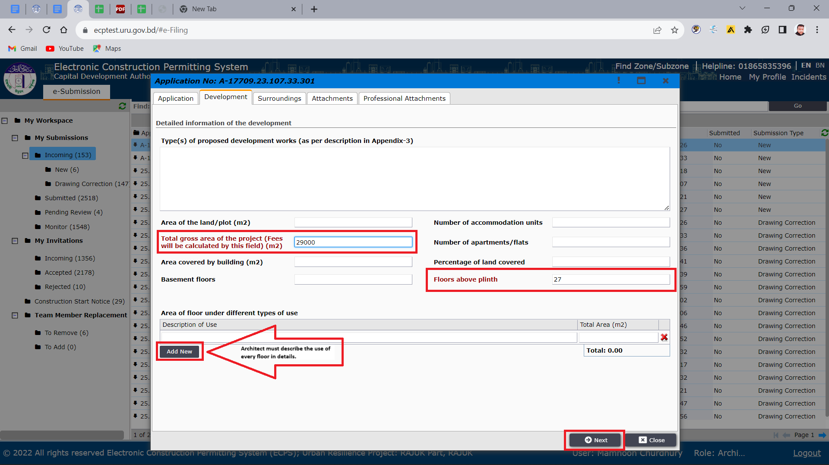
Figure 17. Development tab

Then, Architect will go to “Professional attachments” tab and click on “Add New” as shown in Figure 18, 18.1, 18.2, 18.3,18.4 and 18.5 .
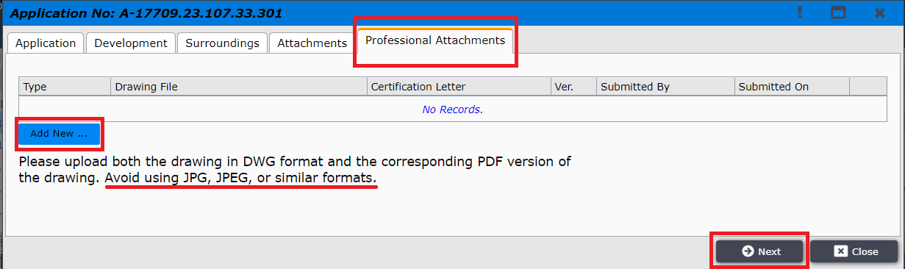
Figure 18. Professional attachments tab

Architect will then select drawing type and attach different drawings.
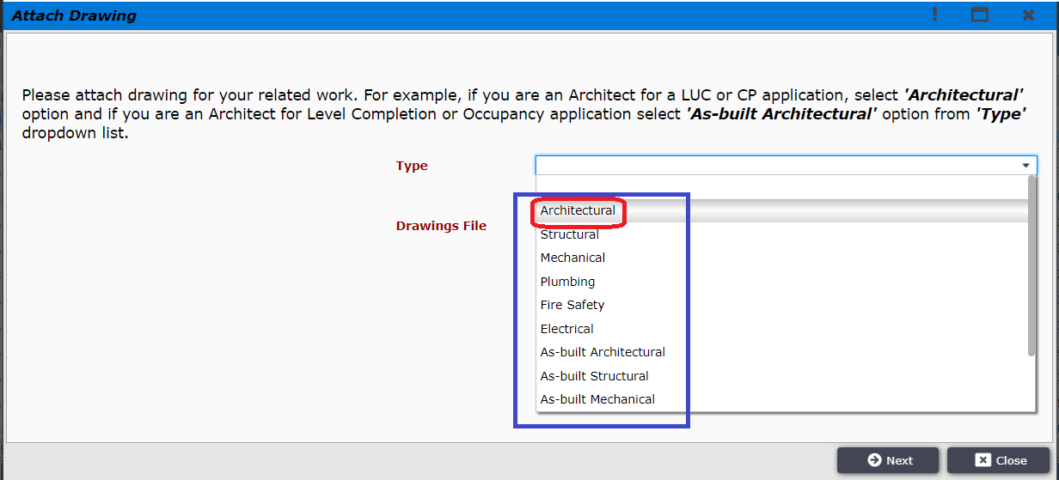
Figure 18.1 Professional attachments tab
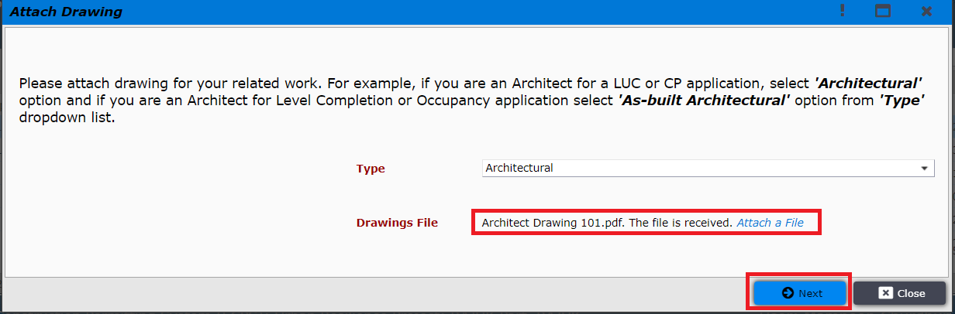
Figure 18.2. Drawing Attachment types
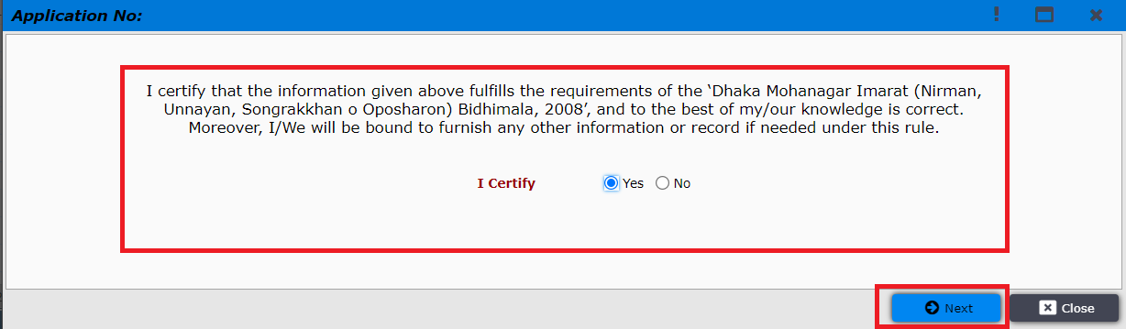
Figure 18.3. I Certify

After agreeing with RAJUK Bidhimala Architect must sign the document and attach to “Signed Technical person Certificate Letter” (Digital signature)as shown in Figure 18.4 Professional attachments tab
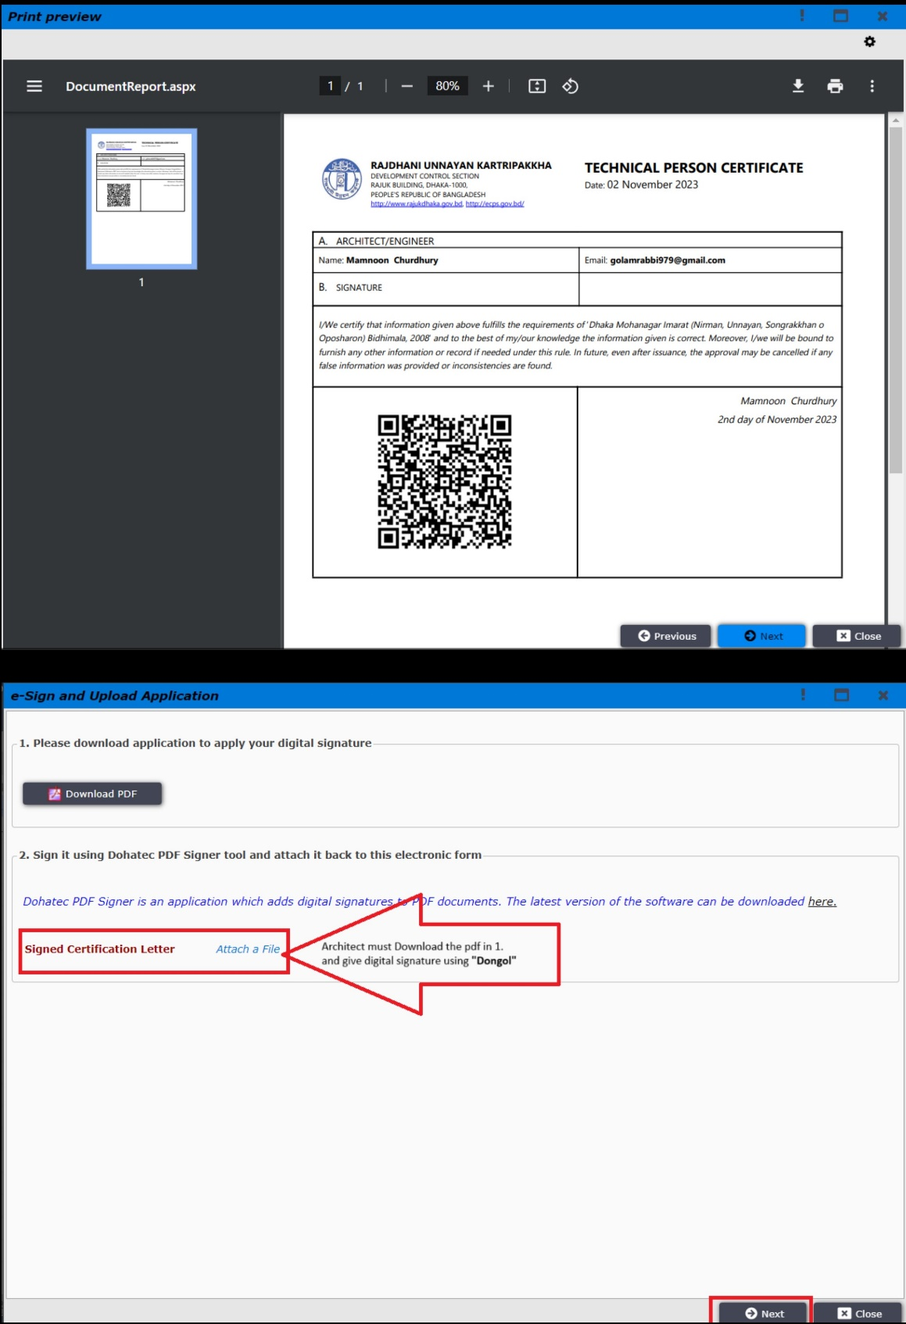
Figure 18.4 Professional attachments tab

After clicking on “Next” Architect will send the file to applicant as shown in Figure: 18.5

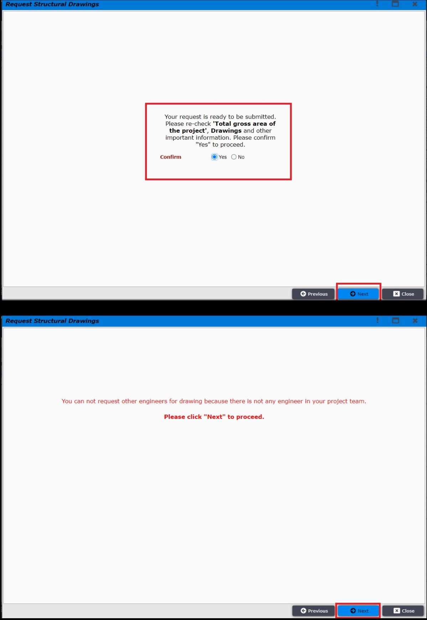
Figure 18.5 Professional attachments tab

If other professionals add their attachment, then the file will go to pending review folder. Here, the focal point “Architect” will decide whether he need other engineers or not to fulfill the applicants file demand as shown in the figure: 18.6, 18.7, 18.8 and 18.9

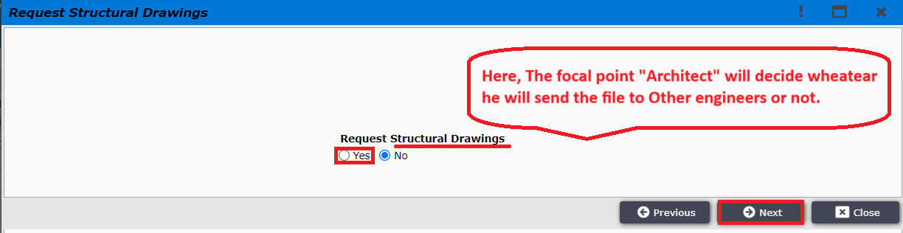
Figure: 18.6

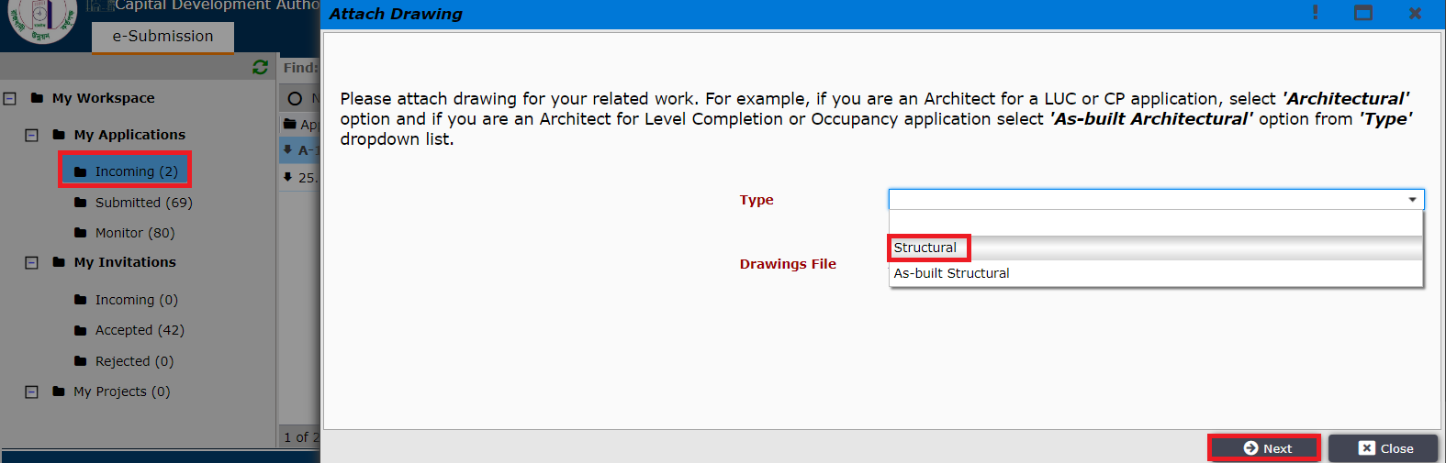
Figure: 18.7

Here, Other engineers, (Electrical Engineer, Fire Safety Specialist, Mechanical Engineer, Plumbing Engineer, Structural Engineer) such as Structural Engineer is attaching drawing as shown in figure 18.8. After attaching drawing other engineers need to follow the same process as shown in figure 18.3 & 18.4

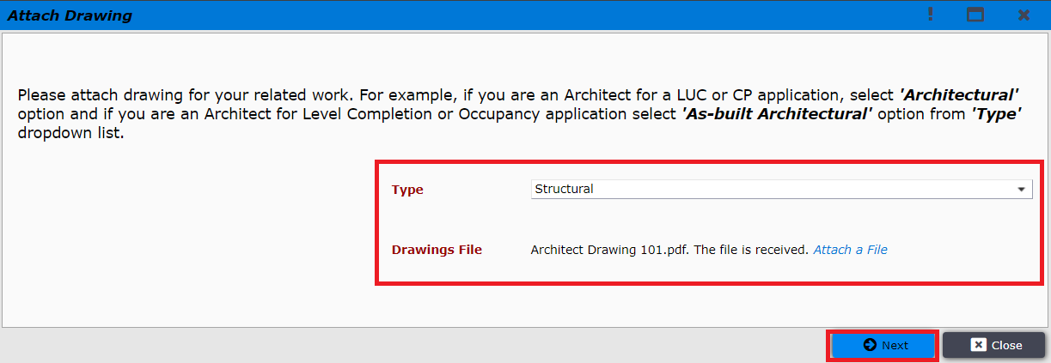
Figure: 18.8

Here, Structural engineer added structural drawing and the file will go to Architects dashboard in “Pending Review” folder as shown in figure: 18.9
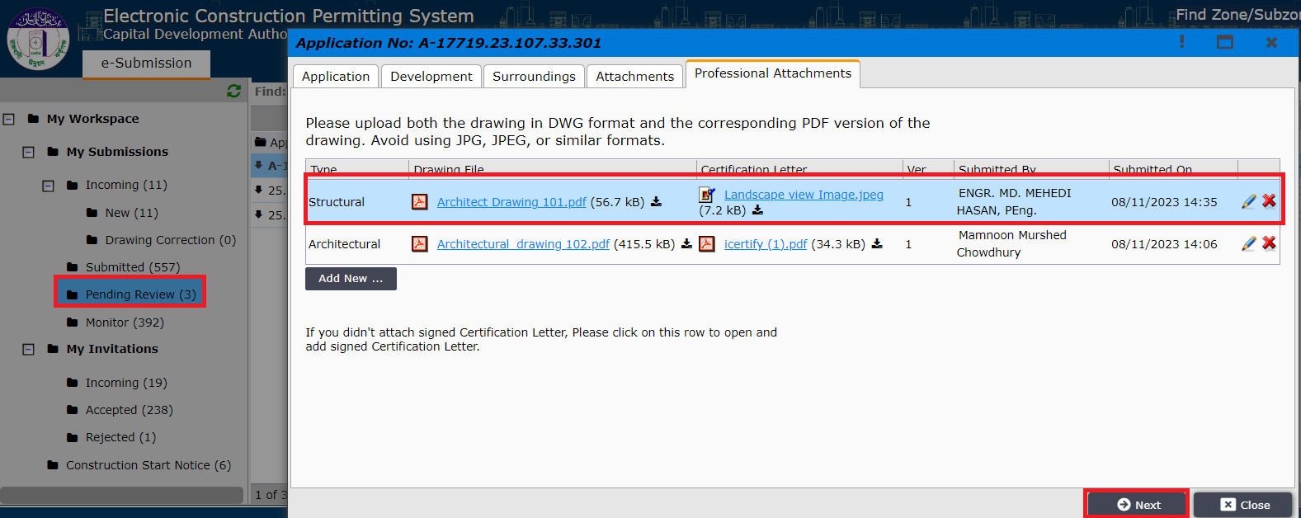
Figure: 18.9
After the focal point has submitted the drawings, the applicant will get the application under his ‘Ready for Submission’ tab as shown in Figure 19
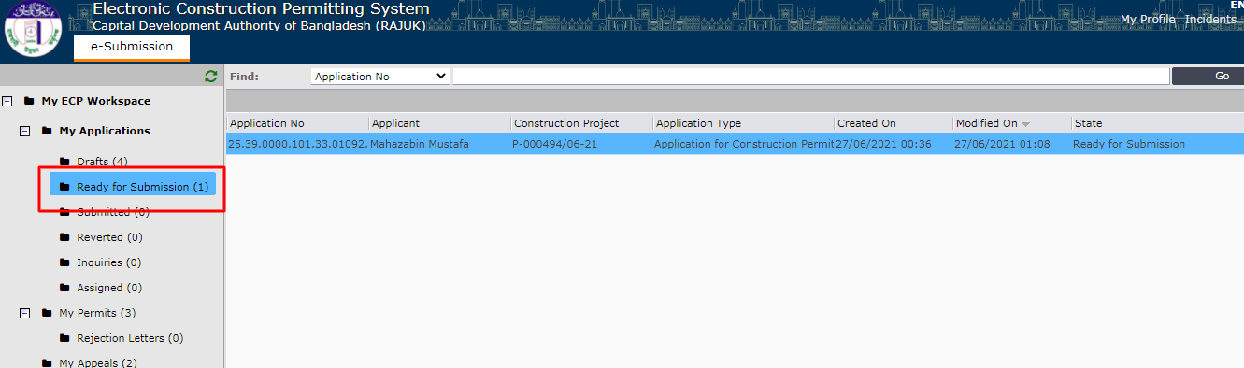
Figure 19. Ready for Submission

Applicant now can open the application and after clicking ‘“Next”’, he will be prompted to the window to pay application fees. Applicant needs to click on “Pay Online” button. It is shown in Figure 20.
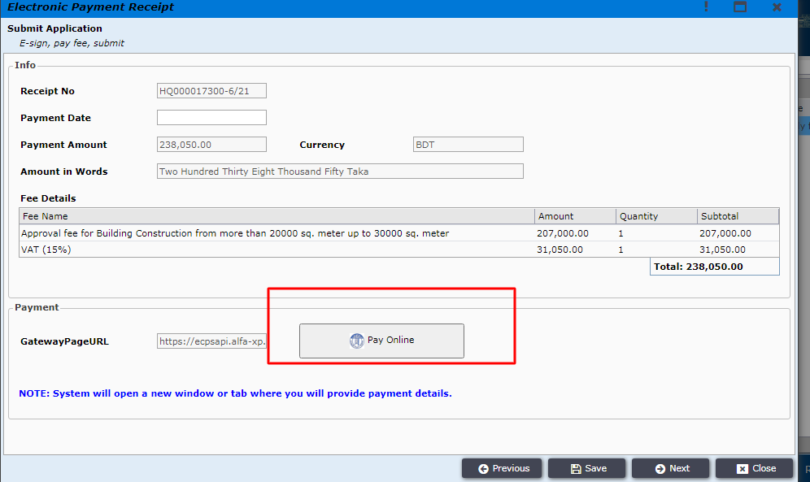
Figure 20. Pay online

After clicking pay online applicant will find different types payment options and can select the preferred option from those. (Figure 21)
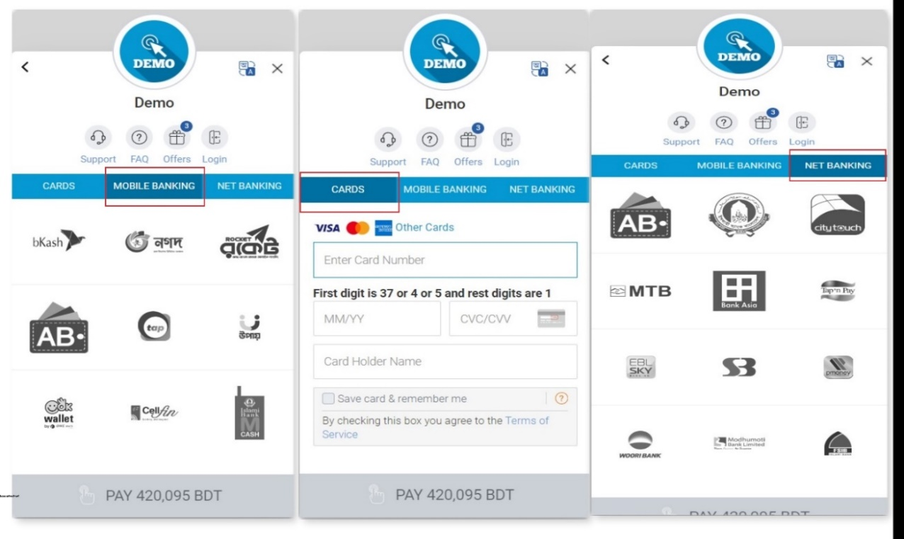
Figure 21. Different types of Payment options
After providing all correct payment information applicant will be able to pay the application fees successfully and a message will be shown confirming it as shown in Figure 22.
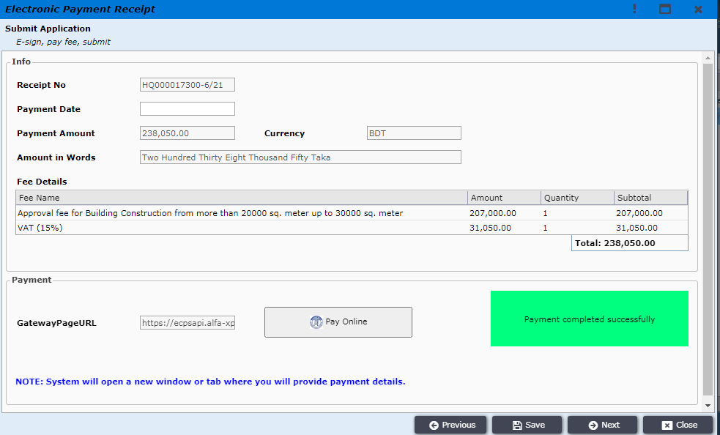
Figure 22. Payment is confirmed
Now applicant needs to click on “Next” and the payment details will be shown along with payment receipt printable PDF file as shown in Figure 23
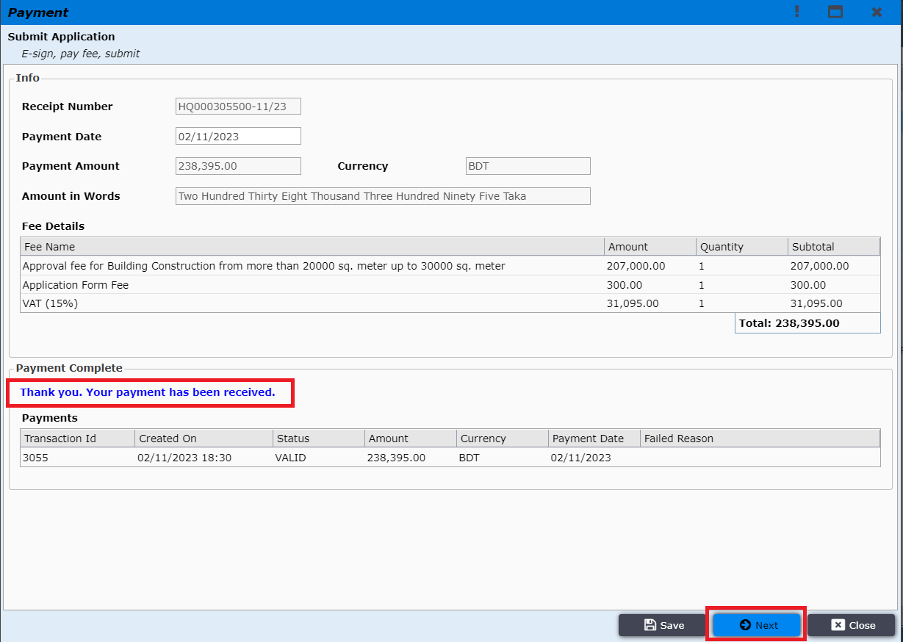
Figure 23. Payment details
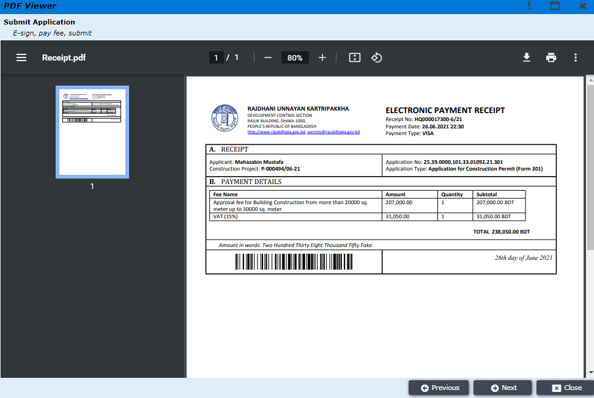
Figure 23.1 Printable PDF receipt
Applicant now needs to certify that the given information is correct by clicking on “Yes” as shown in Figure 24.
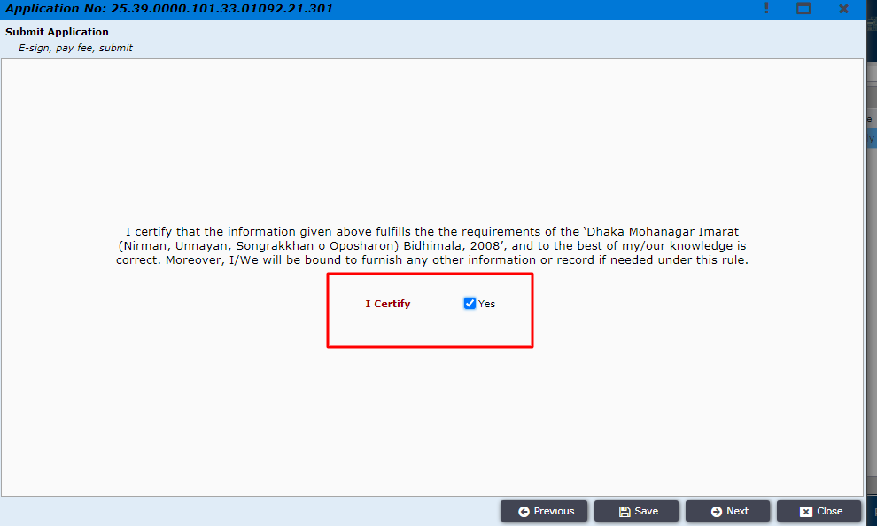
Figure 24. Certify
After certifying, the application printable preview is shown as Figure 25.
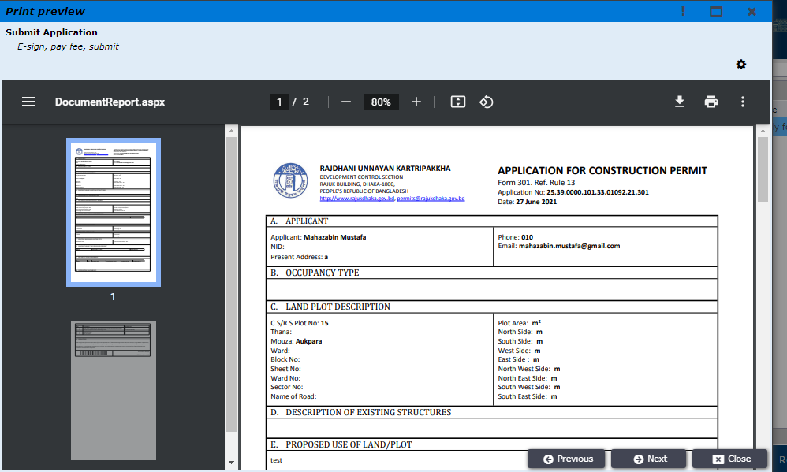
Figure 25. Printable application

Applicant needs to click “Next” and will be prompted to the window to download application and then need to e-sign the document. The e-signed documents need to be uploaded in the “Signed Application”
Section successfully and then the applicant can move “Next”.
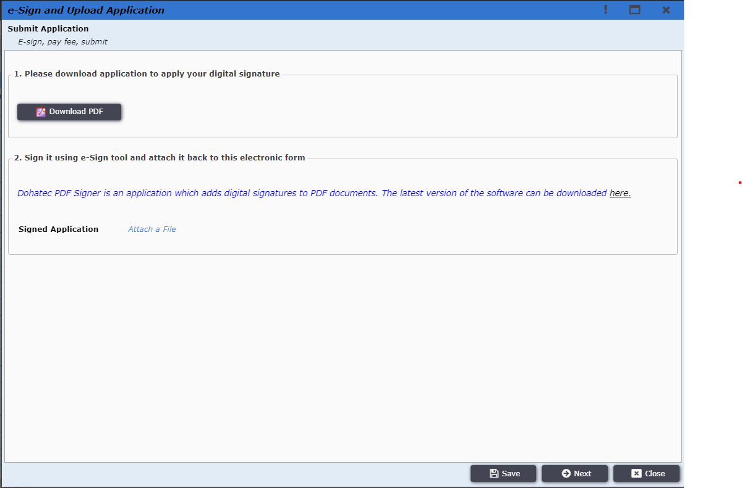
Figure 26. Sign and Validate
After the signed document is uploaded successfully, applicant will be provided the option to submit application as shown in Figure 27. By clicking on the button, the application will be submitted successfully and will be sent to the front desk officer.
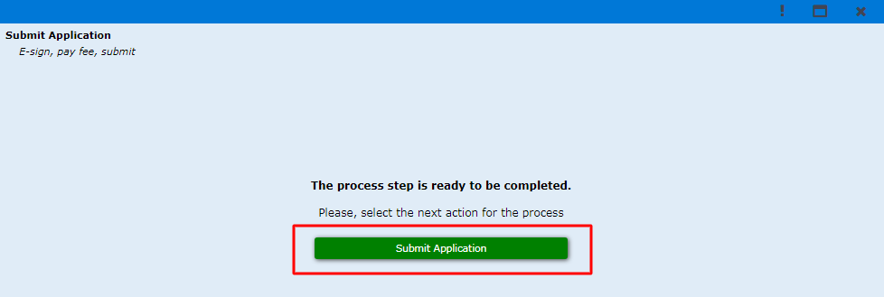
Figure 27. Submit Application
Front desk officer will be able to find the submitted application from E-filings workspace as shown in Figure 28.
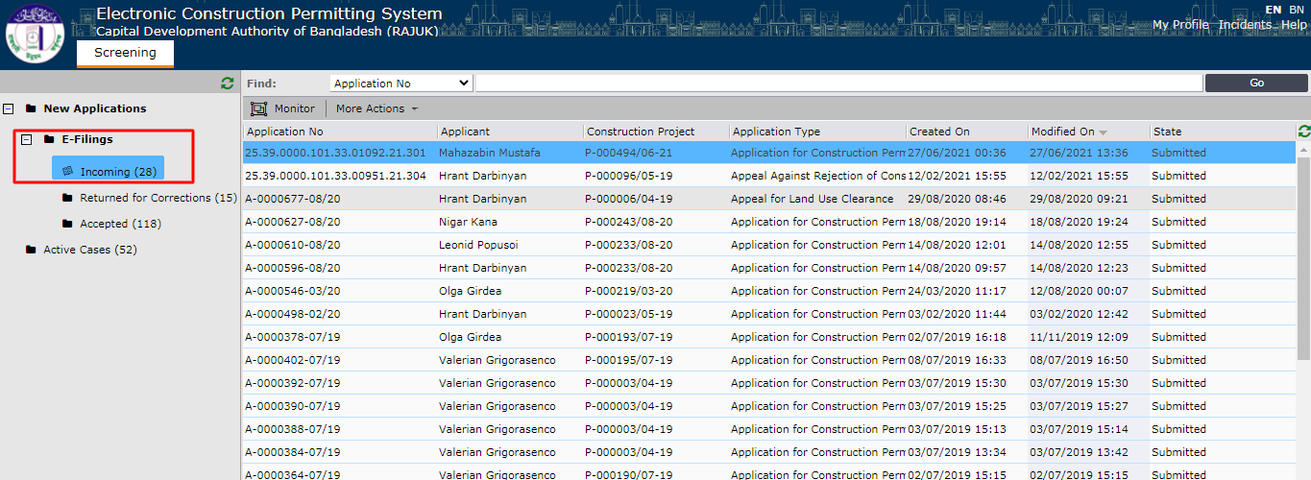
Figure 28. Incoming E-fillings
Now, front desk office will be able to review the application as shown in Figure 29.
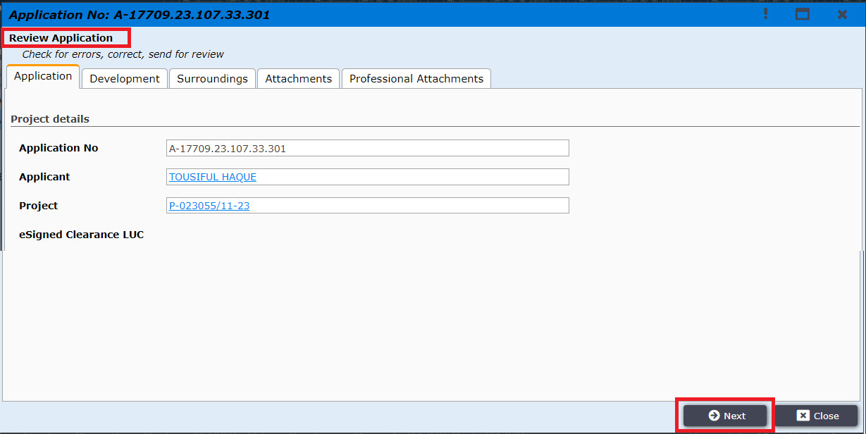
Figure 29. Review Application
After clicking “Next”, the front desk officer is given options to “Accept Application” or “Request Corrections”. If request correction is selected then front desk officer will need to mention the required corrections and send it back to the applicant and then applicant will be doing the required corrections before sending it back to the front desk officer. (Figure 30)
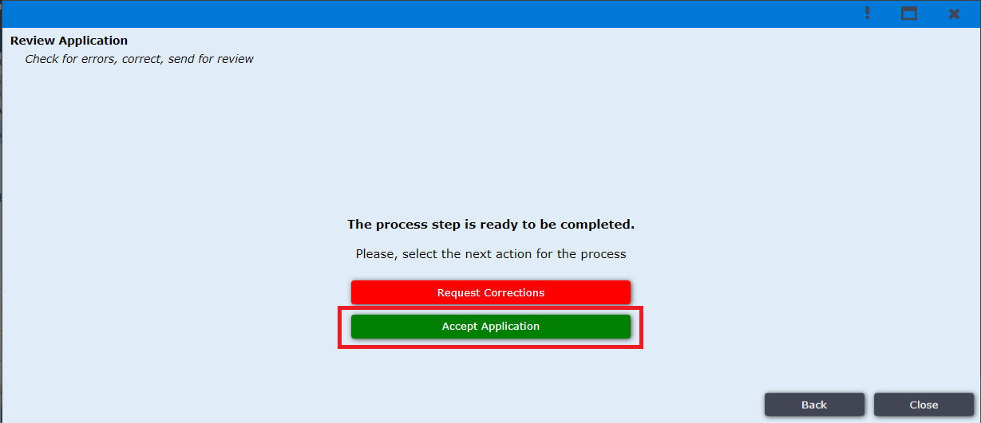
Figure 30. Front Desk Officer Application Processing options

If the front desk officer accepts the application, then he will be prompted to the window shown in Figure 31. And after clicking “Next” the application will be accepted successfully and is sent to the designated authority.
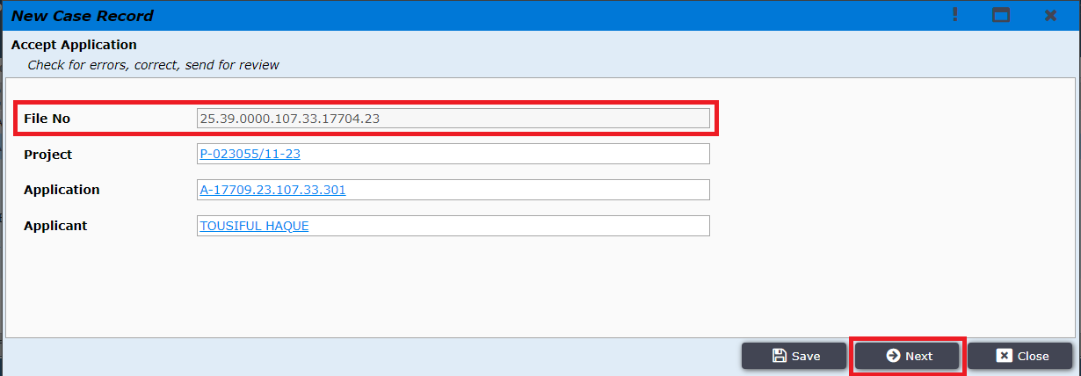
Figure 31. Accept Application

The Application Filing process is successfully completed after front desk officer accepts the application.

Front Desk Assistant can request for correction to applicant by clicking “Request Corrections” button in Figure 32
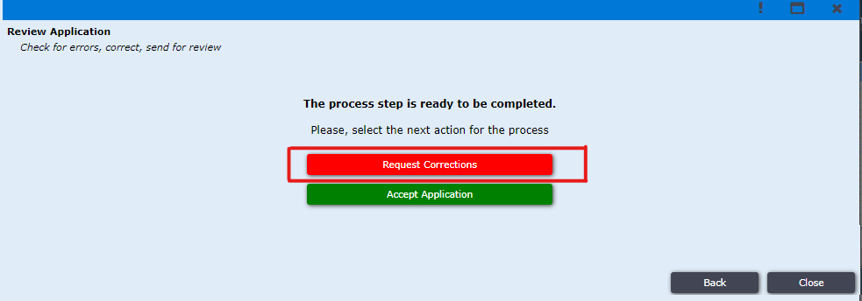
Figure 32. Request Corrections
After clicking Button “Request Corrections” he prompted to the window shown in Figure 33. Here first Field for comment for whole application if there is anything for corrections. Other field is for every attachment if any correction needed for respective attachment.
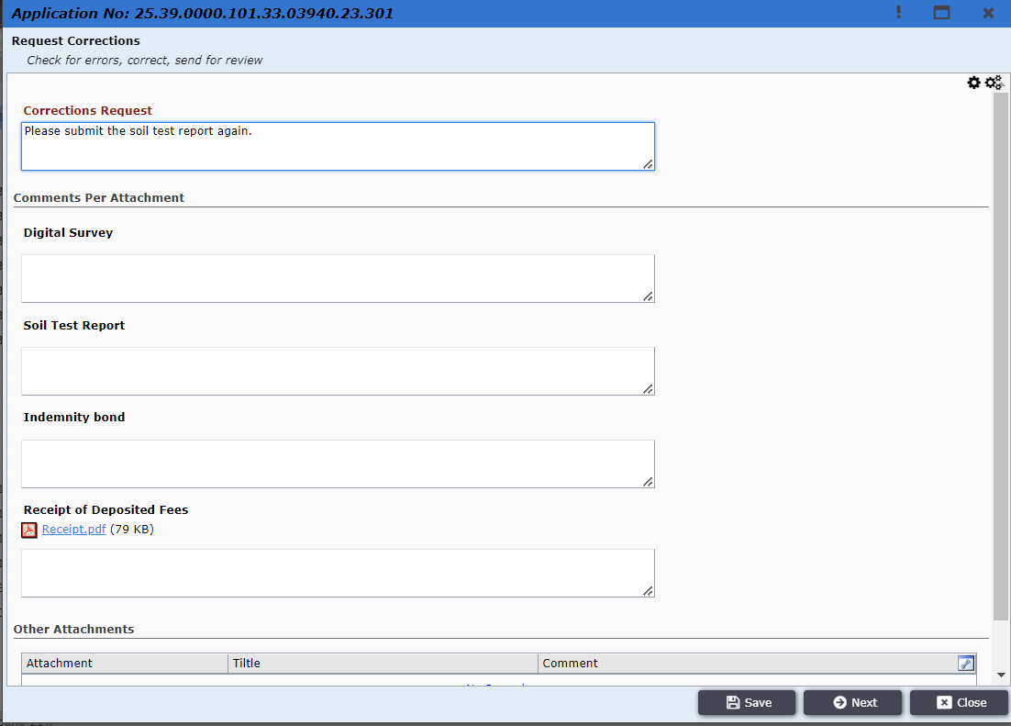
Figure 33. Field for correction
After clicking “Next” the file will go to the applicant Reverted tab section in “My Applications”.
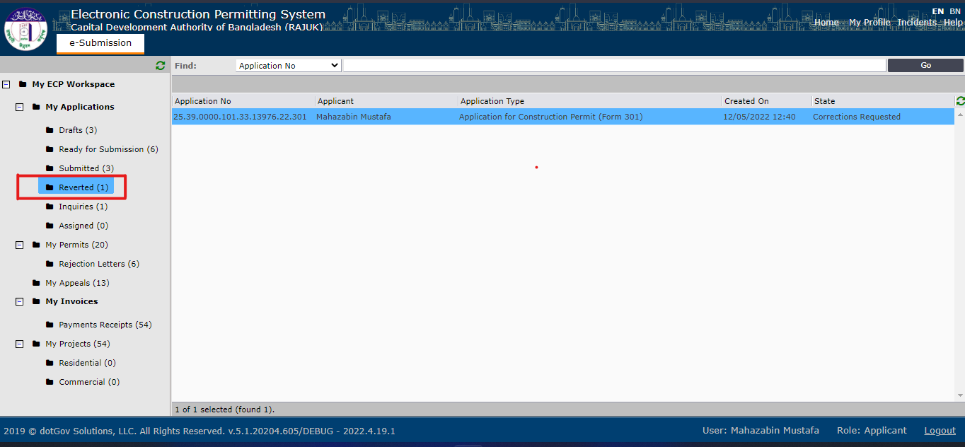
Figure 34. Application come to Applicant for correction
After clicking “Reverted” Figure 34, reverted applications from front desk assistant show as list. After clicking on file, Applicant can see the comment for correction as Figure 35.
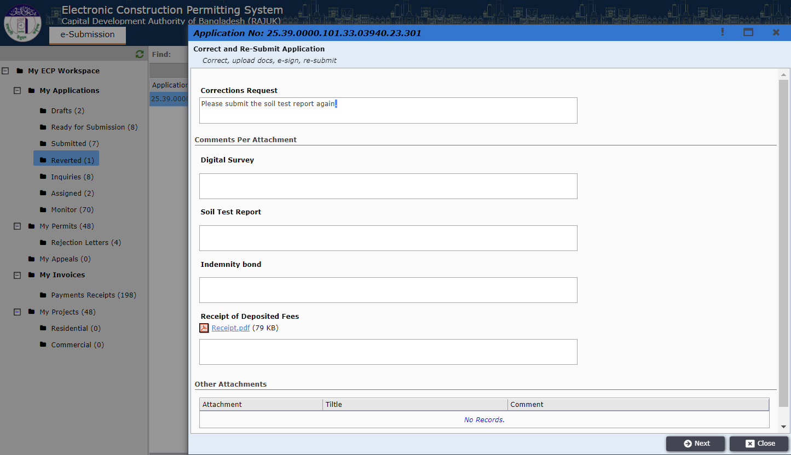
Figure 35. Comment for Correction
After clicking “Next” Applicant can see all data he fills during application in read-only mode Figure 36. He can check out where is the problem.
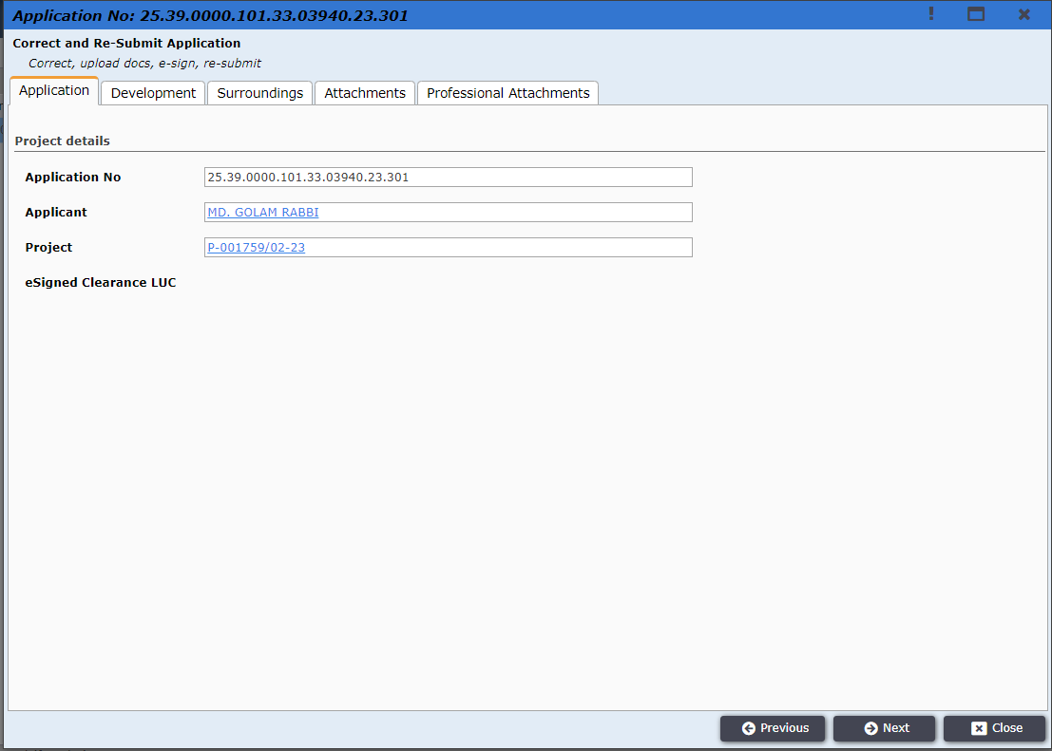
Figure 36. What applicant filled during application
After clicking “Next” he will find two options. For “Re-Submit” his application solving the issue mentioned in correction request comment he have to click “Re-Submit” button Figure 37.
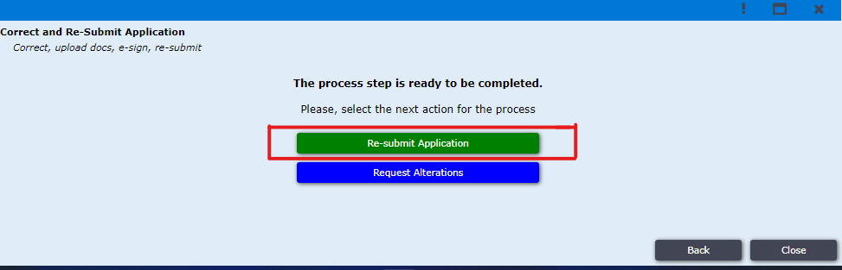
Figure 37. Re-submit Application
After clicking on “Re-Submit” button applicant can see request correction comment for whole application Figure 38.
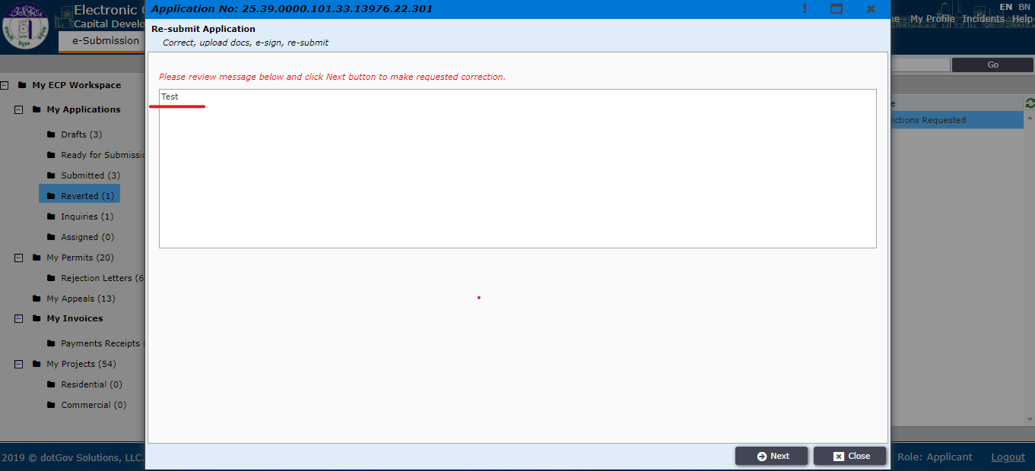
Figure 38. Request Correction Comment for whole application

After clicking “Next” applicant can see the window Figure 39 where applicant can edit his information and re-upload attachment and submit as before.
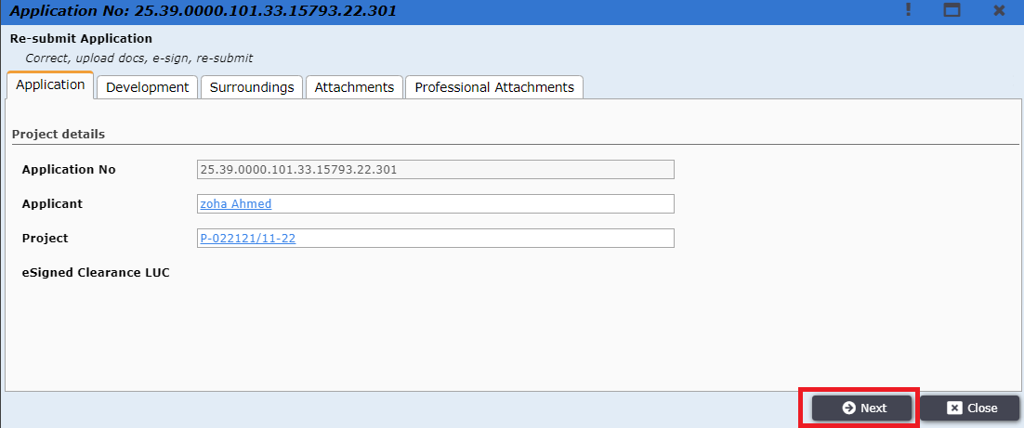
Figure 39. Editable window for re-upload and re-submit

If correction is needed for architect, then applicant have to click on “Request Alternations” Figure 40. Then file will go to the Architect who added with this application during application filing.
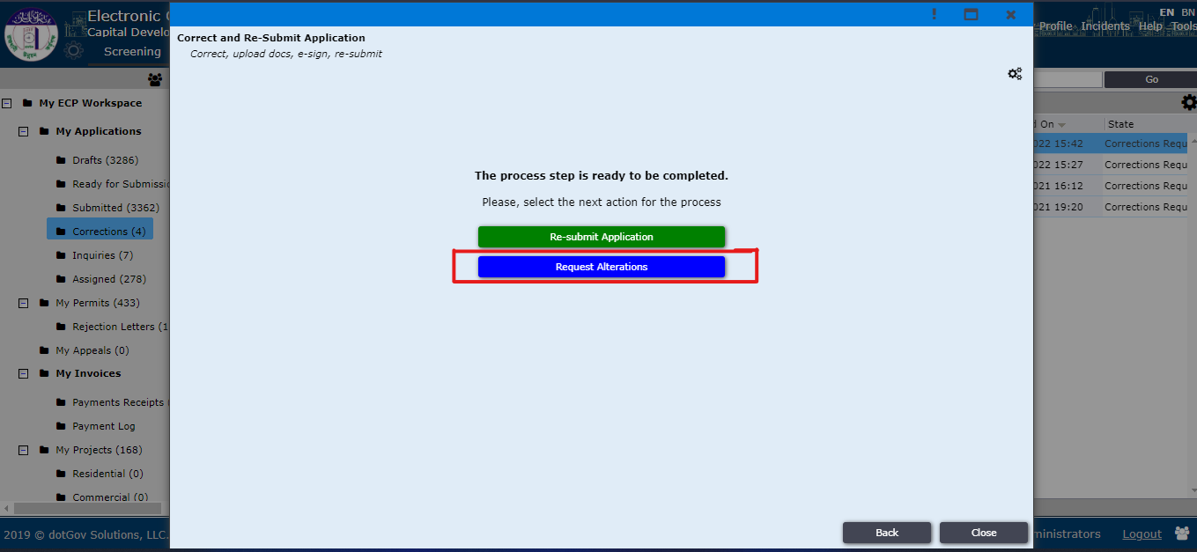
Figure 40. Request Alterations
Then the file will go to architect for giving Drawing correction as Architect is the focal point, only he has the ability to edit information Figure 41. After clicking “Next” the file will return back to applicant.
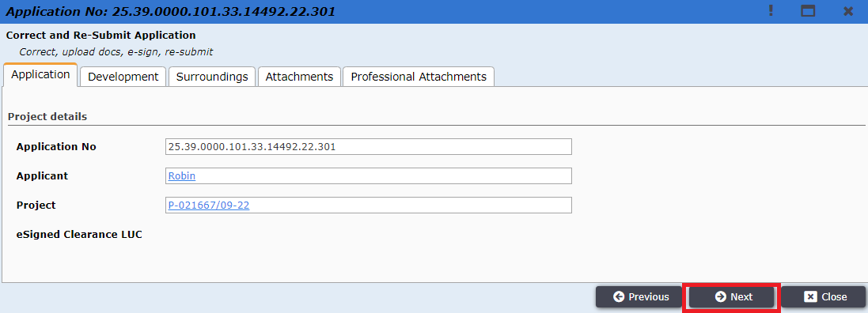
Figure 41. Architect Information

And then applicant can re-submit the application. Shown in Figure 42.
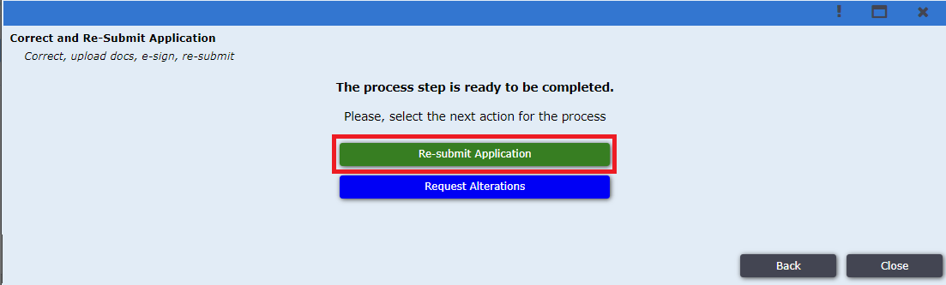
Figure 42. Re-submit Application

When the file is accepted by Front Desk Officer then it will go to Authorized Officer. Applicant can monitor the files status by clicking on the “Monitor”. By clicking on a file, a window will pop up, here applicant can see files current status. shown in Figure: 43.
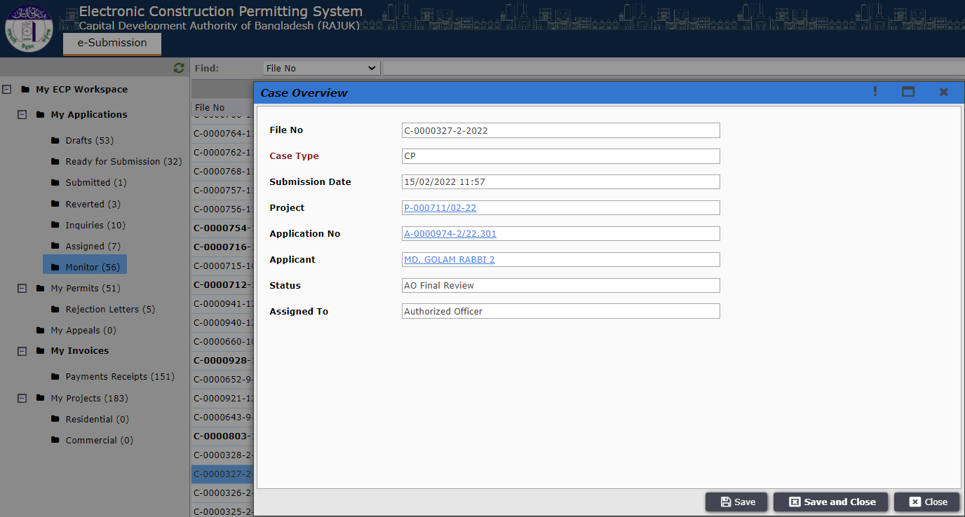
Figure 43. Monitor Files.

At initial stage the Authorized Officer can send the file to applicant for “Request Payment or Clarifications to Applicant”. It will come in “Inquiries” as Shown in Figure: 44. It may require payment; the payment process is same as shown before in Figure: 20 to 23.1
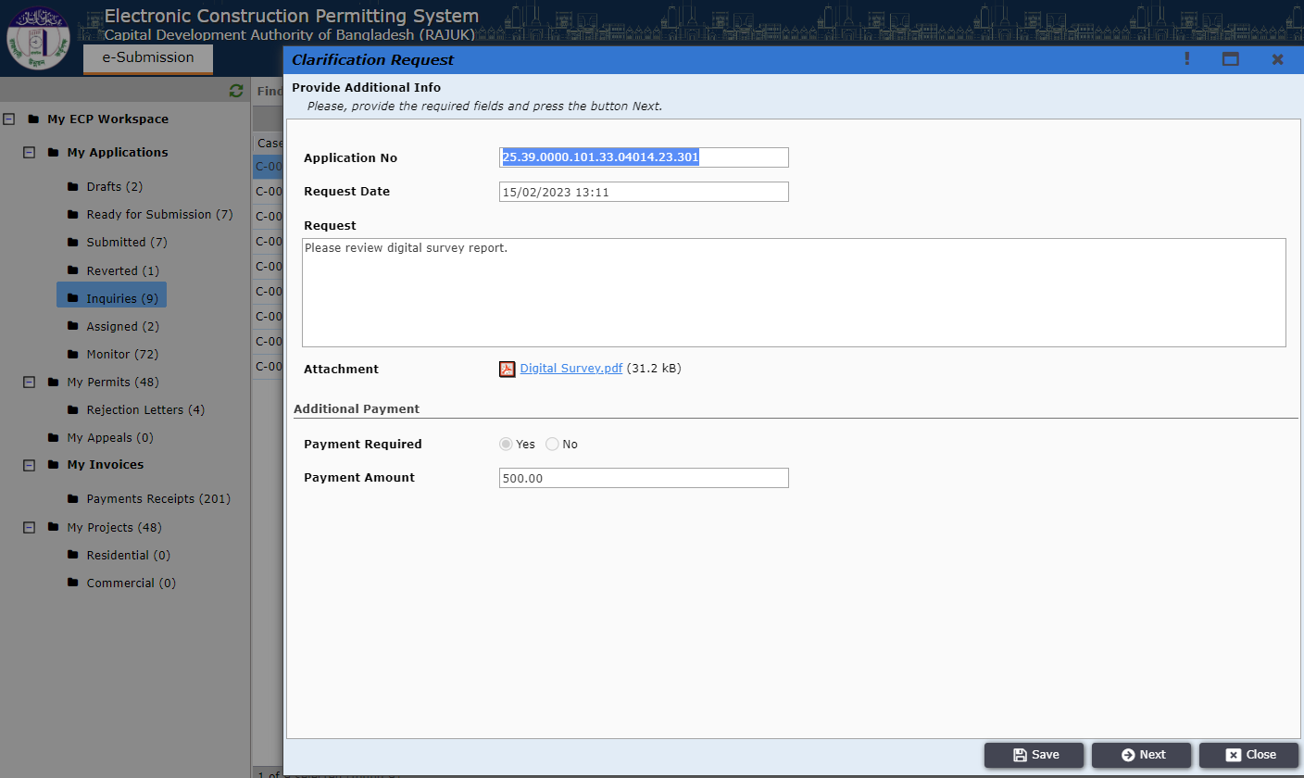
Figure 44. Request Payment or Clarifications to Applicant.
After completing payment process applicant will have to go next and click on “Send Clarifications” button. Shown in Figure: 45.
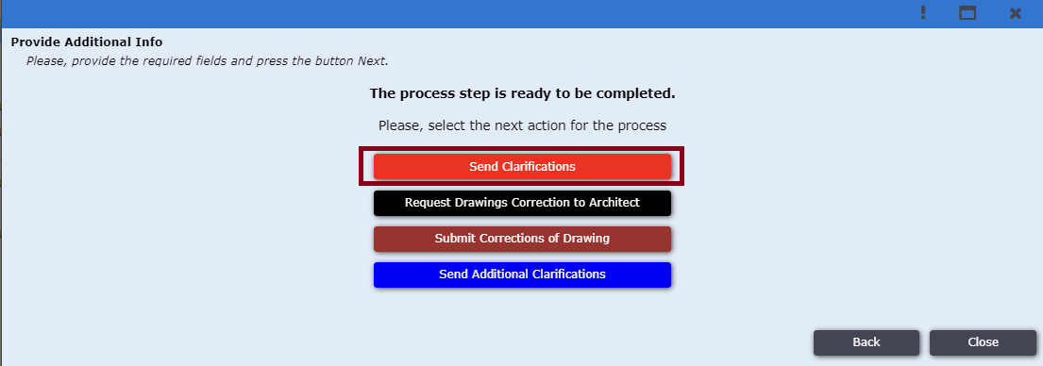
Figure 45: Send Clarification.

In the next step the Authorized Officer can send the file to the applicant for “Additional Clarifications”. It will come in “Inquiries”. Shown in Figure: 46. It may require payment too as shown before.
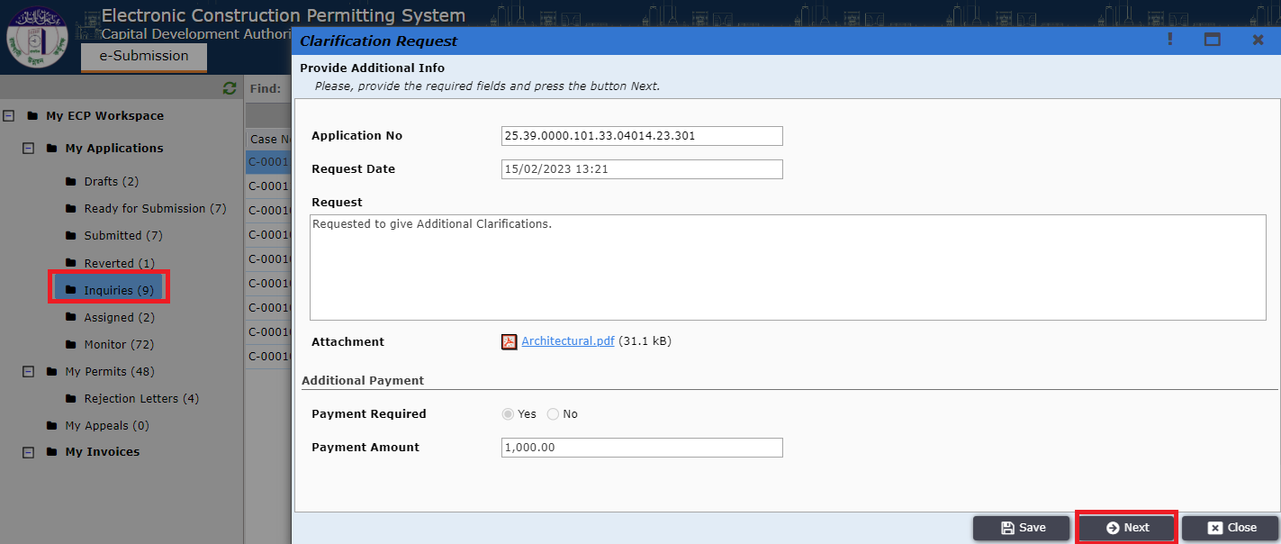
Figure 46: Additional Clarification.
After completing all corrections and payment process Applicant will click on the “Send Additional Clarifications” button as shown in Figure: 47.
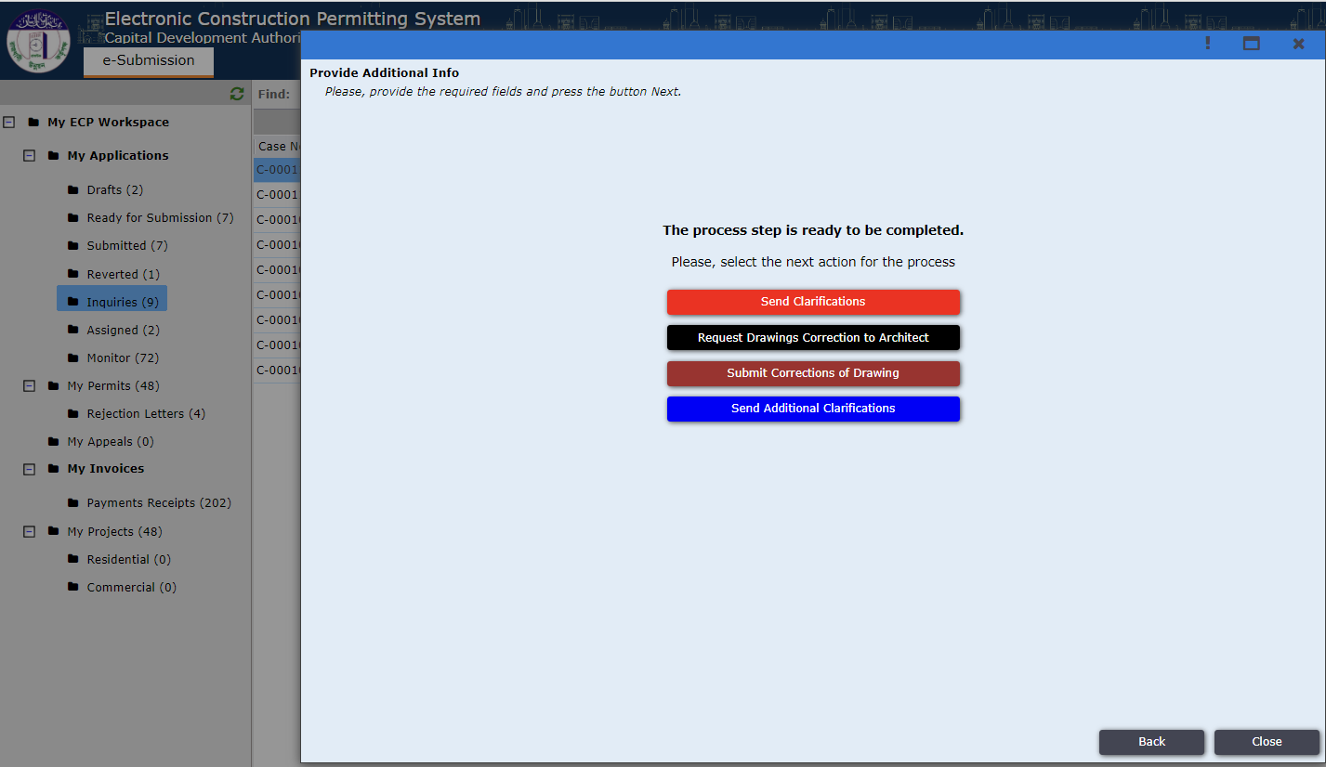
Figure 47: Send Additional Clarification.
After ‘committee review’ and before ‘collect signature’ Authorized Officer can send the file to the Applicant for drawing correction. This process is same as before. It may require payment too. Then the Applicant will have to click on the “Submit Corrections of Drawing” button. Shown in Figure: 48.
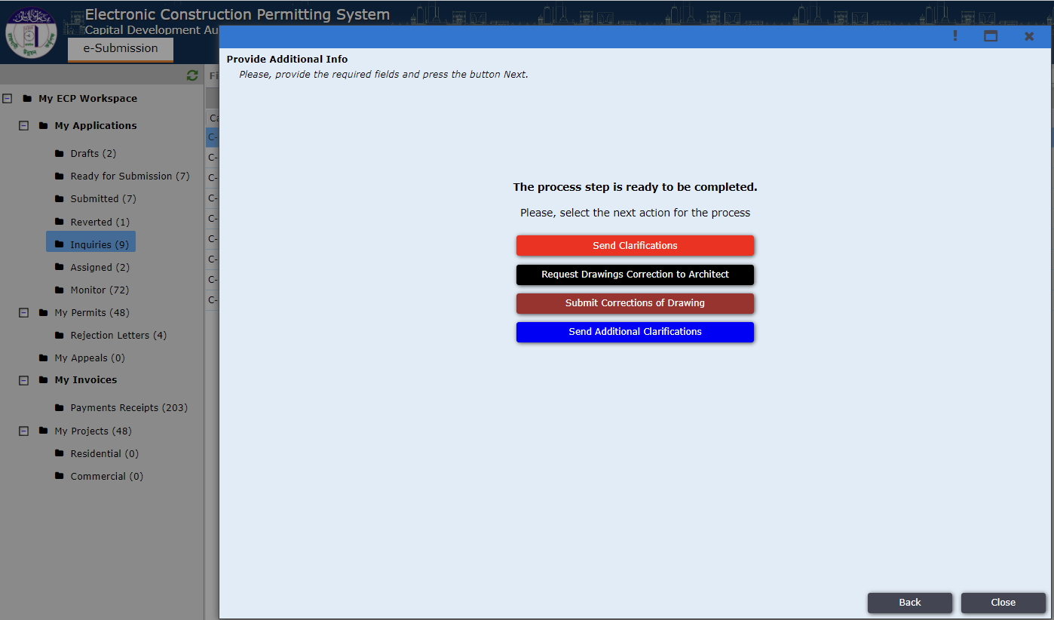
Figure 48: Submit Corrections of Drawing.

After completing all the steps if the Authorized Officer approves then a response will be sent to the applicant, it can be seen in “My Permits” as Shown in Figure: 49.
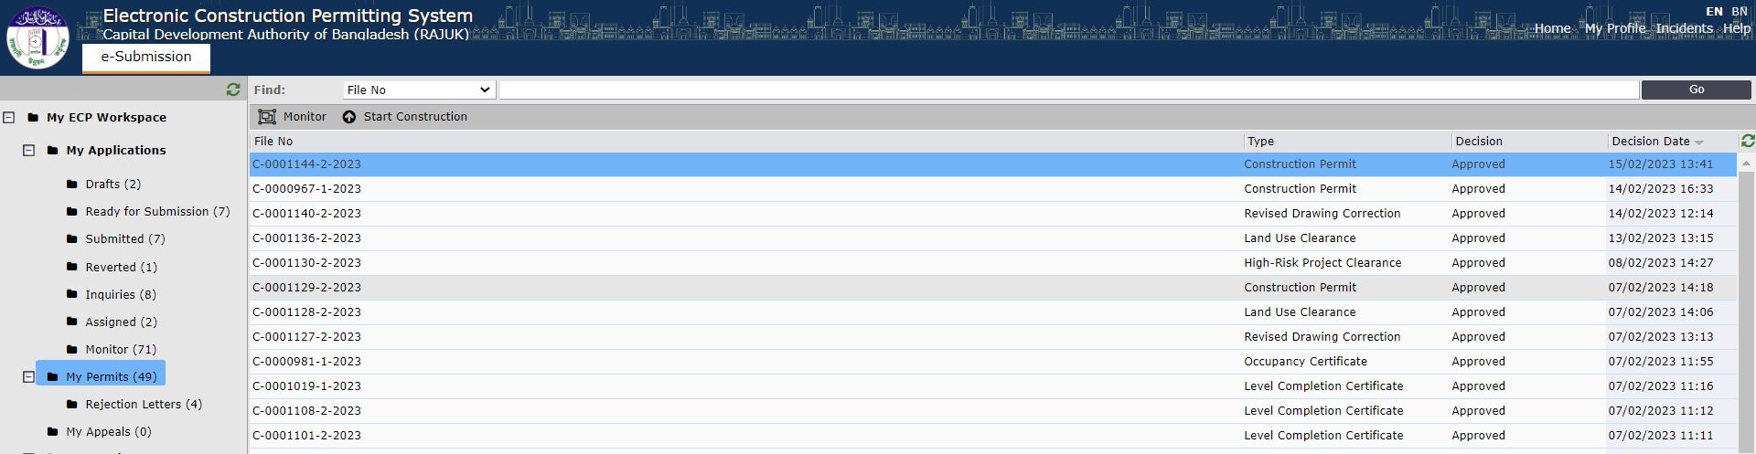
Figure 49: My Permits.

If the file is rejected it can be found in “Rejected Letters” as Shown in Figure: 50.
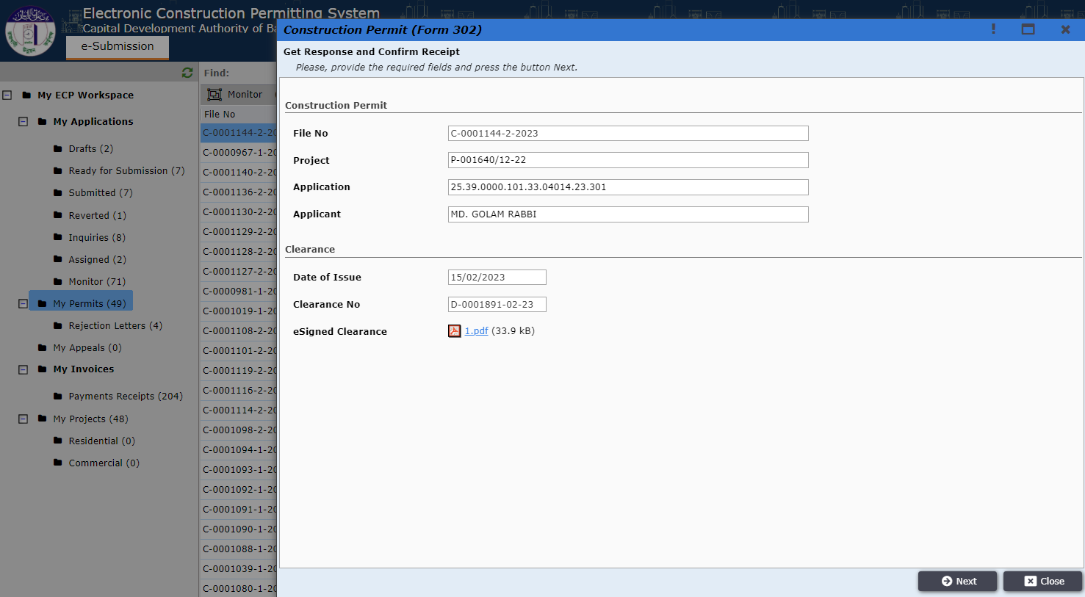
Figure 50: File details in My Permits.

Next Applicant will have to click on the button “Confirm Receipt”. Shown In Figure: 51.

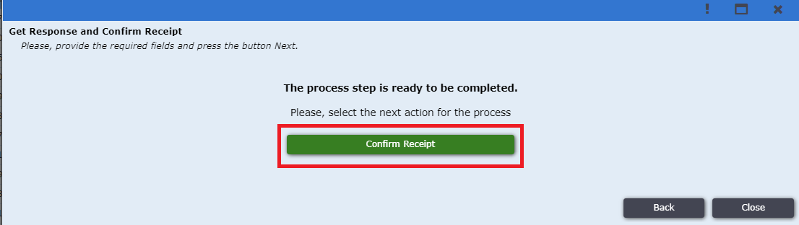
Figure 51: Confirm Receipt.

Then the process of Construction Permit has been completed successfully. “Figure: 52”.
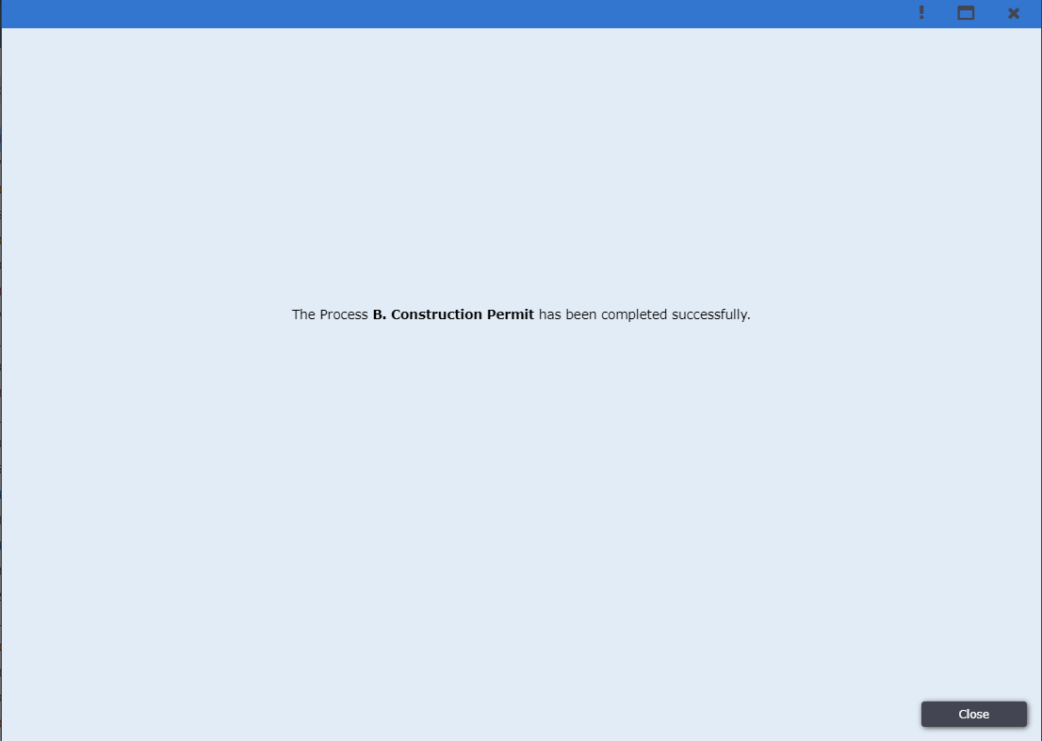
Figure 52: Construction Permit completed successfully.

