User Registration Manual (Applicant)
For Registration, go to Electronic Construction Permitting System website URL https://ecps.gov.bd/
Click “Register” on the upper right section.
As shown in Figure 1

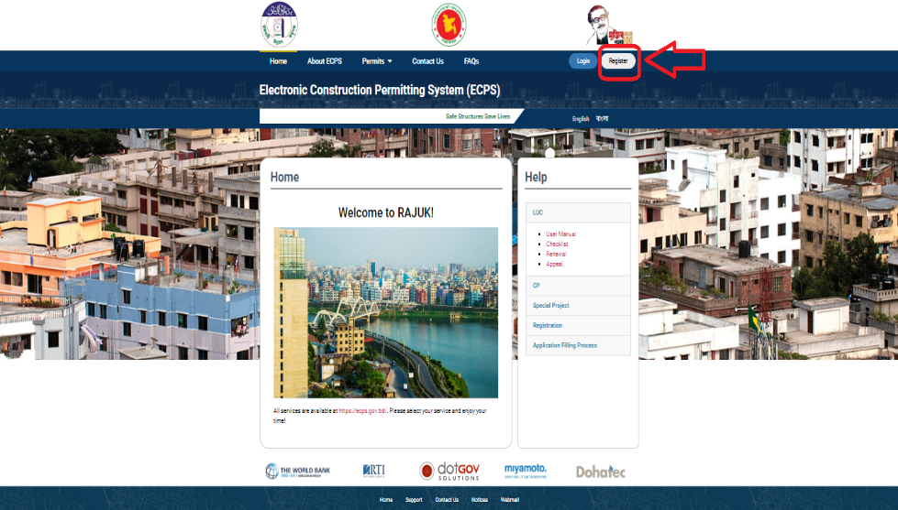
Figure 1

Click “Registration as Individual” link and the system will take the user to the registration page. As shown in Figure 2

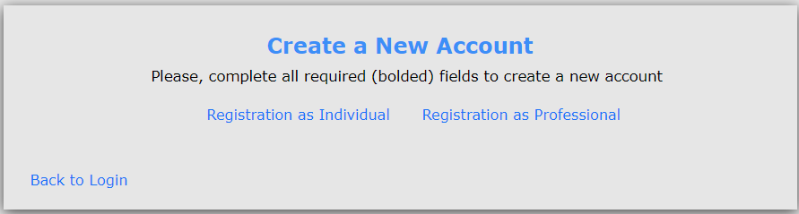
Figure 2
Enter National ID number and Date of birth and press “Verify” button. As shown in Figure 3. ECPS system will fetch data from NID database.

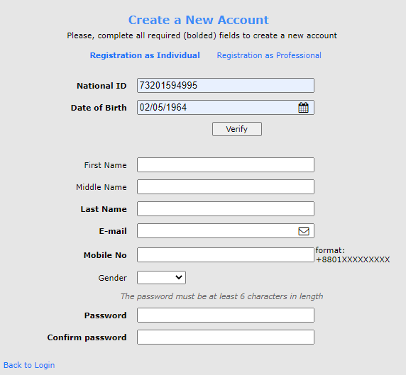
Figure 3

First Name, Middle Name, Last Name and Gender of the applicant will be fetched from NID database. As Shown in Figure 4
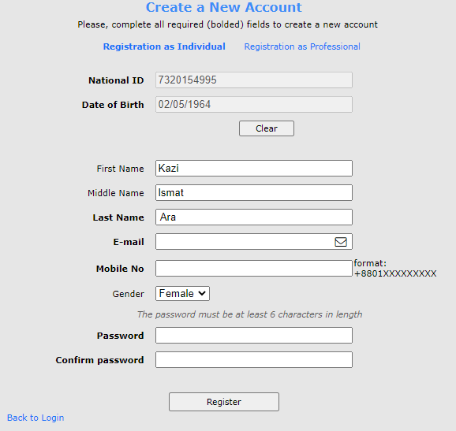
Figure 4

Applicant will have to enter his e-mail address, mobile number and password and press” Register” button. As shown in Figure 5
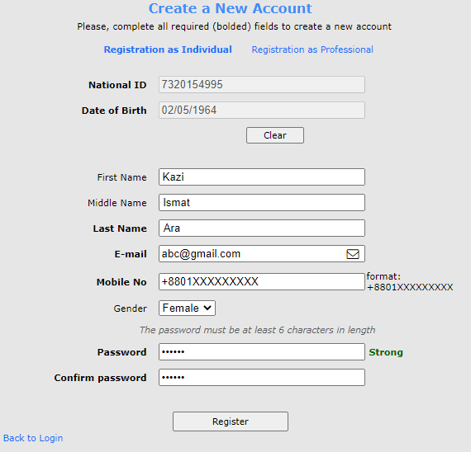
Figure 5

An automatic mail will be sent to the applicants e-mail address and the System will display a message saying the account has been created. As shown in Figure 6
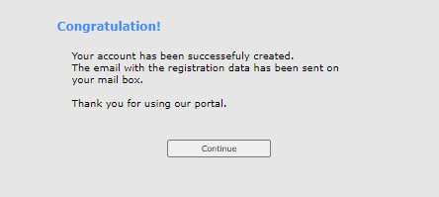
Figure 6

