User Registration Manual (Professional)
For Registration, go to Electronic Construction Permitting System website URL https://ecps.gov.bd/
Click “Register” on the upper right section.
As shown in Figure 1

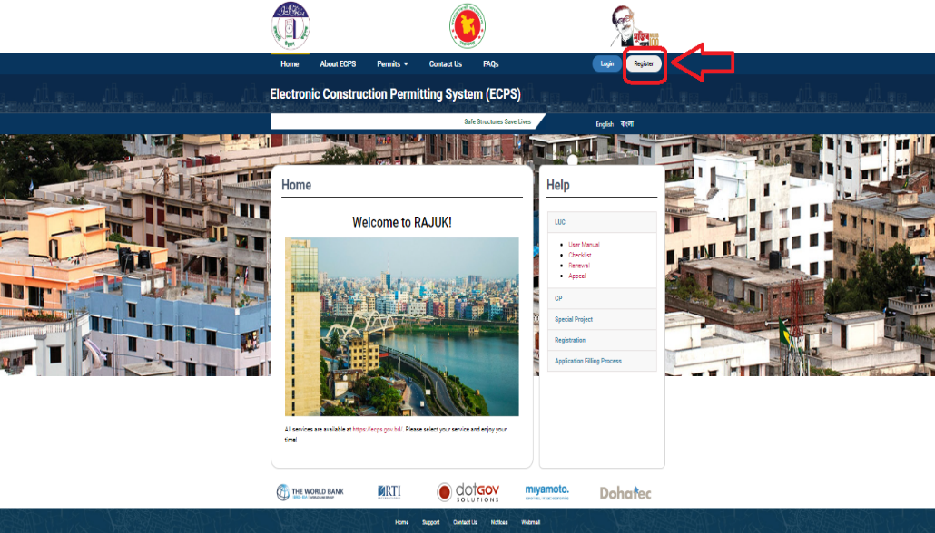
Figure 1

Click “Registration as Professional” link and the system will take the user to the registration page. As shown in Figure 2

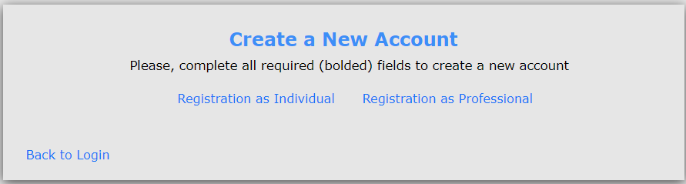
Figure 2

Enter Membership Number and select Role Types (Architects, Structural Engineer, Mechanical Engineer, Electrical Engineer, Plumbing Engineer, Fire Safety Specialist) and press “Verify” button. As shown in Figure 3. ECPS system will fetch data from their corresponding institution’s database.

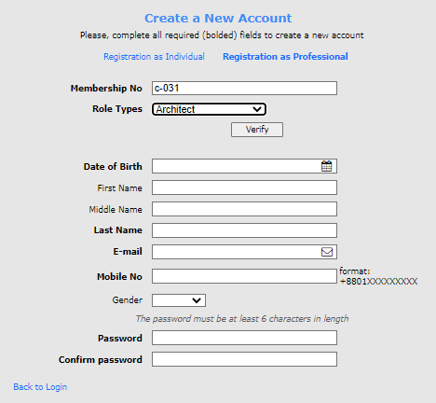
Figure 3
First Name, Middle Name, Last Name, Gender, E-mail and Mobile Number of the professional will be fetched from their corresponding institution’s database. As Shown in Figure 4
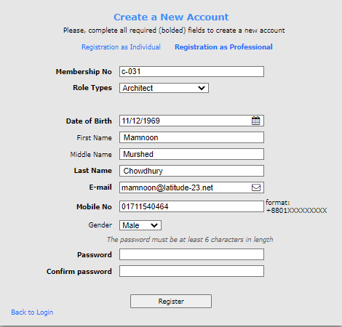
Figure 4

Professional will have to enter his password and press “Register” button. As shown in Figure 5
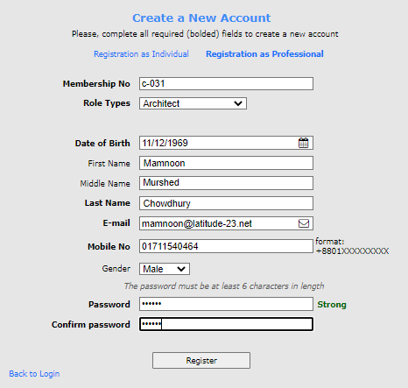
Figure 5
An automatic mail will be sent to the professional’s e-mail address and the System will display a message saying the account has been created. AS shown in Figure 6

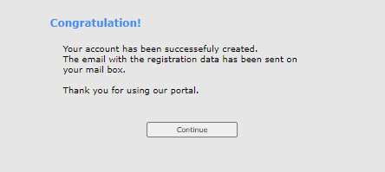
Figure 6

