SP PROCESS MANUAL
Director Development Control (DDC) accesses the Electronic Construction Permitting System Portal using the URL https://ecps.gov.bd/ and then clicking on “Login” button. Then DDC will login to the system using his/ her username and password. Director Development Control (DDC) receives the application when the Front desk assistant accepts the application. Director Development Control will find the application in the Incoming section. Incoming files are sorted from Recent to Oldest. DDC will have to click on the Application he wants to proceed with. As shown in Figure 1.

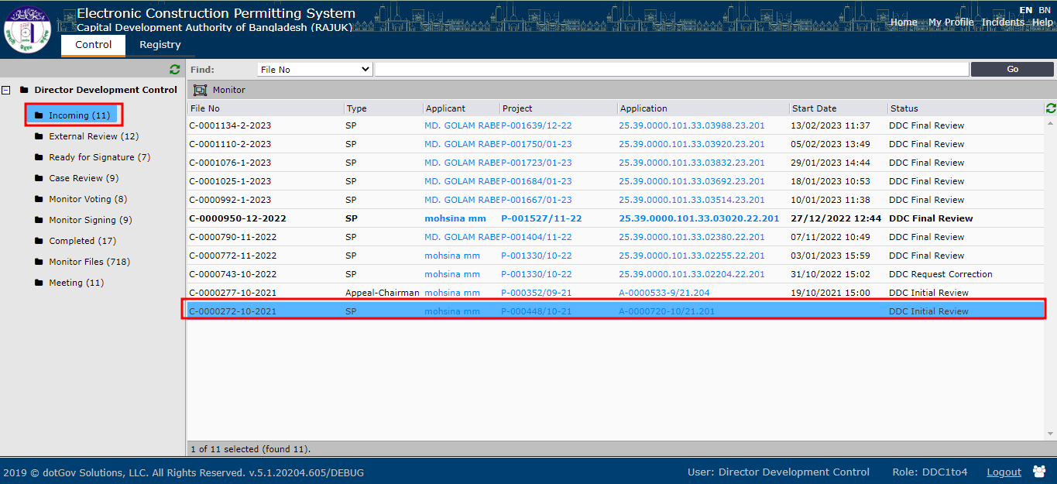
Figure 1

A new pop-up window will appear when DDC clicks on any incoming application. DDC will have access to five different tabs Assignments, Staff Reviews, Committee, Attachments, Applicants’ Clarifications and History. DDC will check all the available information of the application. DDC can check applicant’s details information by clicking on the Applicant name link as shown in Figure 2.
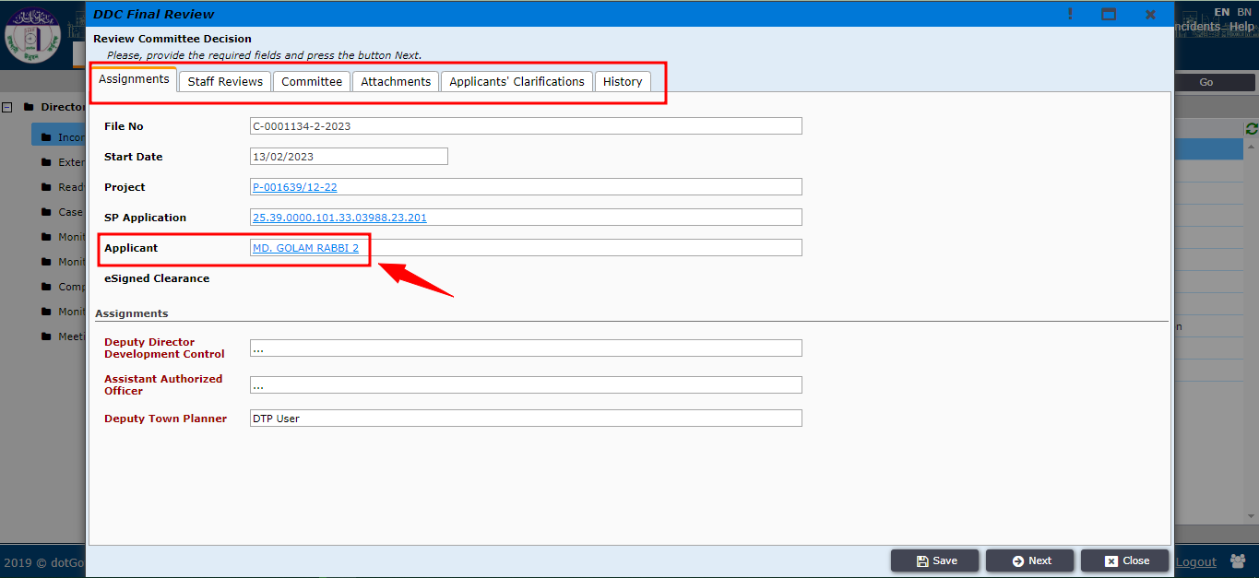
Figure 2

After clicking on the link a pop-up will show up containing applicant’s details. DDC user can close it by clicking on the “Close” button as shown in Figure 3.
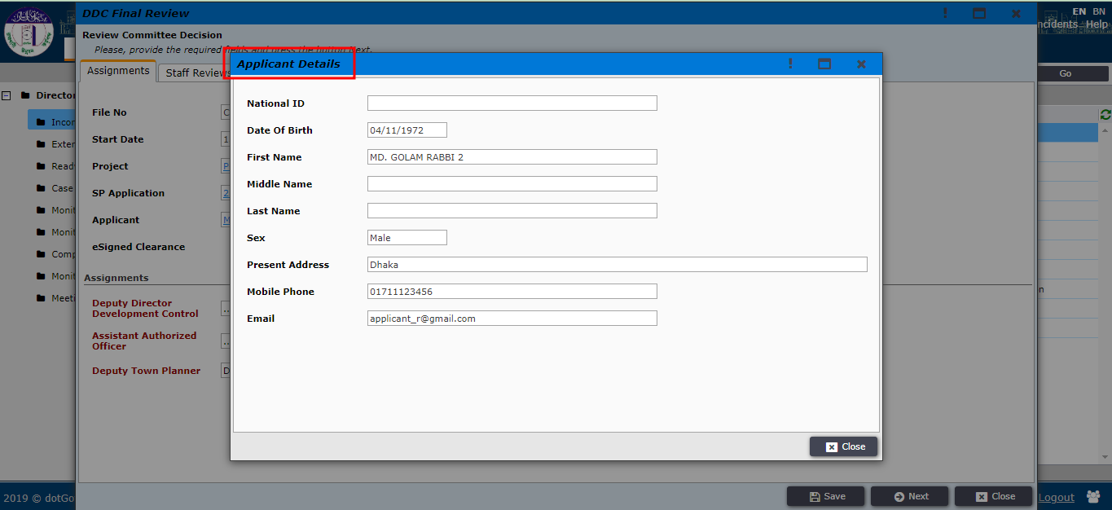
Figure 3
DDC can click on the project link to see the details of the main project as shown in Figure 4.
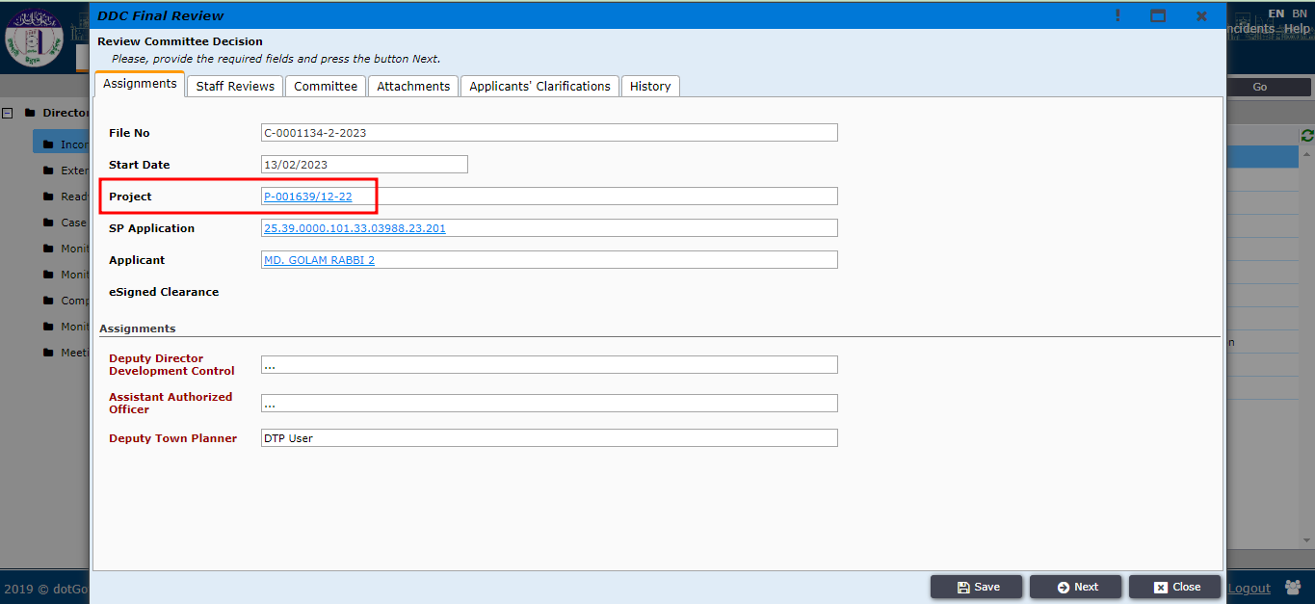
Figure 4

After clicking on the project link the project details window will pop-up as shown in Figure 5.
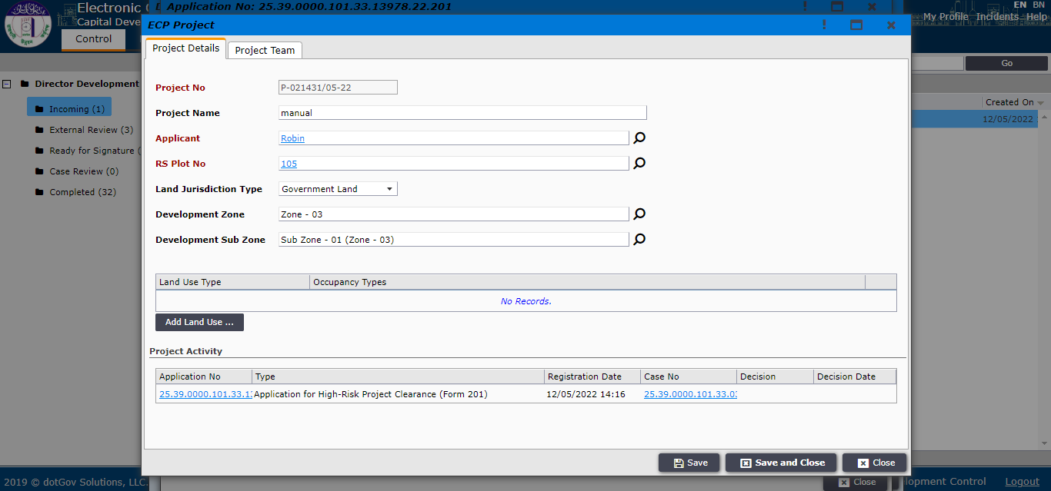
Figure 5
Director Development Control (DDC) can select Deputy Director Development Control (DDDC) by clicking on the search button as shown in Figure 6.
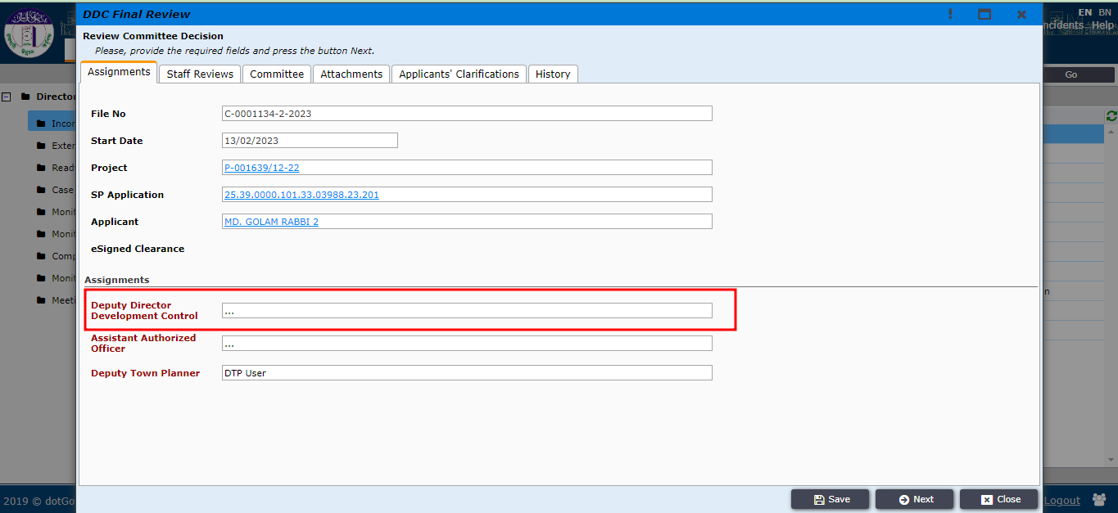
Figure 6

After clicking on the search button the DDC will select the specific DDDC from the pop-up window as shown in Figure 7 and click “Close” after selecting the DDDC.
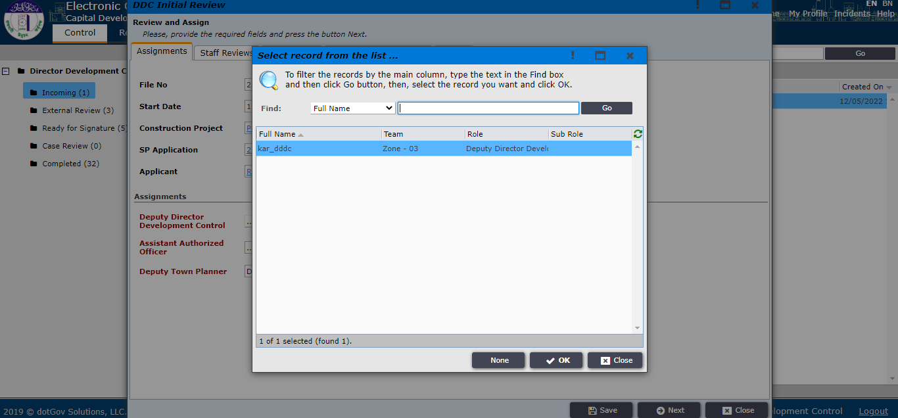
Figure 7
After checking all the tabs DDC will go to the Staff Review tab to put his Initial Review comments and also can attach some files if necessary. Then press ‘Next’ as shown in Figure 8.
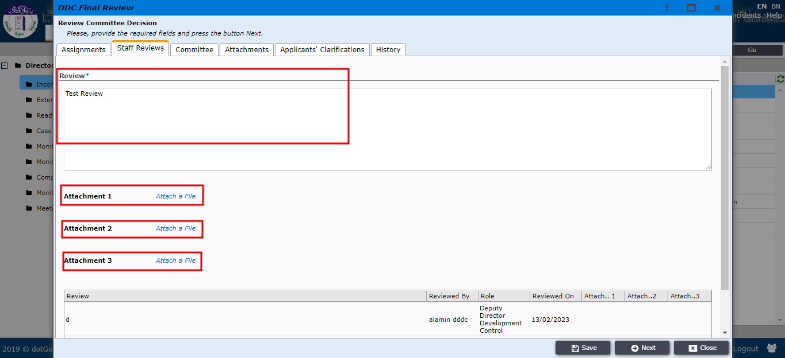
Figure 8
DDC will now find the option Assign to Deputy DDC as shown in Figure 9 and click on it. The application will be sent to DDDC.
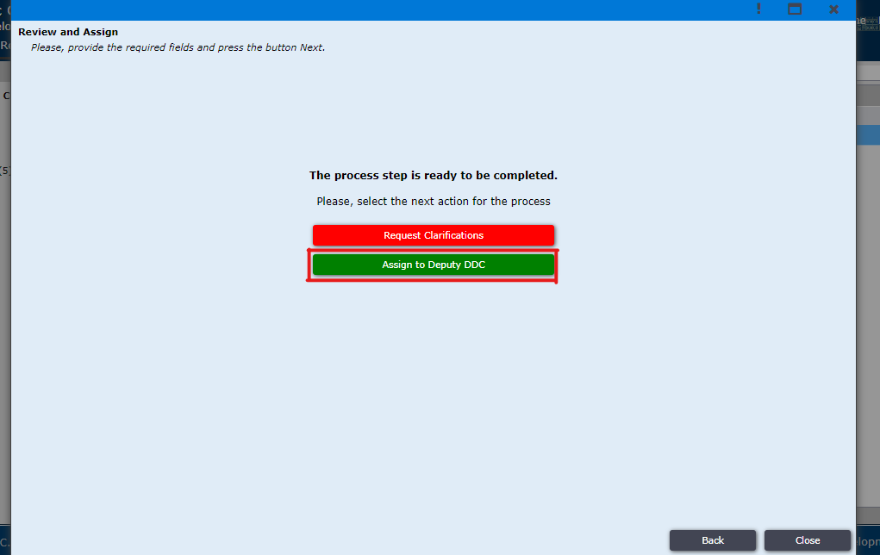
Figure 9
DDDC logs in in the ECP system and in his dashboard all the incoming applications will be found in the Incoming tab. As shown in Figure 10
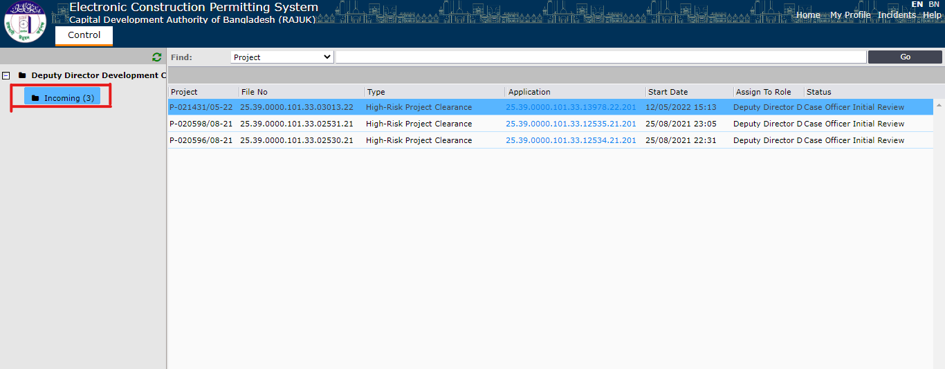
Figure 10
DDDC clicks on the application and the pop-window will open as shown in Figure 11. DDDC will be able to view the tabs Assignments, Staff Reviews, Attachments, Applicant’s Clarifications and History. The tab information is shown in Figure 11, 12, 13, 14 and 15.
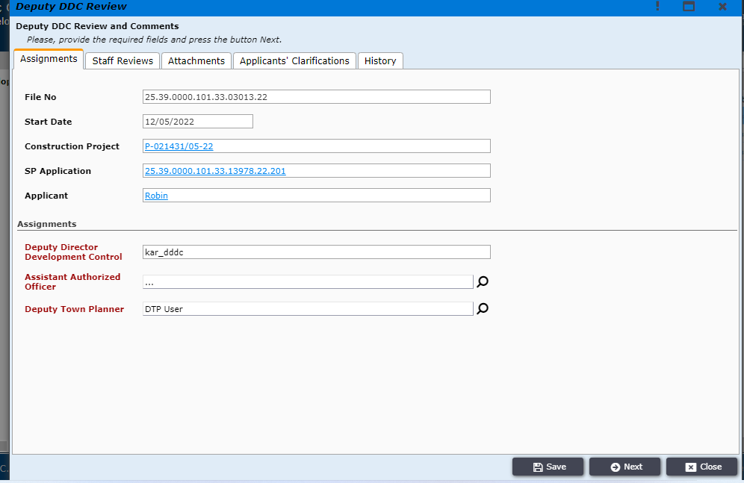
Figure 11

The DDDC can provide his/her review in the staff review tab which is shown in figure 12
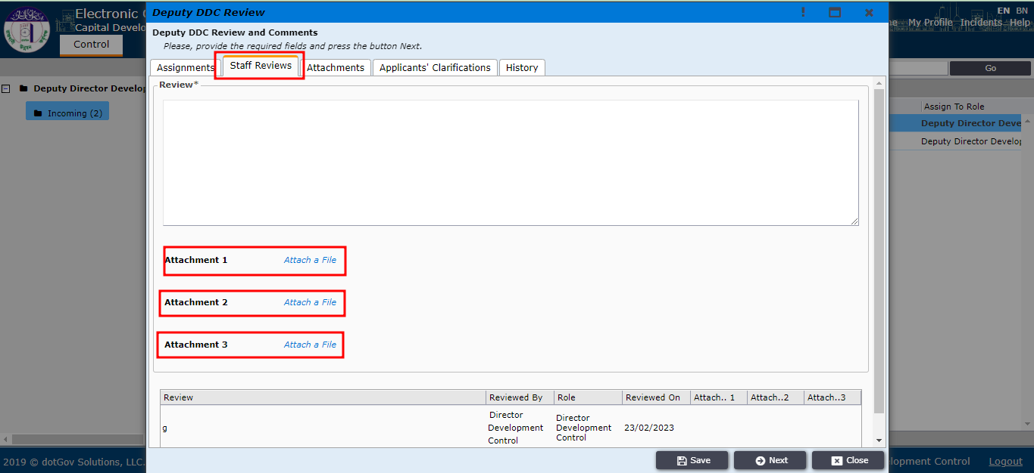
Figure 12
The DDDC can check the attachments in the Attachments tab and also add new if he/she needs to.
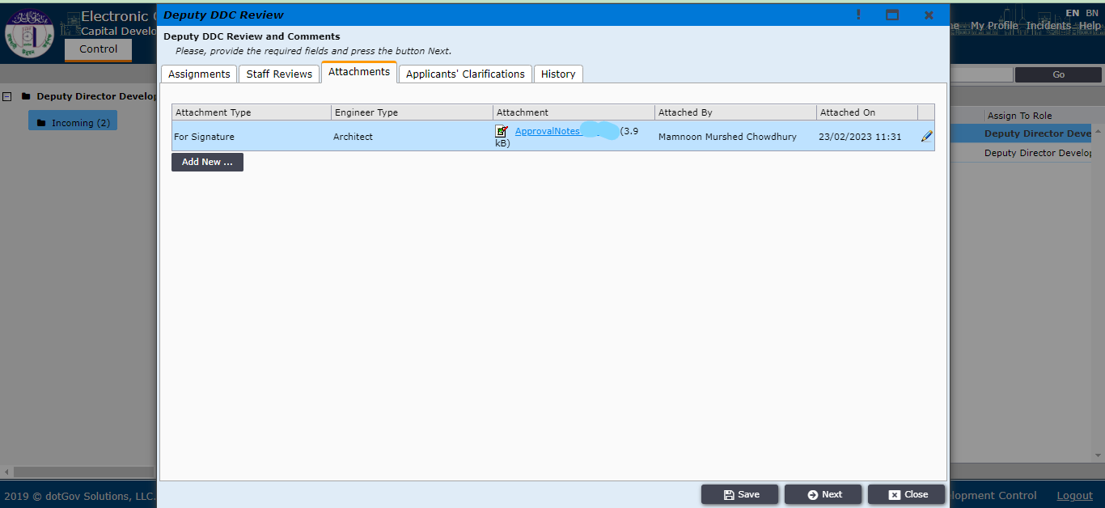
Figure 13
The DDDC can check whether there are any applicant’s clarifications on the Applicant’s Clarifications tab which is shown in figure 14.
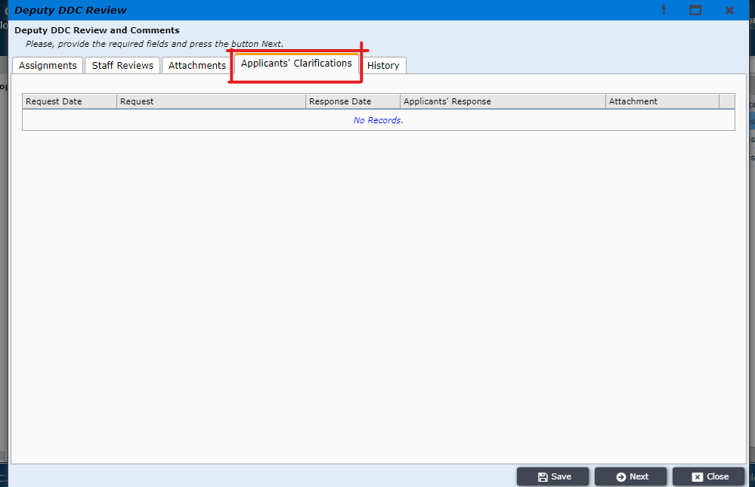
Figure 14
The DDDC can check the history on the history tab which is shown in figure 15.
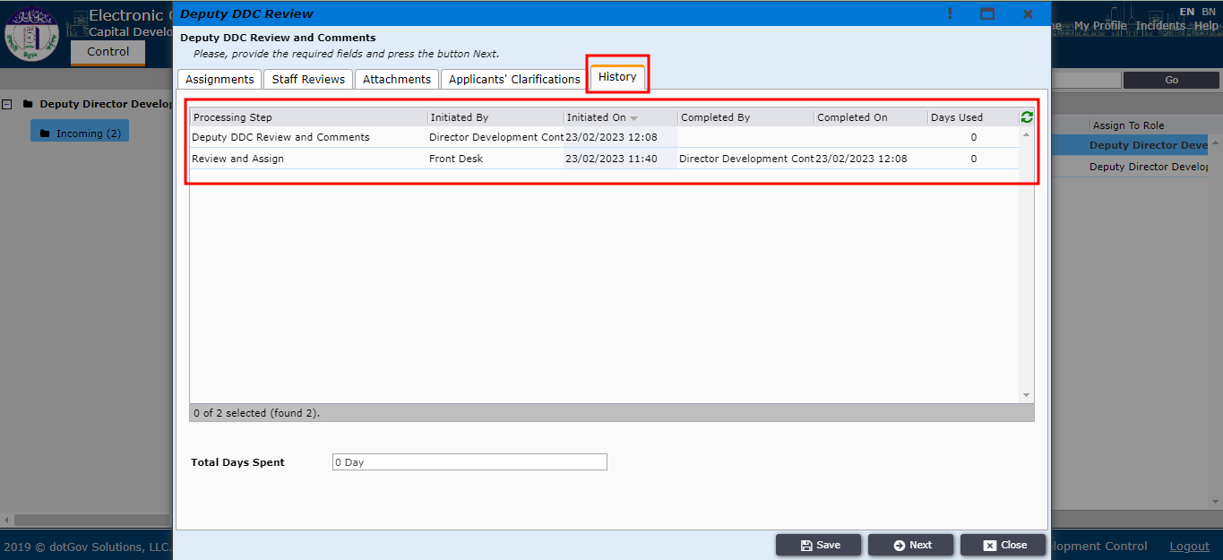
Figure 15
After clicking on the project link as shown in Figure 16, the project details window will pop-up as shown in Figure 17.
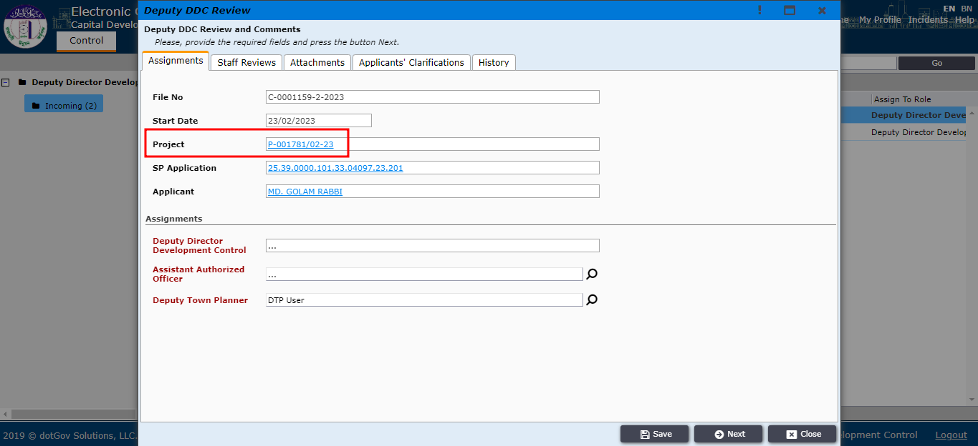
Figure 16
Here in as per figure 17 the DDDC can check the product activity
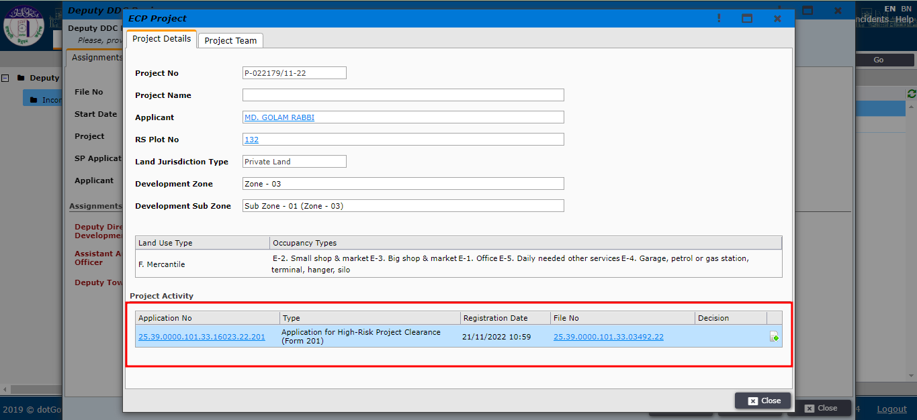
Figure 17
The DDDC has to assign Assistant Authorized Officer (AAO) and Deputy Town Planner (DTP) as per figure 18.
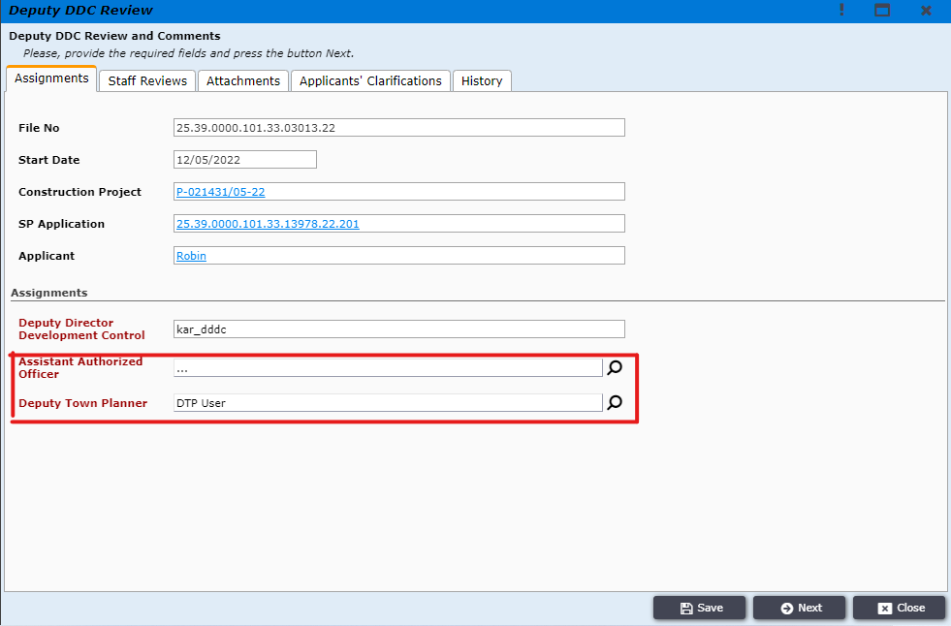
Figure 18

The DDDC will select its desired AAO and click Ok to select. It is shown in figure 19.
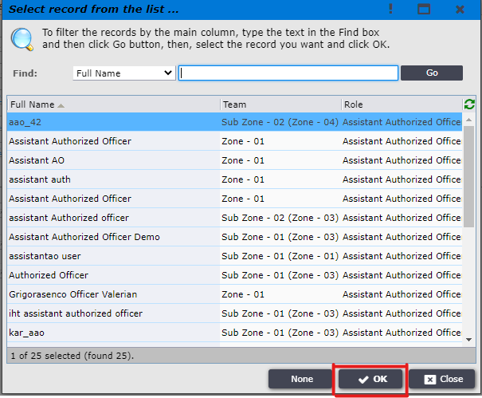
Figure 19
The DDDC will select its desired DTP and click Ok to select. It is shown in figure 20.
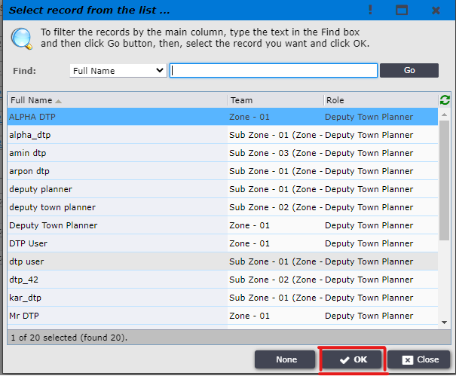
Figure 20

After filling up the desired field the DDDC needs to click on Next.
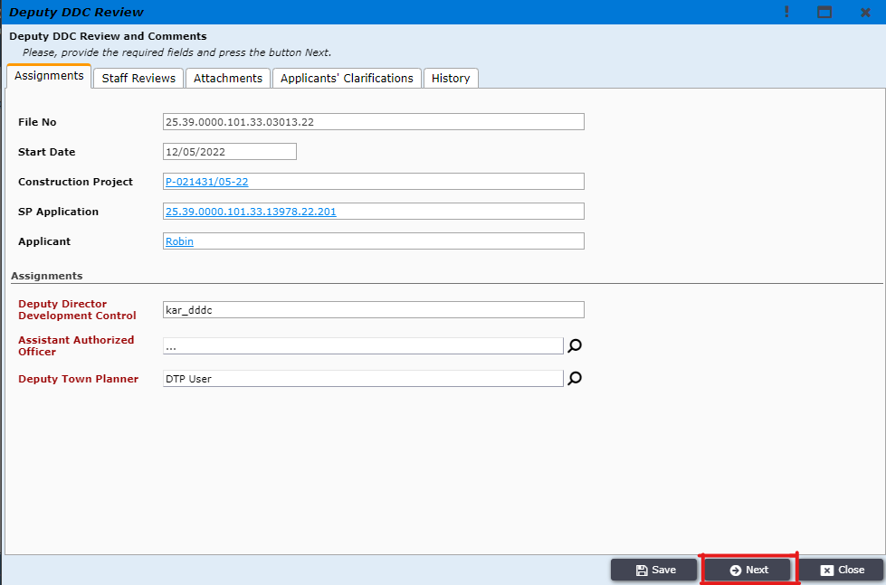
Figure 21
DDDC can now either submit the file to DDC through clicking Submit Review or can send the file to AAO for further review by clicking Request AAO Review or can revert the file to DDC by using Revert to DDC button. If DDDC clicks on Request AAO Review the file will go to AAO as per Figure 22.

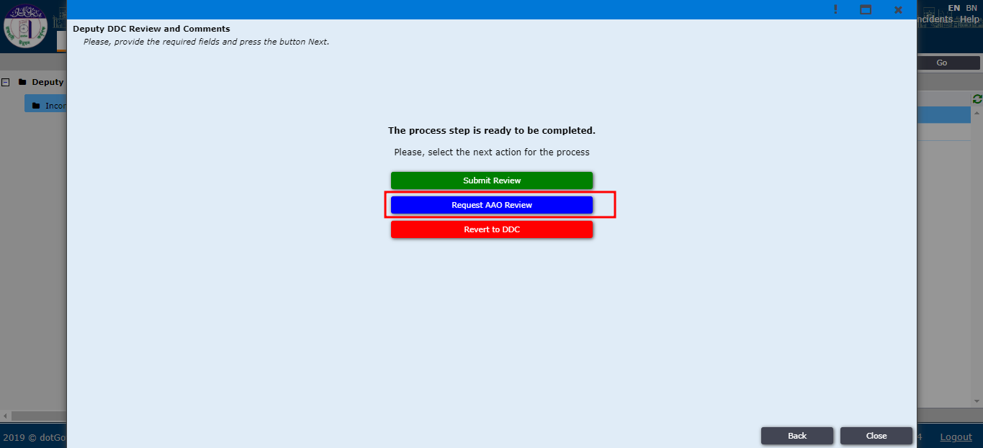
Figure 22
Assistant Authorized Officer (AAO) receives the application in his Incoming folder as shown in the image Figure 23.
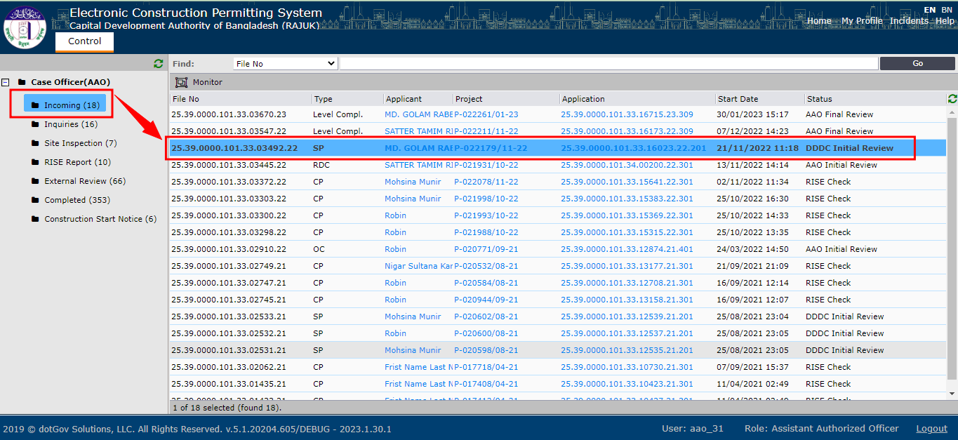
Figure 23
The AAO has access to Assignment tab. There he can check the project activity by clicking on the project. We can see that in figure 24. 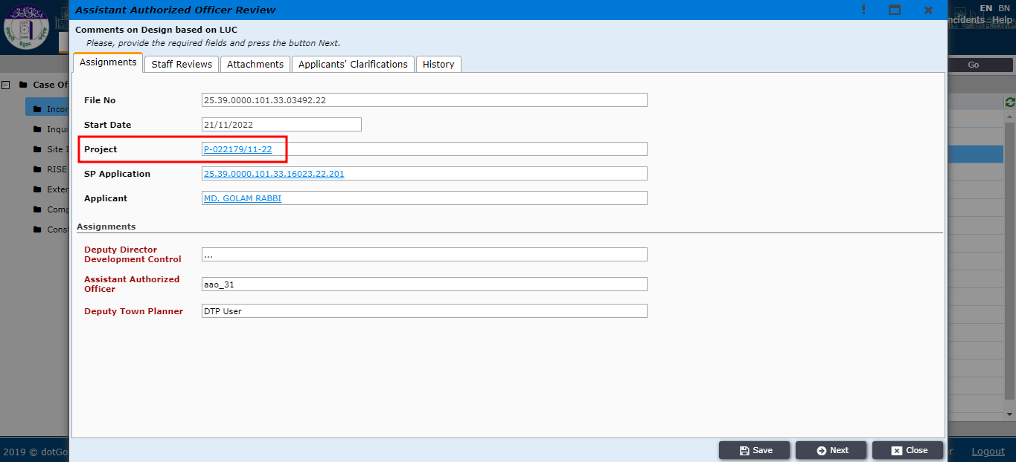
Figure 24

On the staff review tab the AAO can check DDC and DDDC’s review and afterwards give his own review as shown in figure 25.
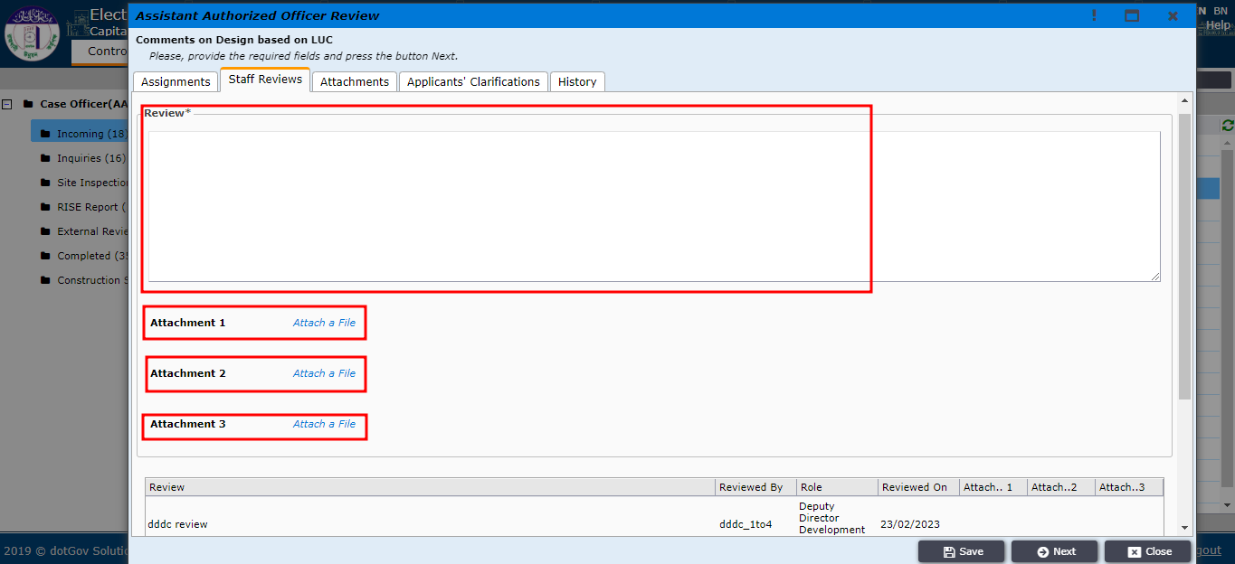
Figure 25

On the Attachment tab the AAO can add new attachments as shown in figure 26.
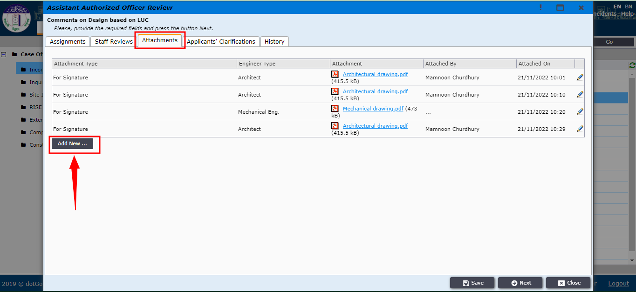
Figure 26

On the Applicant’s Clarifications tab the AAO can check if there is any clarification by the applicant. It is shown in figure 27.
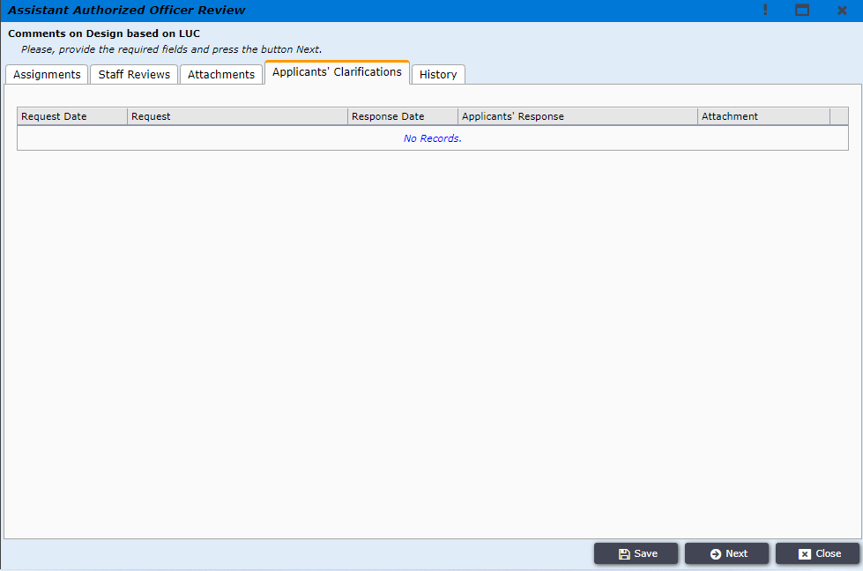
Figure 27

On the History Tab the AAO can see the whole history of this application as per figure 28.

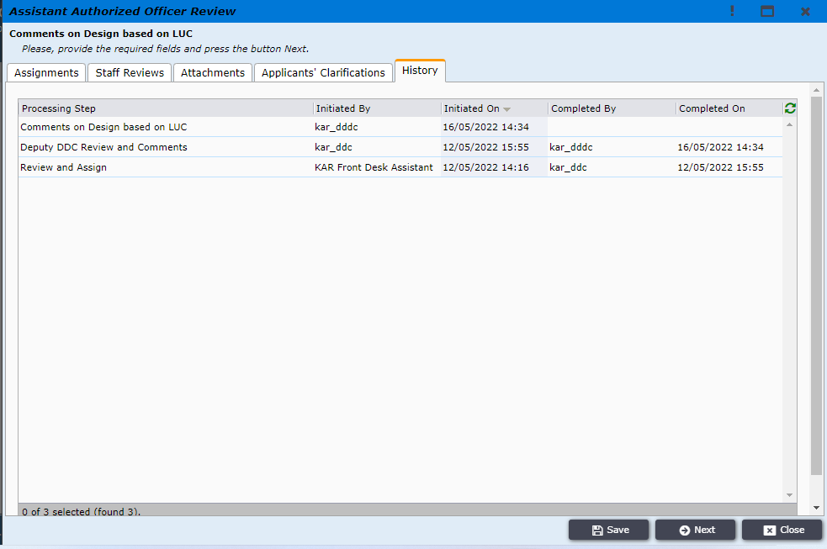
Figure 28

After going through all the tabs and giving AAO’s own review, the AAO will click on Next as per figure 29.
Figure 29

By clicking on Submit review AAO will send the file back to DDDC.
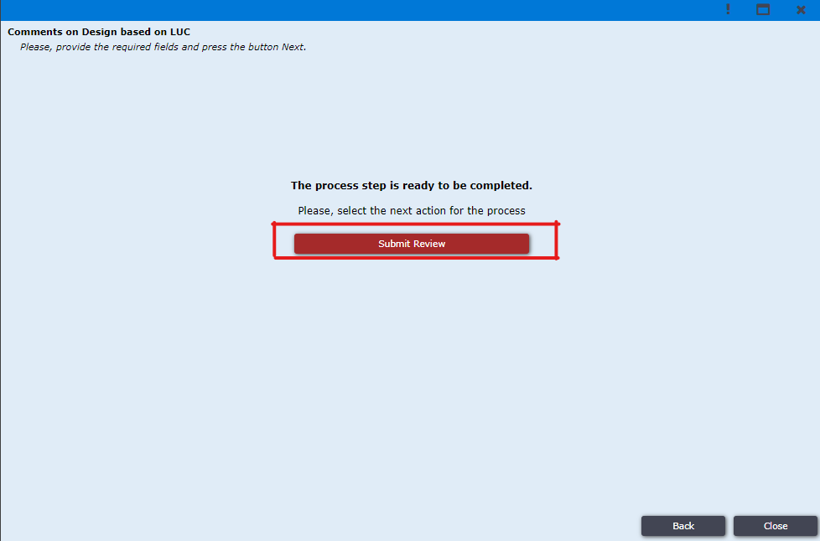
Figure 30
The file will now go back to DDDC again and the DDDC will find the file in the Incoming section as per figure 31.
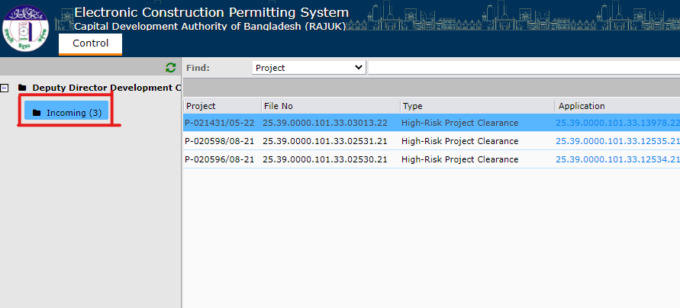
Figure 31
Like before DDDC can go through all the tabs including Assignments, Staff Reviews, Attachments, Applicants Clarifications and History. The DDDC can now also check the review just given by the AAO which is shown in figure 32.
Figure 32

By clicking on Submit Review the file will now go to Director Development Control (DDC) which is shown in figure 33.
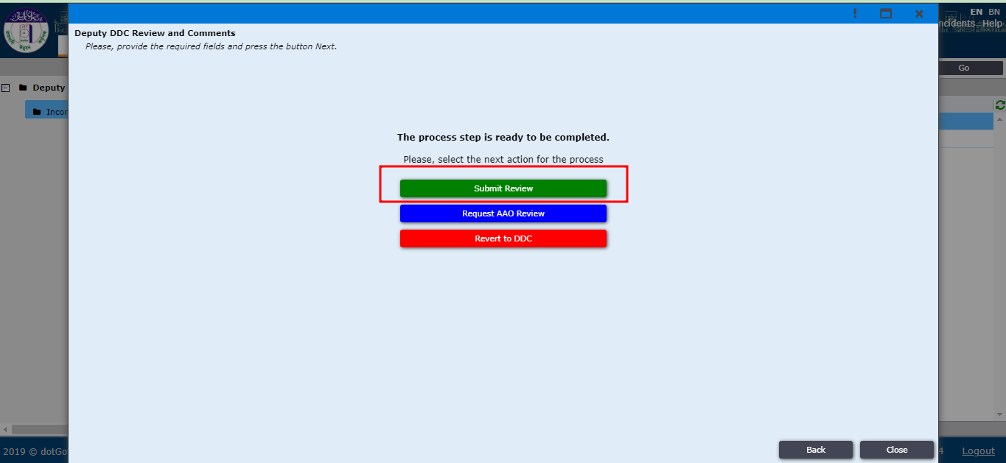
Figure 33
Director Development Control (DDC) will find the file now in the Incoming Section which is shown in figure 34.
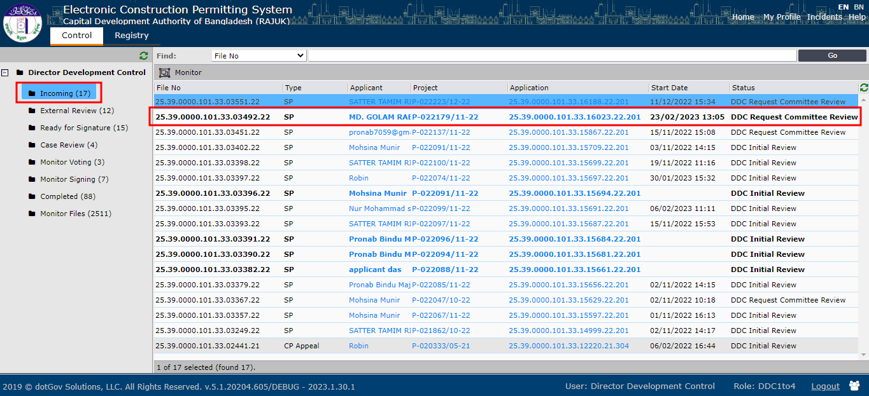
Figure 34
By clicking on Send Back to Deputy DDC the file will go back to DDDC which is shown in Figure 35

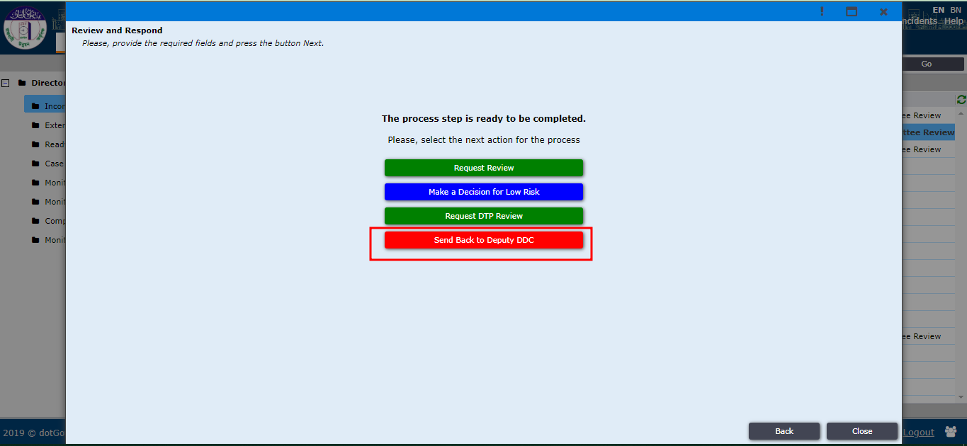
Figure 35

By clicking on Request DTP Review the file will be passed to Deputy Town Planner (DTP) which is shown in Figure 36.
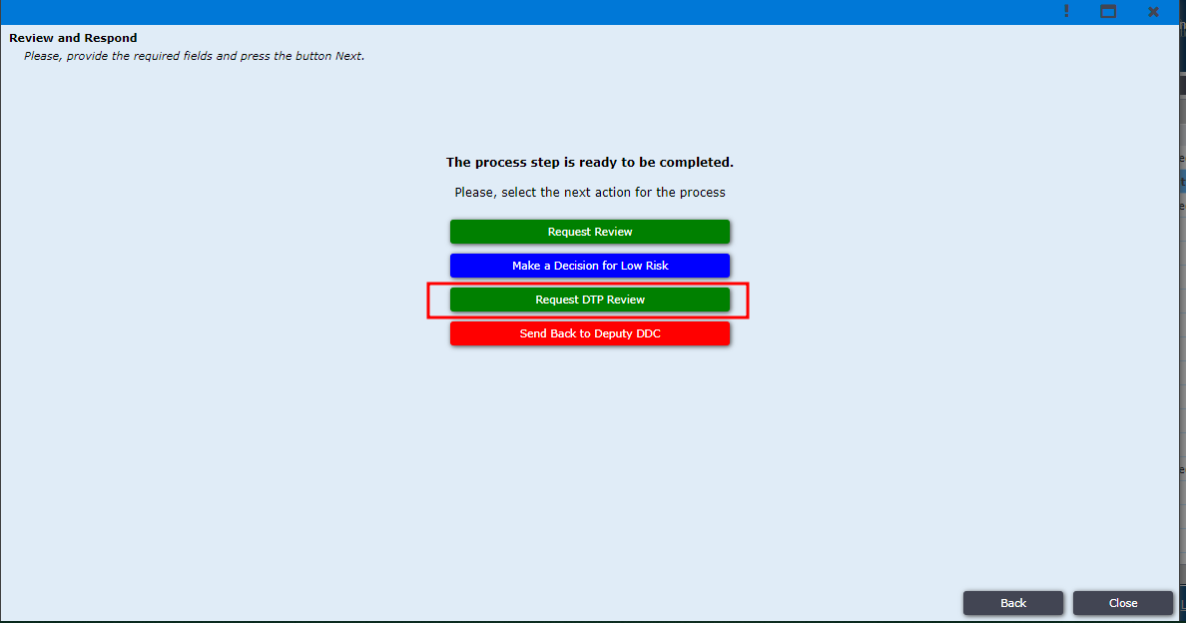
Figure 36

Deputy Town Planner (DTP) will receive the file in the Incoming section as shown in Figure 37.
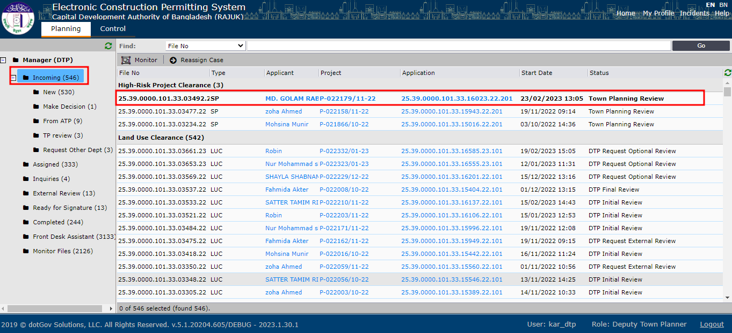
Figure 37

DTP will have access to all the 5 tabs just like DDC, Deputy DDC and AAO. He can also add attachments on the Attachments tab, he can check if there is any applicants clarifications on the applicants’ clarifications tab and check the history of this file in the history tab which is shown in figure 38.

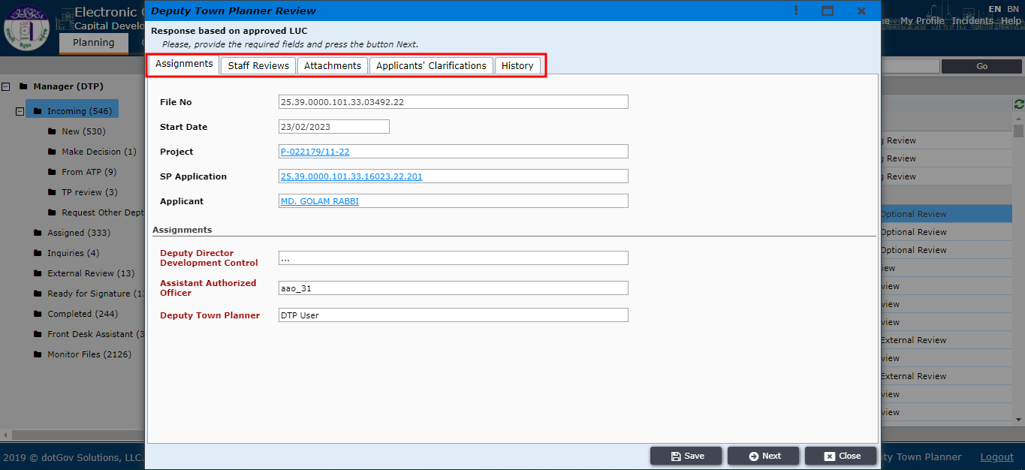
Figure 38

Deputy Town Planner (DTP) can check the reviews of other staff. Afterwards he will give his own review in the Deputy Town Planner Review tab which is shown in figure 39.
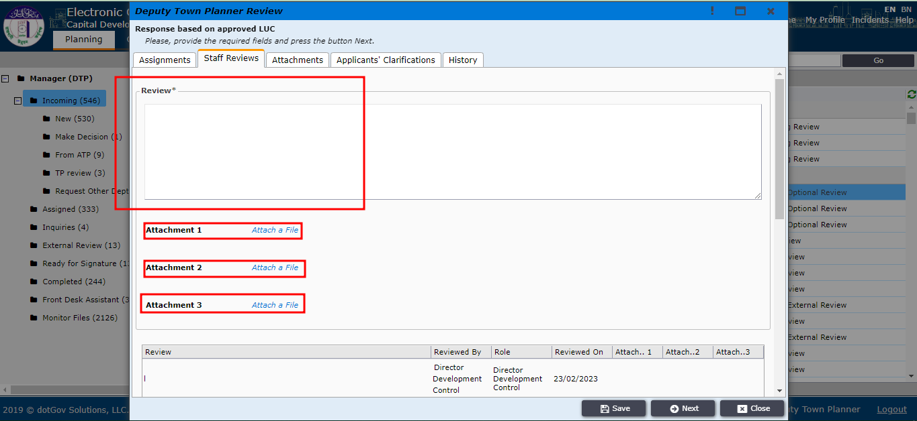
Figure 39
After checking everything and giving his own review DTP will now select next as per figure 40.
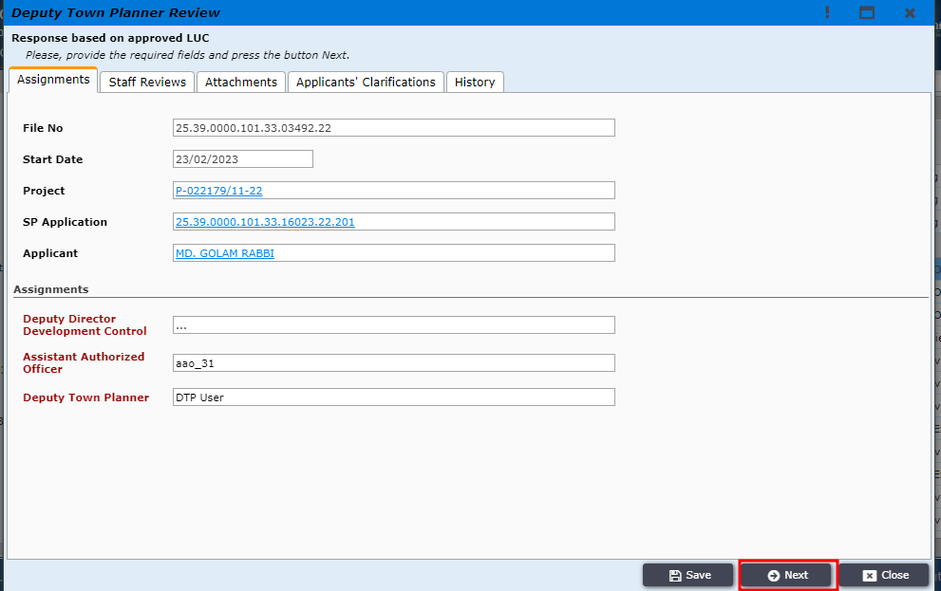
Figure 40

DTP will now find the option Submit Review as shown in Figure 41 and click on it.
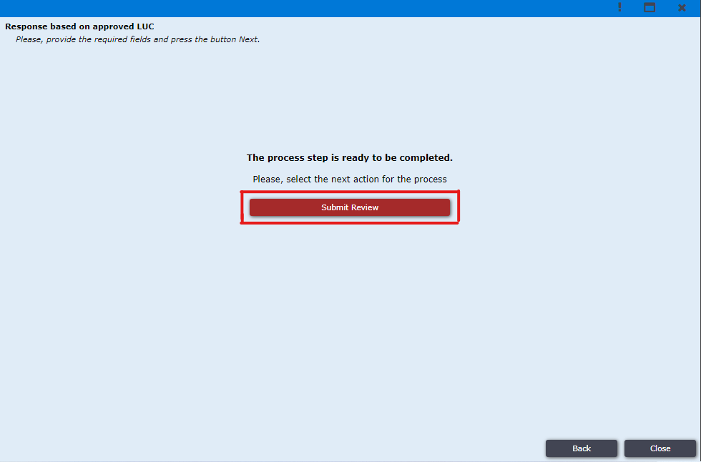
Figure 41
Director Development Control (DDC) will receive the file in the Incoming section which is shown in figure 42
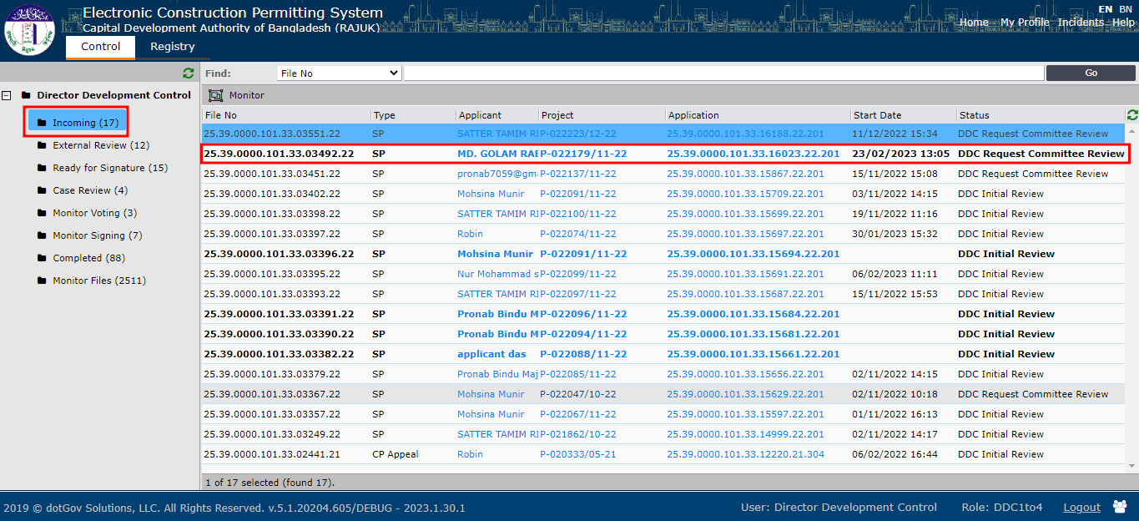
Figure 42
Director Development Control (DDC) will open the file. He will have access to all the 5 tabs like before. He can also check all the reviews given by all the staff which is shown in figure 43.
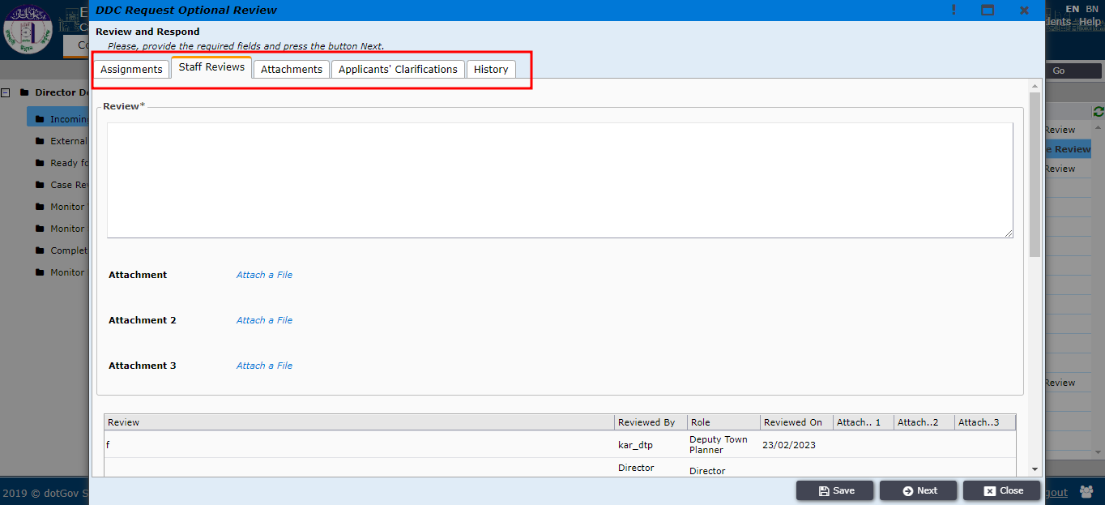
Figure 43

After checking everything DDC will now click on Next which is shown in figure 44.
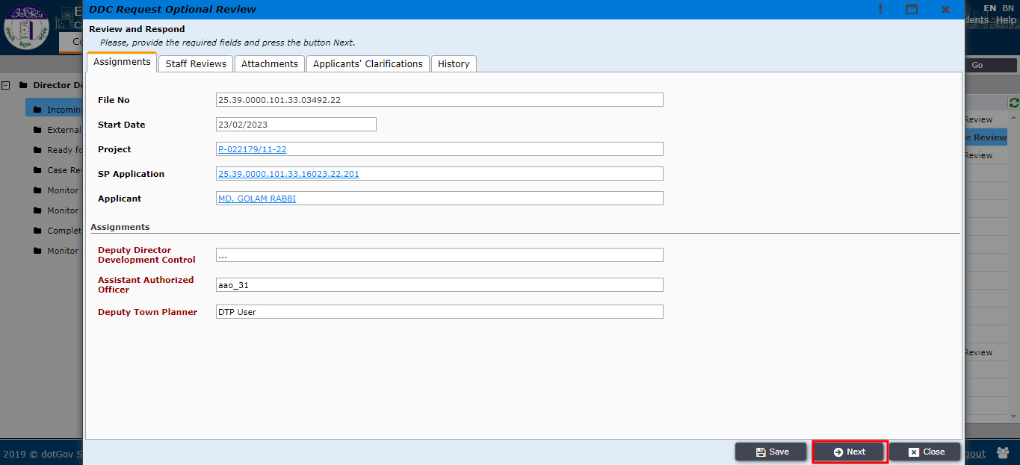
Figure 44

DDC take decision to approve or reject the application by clicking on Make a Decision for Low Risk. Which is shown in figure 45.
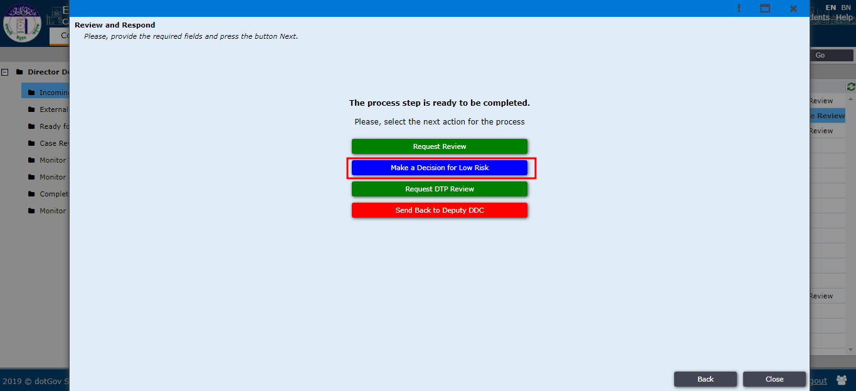
Figure 45

By clicking on Request Online Review, DDC will now send the file to Special Project Committee Reviewer which is shown in figure 46.
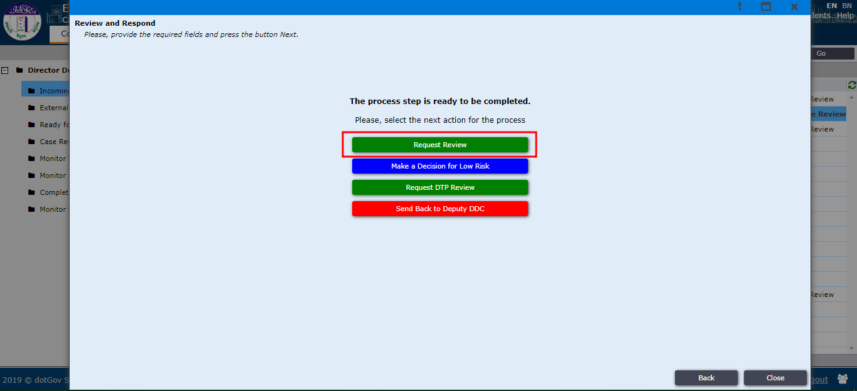
Figure 46

(DDC can create meeting by click on Meeting option (Figure 46.1) then he/she will click on New. Then meeting tab will open, then he will write the Committee name, Start date, Actual date, Close date, Status and click on save and close button(Figure 46.2)).
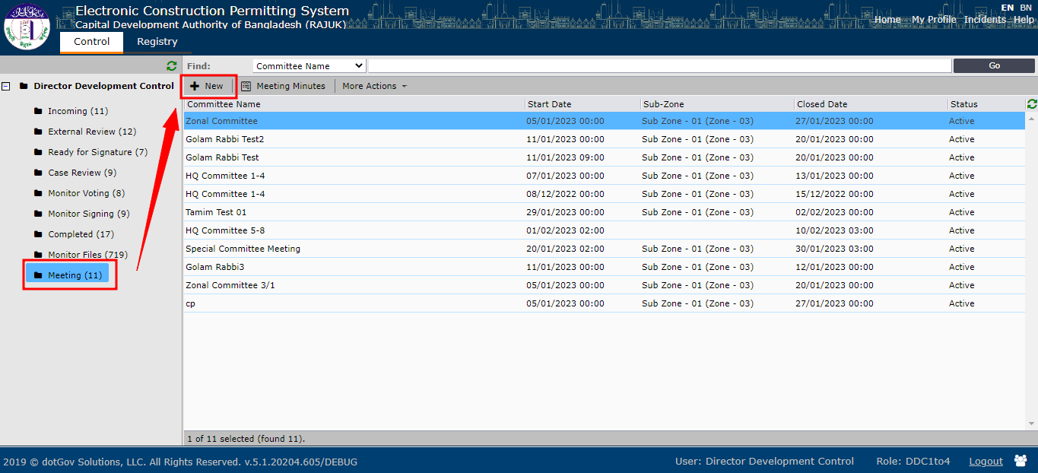
Figure 46.1
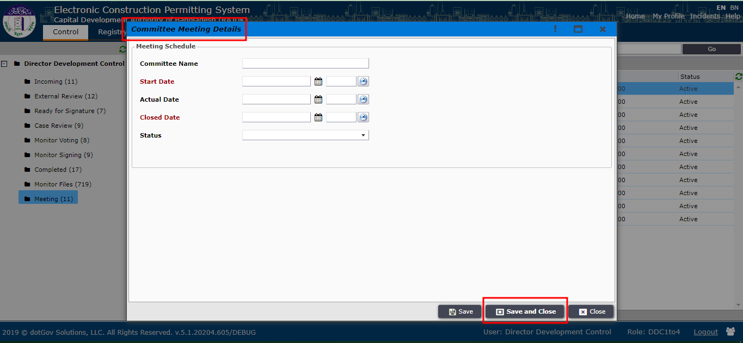
Figure 46.2

Now DDC will add the application file in a SP-Committee meeting. DDC will click on application from incoming section then DDC assign Meeting by click on Meeting ID (Figure 47)
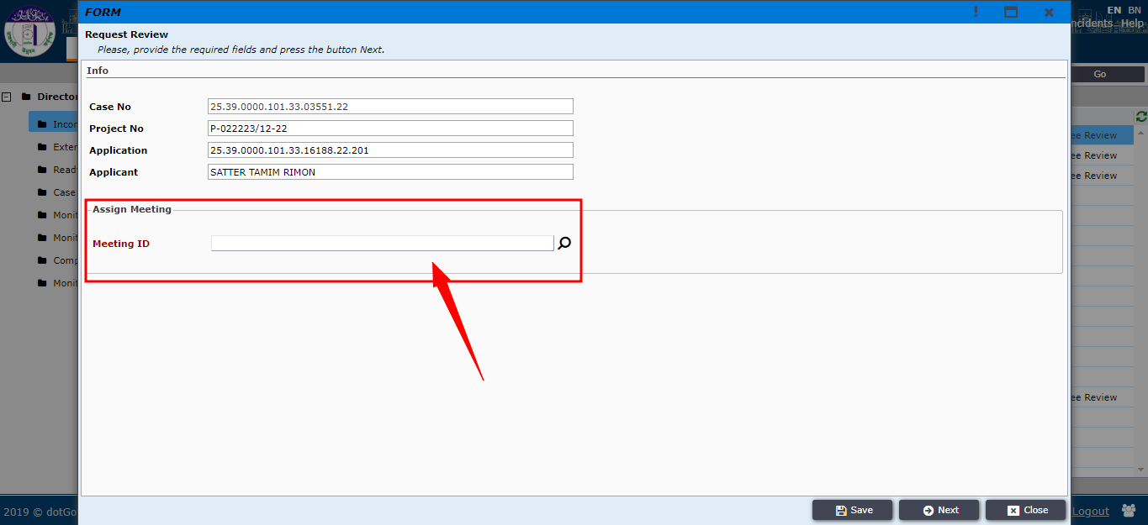
Figure 47

Then DDC will select meeting and click on ok button. Then DDC will click on Next button (Figure 48). Then DDC can see the Meeting Info, Committee Member. Then DDC will click on Next button (Figure 49)
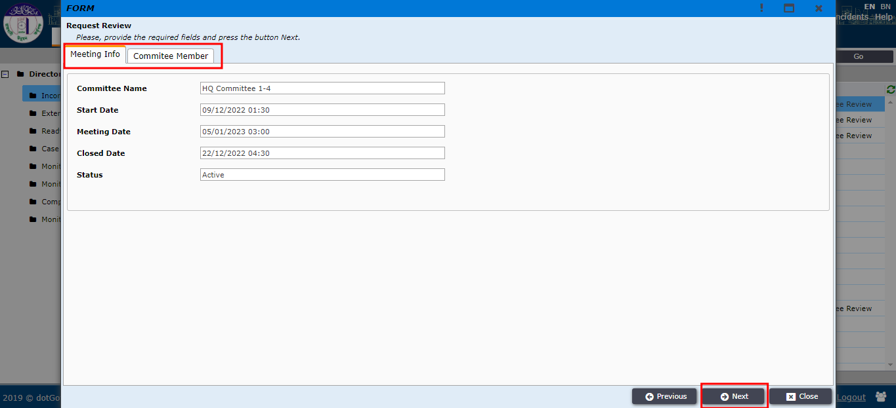
Figure 49

Special Project Committee reviewer member will receive the file in the External Review section which is shown in figure 50.
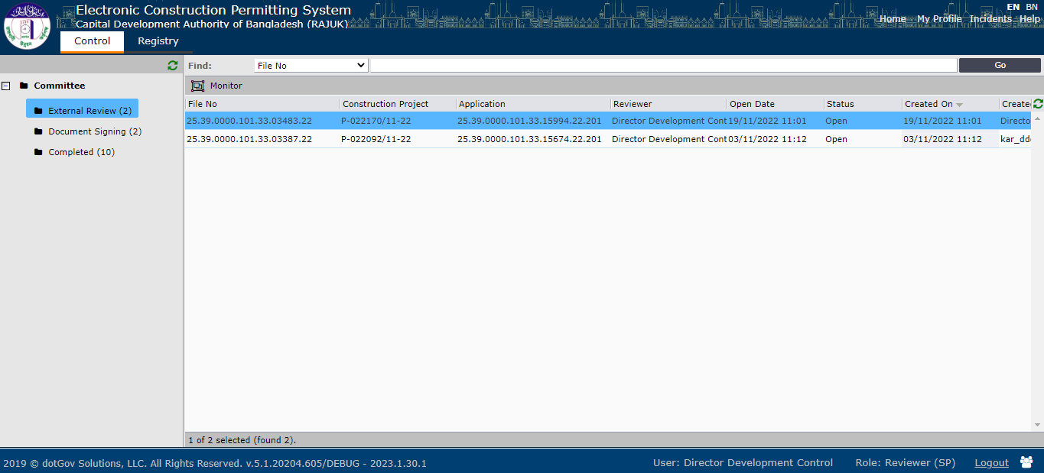
Figure 50

Reviewer will have access to four tabs which are Assignments, Staff Reviews, Attachments and Applicant’s Clarification. He can go through all the tabs and check everything which is shown in figure 50.1.
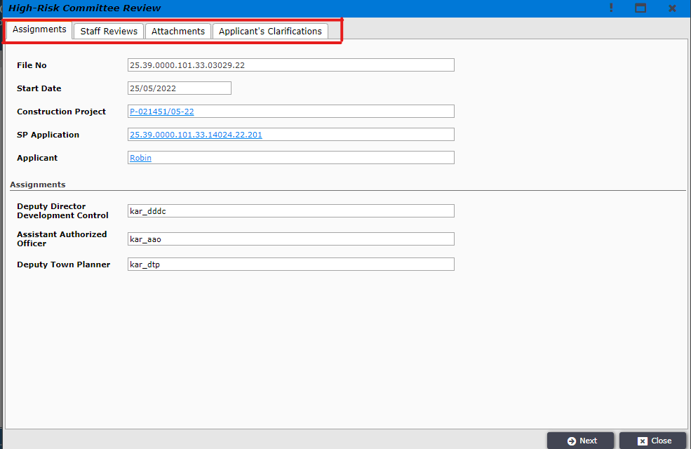
Figure 50.1

Afterwards the reviewer will click on Next to go to the next page which is shown in figure 51.
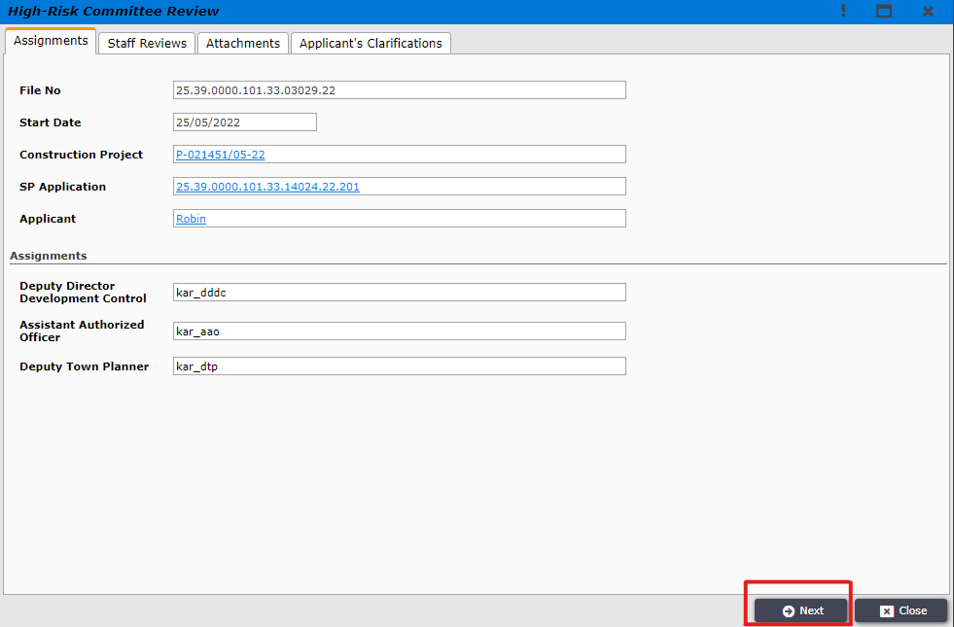
Figure 51

Reviewer will now give his own review. First he will click on Review Outcome. There he will find three options which are Approved, Drawing Corrections and Rejected. He will select any one of them according to his own review which is shown in figure 52.
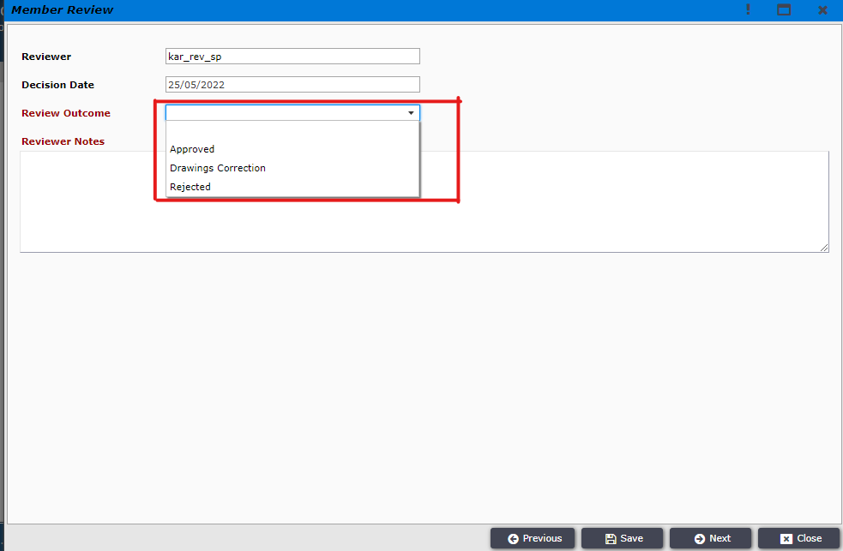
Figure 52

Next the reviewer will write a note about his review on the Reviewer Notes section which is shown in figure 53.
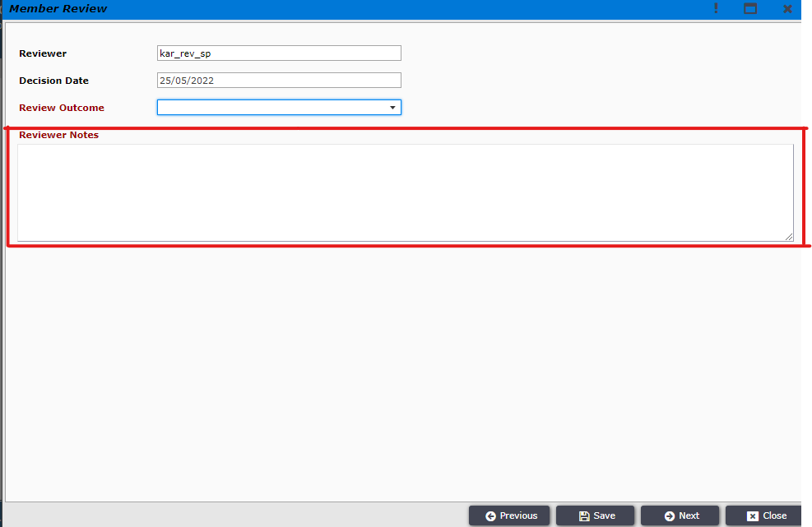
Figure 53

Afterwards the Reviewer will click on Next to send his review to DDC which is shown in figure 54
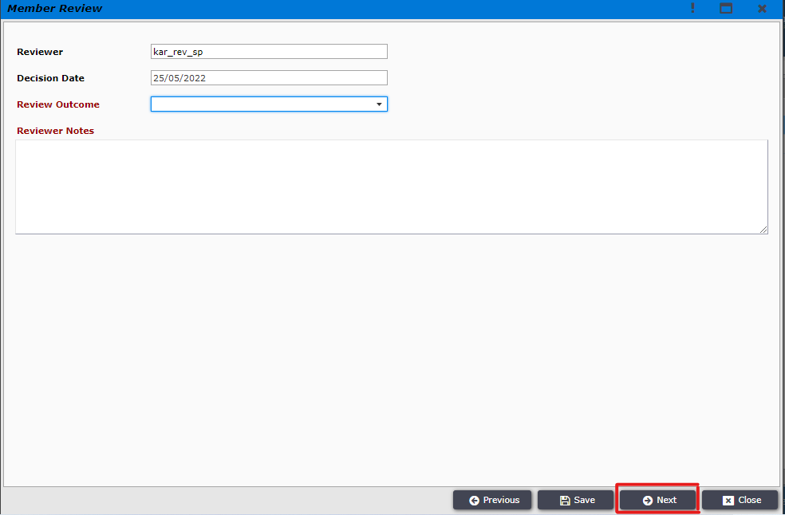
Figure 54

Director Development Control (DDC) will receive the file in the Incoming section which is shown in figure 55.
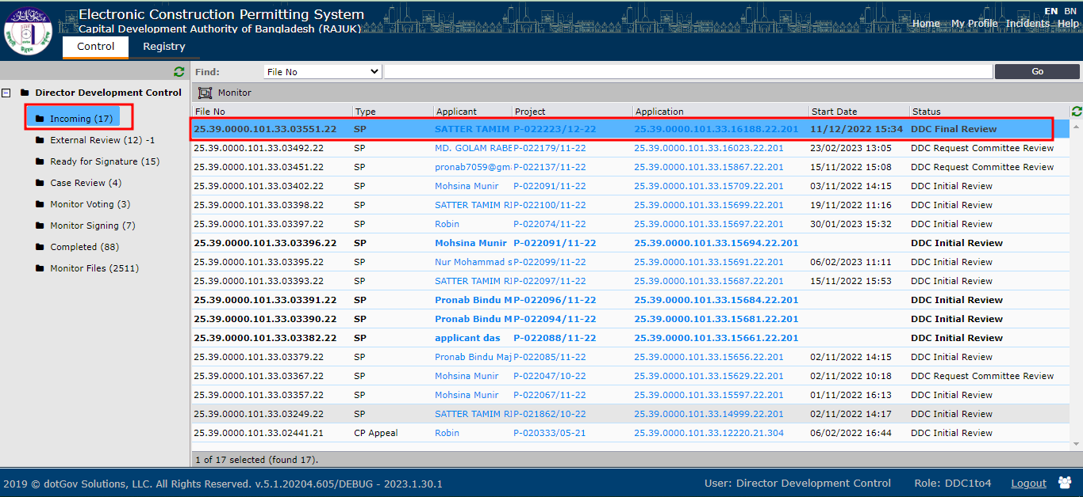
Figure 55
Director Development Control (DDC) will open the file. He will have access to all the 5 tabs like before. He can also check all the reviews given by all the staff which is shown in figure 56.
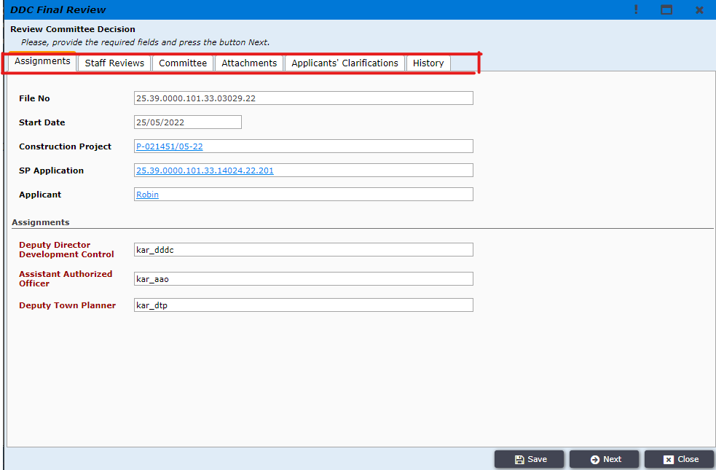
Figure 56
After checking everything DDC will now click on Next which is shown in figure 57
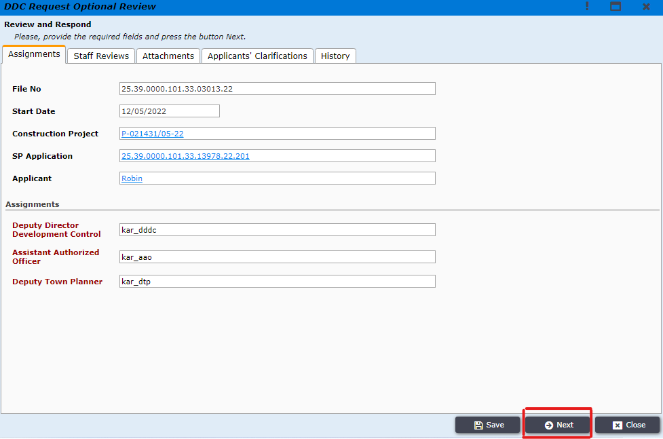
Figure 57

Director Development Control (DDC) will have four options now. By clicking on Correct the file will be sent to the applicant and he will rectify any errors according to the DDC’s instructions. By selecting Approve the file will be accepted and an acceptance letter will be sent to the applicant. By selecting Reject a rejection letter will be sent to the applicant. By clicking on Collect Signature then this file will send to the committee member for signature. This is shown in figure 58.
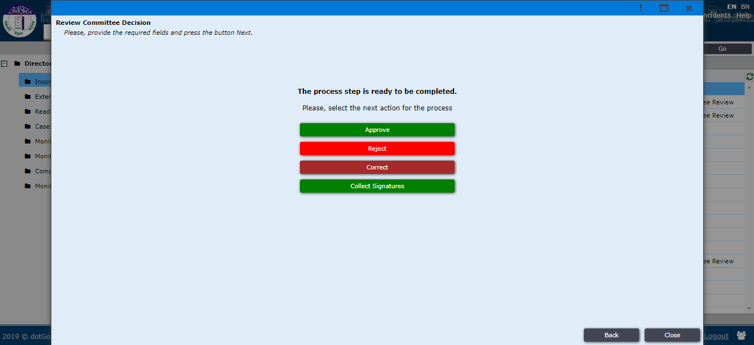
Figure 58
Now DDC will click on Collect Signatures (If necessary) then the SP Committee members will receive the file in his Document Signing Section (Figure 59) and SP-Reviewer will click on the file and click on Next.
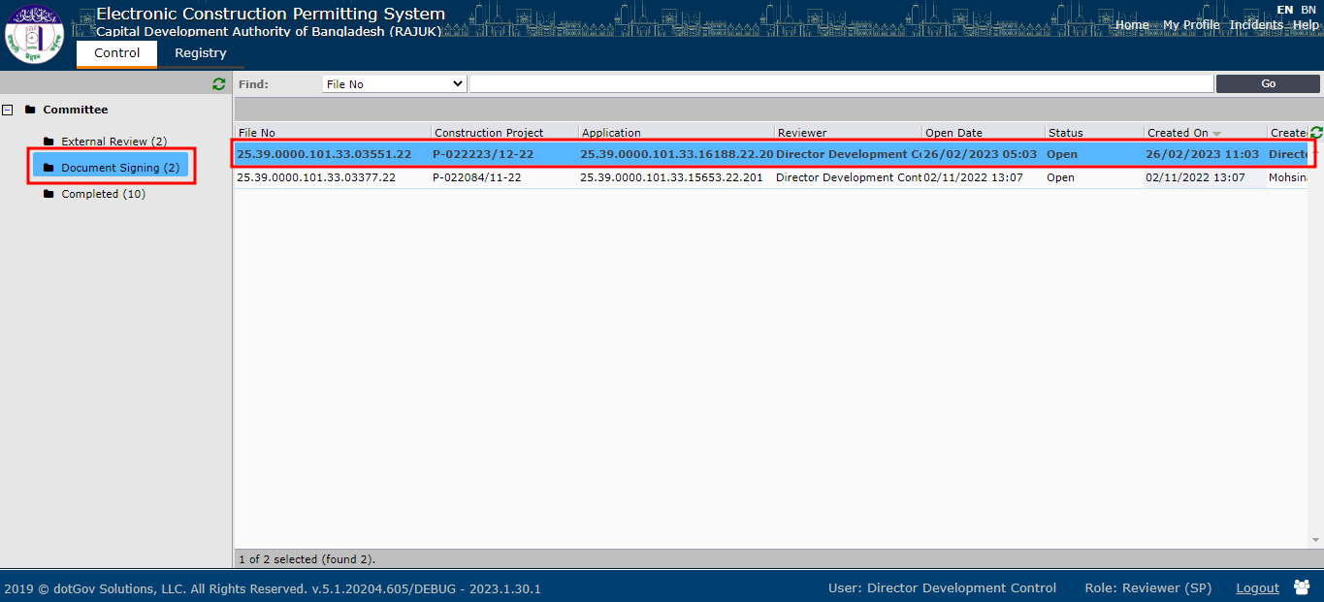
Figure 59

Then he can see then monitor signing tab and click on Next (Figure 60) then clicking on Drawings files (Figure 61)
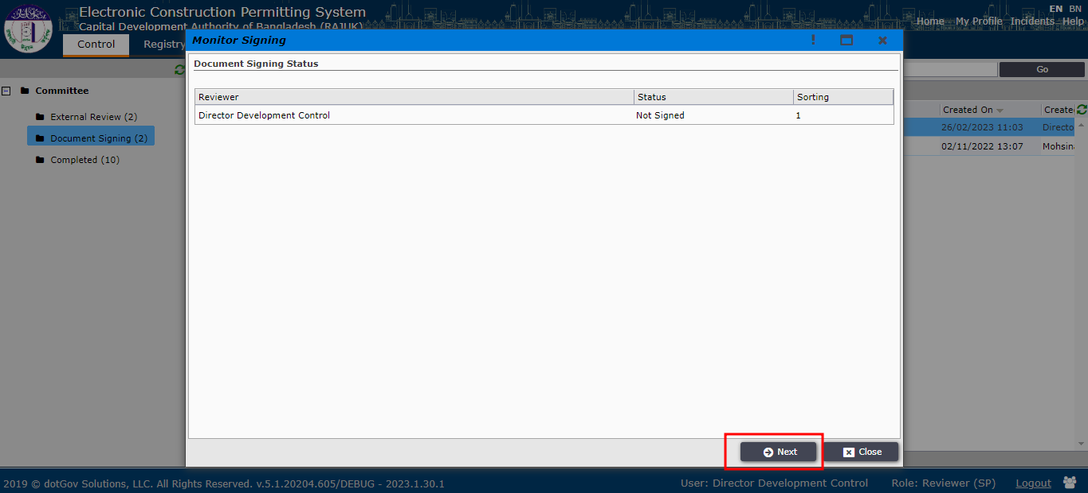
Figure 60
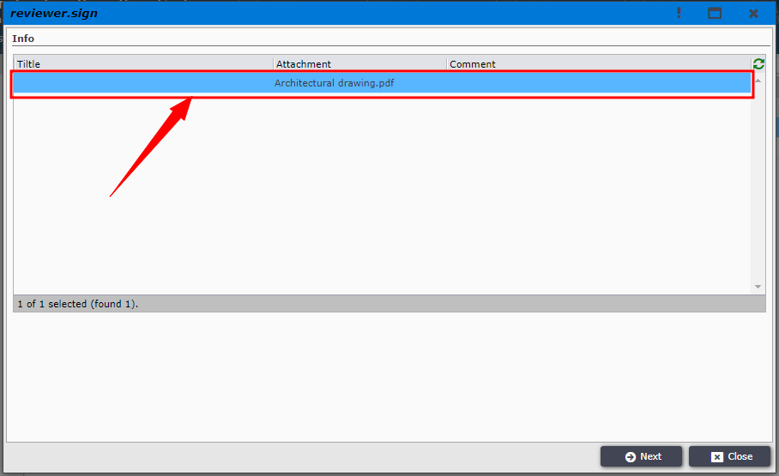
Figure 61

SP-Reviewer will download (Click on file) the file and use pdf signer for signing and attach it to Attach a file. Then SP-Reviewer will Click on Save and Close Button (Figure 62).
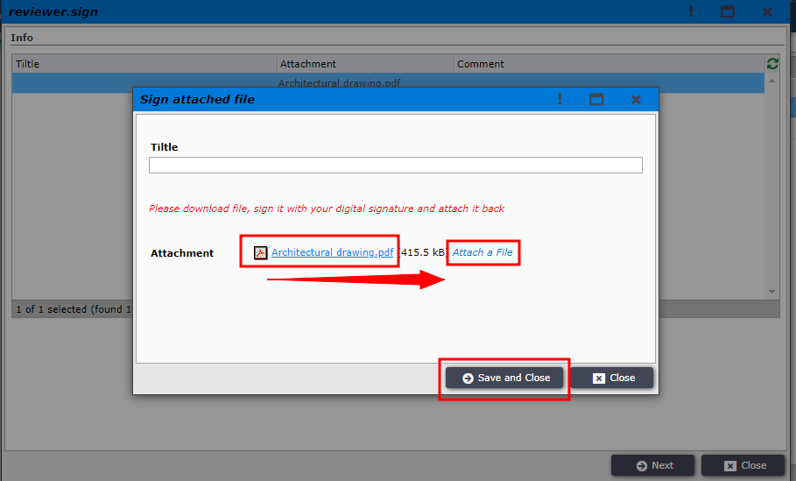
Figure 62
Then SP-Reviewer will click on Next button(Figure 63).
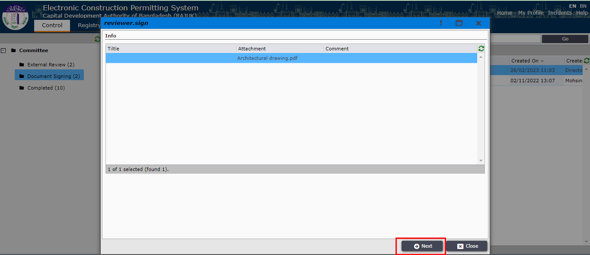
Figure 63

Now, DDC will receive this file in his/her Incoming Section (Figure 64) and clicking on file. DDC will now click on Next. DDC will now click on Approve and the file will go for signature.

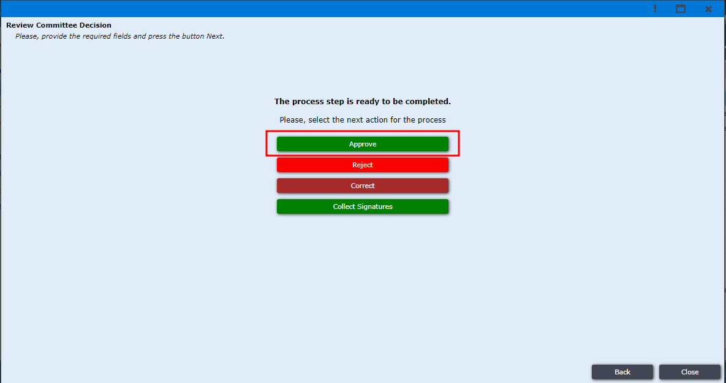
Figure 64

Director Development Control (DDC) will find the file on the Ready for Signature section as shown in figure 66.
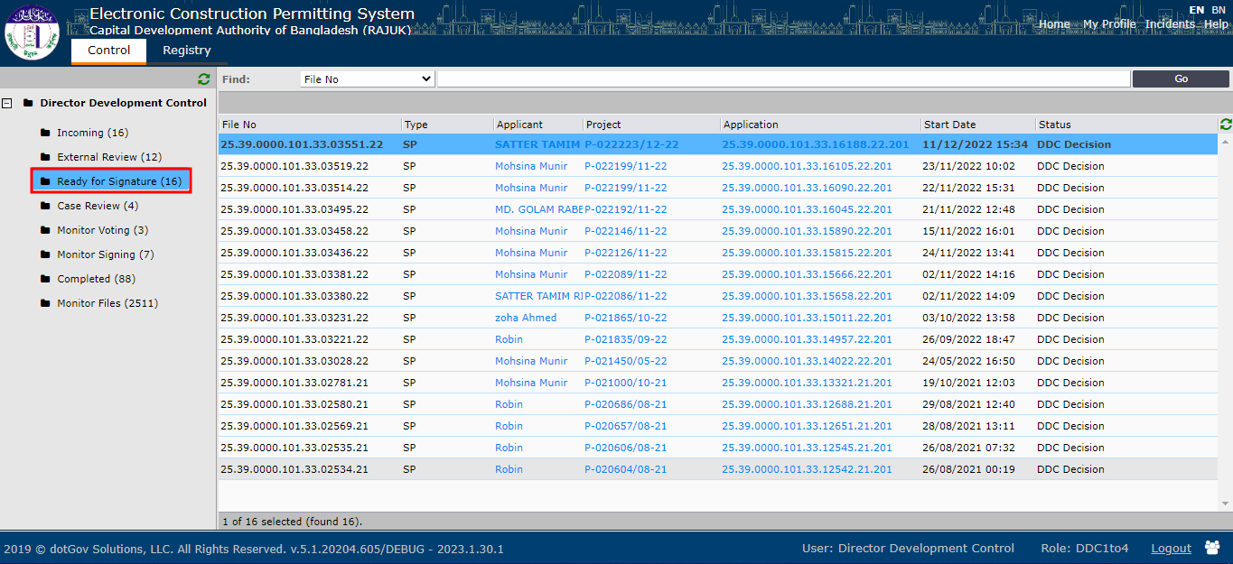
Figure 66
By opening the file DDC will now write approval notes on the Approval Notes tab and click on Next which is shown in figure 67.
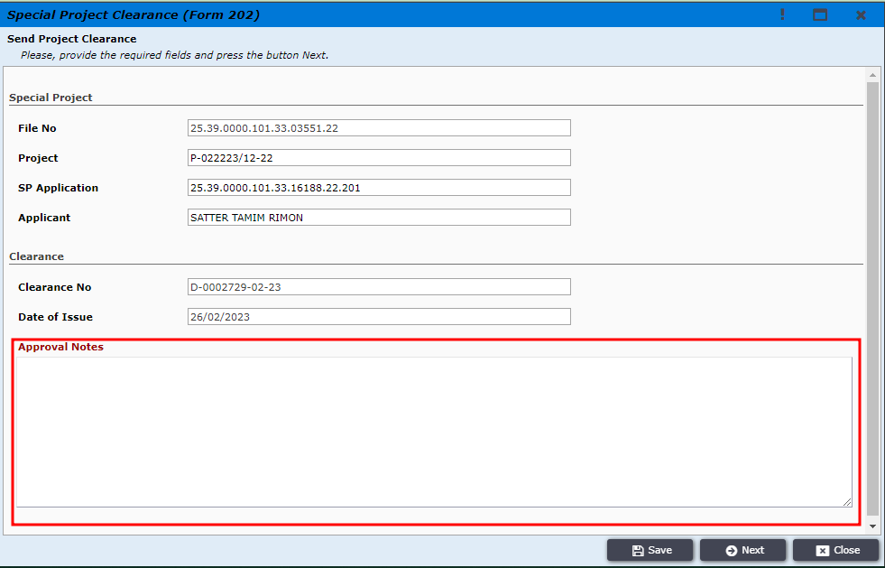
Figure 67

The Special Clearance print preview is shown at figure 68.
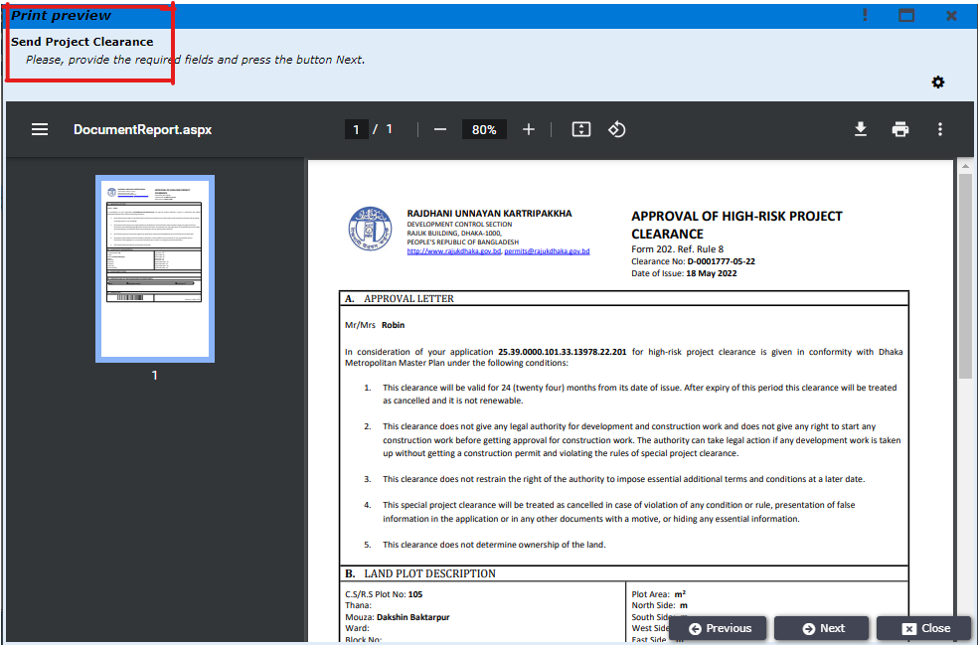
Figure 68

The e-Sign window is opened where DDC will upload the signed documents as shown in Figure 69.
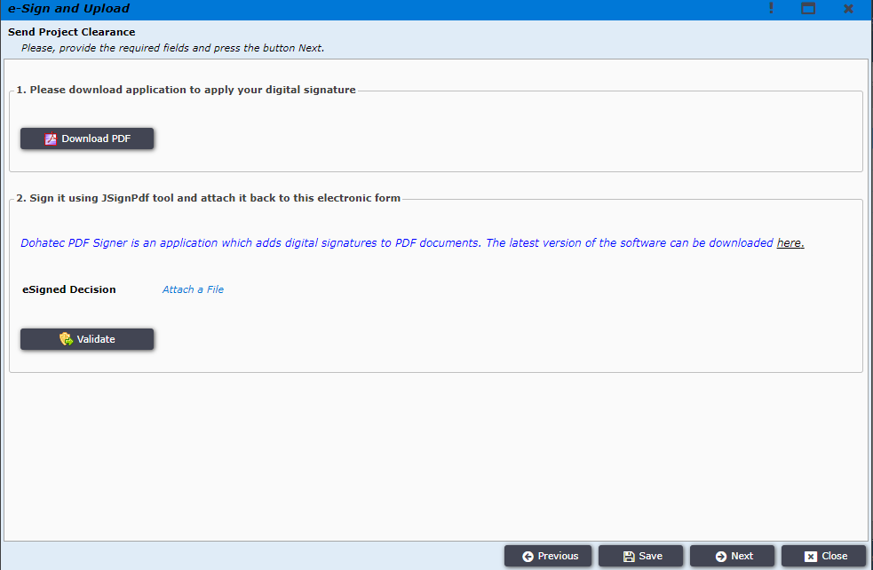
Figure 69

After clicking on the Next button, DDC gets the Send Official Response button. The DDC clicks on it and an official response will be sent to the Applicant which is shown in figure 70.
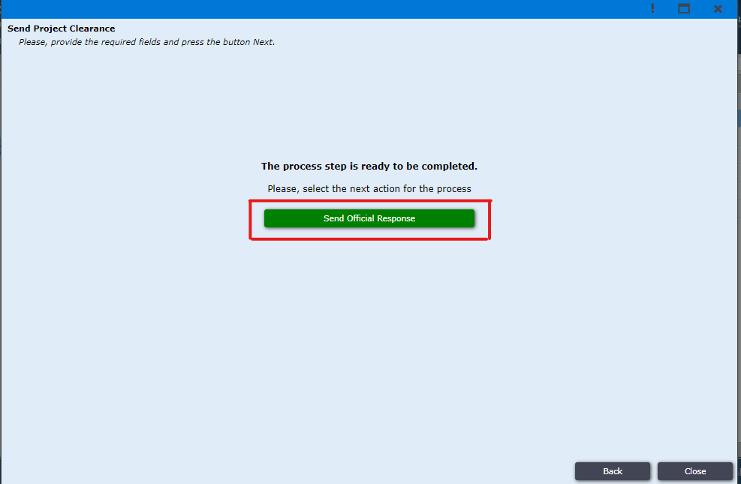
Figure 70

Applicant logins to the system and can find the permit under My Permits tab as shown in Figure 71.
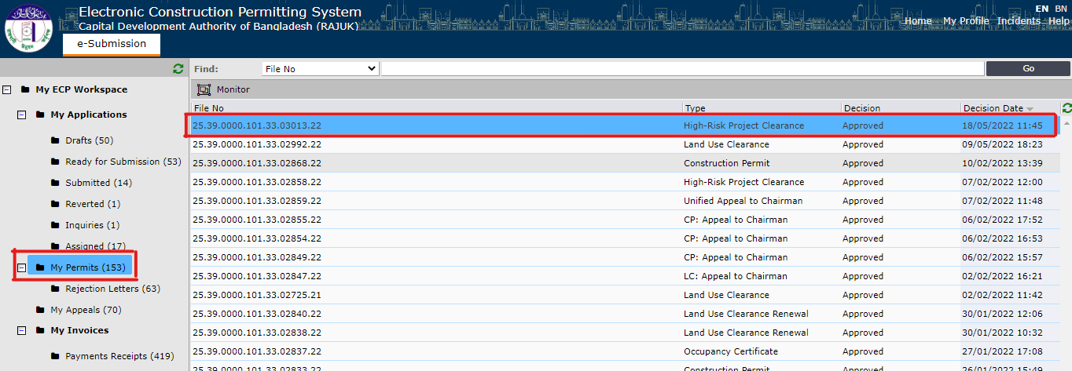
Figure 71
After clicking on the permit the window is opened to confirm receipt as shown in Figure 72. Applicant clicks on Next.
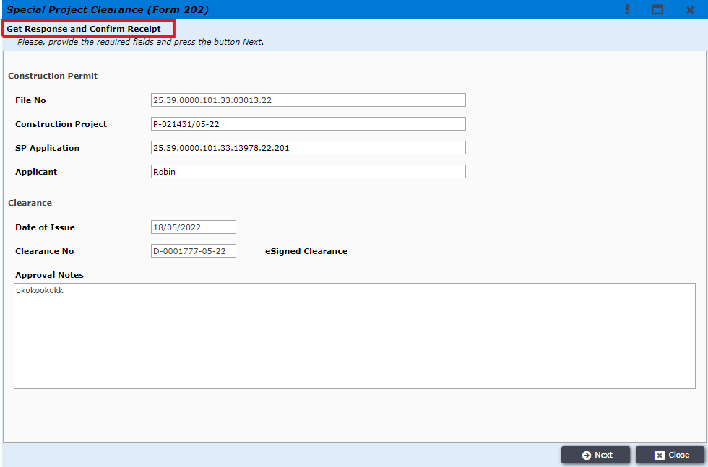
Figure 72

The window to confirm receipt is opened and the user clicks on Confirm Receipt button as shown in Figure 73
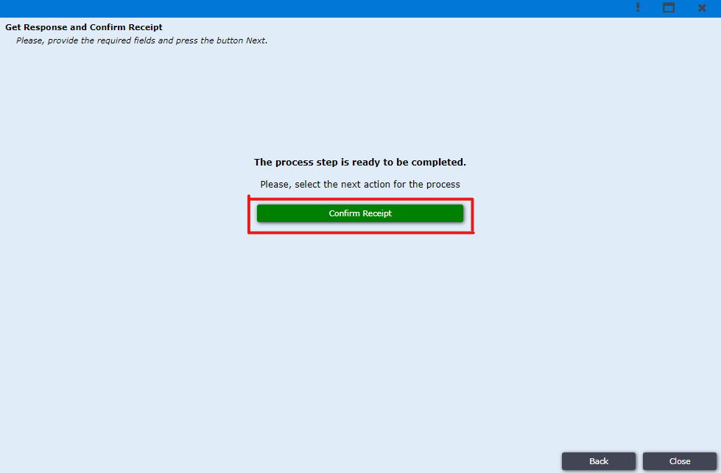Figure 73

After clicking on it the Applicant gets the successful message as shown in Figure 74.
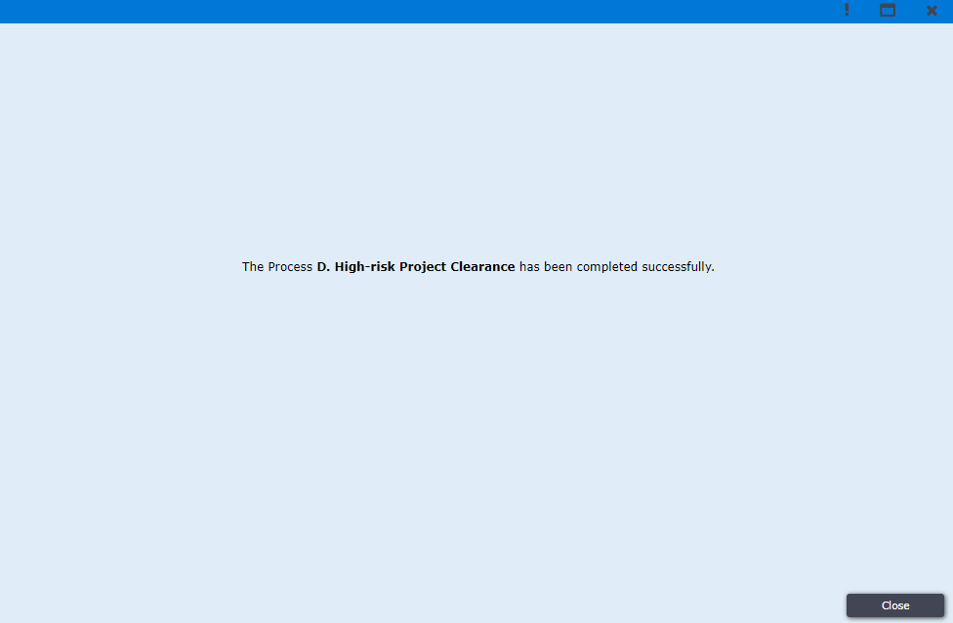
Figure 74

