LUC PROCESS MANUAL
Deputy Town Planner (DTP) accesses the Electronic Construction Permitting System Portal using the URL
https://ecps.gov.bd/ and then clicking on “Login” button. Then DTP will provide his/her username and password to login. DTP receives the application for Land Use Clearance certificate when Front desk assistant accepts the application. DTP will find the application in the Incoming section. Incoming files are sorted from Recent to Oldest. DTP will have to click on the Application he wants to proceed with. As shown in Figure 1
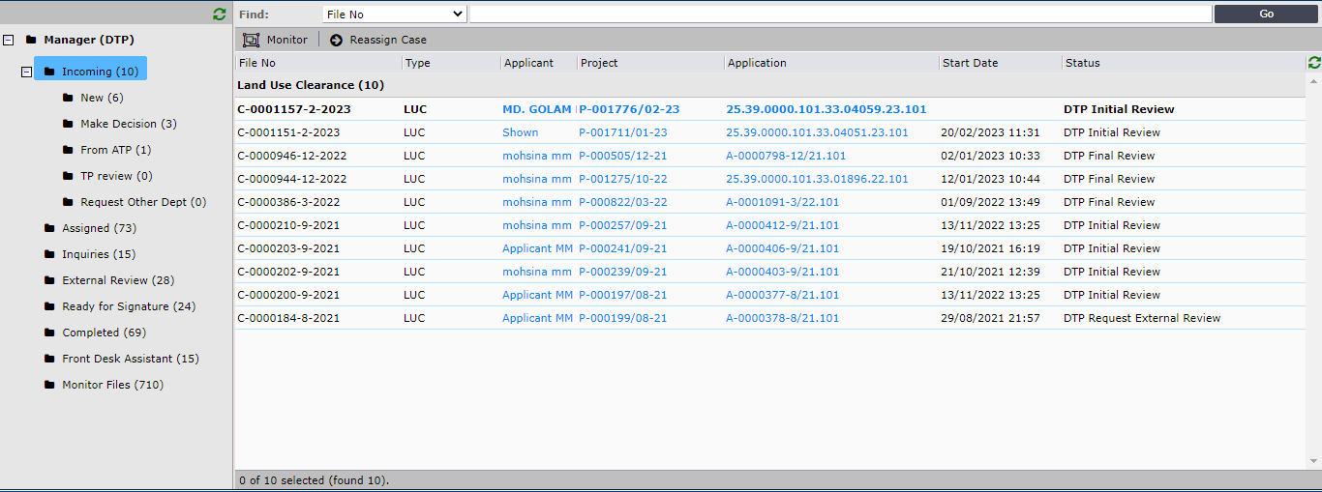
Figure 1

A new pop-up windows will appear when DTP clicks on any incoming application. DTP will have access to six different tabs Assignments, Staff Reviews, Attachments, Applicant Attachments, Applicants’ Clarifications and History. DTP will check all the available information of the application. As shown in Figure 2 and 3.
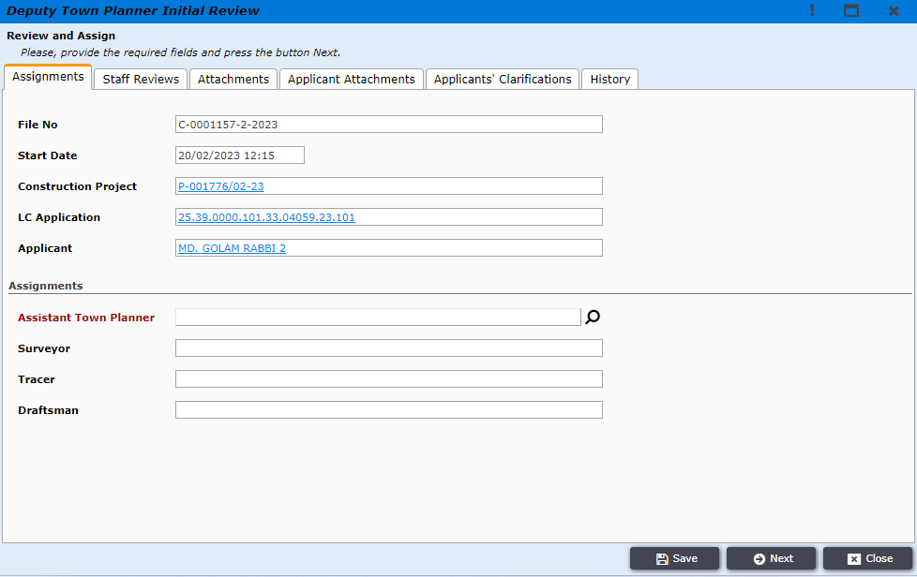
Figure 2
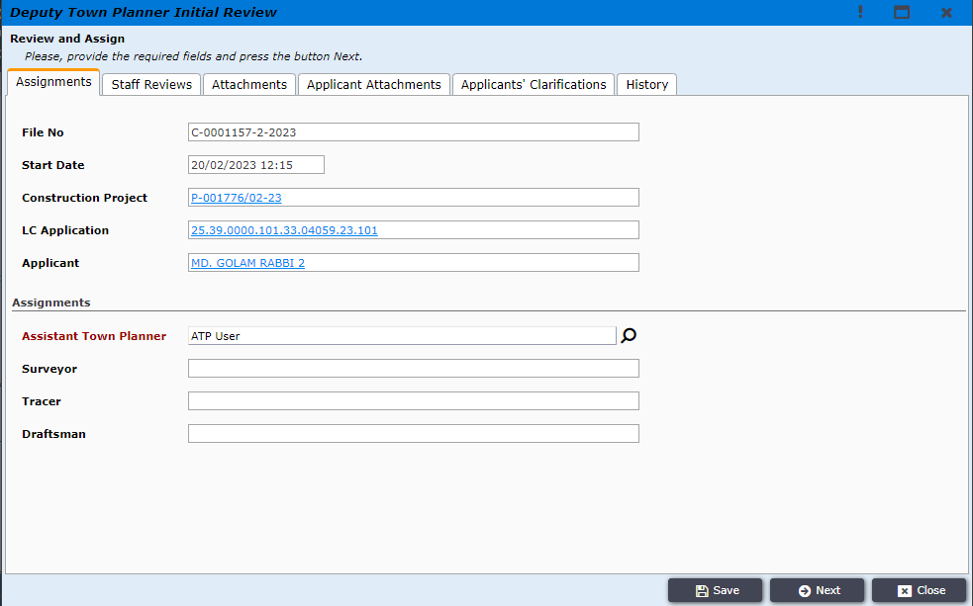
Figure 3

In the Staff Reviews tab DTP will write a review and add attachments. As shown in Figure 4
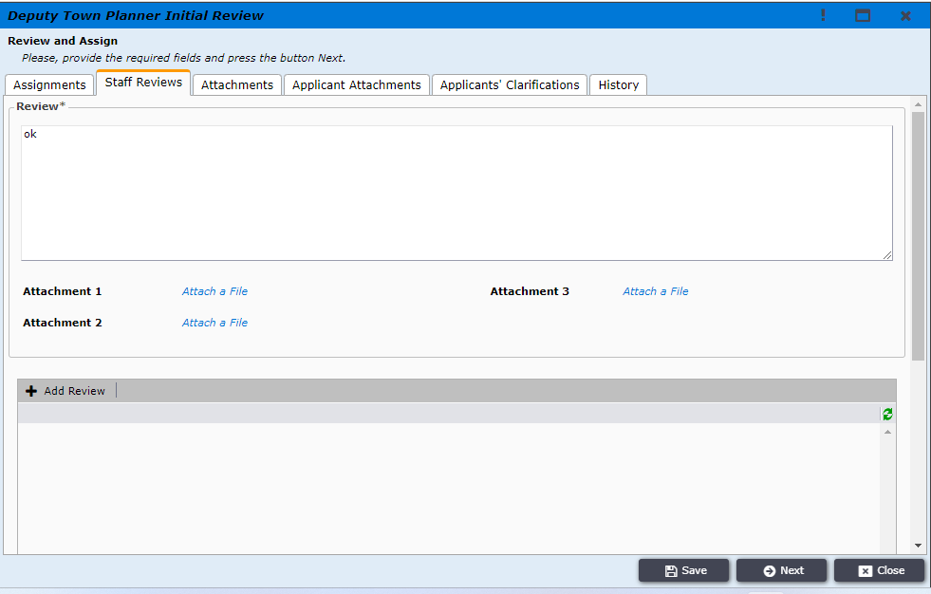
Figure 4
In the Attachments tab DTP will find all the attachment provided by any RAJUK users. As shown in Figure 5
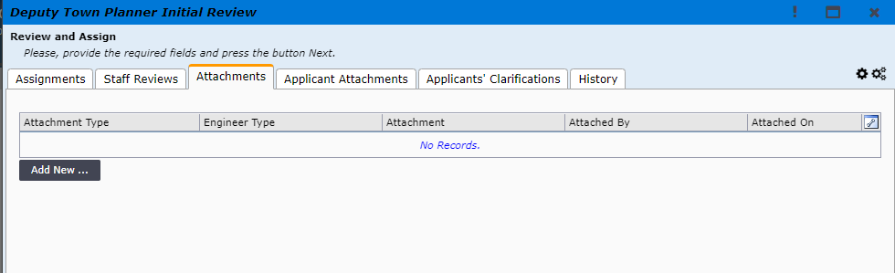
Figure 5
In the Applicant Attachments tab DTP will find all attachments provided by the applicant during application submission. As shown in Figure 6
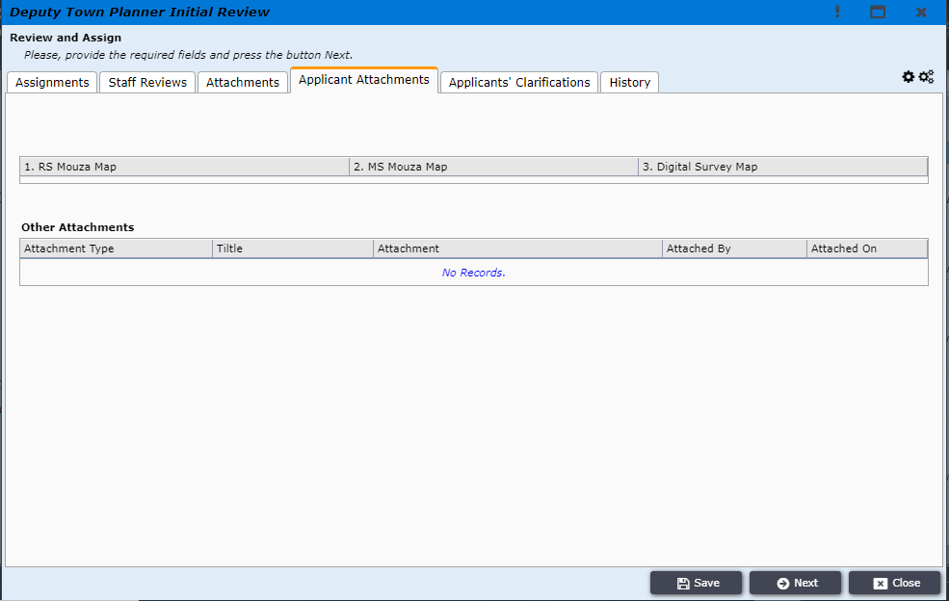
Figure 6
In the Applicants’ Clarifications tab DTP will find all the clarification provided by the applicant. As shown in Figure 7

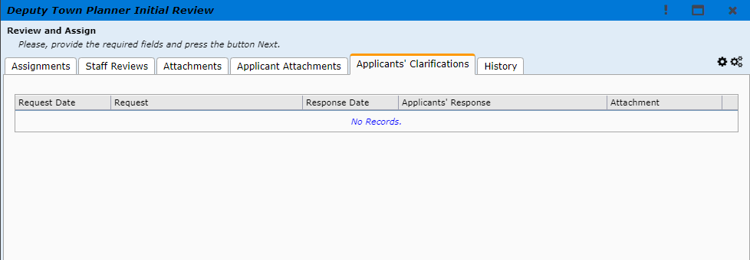
Figure 7

In the History tab DTP will find the history of this File, where processing step, initiated by, initiation time and how much days used will be available. As shown in Figure 8

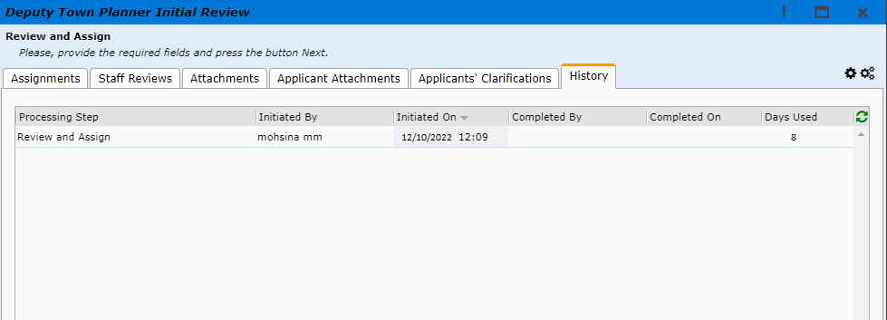
Figure 8
After checking all the tabs DTP will go to the Assignments tab to put his Review comments and assign an Assistant Town Planner (ATP) and press next. As shown in Figure 9
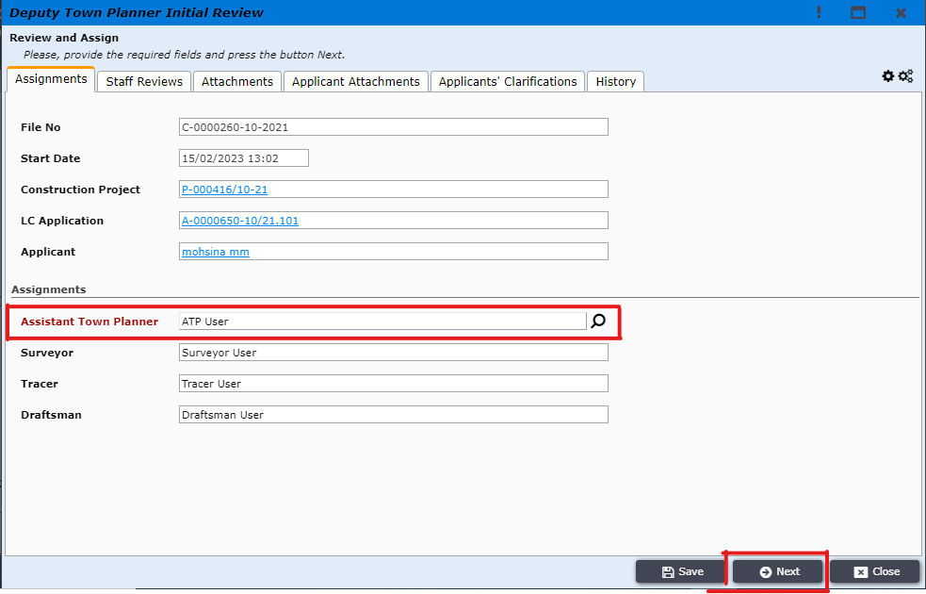
Figure 9

At this stage of the process DTP will have two options, he can either Assign the file to an ATP or DTP can request clarification from the applicant. As shown in Figure 10
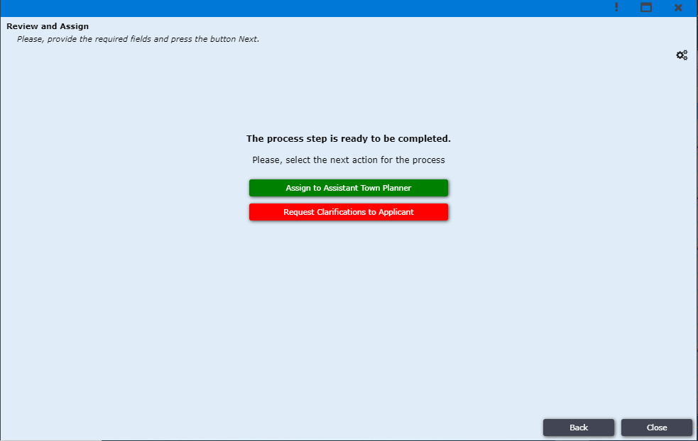
Figure 10
When DTP clicks on Assign to Assistant Town Planner the file is forwarded to ATP and in the ATP dashboard the file is moved to Incoming tab. As shown in Figure 11

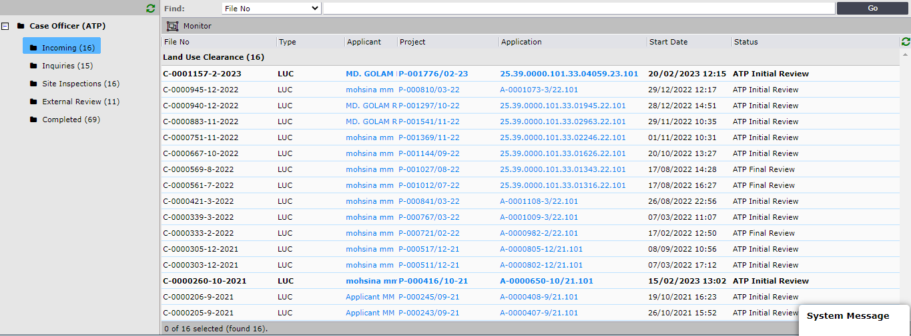
Figure 11

ATP will click on the file that he wants to work with, and he will get a new pop-up window with five different tabs to work in. As shown in Figure 12
In the Assignments tab ATP will be able to check details about the Project, Application and the Applicant. In Assignments section (below assignment tab) ATP can assign surveyor, tracer and draftsman. As shown in Figure 12
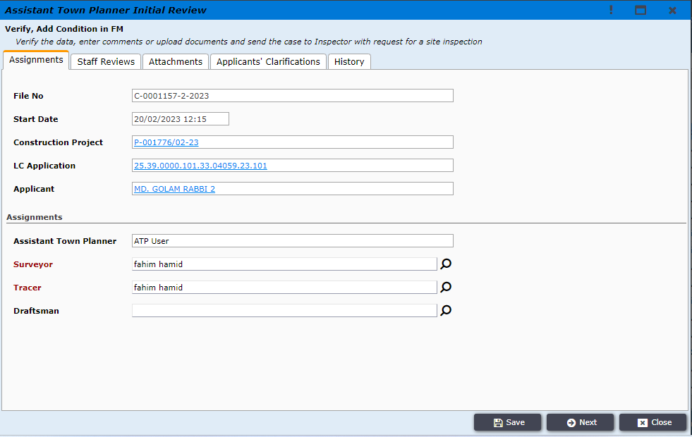
Figure 12

In the Staff Review tab ATP will be able to view the review comments made by DTP and ATP will also find a different text field to write his review comments. As shown in Figure 13
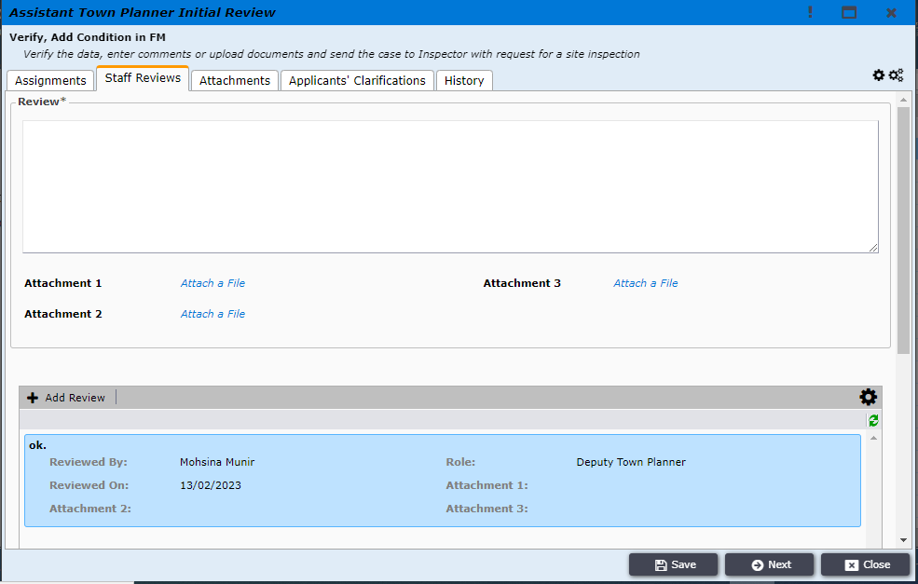
Figure 13

In the Attachments tab ATP will find all the attachment provided by RAJUK users. ATP will also be able to add attachments by clicking on Add New button. As shown in Figure 14
Figure 14

In the Applicants’ Clarifications tab ATP will find all the clarification provided by the applicant during initial review of DTP. As shown in Figure 15
Figure 15
In the History tab ATP will find the history of this File, where processing step, initiated by, initiation time and how many days used will be available. As shown in Figure 16
Figure 16
After checking all the tabs ATP will come back to Staff Review tab to write his review comments in the allotted textbox and then press Next. As shown in Figure 17

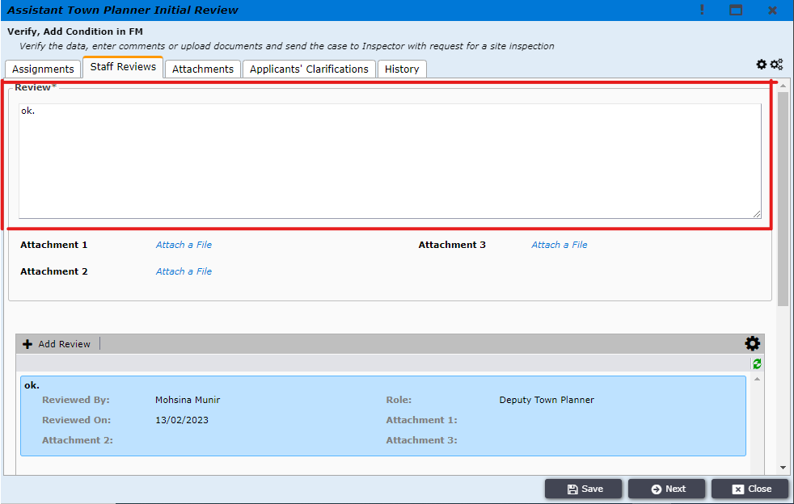
Figure 17

ATP will the request the Surveyor to conduct site survey. To do so ATP will click on Request Site Survey and the file will be automatically forwarder to the corresponding Surveyor. As shown in Figure 18
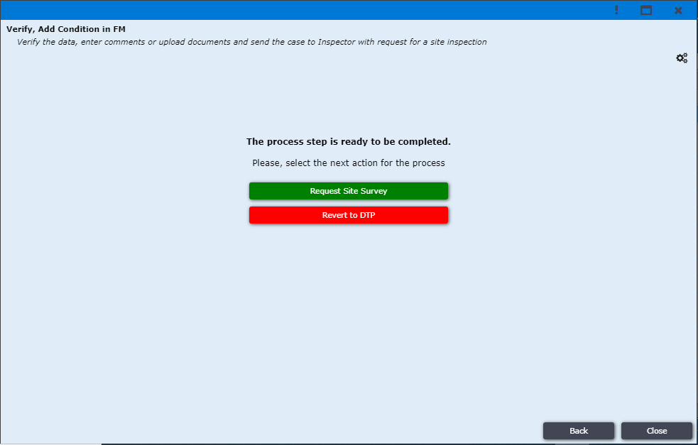
Figure 18

When ATP forwards the application for site survey, the file is automatically sent to the corresponding Surveyor. The surveyor logs into the system and will find the application under Inspections. Where the surveyor will have to click on the desired application to start the process, and the system will bring-up a new pop-up window.
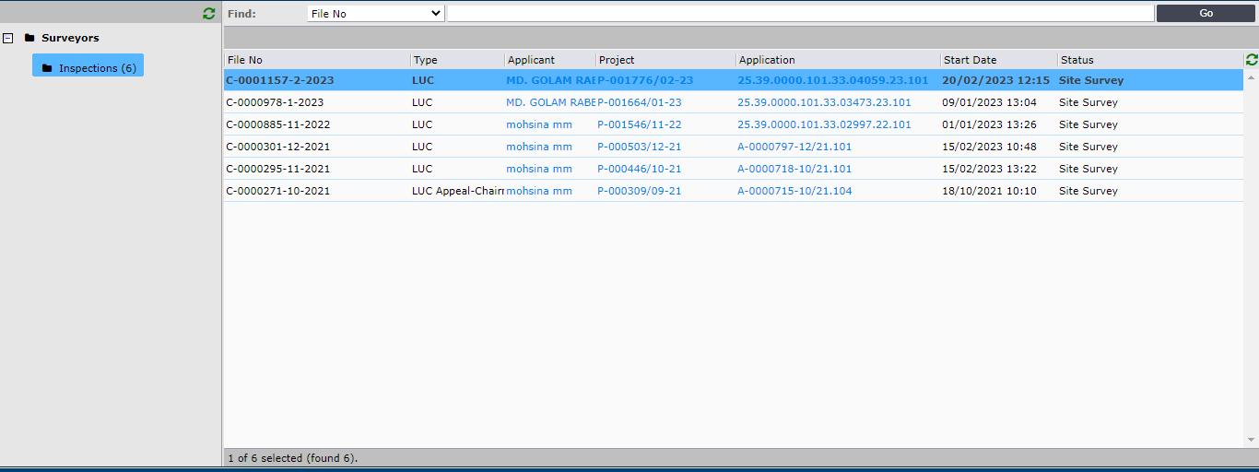
Figure 19

Surveyor will get a new pop-up window with different tabs to work in. As shown in Figure 20
In the Assignments tab Surveyor will be able to check details about the Project, Application and the Applicant. As shown in Figure 20
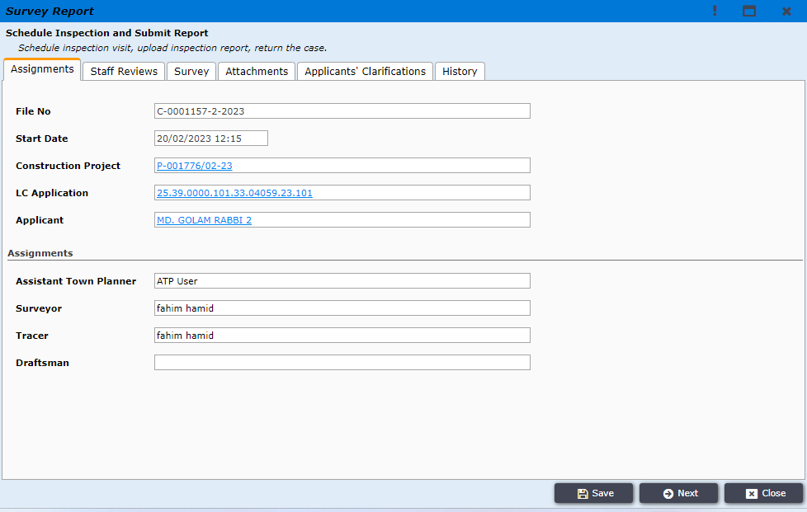
Figure 20

In the Staff Reviews tab Surveyor will be able to view the initial review comments made by DTP and ATP. As shown in Figure 21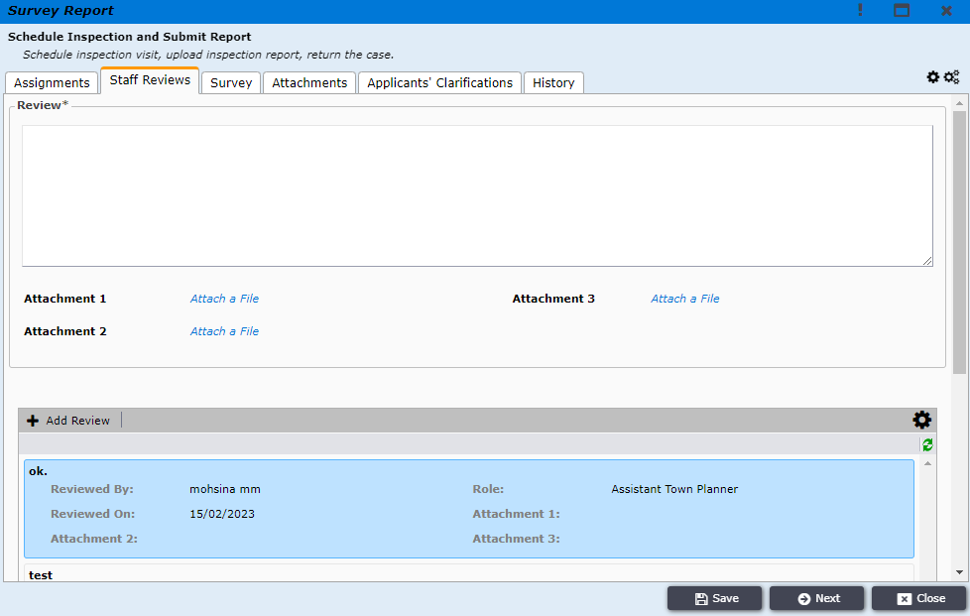
Figure 21

In the Attachments tab Surveyor will find all the attachment provided by all RAJUK users. Surveyor will also be able to add attachments by clicking on Add New button. As shown in Figure 22

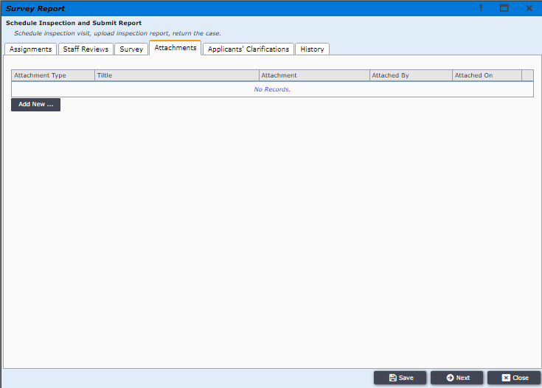
Figure 22
In the Applicants’ Clarifications tab Surveyor will find all the clarification provided by the applicant during the initial screening process or during initial review of DTP. As shown in Figure 23
Figure 23

In the History tab Surveyor will find the history of this File, where processing step, initiated by, initiation time and how many days used will be available. As shown in Figure 24
Figure 24
After checking all the details of this application Surveyor will go for site visit, and conduct site survey according to the rules and regulations and will create Situational Map and Situation of Plot in the Mouza Map. Then Surveyor will type his survey report and attach situational map, situation of plot in the Mouza Map and any other document if required, and press next. As shown in Figure 25
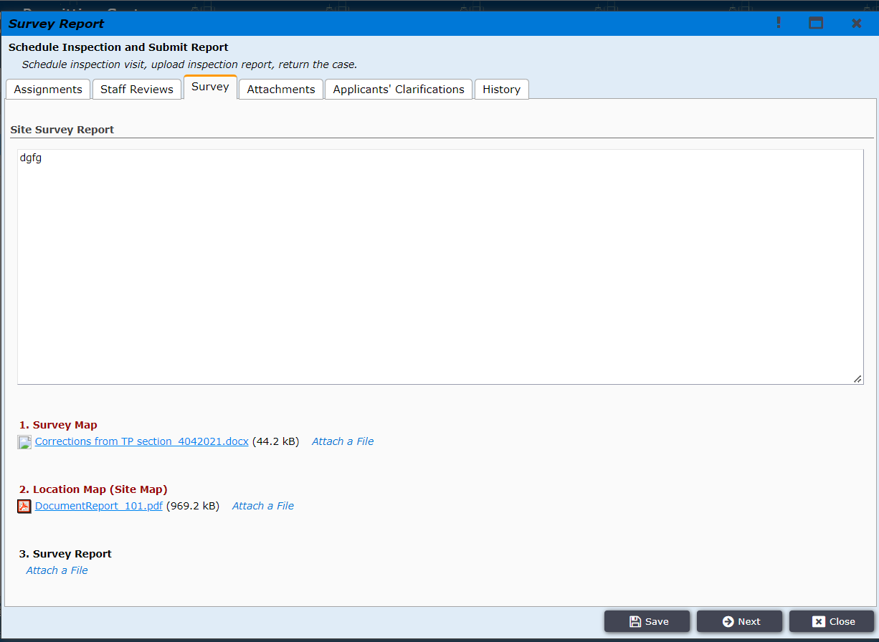
Figure 25
Then the surveyor will then click on Request Format Map and send the application to Tracer and request him to prepare format map.
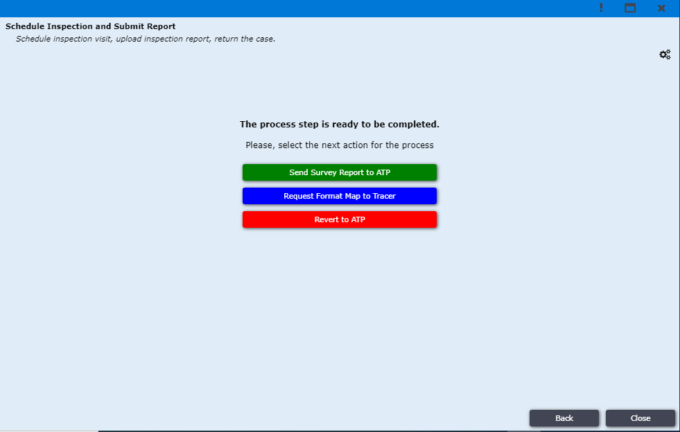
Figure 26

When Surveyor forwards the application to Tracer for Format Map, the file is automatically sent to the corresponding Tracer. The Tracer will log into the system and will find the application under Inspections. Where the Tracer will have to click on the desired application to start the process, and the system will bring-up a new pop-up window.
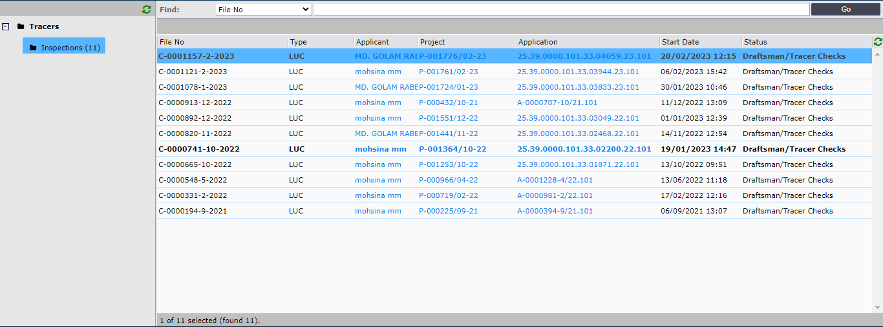
Figure 27

Tracer user will get a new pop-up window with five different tabs to work in. As shown in Figure 28
In the Assignments tab Tracer will be able to check details about the Project, Application and the Applicant. As shown in Figure 28
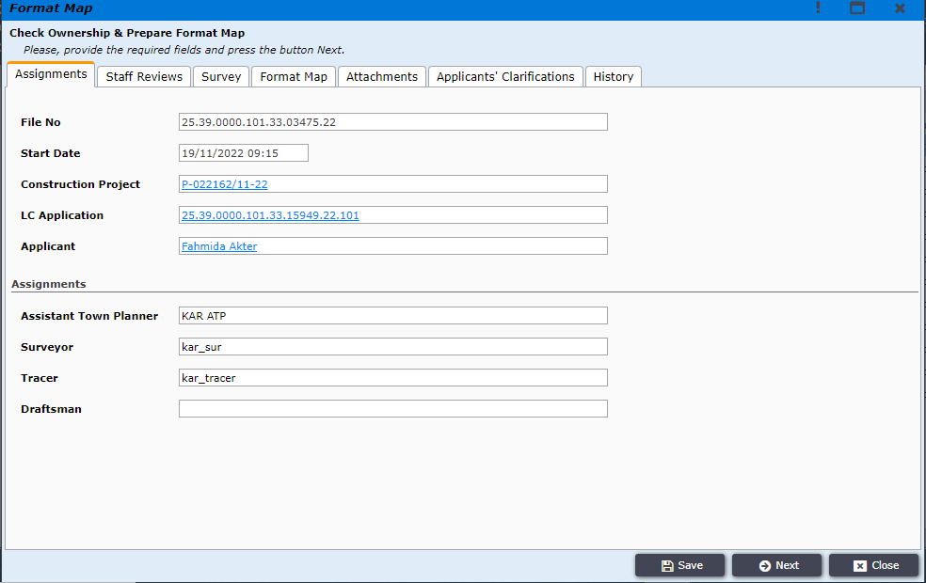
Figure 28
In the Staff Reviews tab Tracer will be able to view the review comments made by DTP and ATP. As shown in Figure 29
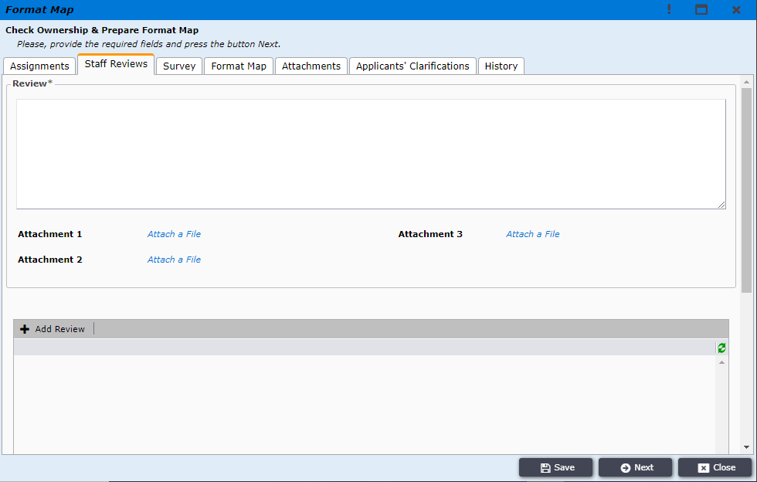
Figure 29

In the Survey tab Tracer will be able to view the survey report prepared by the surveyor along with the Survey Map and Location Map. As shown in Figure 30
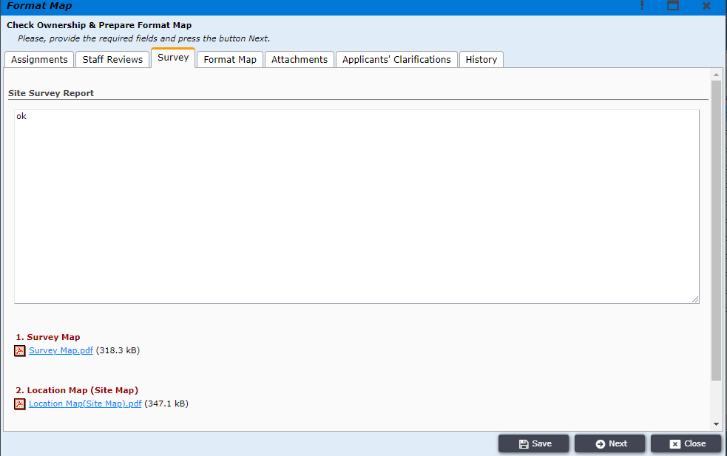
Figure 30
In the Format Map tab tracer will add description and attachment. Shown in Figure 31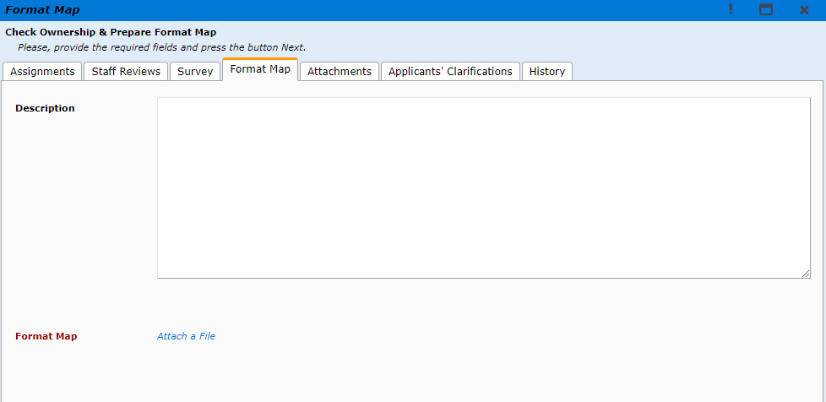
Figure 31
After checking all the details of this application and survey report, Tracer will prepare the format map and attach it will this application in the Attachment tab and press next. As shown in Figure 32
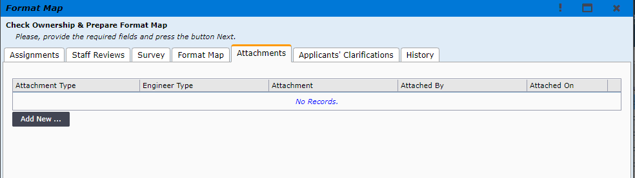
Figure 32
Then the Tracer will then click on Submit Report to forward the Format Map to the ATP.
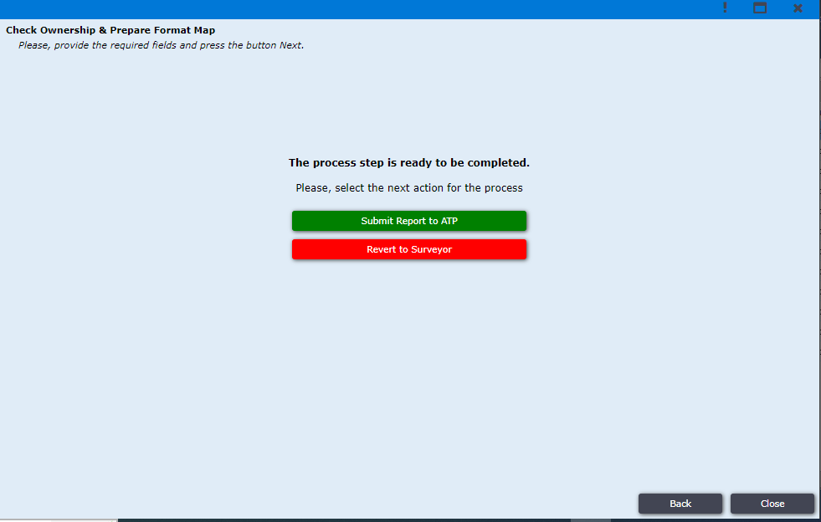
Figure 33

When Tracer forwards the application to ATP user with the Format Map, the file is automatically sent to the corresponding ATP account.
Assistant Town Planner will receive the application in Incoming section where the user has to click on the corresponding application as shown in Figure 34

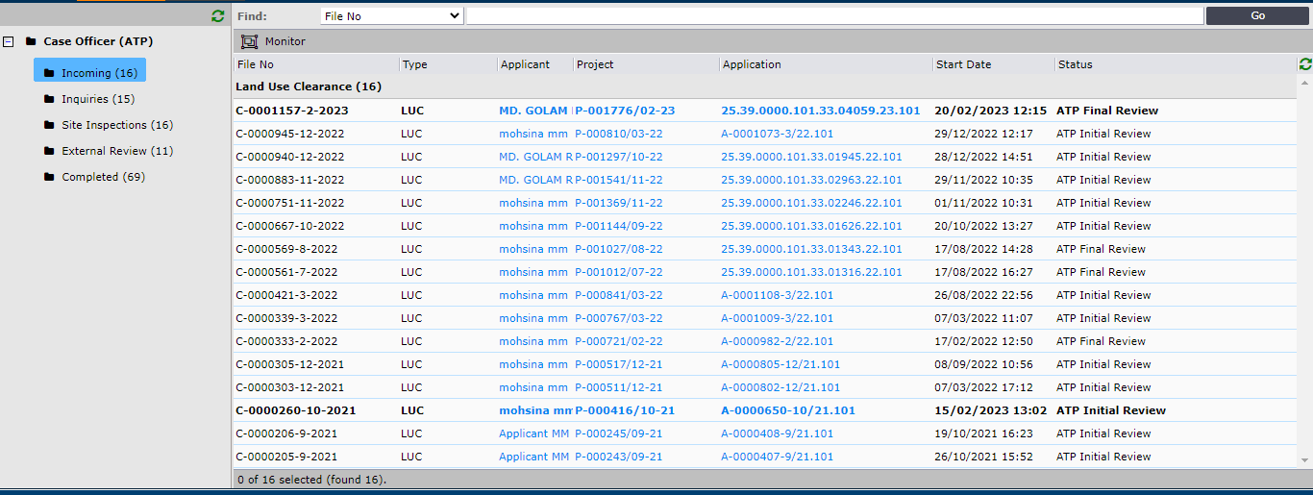
Figure 34

ATP will get a new pop up window where ATP user will be able to check the survey report and format map attached by the Surveyor and Tracer, as shown in Figure 35

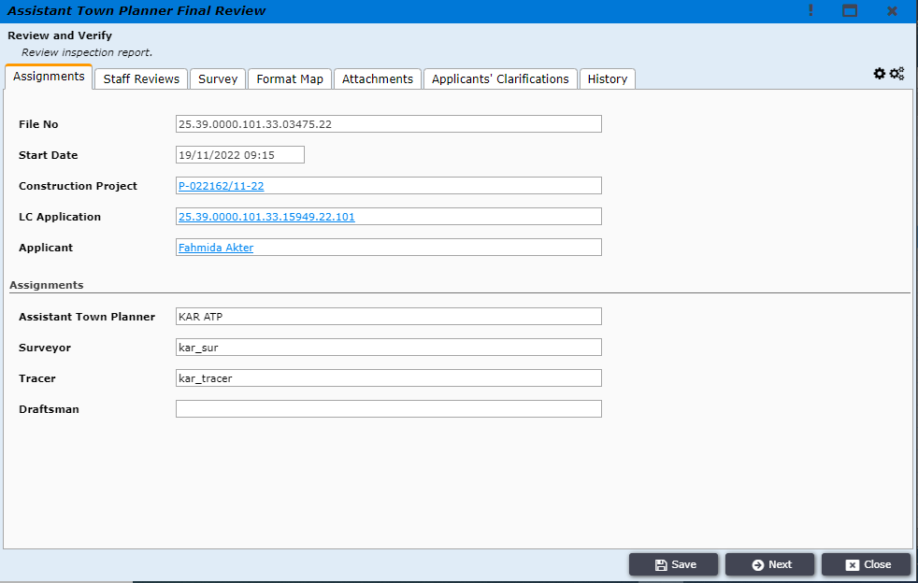
Figure 35
After reviewing ATP will have to click on Next as shown in Figure 35 , upon clicking on next the user will get two option Submit to Deputy Town Planner and Request Report Correction
ATP user will click on Request Report Correction if the user decide that the Survey report or Format map is not up to the mark and needs some correction, otherwise the ATP user will click on Submit to Deputy Town Planner to forward the application to the DTP.
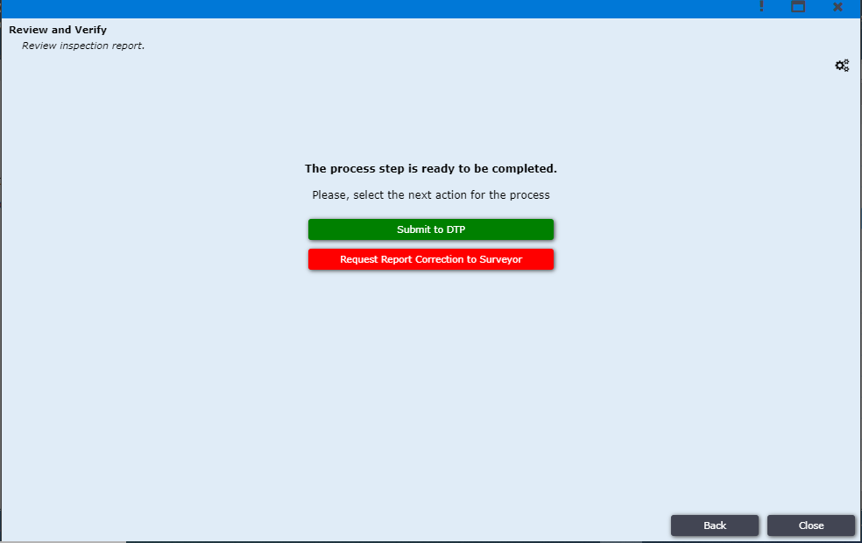
Figure 36
DTP will receive the application in his Incoming section, where the user will click on the application to start working as shown in Figure 37
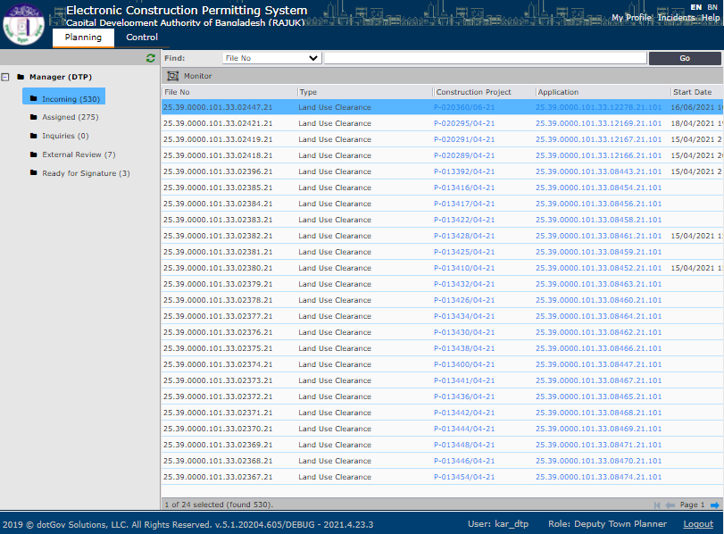
Figure 37

When DTP opens the application the user will get a new window with multiple tabs, where the user will click on Survey tab to review Site Survey Report and check Situational Map and Situation of plot in the Mouza Map
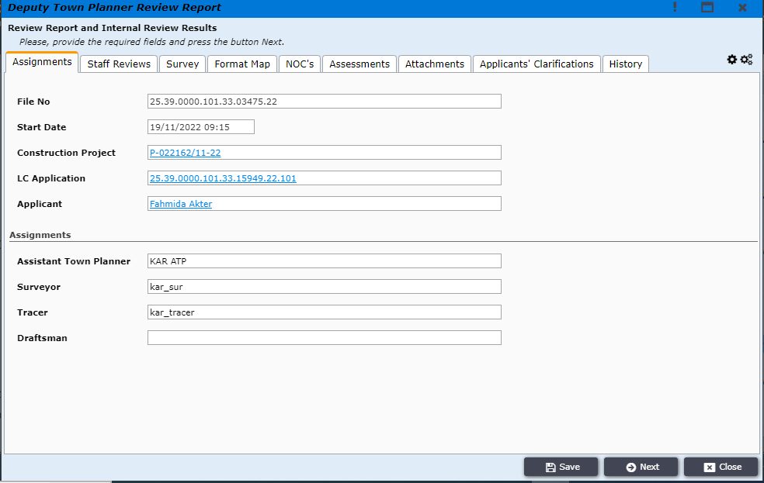
Figure 38

Afterwards DTP will decide if it is required to forward the application to any compliance authority for external review. If DTP user decides to forward the application to any External Compliance Authority then user will check the box of that compliance authority, and press next, as shown in Figure 39
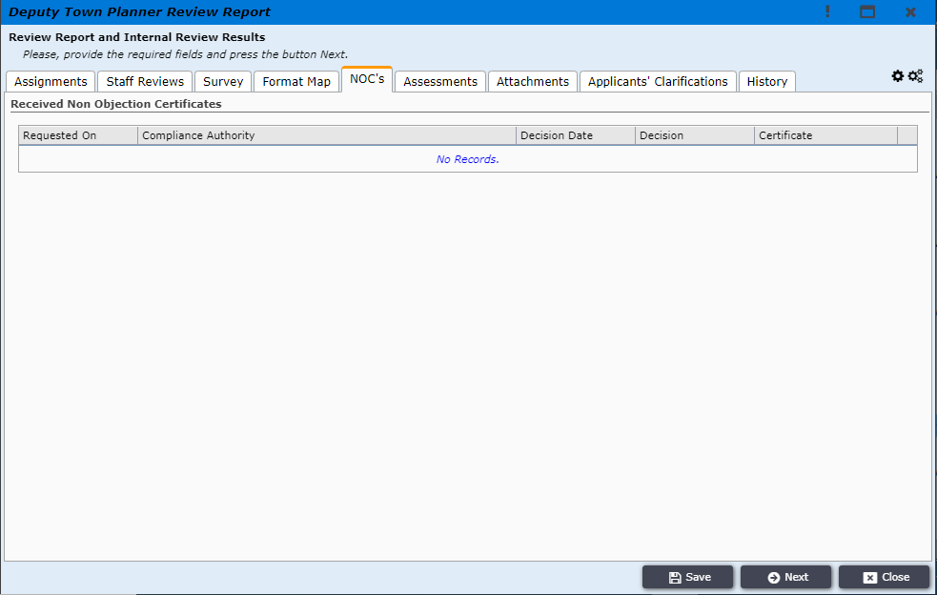
Figure 39

DTP user will then click on Request For NOC to forward the application to the corresponding external compliance authority, as shown in Figure 40.
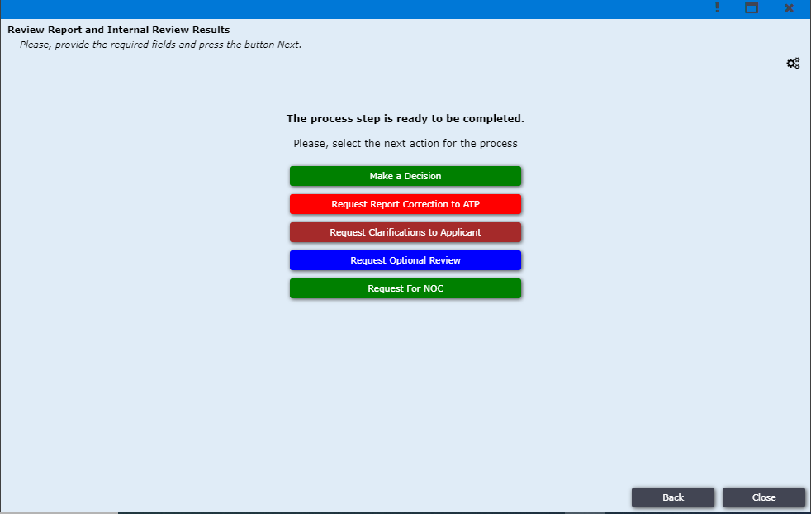
Figure 40

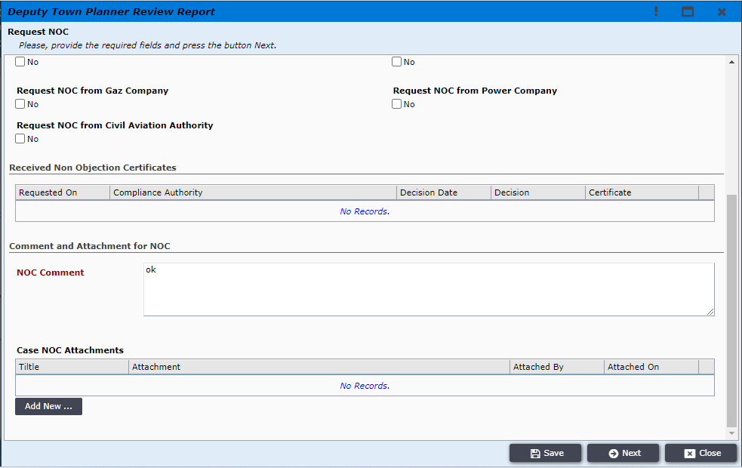
Figure 40 (1)
External Compliance Authority user will login to the ECPS system using his login credentials and will find all the incoming applications in the External Review section, as shown in Figure 41
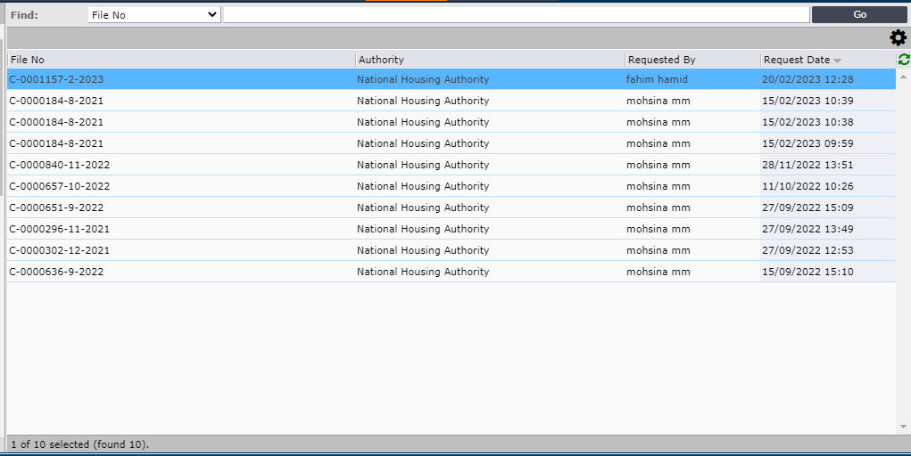
Figure 41

Upon clicking on the application system will open a new window where External Reviewer will be able to view all the relevant documents related to that application, afterwards the user will have to press on Next button to give his response as shown in Figure 42
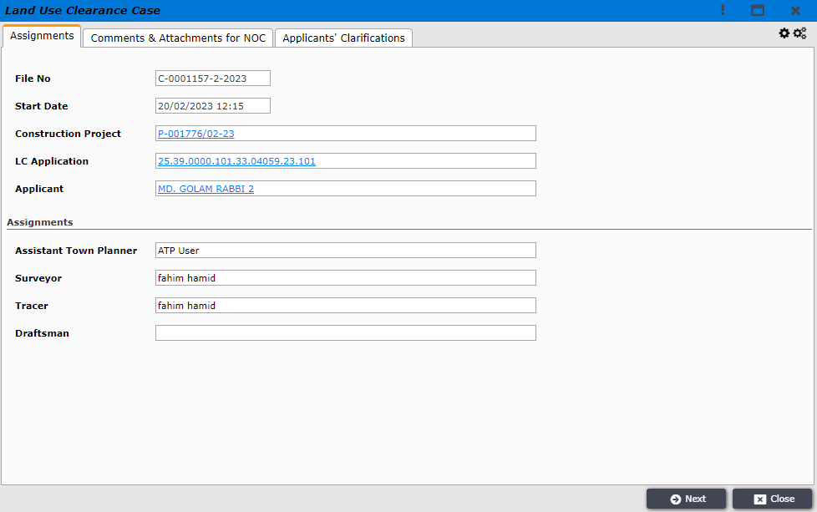
Figure 42

Once the user clicks on the Next button, system will take the user to the page where the user will be able to give his decision along with a decision note, furthermore the user will also be able to attach any document when required, as shown in Figure 43
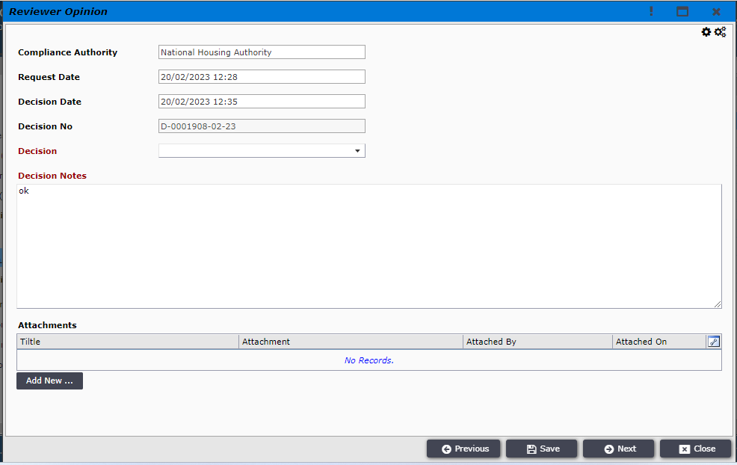
Figure 43

When the external reviewer completes selecting his decision and writing decision notes, the user will have to click on Next and the application will be forwarder to DTP with the decision, as shown in Figure 44
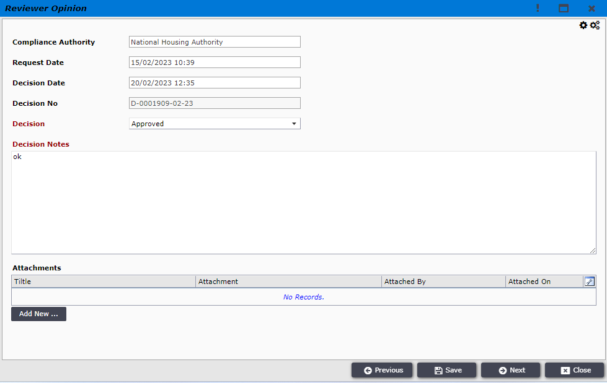
Figure 44

After receiving the application from External Reviewer, DTP will login to the system and find the application in the Incoming section, as shown in Figure 45
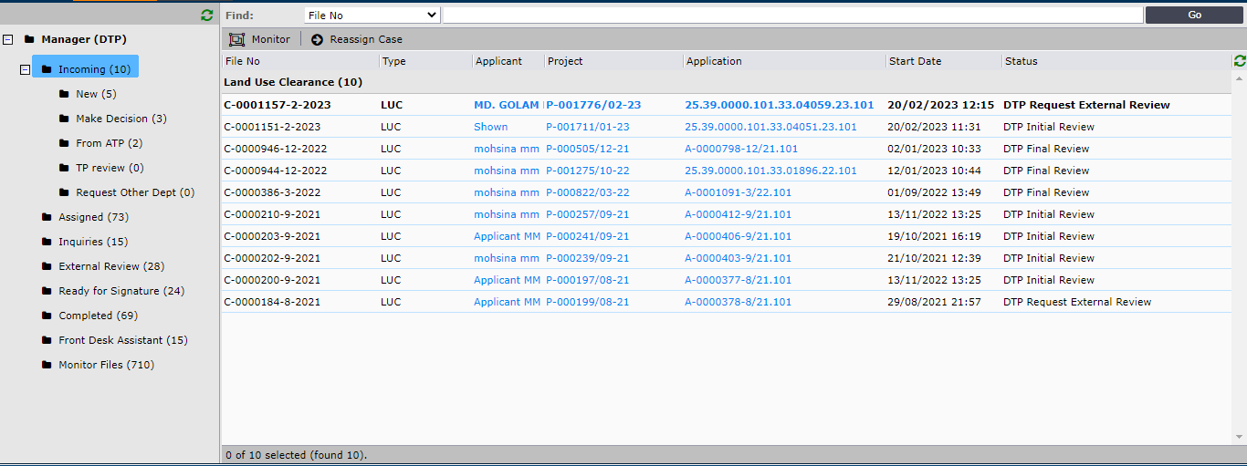
Figure 45

DTP user will then click on the application to open a new window where the user will be able to see the review decision made by the External Reviewer in the NOC’s tab, as shown in Figure 46 . DTP user will have to click on Next button and the system will guide the user to another screen.
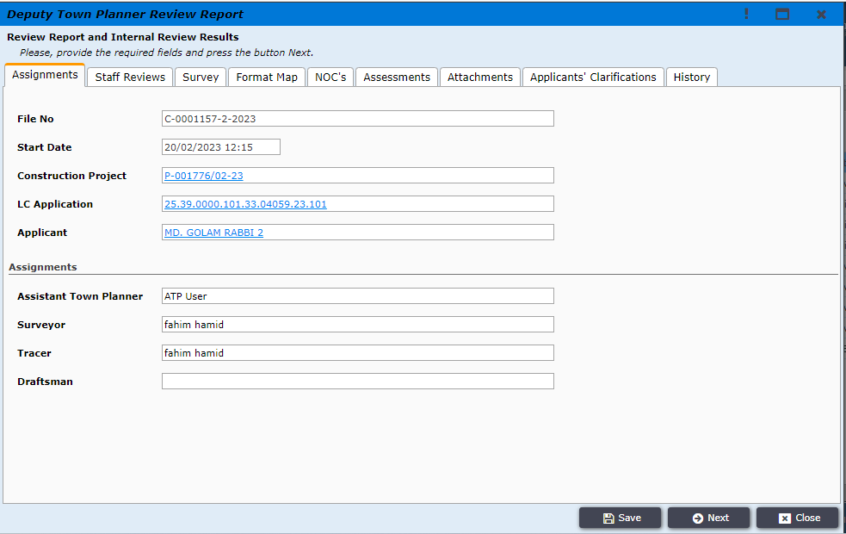
Figure 46

Here DTP user will find the option to either Request Optional Review (Request review from internal departments of RAJUK) or Request Report Correction (From Surveyor) or Request Clarification (From Applicant) or DTP can directly go to Make a Decision, as shown in Figure 47
If DTP user decides to request review comments for any internal department of RAJUK, then the user will click on Request Optional Review button.
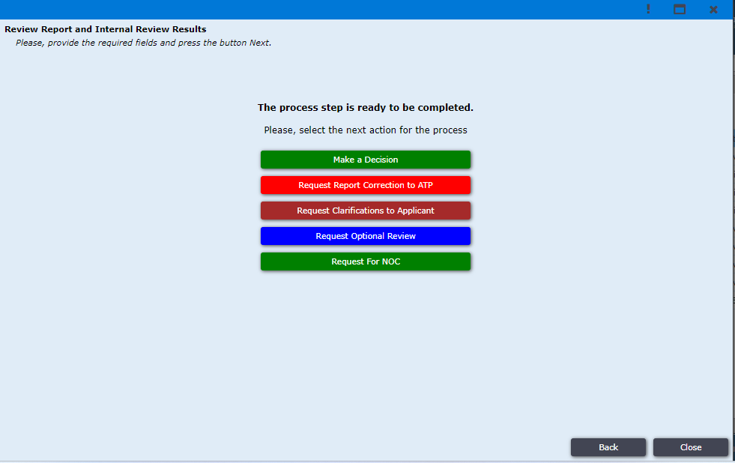
Figure 47

After DTP clicks on Request Optional Review the application will be available in Incoming section and DTP will have to click on the application again, as shown in Figure 48
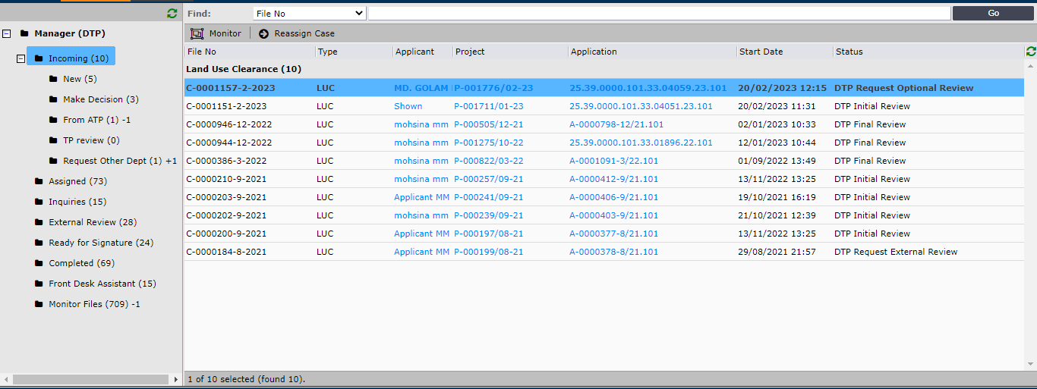
Figure 48
The system will prompt a new window where DTP will have to click on Next to go forward, as shown in Figure 49
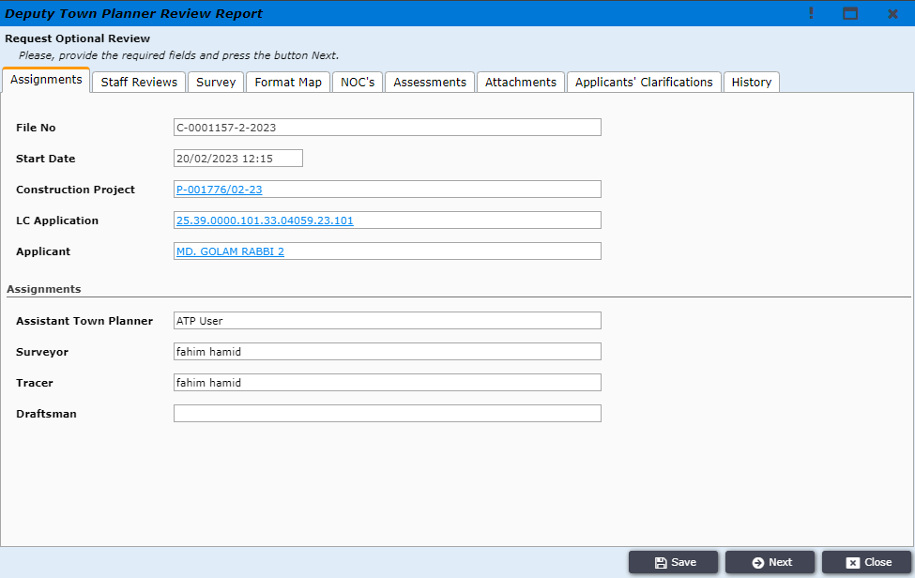
Figure 49
In this new window DTP will get the option to select a specific internal department of RAJUK where the users wants to forward the application for review, as shown in Figure 50 . The application will then be forawrded to the corresponding officers of that department.
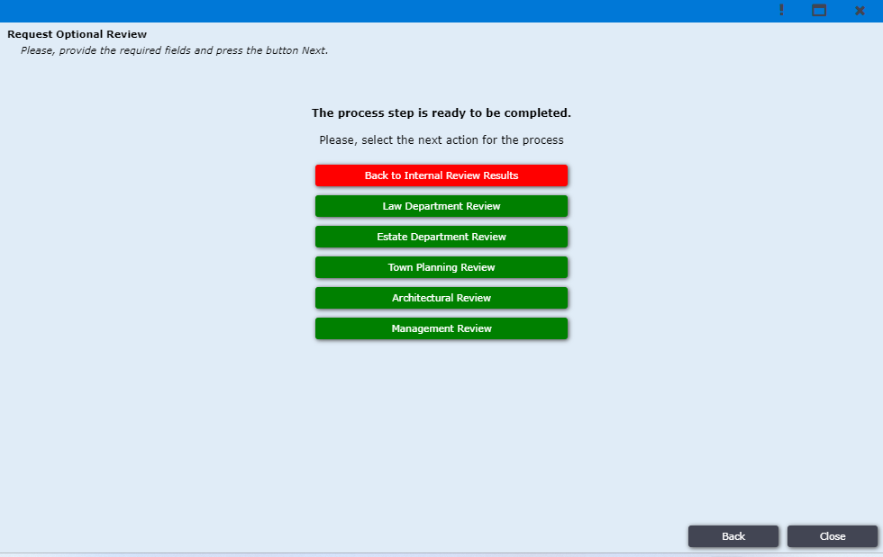
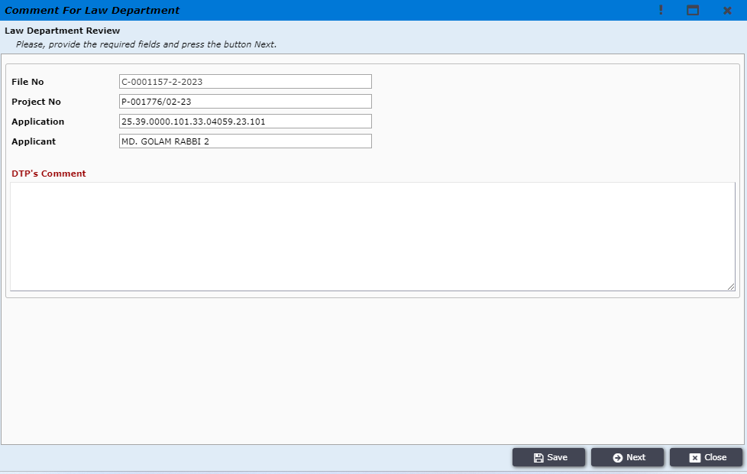
Figure 50

Once DTP user selects the Request Optional Review department then the application will be moved to External Review menu, as shown in Figure 51

Figure 51

As the DTP user forwarded the application to the Law Department the application will be forwarded to the designated users of Law Department (Assistant Law Officer, Law Officer and Director Law). Assistant Law Officer user will then login to the system and find the application in Case Review, as shown in Figure 52, where user will click on the application which the user would like to work on.

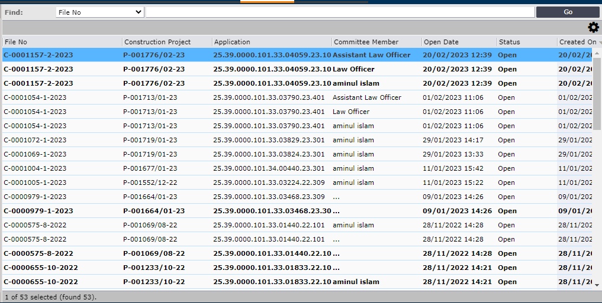
Figure 52

System will prompt a new window where Assistant Law Officer wil have to click on Next to proceed working on that applcation, as shown in Figure 53
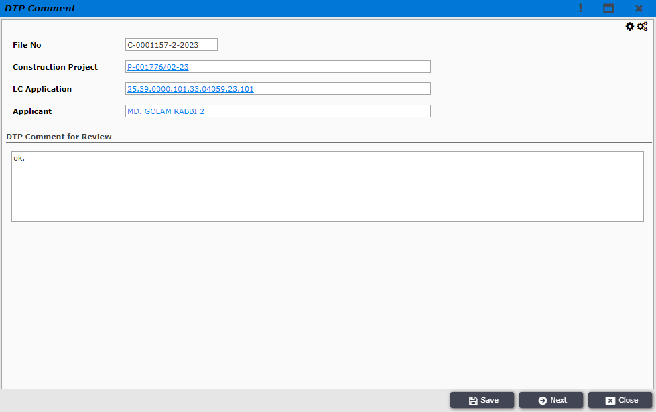
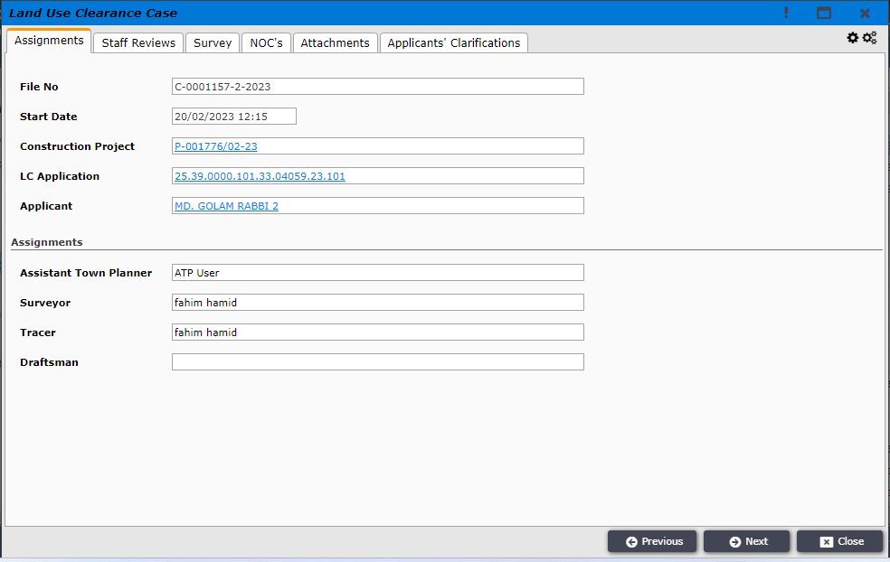
Figure 53

Upon clicking on Next system will guide Assistant Law Officer to a new window where the user will have to select Review Outcome and write Reviewer Notes, after completing assistant law officer will click on Next and the users work will be completed, as shown in Figure 54. Similarly Law Officer and Director Law will login to their own account and give their input as Review Outcome and Reviewer Notes for the same application. Once Assistant Law Officer, Law Officer and Director Law all three user submits their notes, the application will be forwarded to DTP.

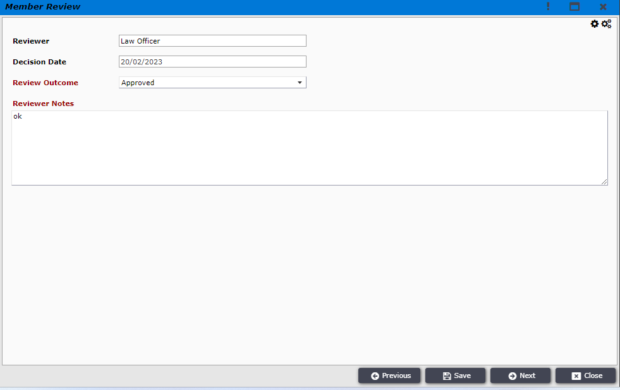
Figure 54

When all the user of the Law Department completes their review DTP usr will find the application in his Incoming section. DTP user will click on the application

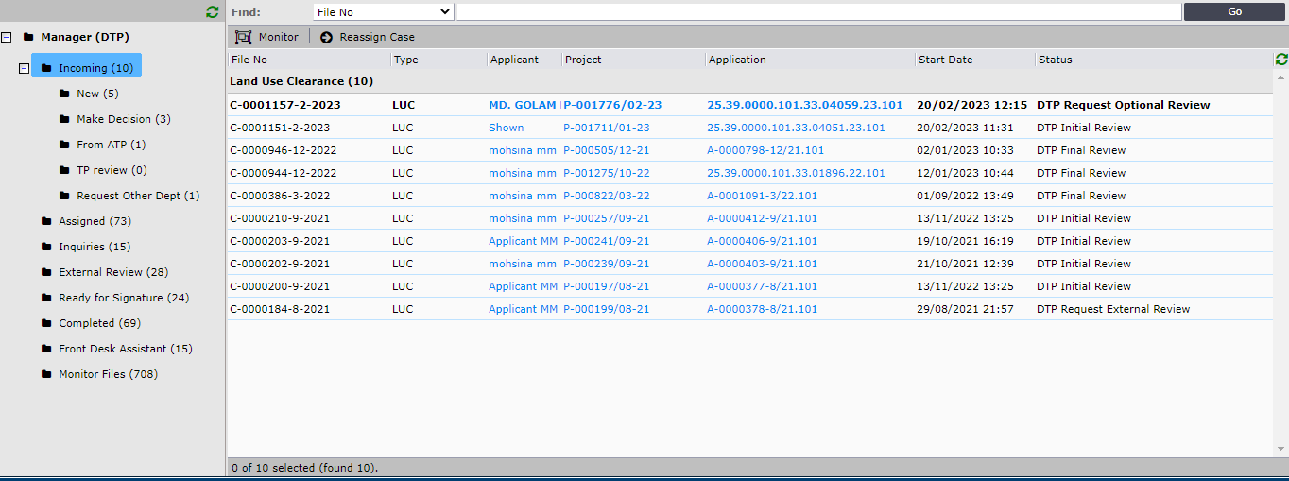
Figure 55

DTP user will click on the application and go to Assessments tab to check the assesments made by the users of the Law Department, as shown in Figure 56
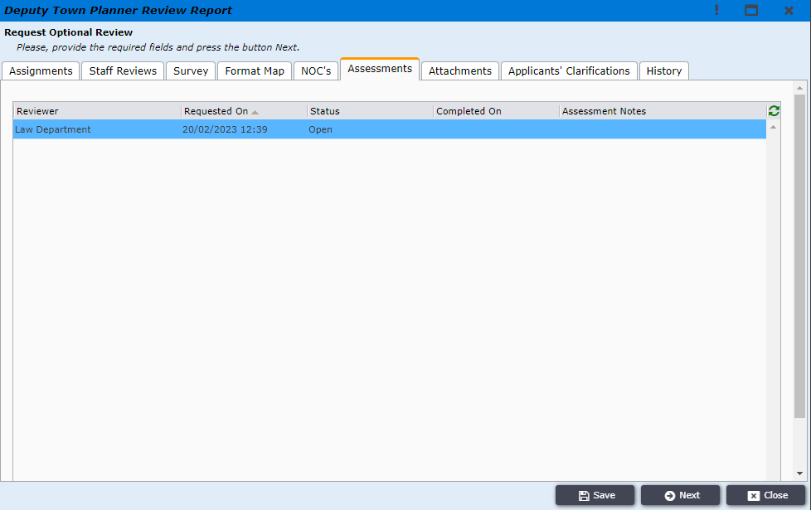
Figure 56

DTP user will click on the assessment to check the assessments made by the users of the Law Department and will then change the status and write his assessment notes and then click on Save and Close, as shown in Figure 57
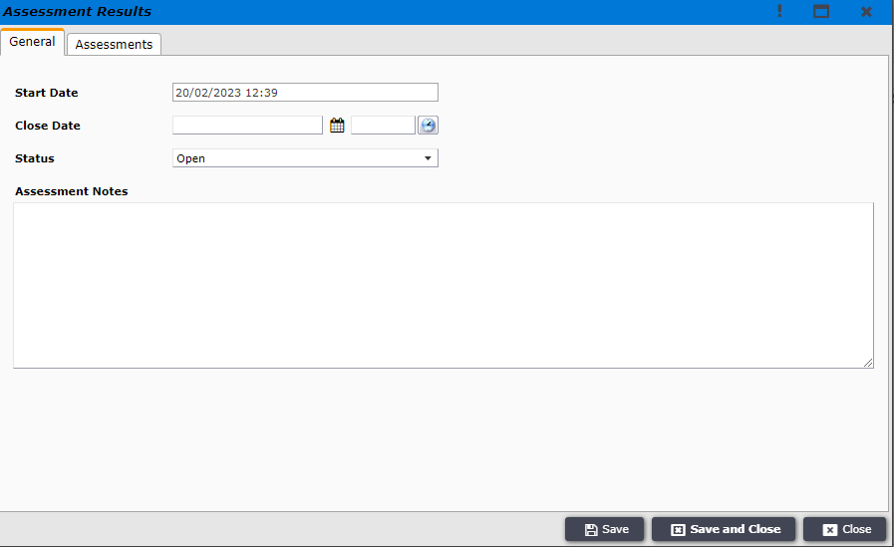
Figure 57

After that DTP user will click on Next, and the application will be moved to Request Optional Review section.

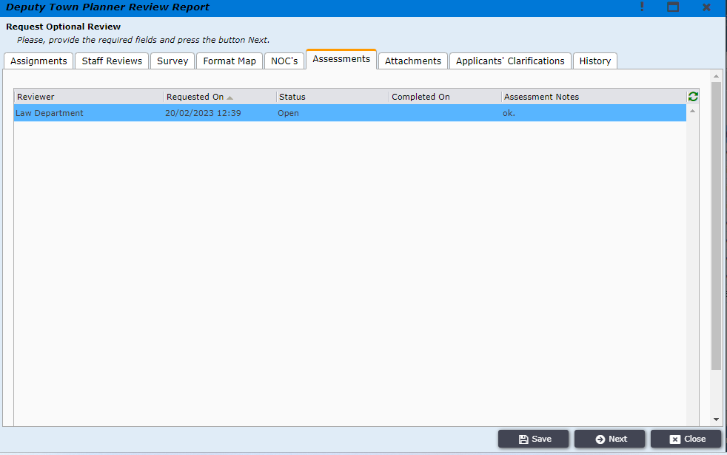
Figure 58

DTP user will then click on Back to Internal Review Results to go back to the incoming section, as shown in Figure 59
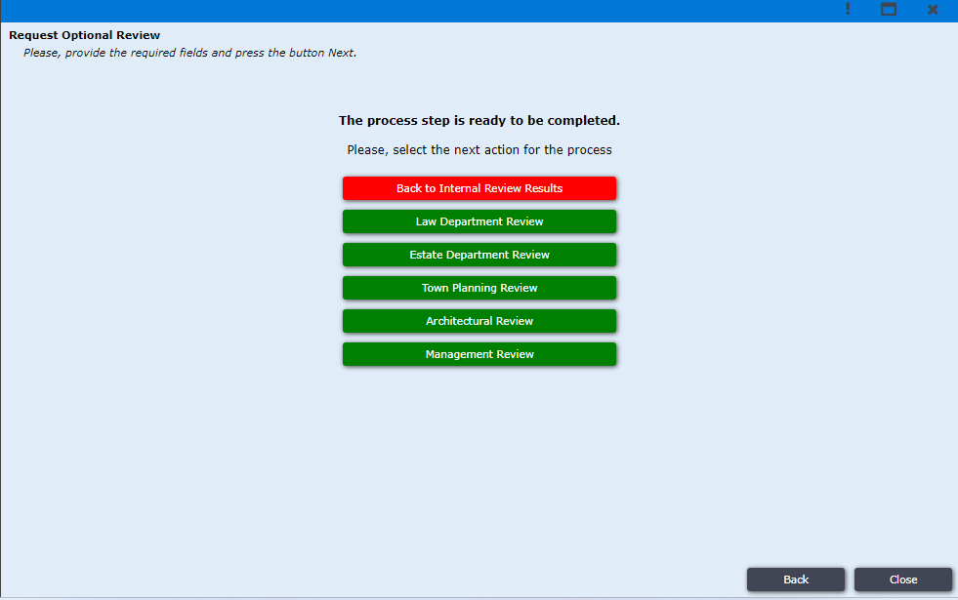
Figure 59

User will then click on the application and click on Next to proceed forward with this application.

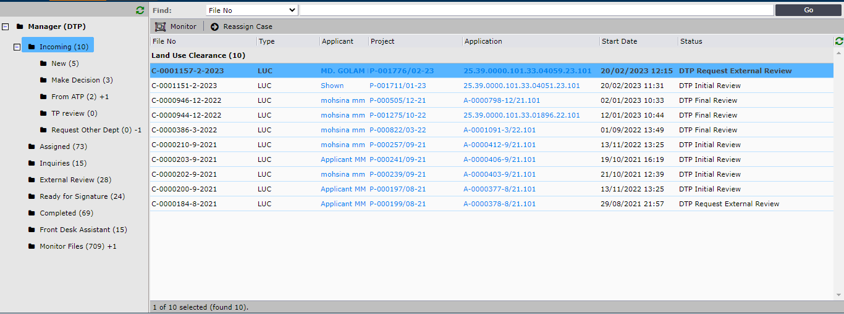
Figure 60

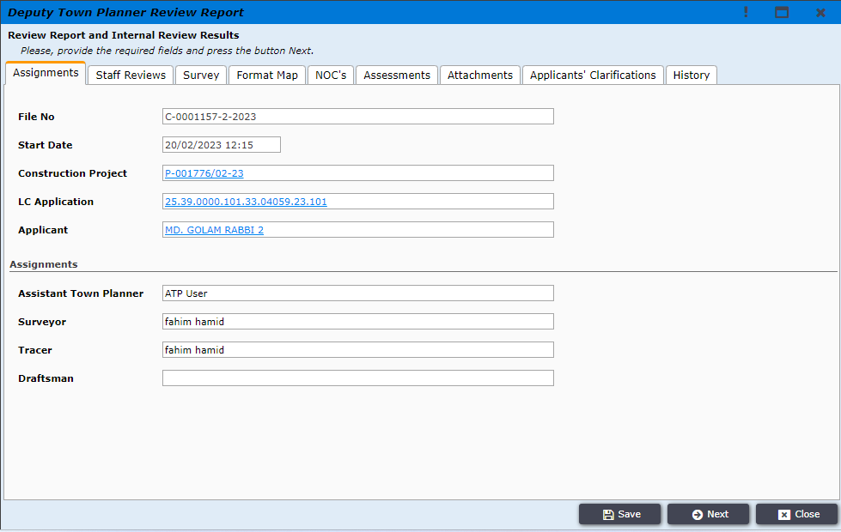
Figure 61
DTP user will click on Make a Decision to decide wheather to Accept or Reject this application, as shown in Figure 62
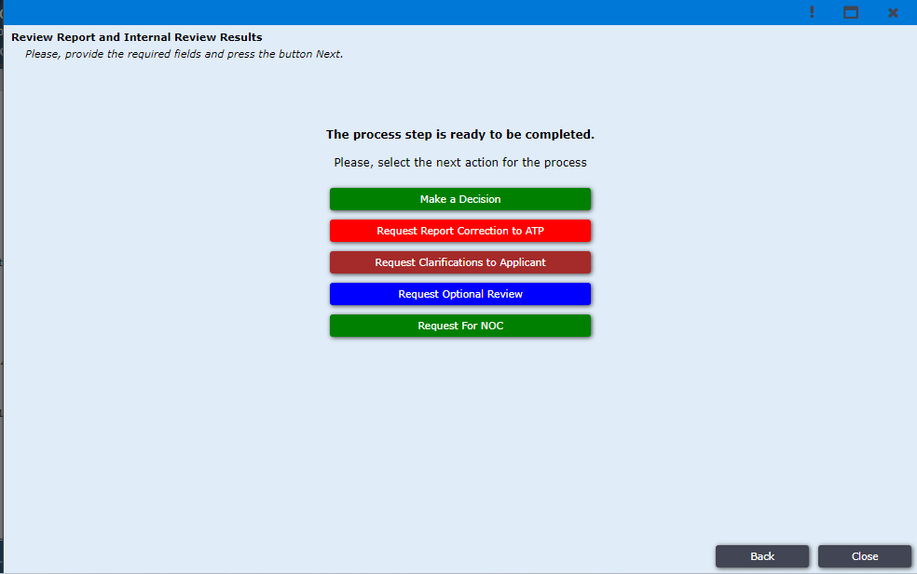
Figure 62

Application will be available in the Incoming section where DTP user will have to click on the application and the system will take the user to a new window where the user has to click on Next to select his final decision.
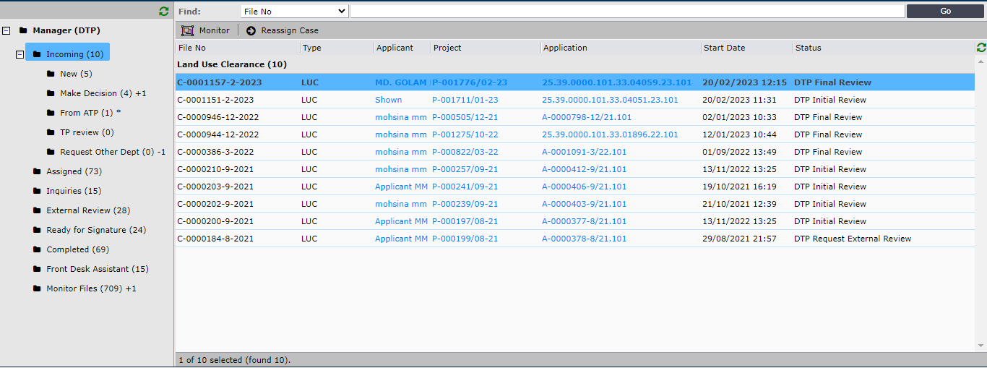
Figure 63
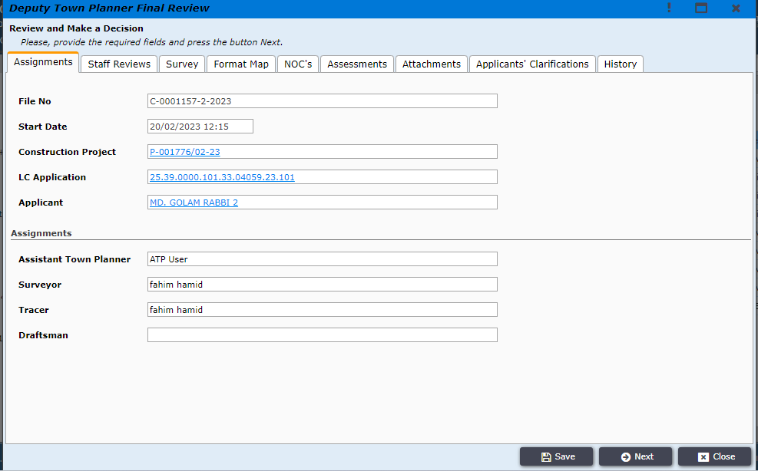
Figure 64

DTP user will have to make decision and click on Approve or Reject the application, as shown in Figure 65
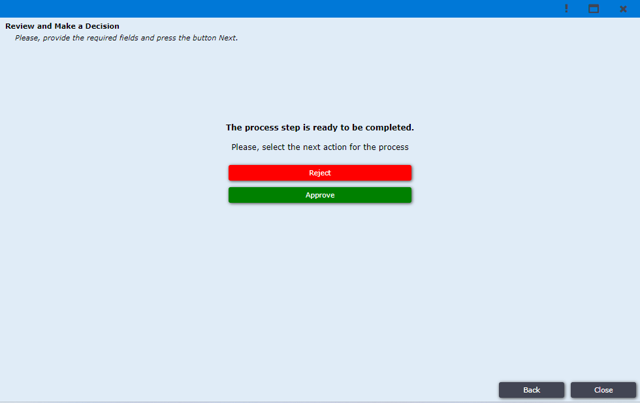
Figure 65

Once DTP user selects a decision the application is moved to Ready For Signature section and DTP user will have to click on the application and the system will request the user to write down Approval or Rejection Note, as shown in Figure 66
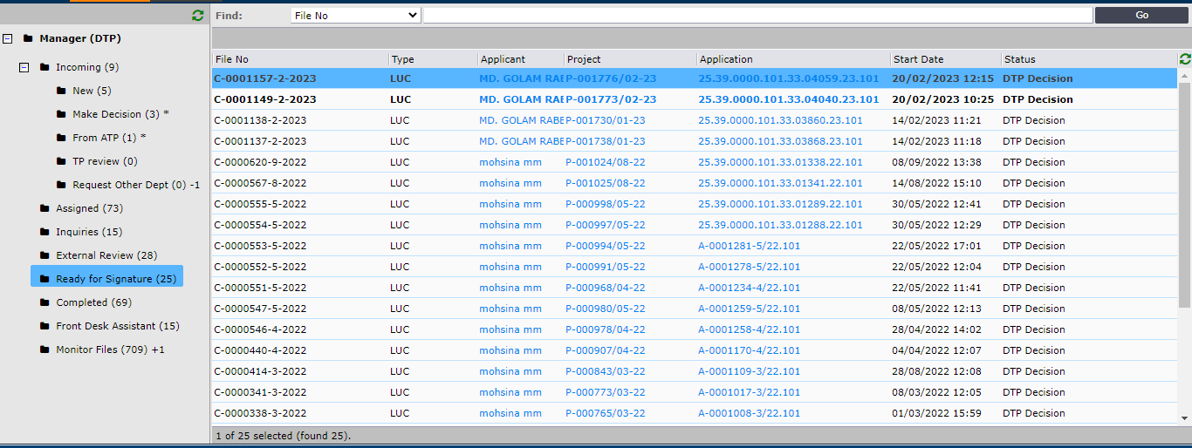
Figure 66

Afterwards the DTP user will have to click on Next button as shown in Figure 67
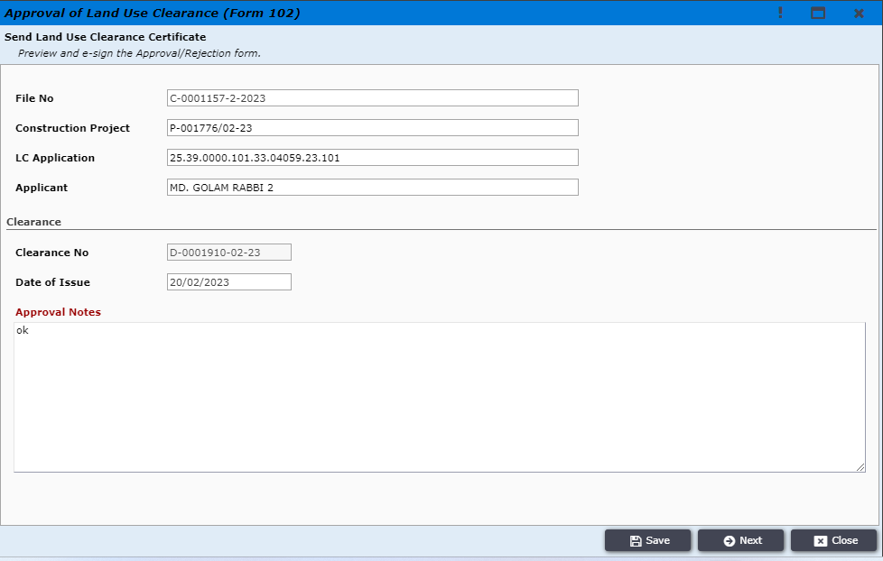
Figure 67

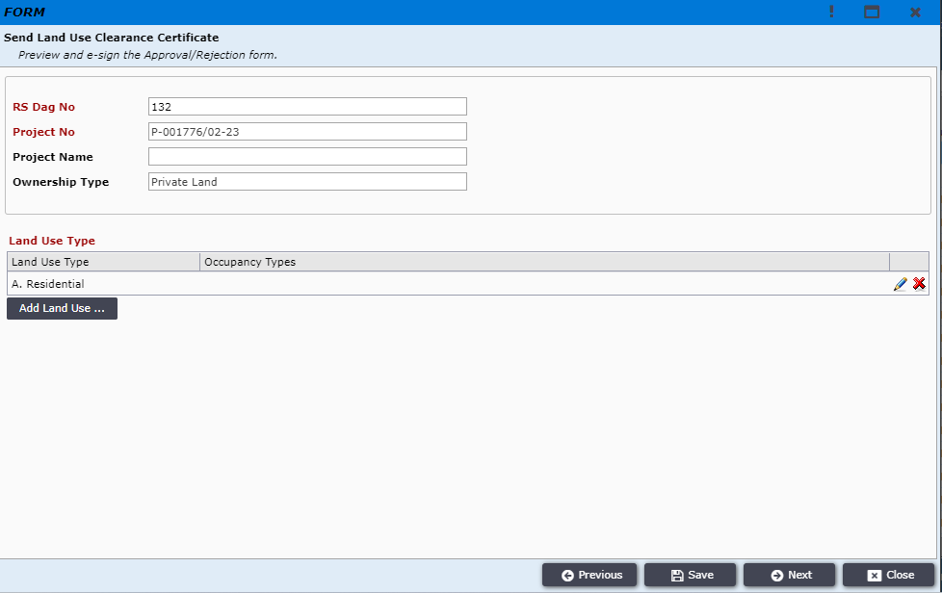
Figure 68

DTP will then Digitally Sign the Land Use Clearance Certificate and click on Next button, and then click on Send Official Response to send the official response to the Applicant
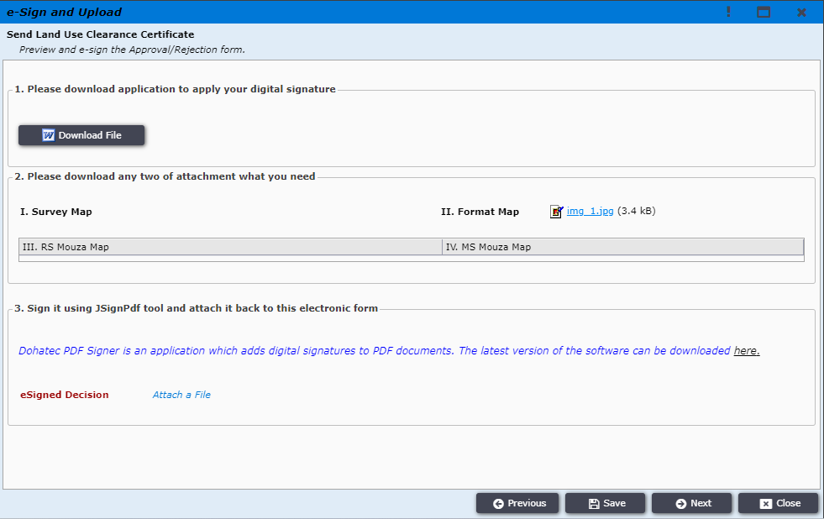
Figure 69

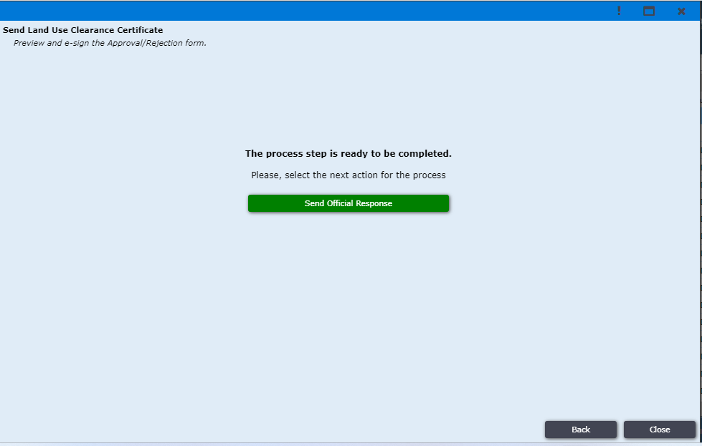
Figure 70

Applicant logins to the system and can find the permit under My Permits tab as shown in Figure 71.
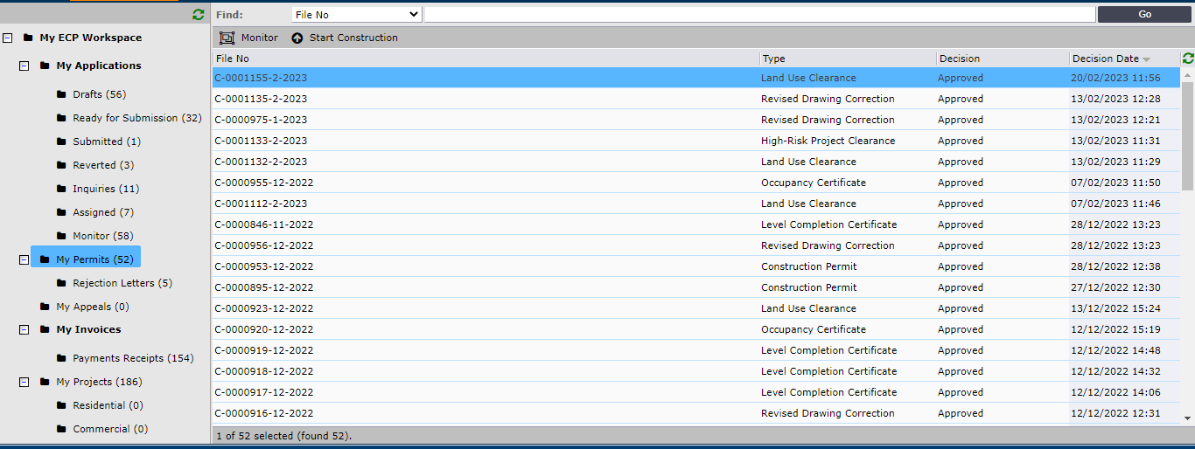
Figure 71
After clicking on the permit the window is opened to confirm receipt as shown in Figure 72. Applicant clicks on Next.
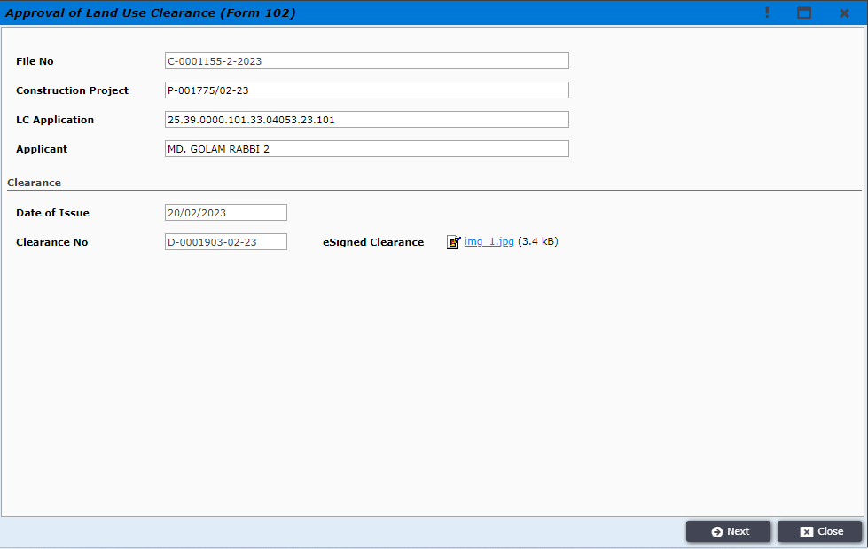
Figure 72

The window to confirm receipt is opened and the user clicks on Confirm Receipt button as shown in Figure 73.
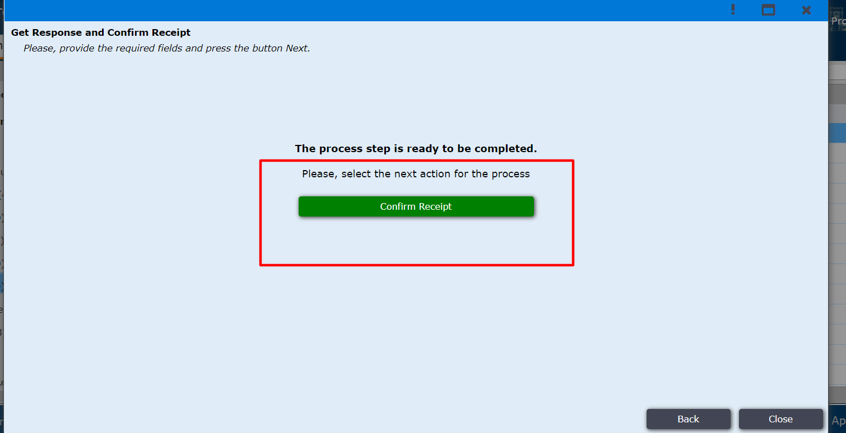
Figure 73
After clicking on it the Applicant gets the successful message as shown in Figure 74.
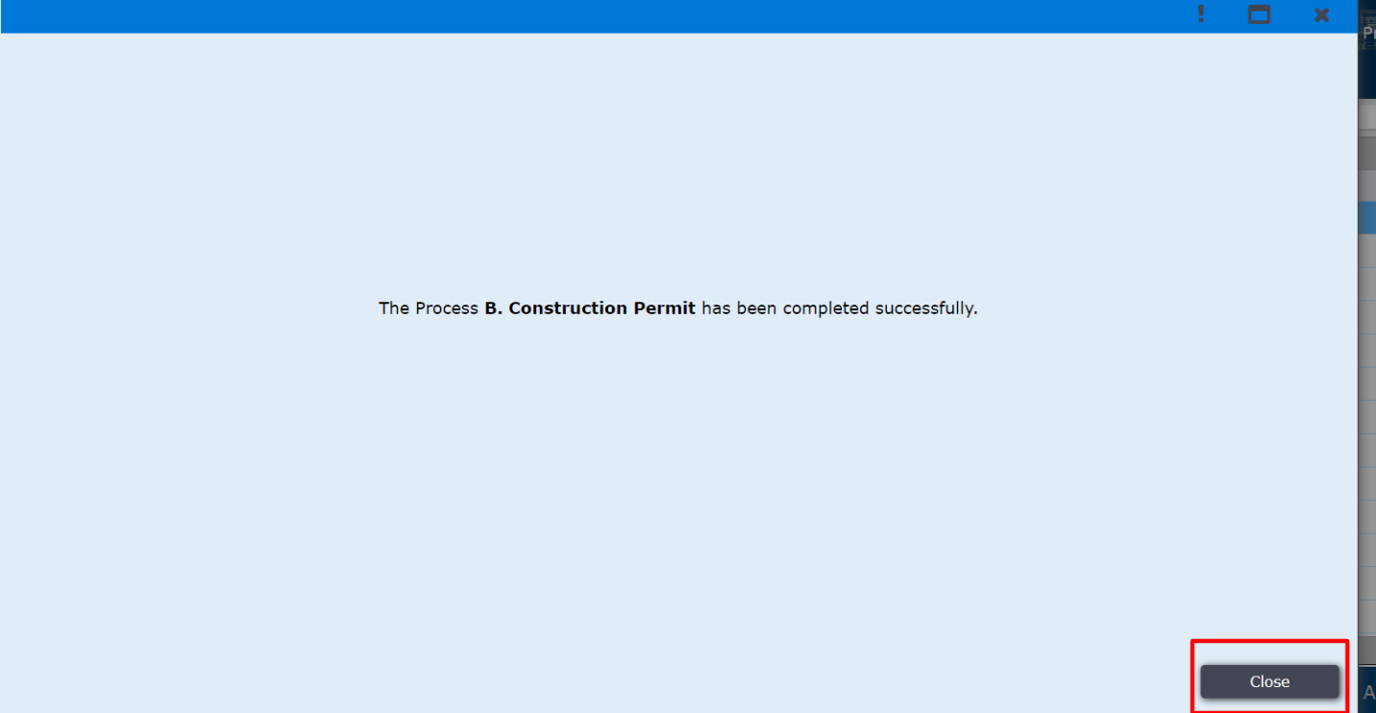
Figure 74

