CP PROCESS MANUAL
Authorized Officer (AO) accesses the Electronic Construction Permitting System Portal using the URL https://ecps.gov.bd/ and then clicking on “Login” button. Then AO will login to the system using his/ her username and password. The authorized Officer receives the application for Construction Permit when the Front desk assistant accepts the application. The authorized Officer will find the application in the Incoming section. Incoming files are sorted from Recent to Oldest. Also, there are some sub-folder as per AO’s action on the application. AO will have to click on the Application he wants to proceed with. As shown in Figure 1
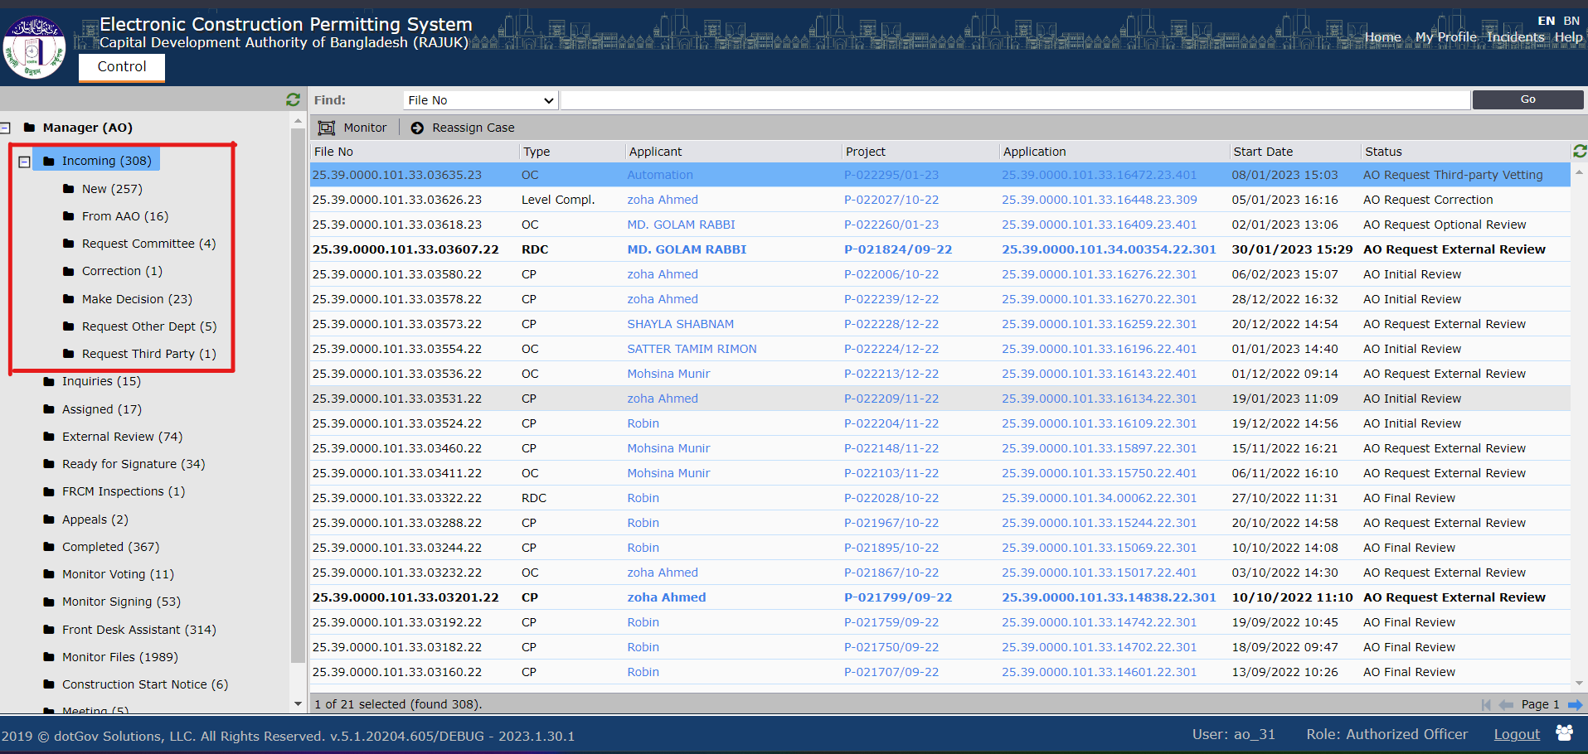
Figure 1
A new pop-up window will appear when AO clicks on any incoming application. AO will have access to four different tabs Assignments, Attachments, Applicants’ Clarifications, and History. AO will check all the available information on the application. AO can check the applicant’s details information by clicking on the Applicant name link as shown in Figure 1.1.

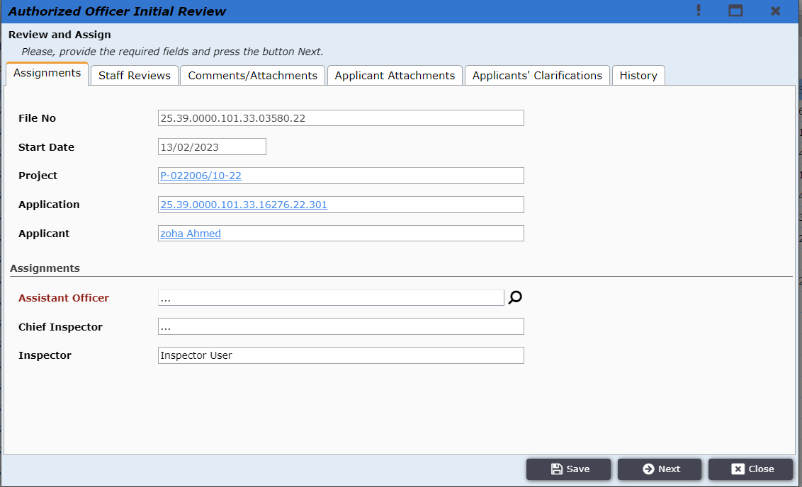
Figure 1.1
After clicking on the link a pop-up will show up containing the applicant’s details. AO user can close it by clicking on the “Close” button as shown in Figure 1.2.

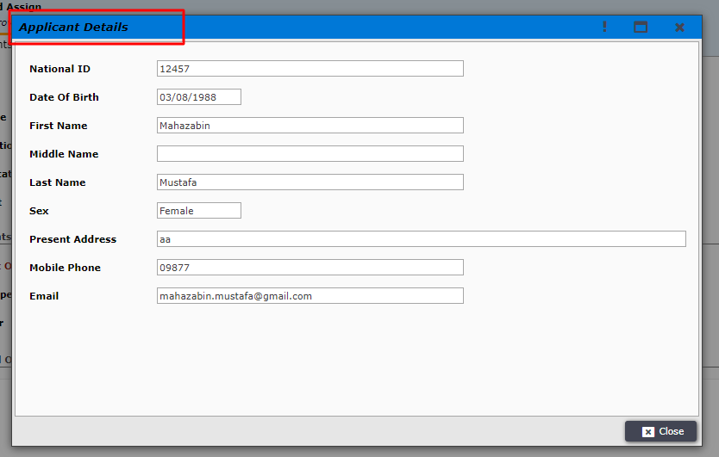
Figure 1.2
AO can click on the project link to see the main project details as shown in Figure 1.3.
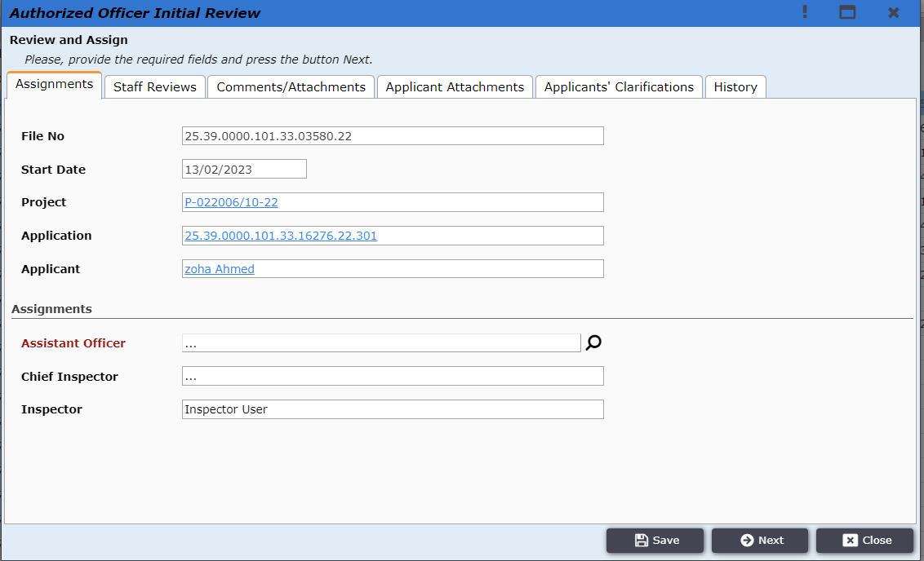
Figure 1.3
After clicking on the project link the project details window will pop up as shown in Figure 1.4. There the links to the LUC of the same project can be found. And AO can click on it to check the details of the LUC.
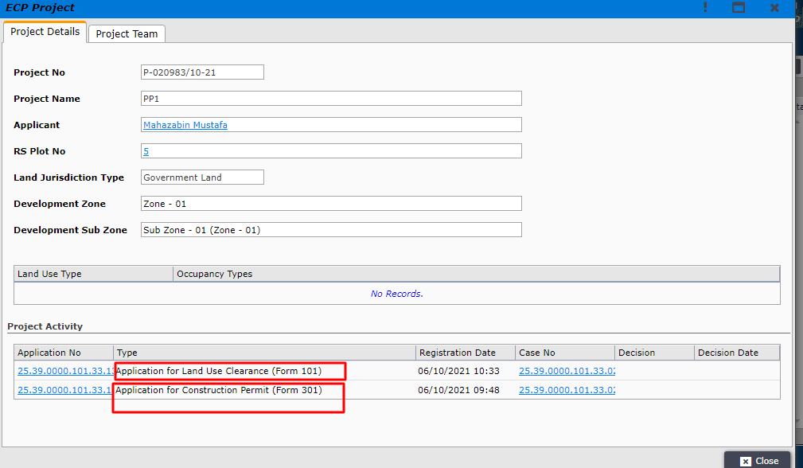
Figure 1.4
The LUC case details will be shown in Figure 1.5 and application details in Figure 1.6.
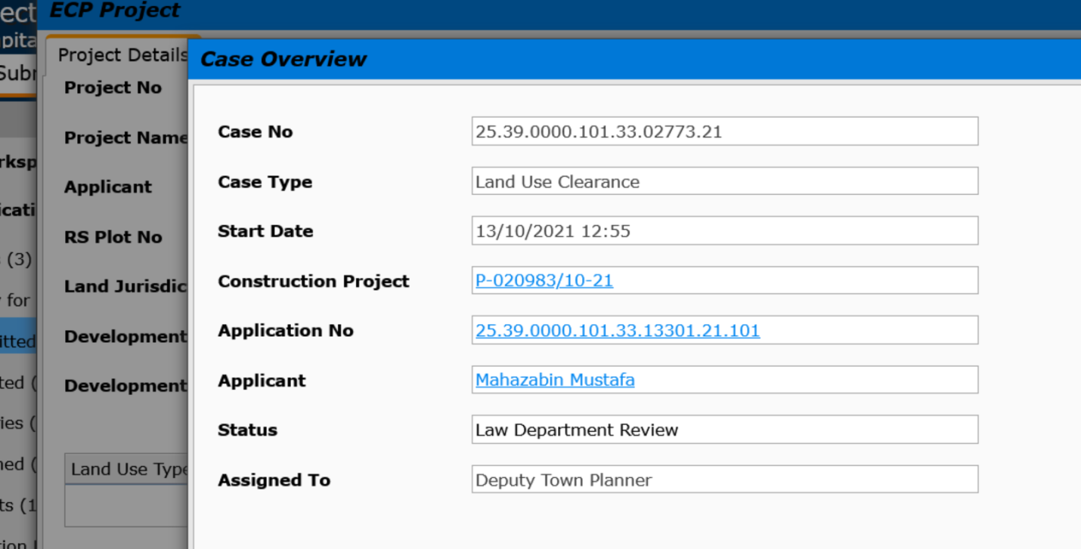
Figure 1.5
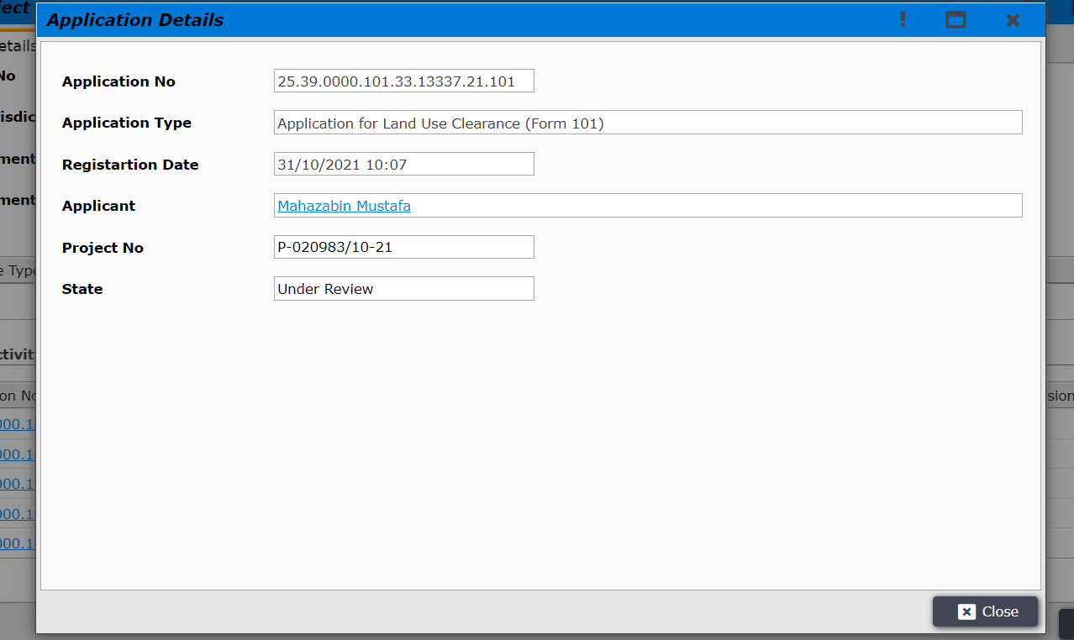
Figure 1.6

The authorized officers can select Assistant AO by clicking on the search button as shown in Figure 2.
Figure 2
After clicking on the search button the AO will select the specific AAO from the pop-up window as shown in 2.1 and click “Close” after selecting the AAO.
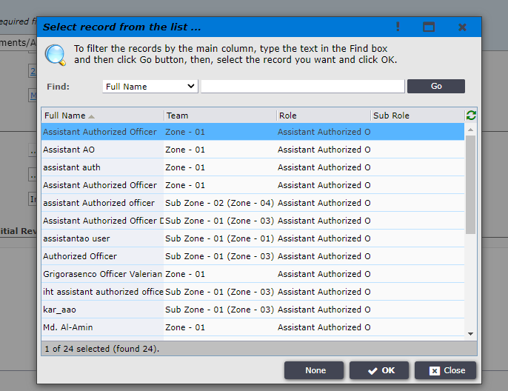
Figure 2.1
After checking all the tabs AO will go to the Staff Review tab :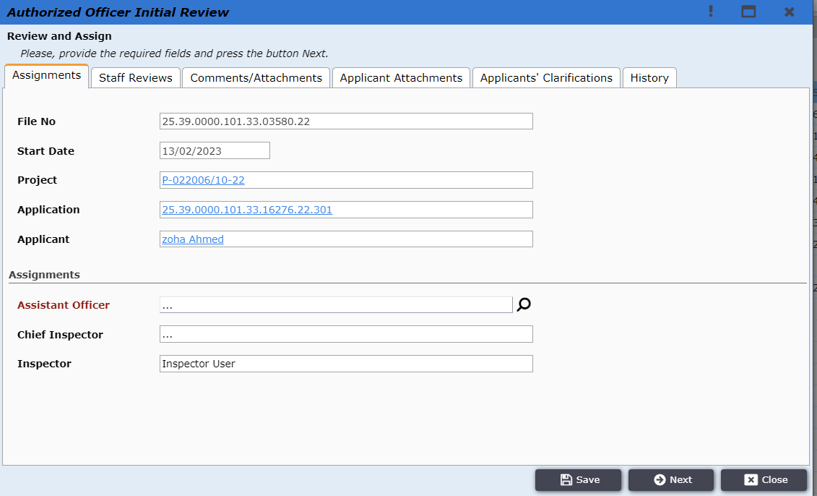
Fig 2.2

In the Staff Review tab, AO will give an initial review and attachments about this file in fig 2.3
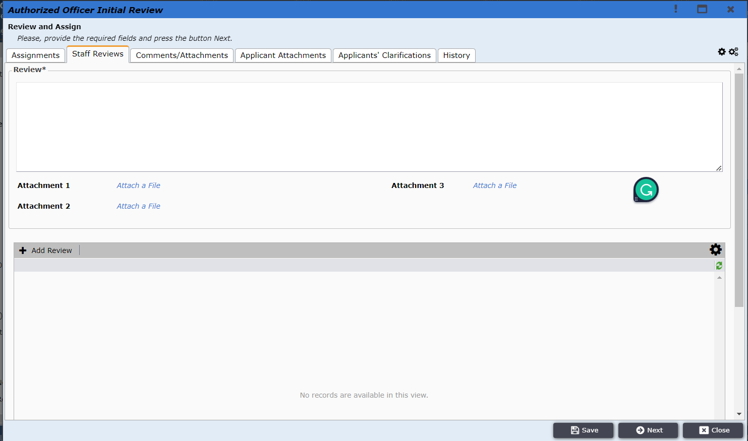
Figure 2.3

After giving Initial Review comments and press ‘Next’ as shown in Figure 2.4.
Figure 2.4

AO will now find the option Assign to Assistant Authorized Officer as shown in Figure 3 and click on it. The application will be sent to AAO.
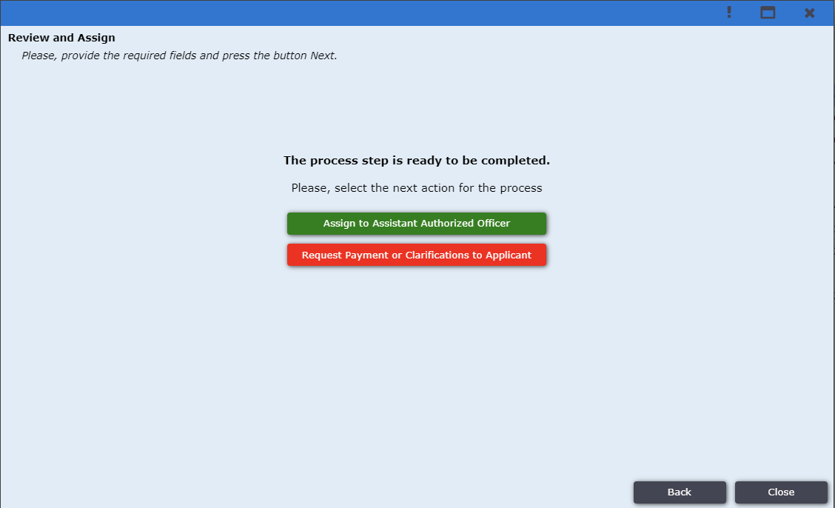
Figure 3

The application goes under the ‘Assigned’ tab after the AO user assigns the application to AAO. The image is shown in Figure 3.1.
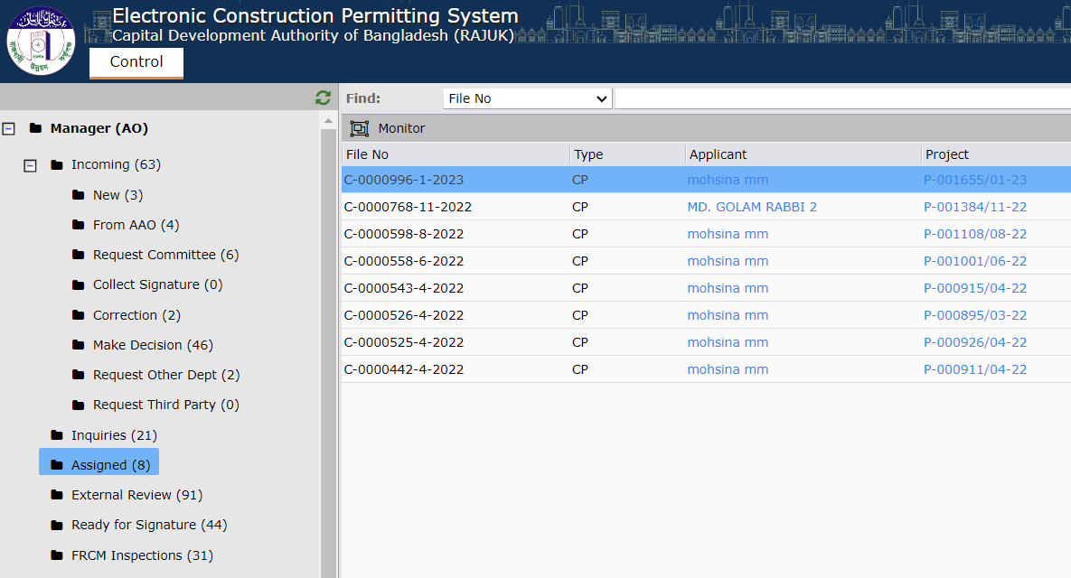
Figure 3.1

There are another Button Request Payment or Clarification to Applicant. After clicking on this button new form will come shown in Figure 3.2. And then AO user click on “Yes” if Additional Payment is required. After clicking this new field pop up and have to give payment amount. Also he put some text what clarifications he need. After clicking Next file will go to applicant. If applicant send the clarifications and payment the file will come in NEW sub folders.
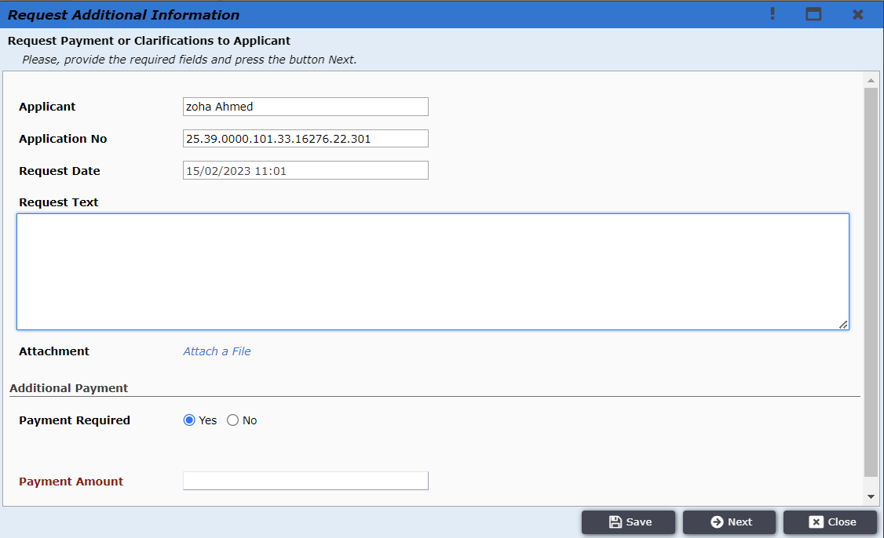
Figure 3.2

AAO logs in to the ECP system and in his dashboard all the incoming applications will be found in the Incoming tab. As shown in Figure 4
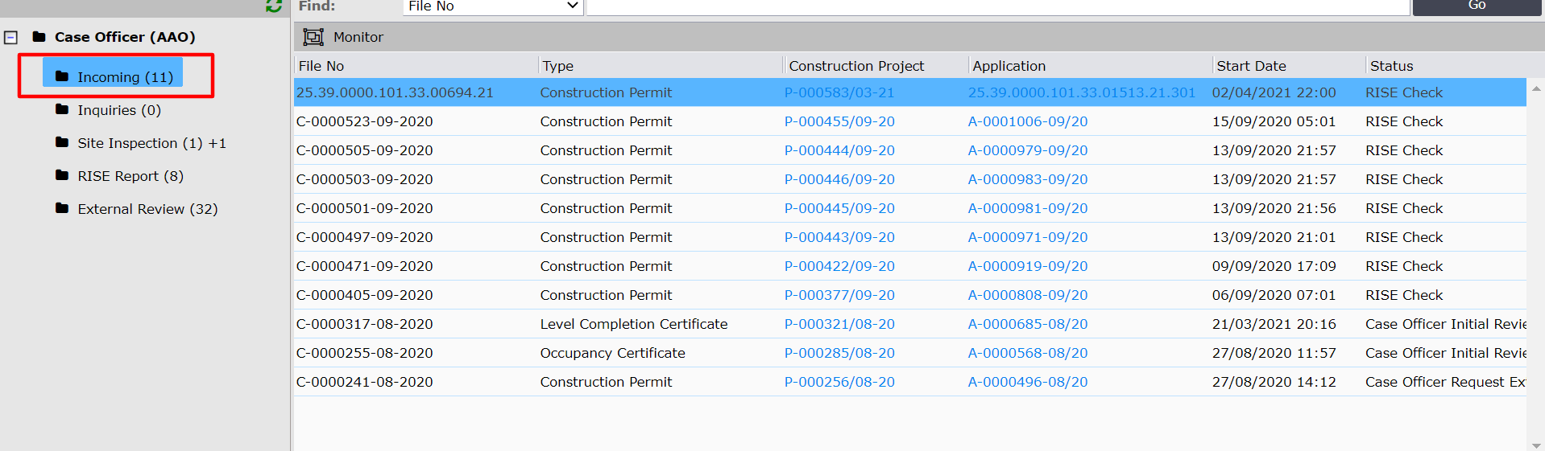
Figure 4
AAO clicks on the application the pop window will open as shown in Figure 4.1. AAO will be able to view the tabs Assignments, Staff Reviews, Attachments, Applicant’s Clarifications, and History. The tab information is shown in Figures 4.1, 4.2, 4.3, 4.4 and 4.5.
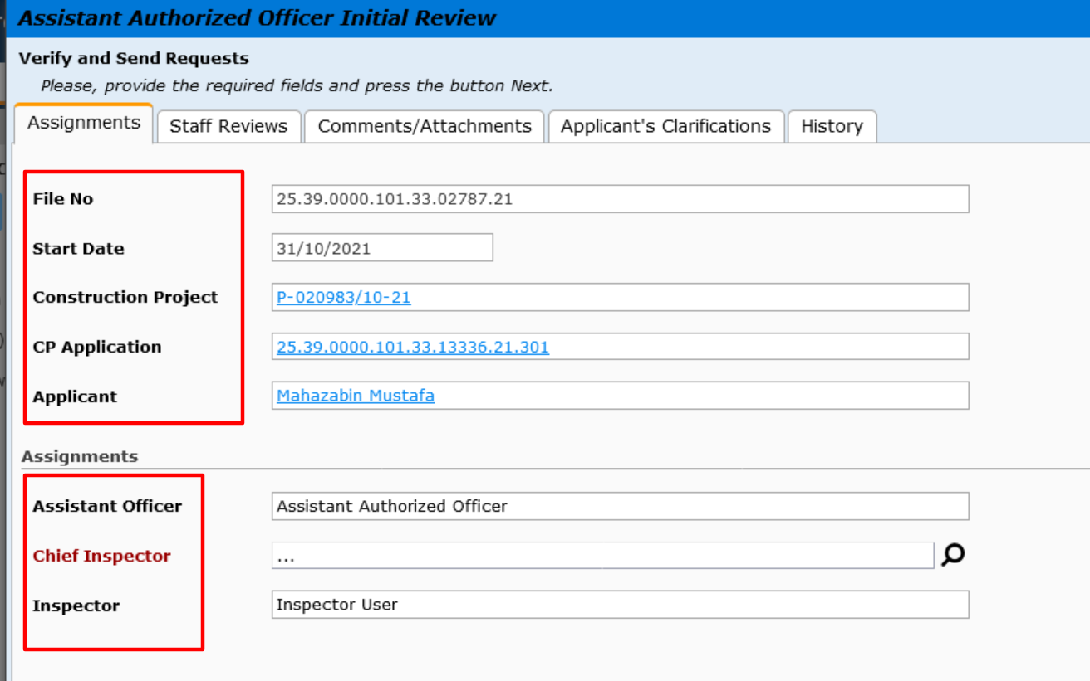
Figure 4.1
The AAO can check AO’s review and attachment and provide his review and attachment about this file shown in fig 4.2
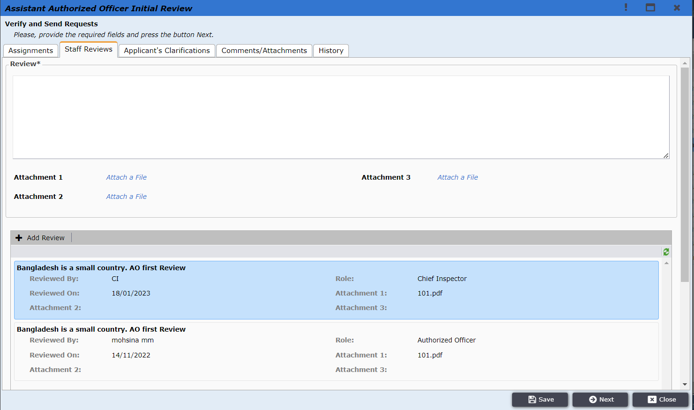
Figure 4.2

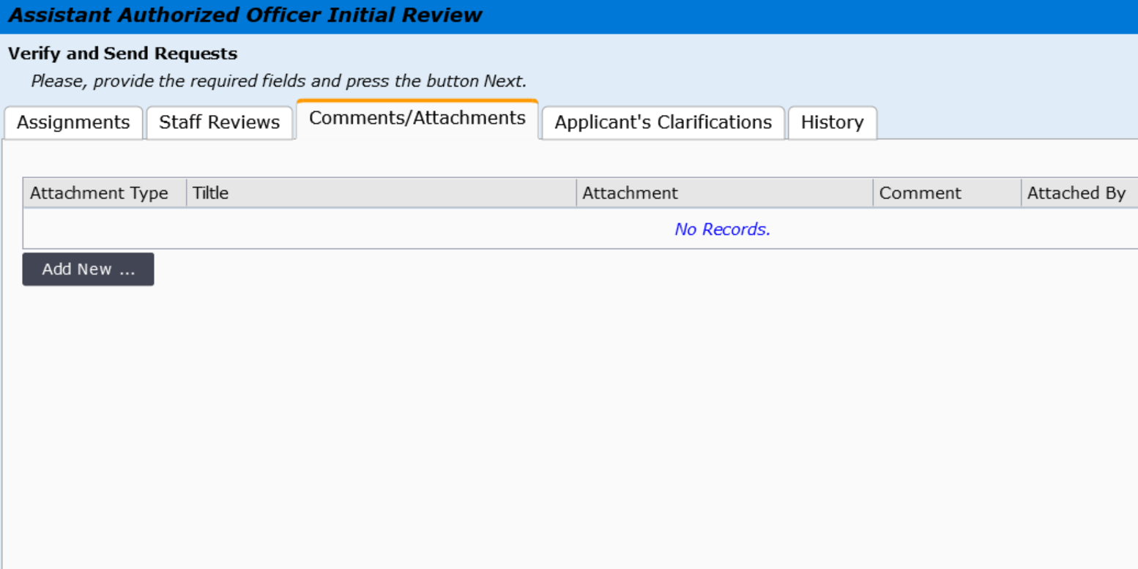
Figure 4.3

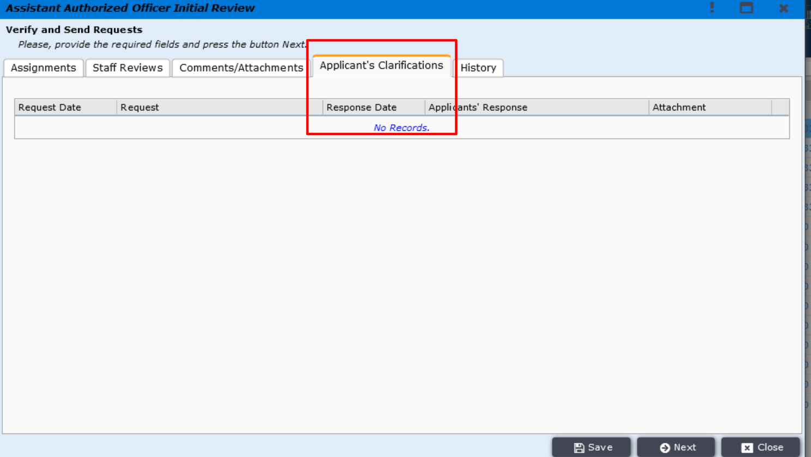
Figure 4.4

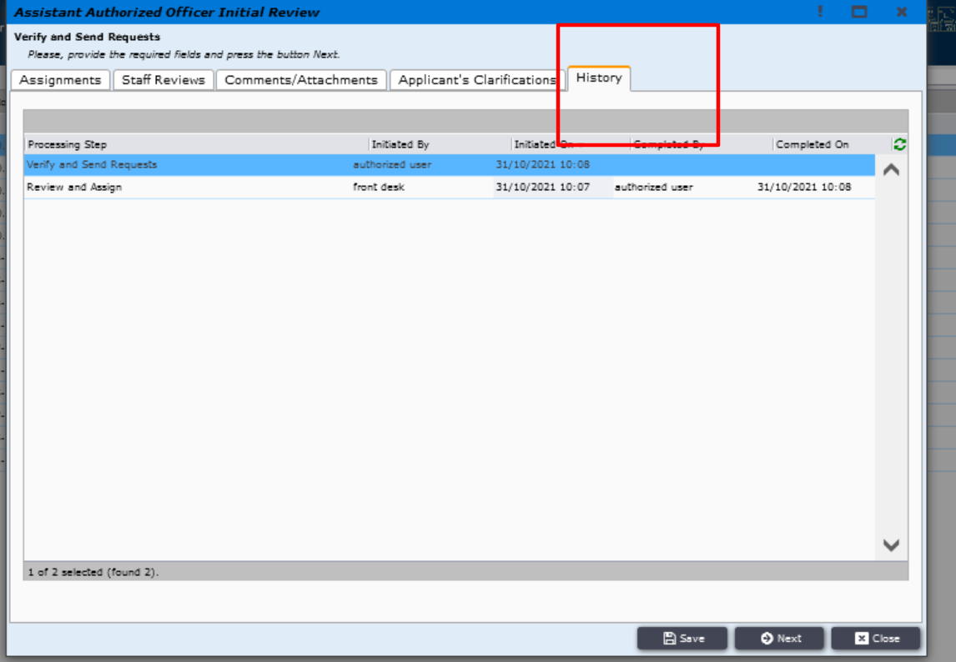
Figure 4.5
After clicking on the construction project link as shown in Figure 4.6, the project details window will pop up as shown in Figure 4.7. There the links to the LUC of the same project can be found also. And AAO can click on the link to check the details of the LUC.
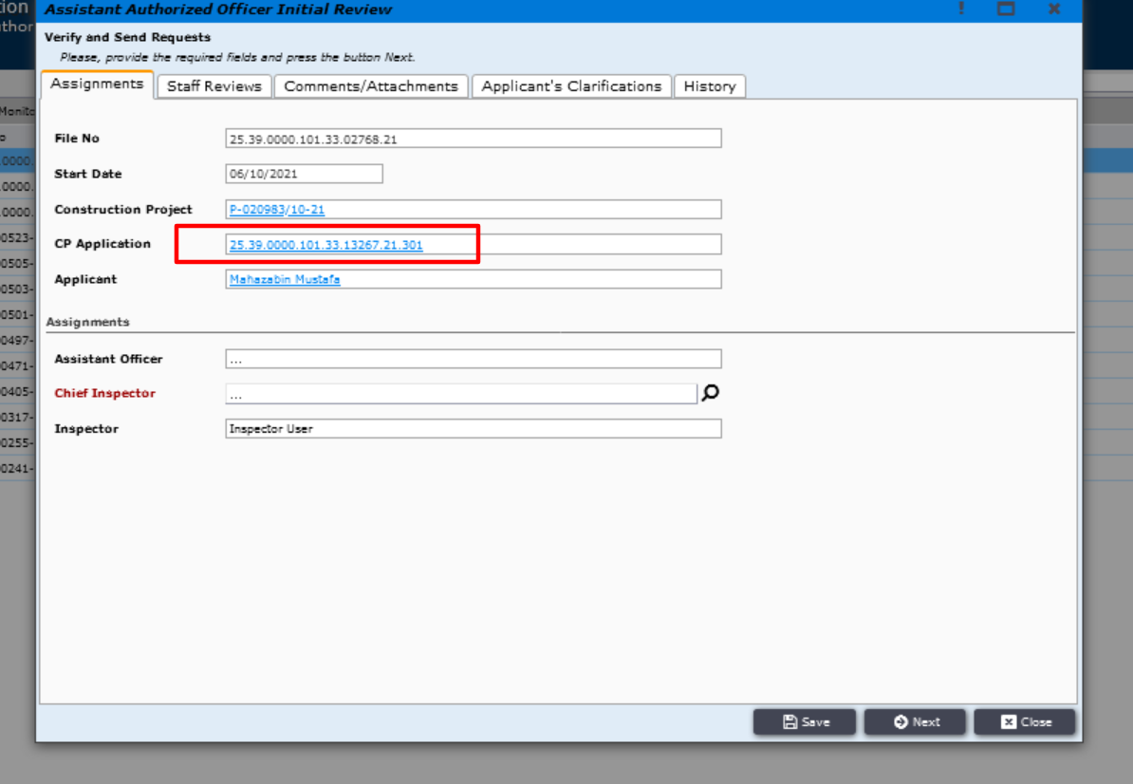
Figure 4.6

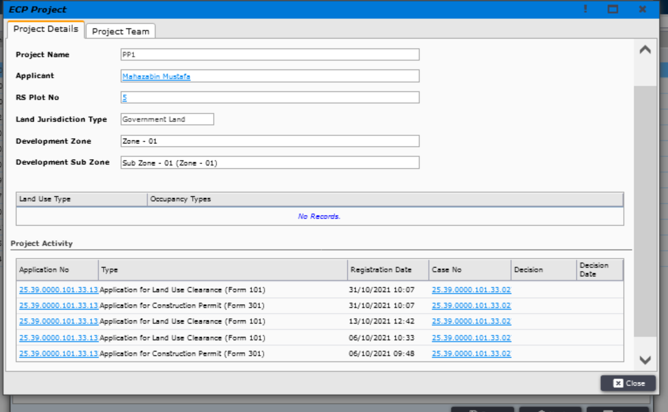
Figure 4.7
After filling up the desired field the AAO needs to click on Next.
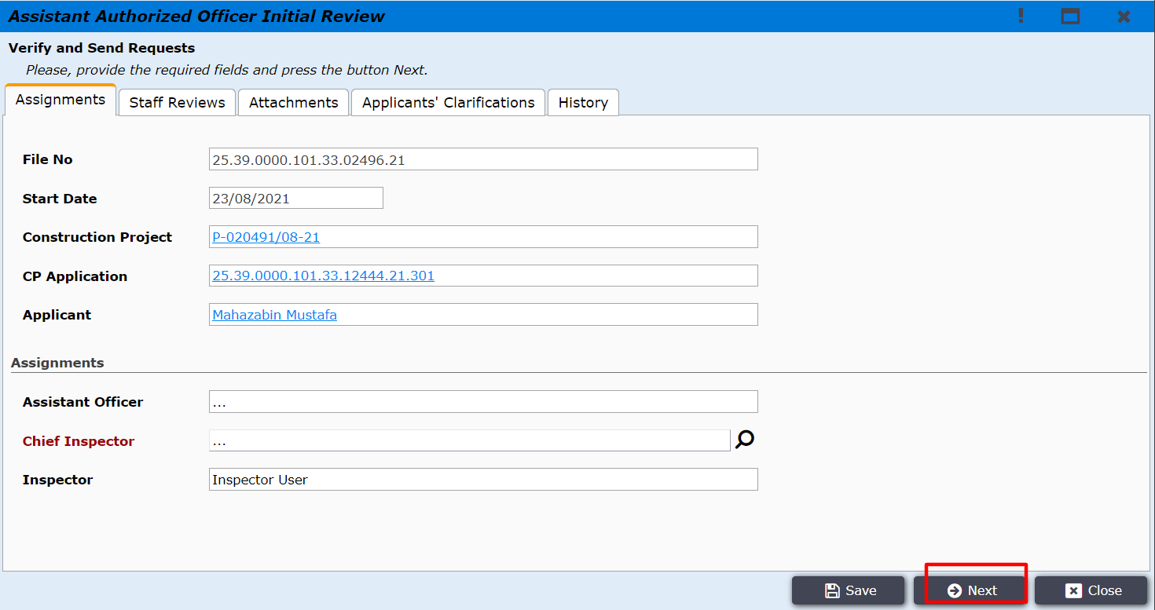
Figure 5
AAO can select Chief inspector from Assignments tab before clicking ‘Next’ as shown in Figure 6.
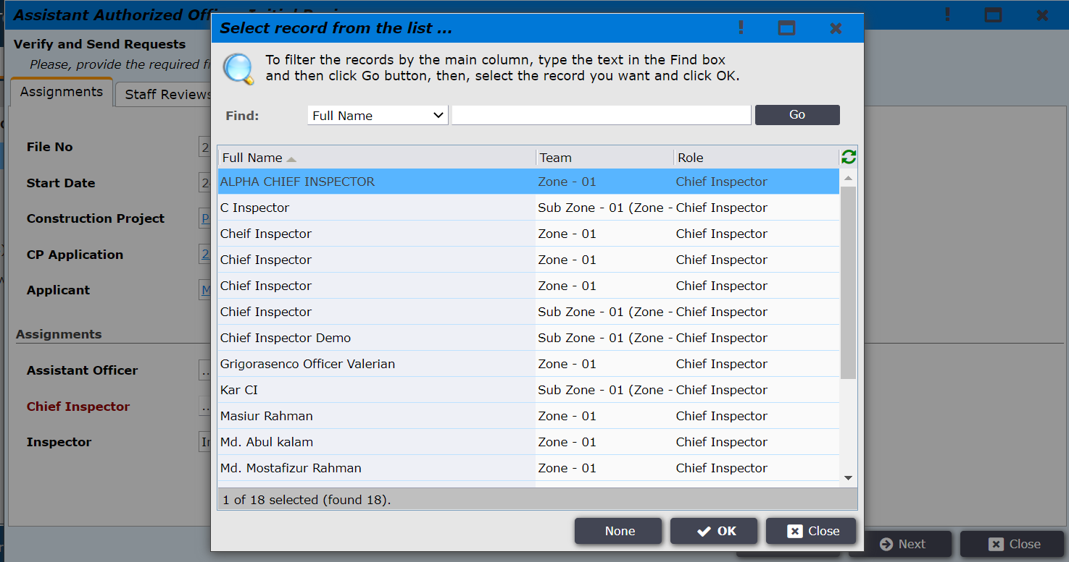
Figure 6

After clicking ‘Next’, the user is taken to the window as shown in Figure 7 to write comments and add attachments in the Staff Reviews tab.
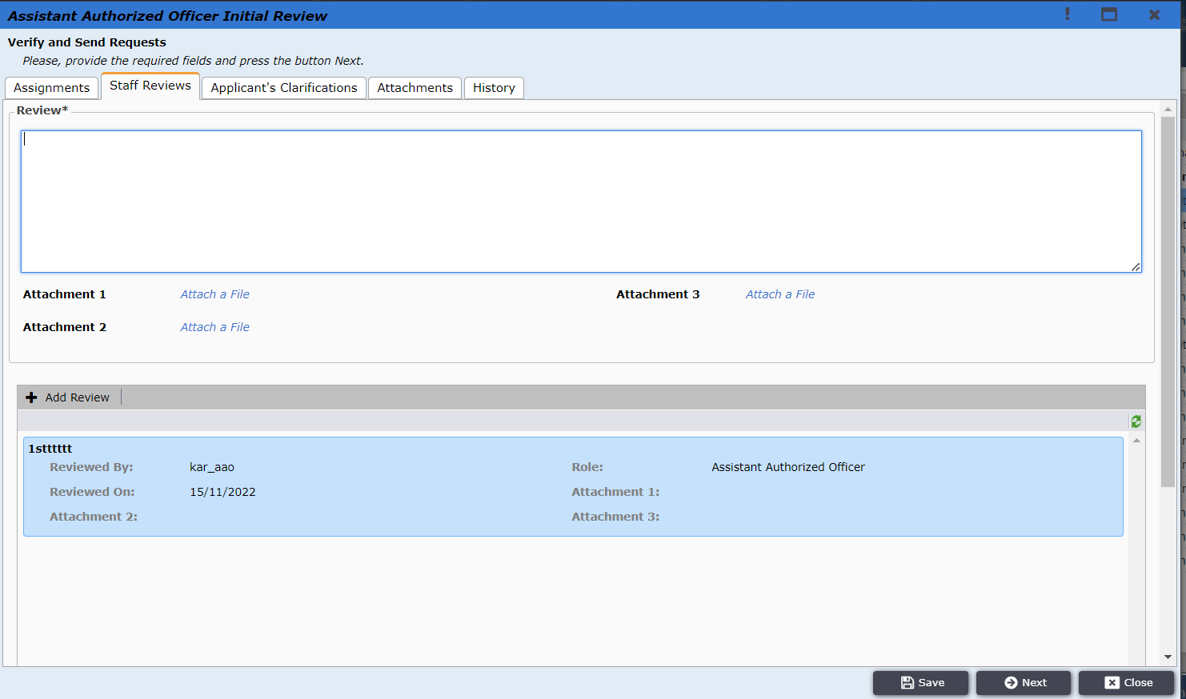
Figure 7
After clicking Next, the pop-up window will be shown with the Request Inspection button as shown in Figure 8. AAO will click on the button to send the application to the chief inspector. AAO can also revert the application back to the AO by clicking the Revert button.
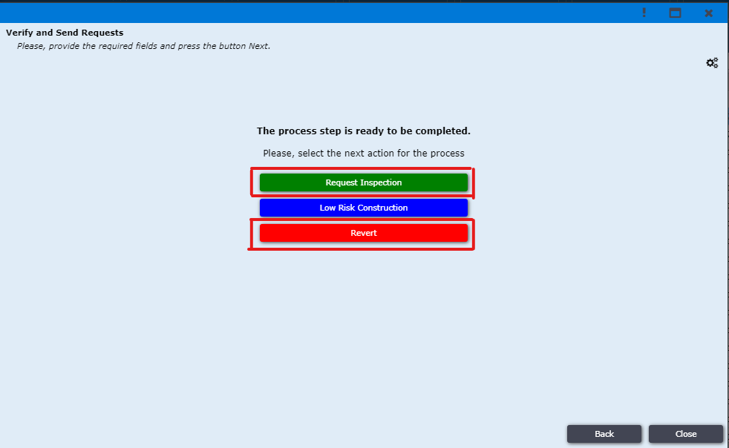
Figure 8

The application is then moved to AAO’s Site Inspection folder. Recently sent file will bold which still not open by Chief Inspector. As shown in Figure 8.1.
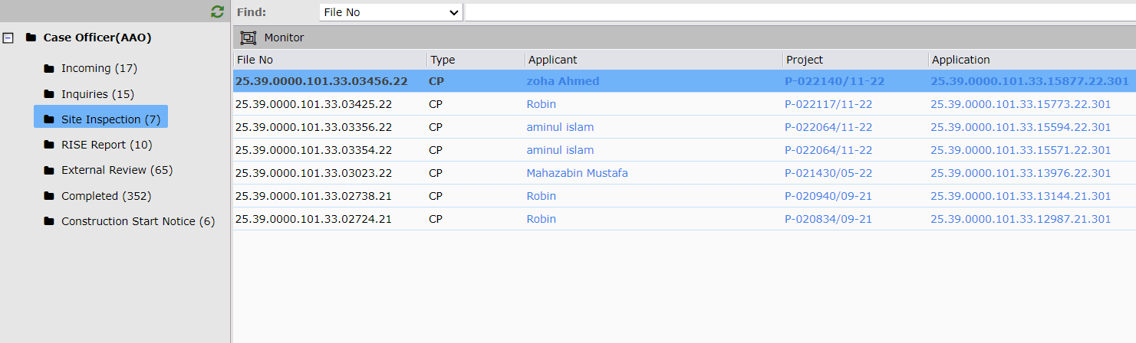
Figure 8.1
Chief Inspector receives the application in his Incoming folder. As shown in the image Figure 9.
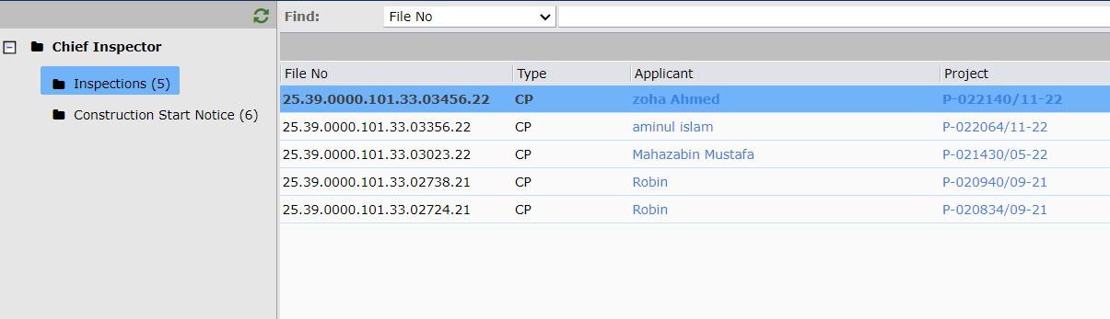
Figure 9
After the Chief Inspector clicks on the application the pop-up window will show up as in Figure 10. He can view the information of the tabs Assignments, Staff Reviews, Attachments, Applicants’ Clarifications, and History.
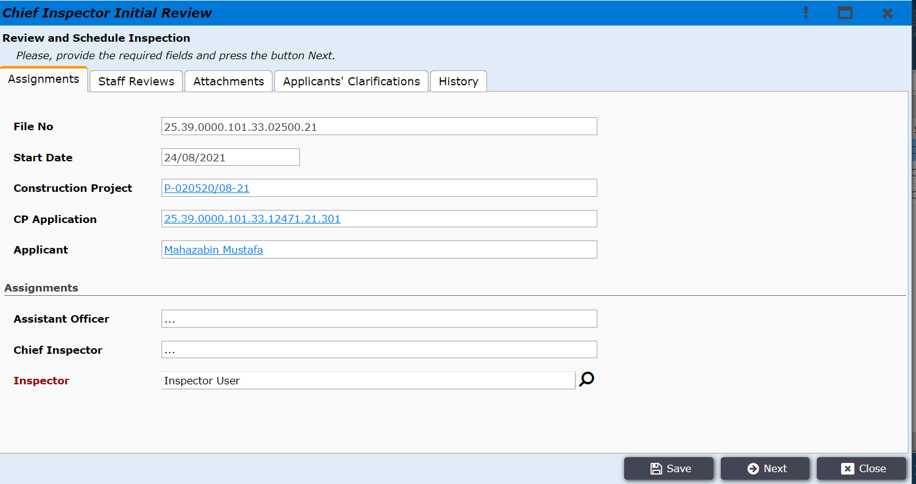
Figure 10
The Chief Inspector can click on the Construction Project link as shown in Figure 10.1.
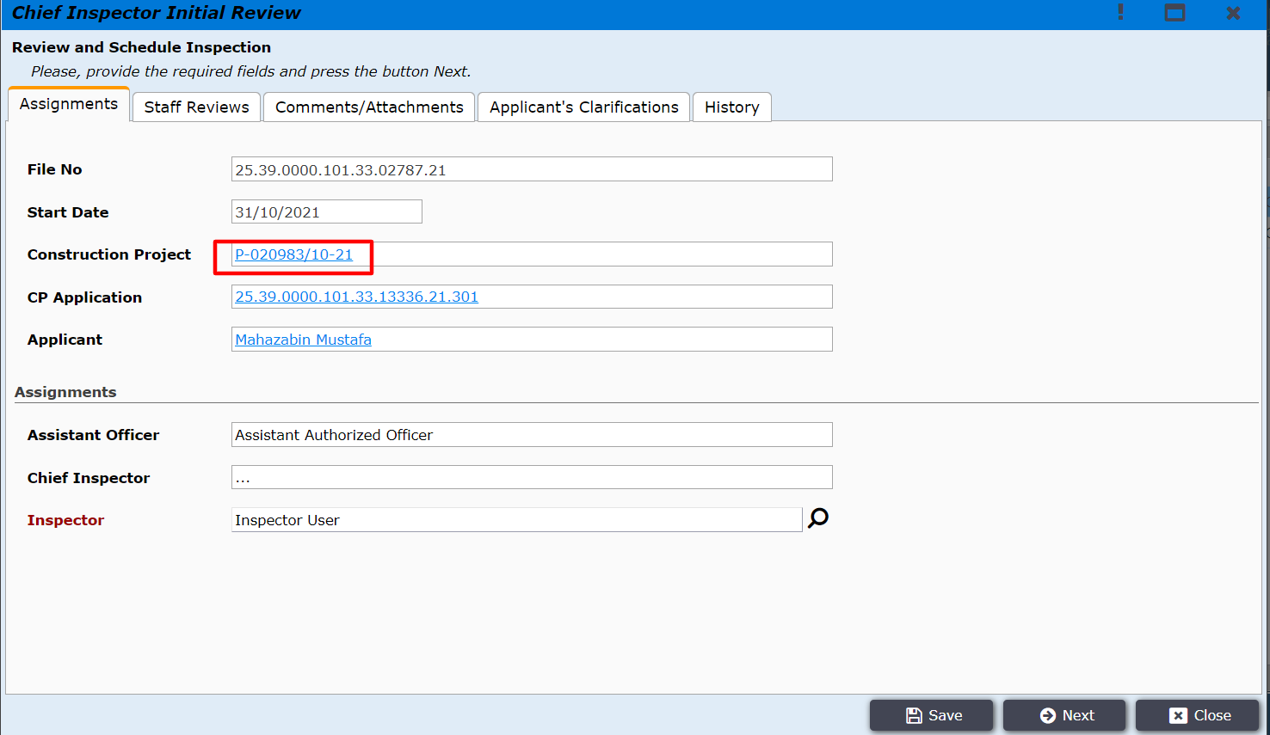
Figure 10.1

The project details will be shown as shown in Figure 10.2. The project activity contains the same project’s LUC details.
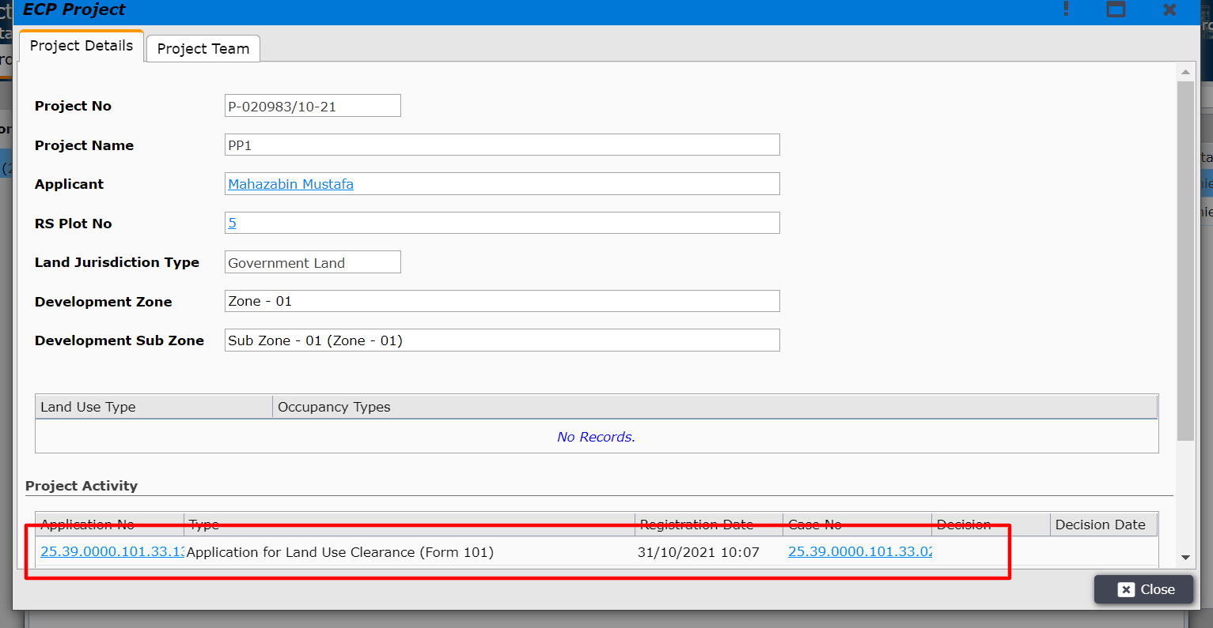
Figure 10.2
By clicking on the LUC application Chief Inspector can view the details as shown in Figure 10.3.
Figure 10.3
The Chief Inspector will click on the search button and a pop-up containing all the inspectors will be shown as shown in Figure 11. The chief inspector can select the inspector by clicking on the desired inspector and click ‘OK’. The inspector will be selected.
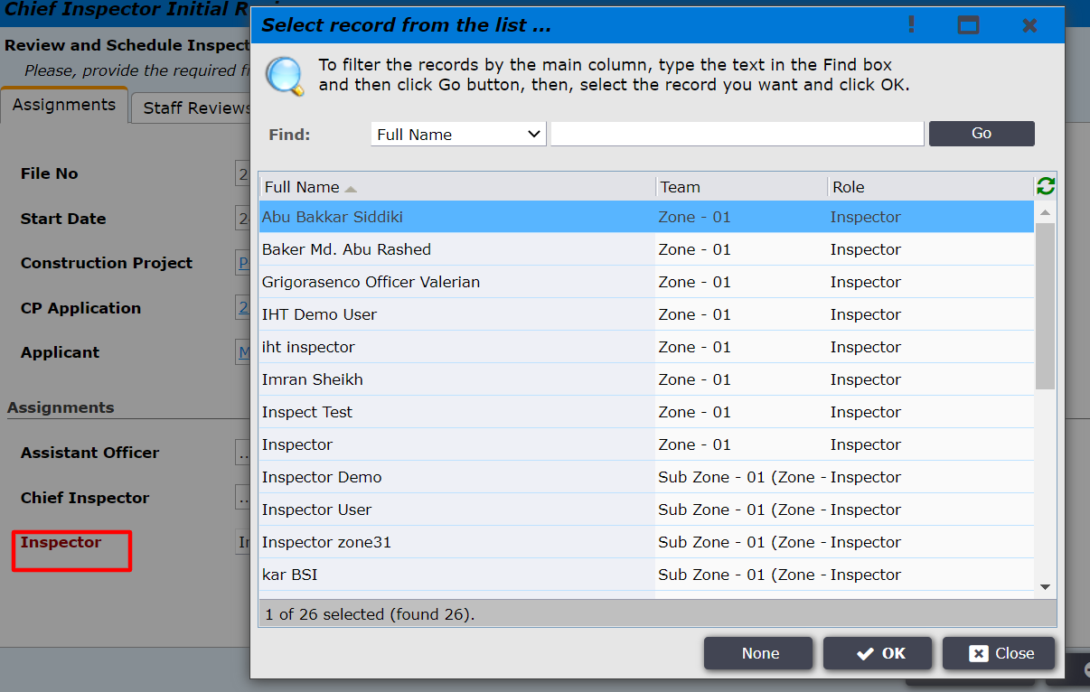
Figure 11
Chief Inspector check the review of AAO and AO in below of the pop up window and then he/she also can provide his comments and attachments in Staff Reviews tab and click ‘Next’ (Figure 12)
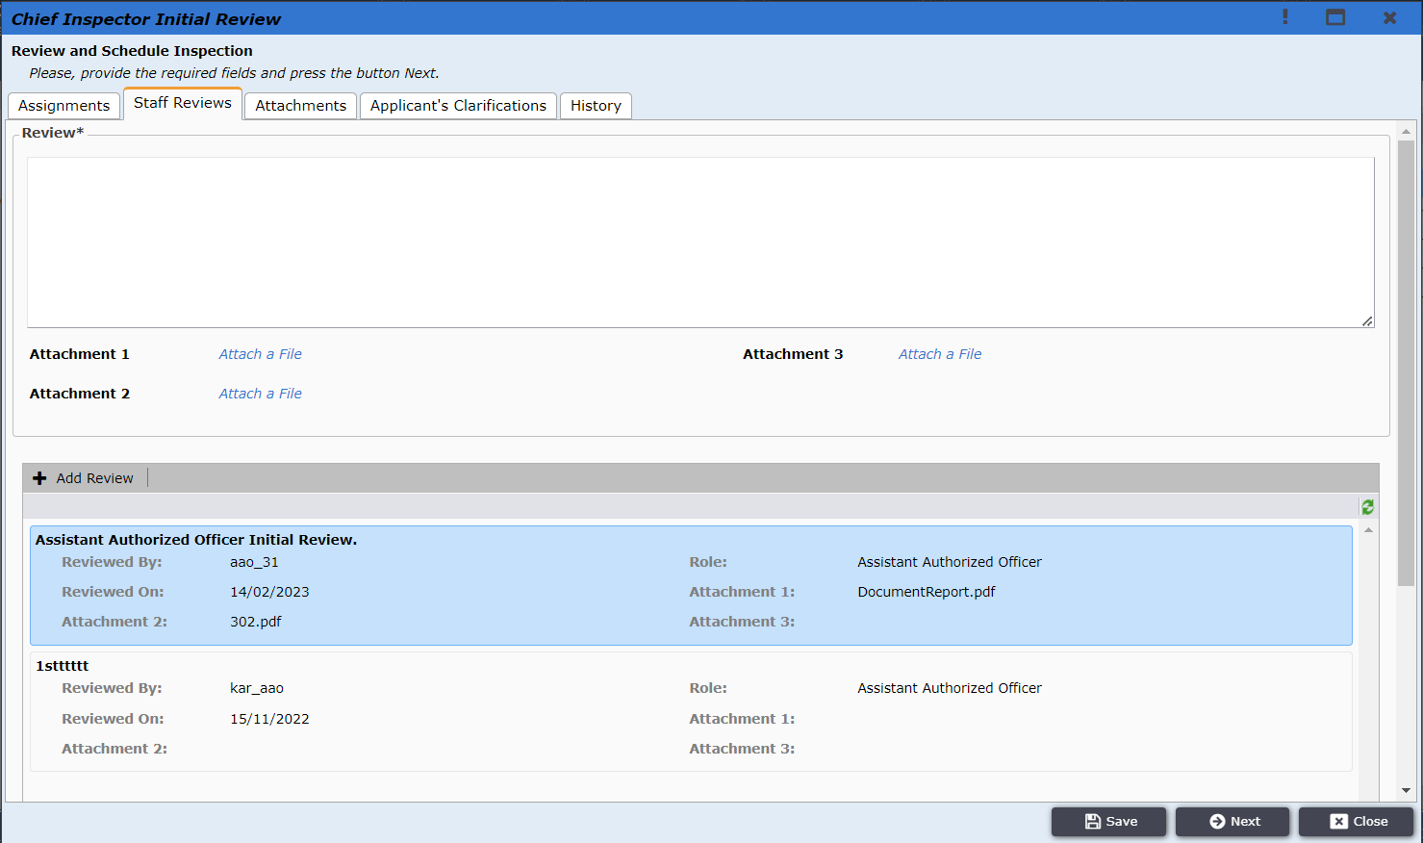
Figure 12

Application history details can be viewed as shown in Figure 12.1.
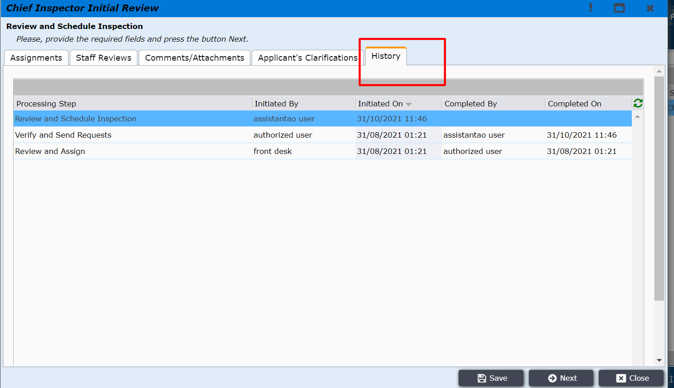
Figure 12.1
After clicking Next, the Chief Inspector will finally find the option to Request Site Inspection by clicking on the button as shown in Figure 13. After clicking on the button the application will be sent to the inspector. The Chief Inspector can also revert the application back to the AAO by clicking the Revert button.
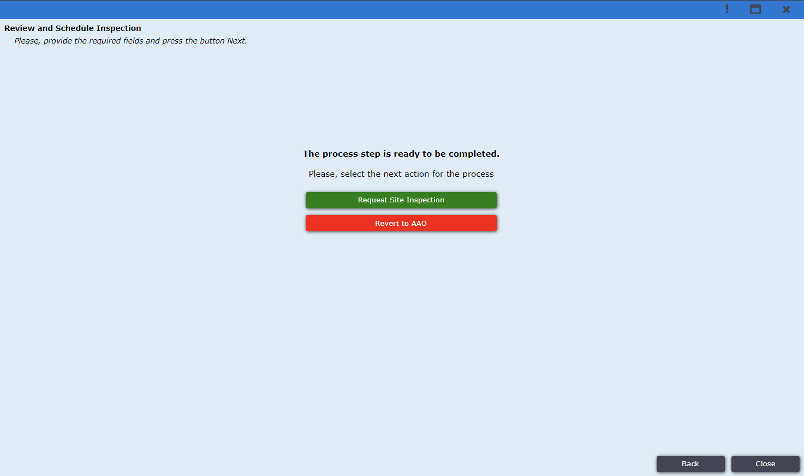
Figure 13
The inspector will log in to the system and will find the application under Inspections.
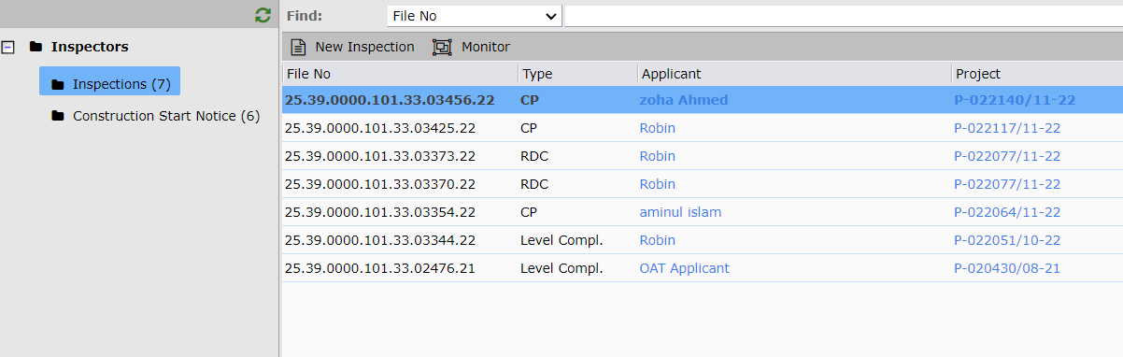
Figure 14
After Inspector clicks on the application, the pop-up window will be shown as in Figure 15. Inspector needs to provide the required information the in Assignments, Staff Reviews, Inspection, Attachments, Applicants’ Clarification, and History tabs And click Next.
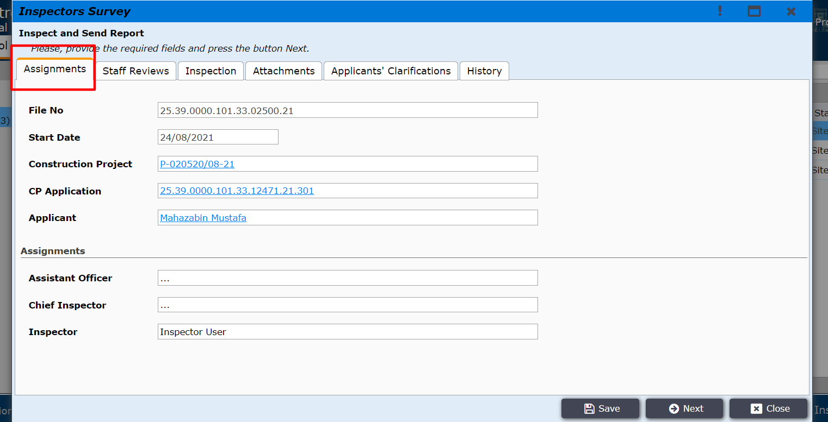
Figure 15
After clicking Next user will be taken to the Staff Review tab where Inspector needs to provide the comment and attachments as shown in Figure 15.1.
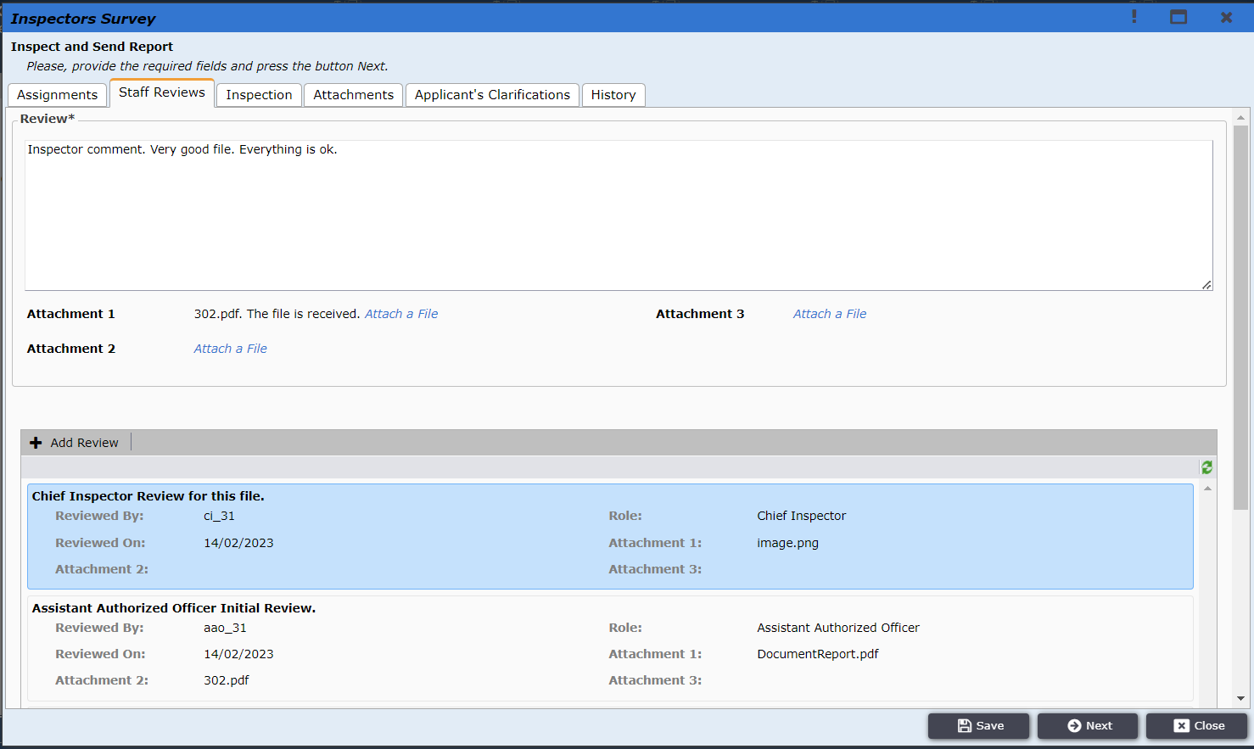
Figure 15.1

After clicking Next user will be taken to the Inspection tab where Inspector needs to provide the Inspection report as shown in Figure 16.
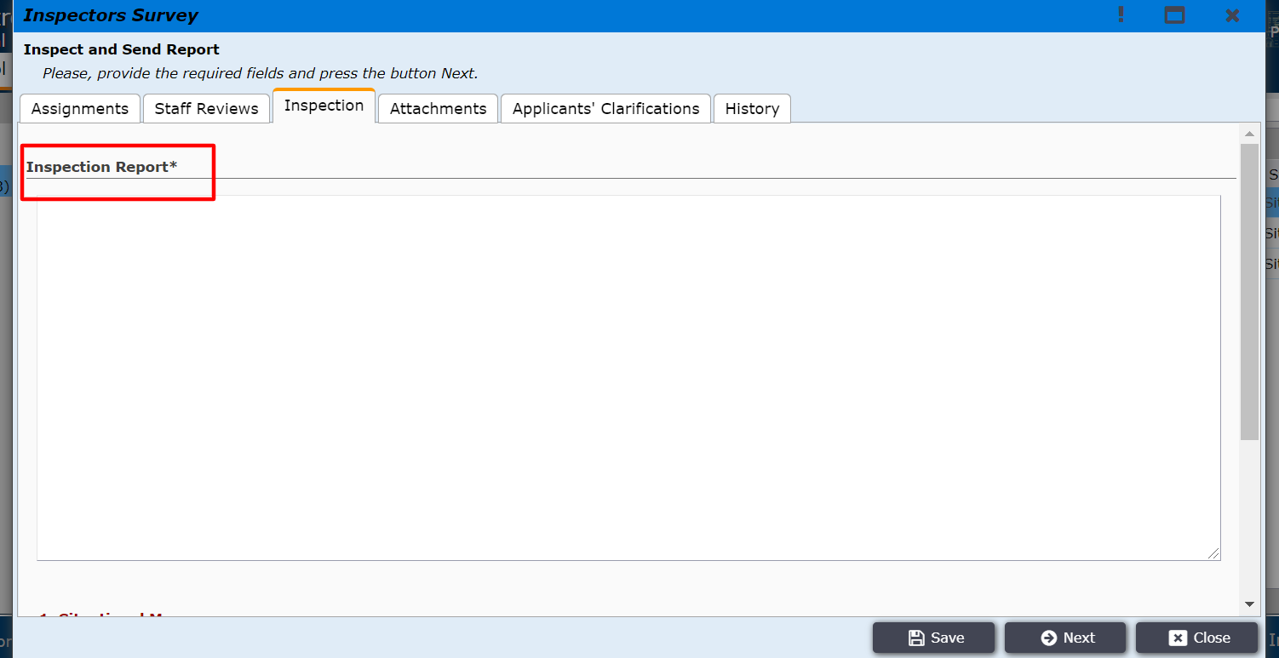
Figure 16

Inspector also will have to work on Site Inspection Statements. In order to provide Site Inspection Statements, he/ she will click on Add New button and fill up the fields as shown in figure 17.2.

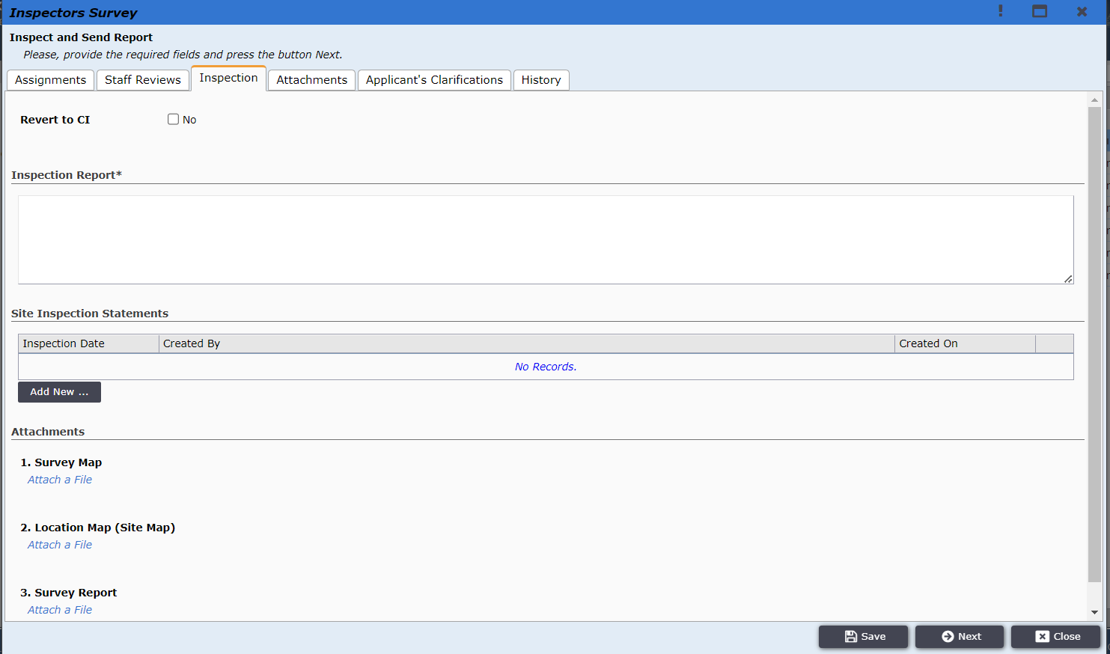
Figure 17.1
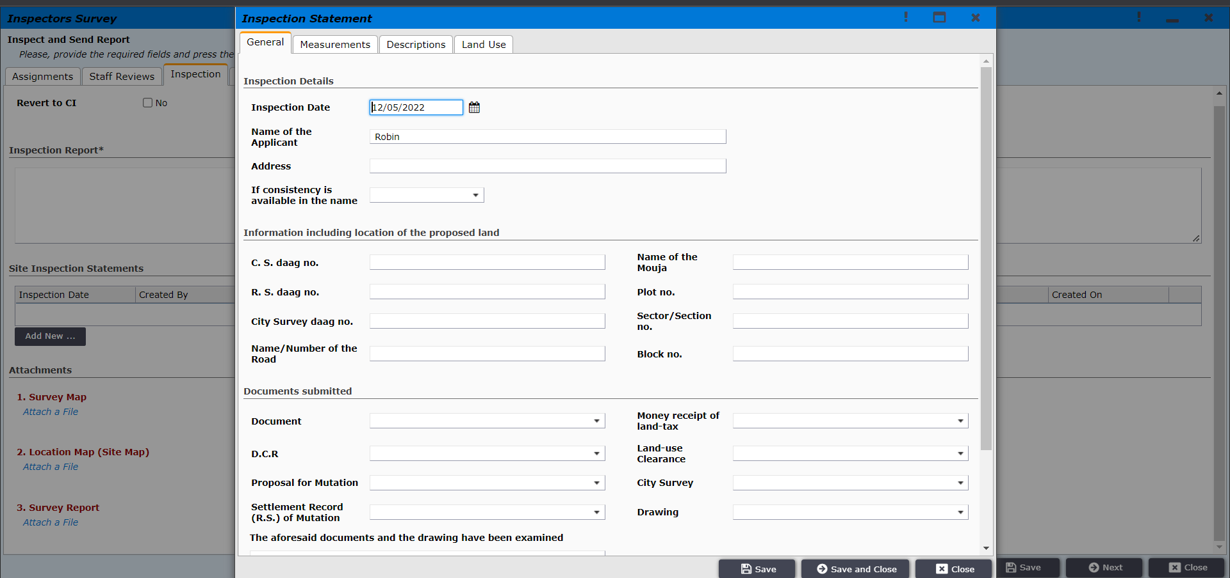
Figure 17.2

Then inspector will upload Survey Map, Location Map (Site Map), and Survey Report by attaching files. Shown in figure 17.3.
Figure 17.3
After attaching the required files Inspector will click Next and will be prompted to the window to send the report to the chief inspector. As shown in figure 18. The inspector will click on Send Inspection Report to Chief Inspector and the report will be sent to the chief inspector. Inspector can also revert the application back to the Chief Inspector by clicking the Revert to Chief Inspector button.
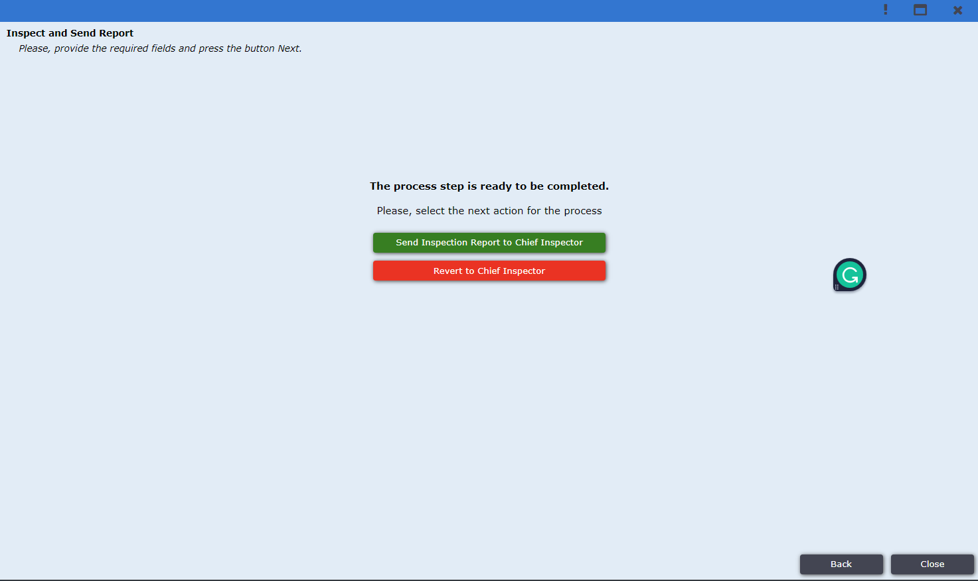
Figure 17.2
The chief inspector will login to the system and find the application under the Chief Inspector tab as shown in Figure 18.
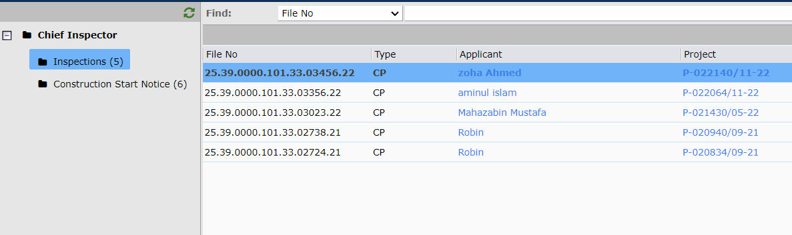
Figure 18
After clicking on the application the chief inspector will do the final review, he can check the report by clicking on the Inspection tab. The details along with Survey The location and on Map, Survey Report can be found there as shown in Figure 18.1.
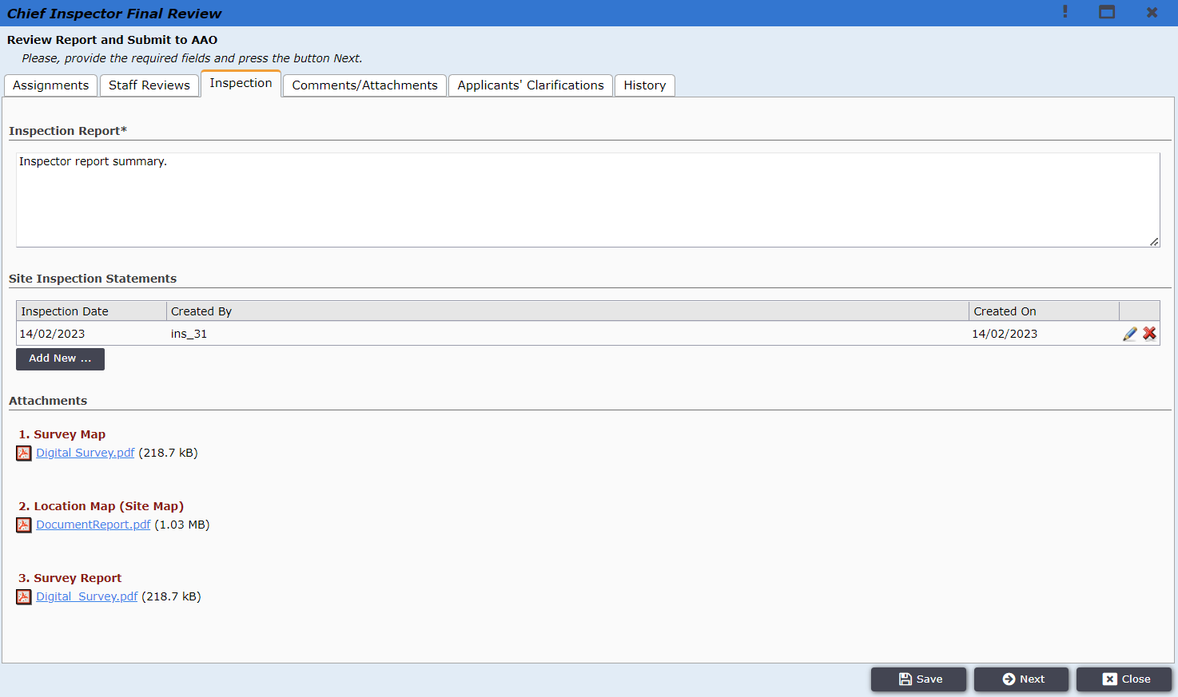
Figure 18.1
After checking the tabs, the Chief Inspector will click ‘Next’ as shown in Figure 19. Then Chief Inspector has to provide a staff review and attachment before sending to AAO.
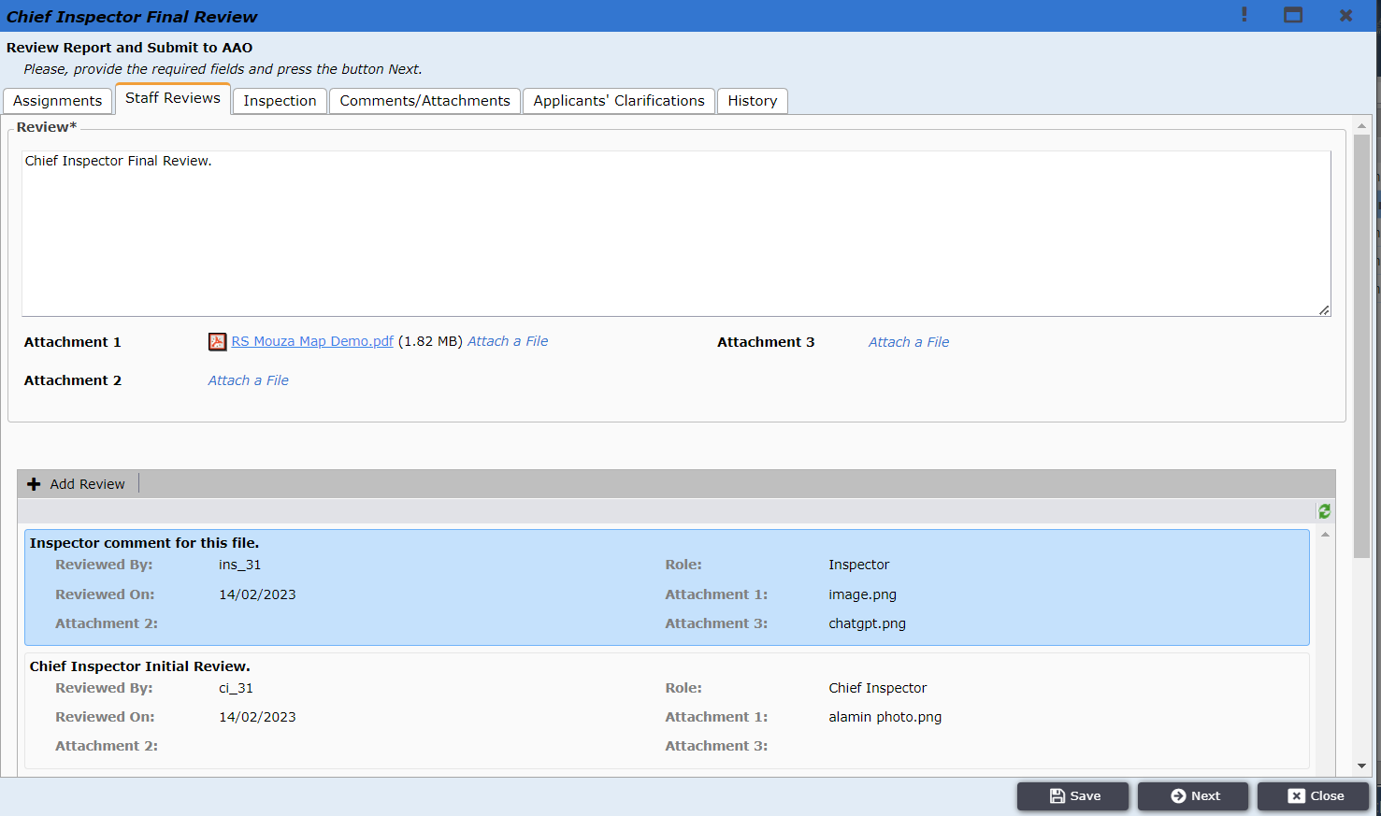
Figure 19

After clicking Next Chief Inspector will find option to ‘Request Report Correction’ and by clicking on the button the report will be sent back to Inspector so that he can do required changes. Otherwise he can click on ‘Submit Inspection Report’ and it will be sent to AAO.
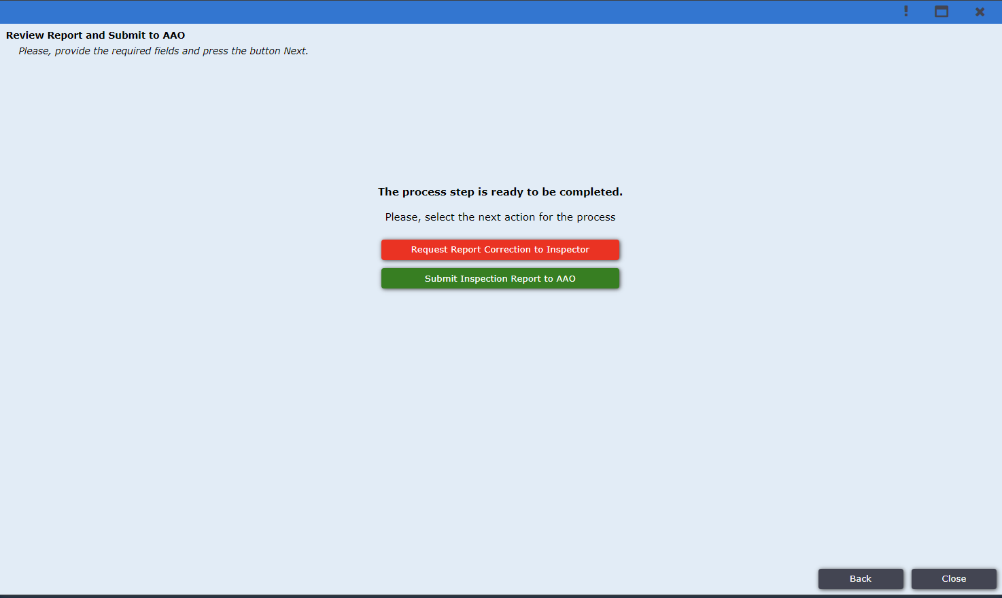
Figure 20
AAO user logs in to the system and finds the application under Incoming tab as shown in Figure 21.
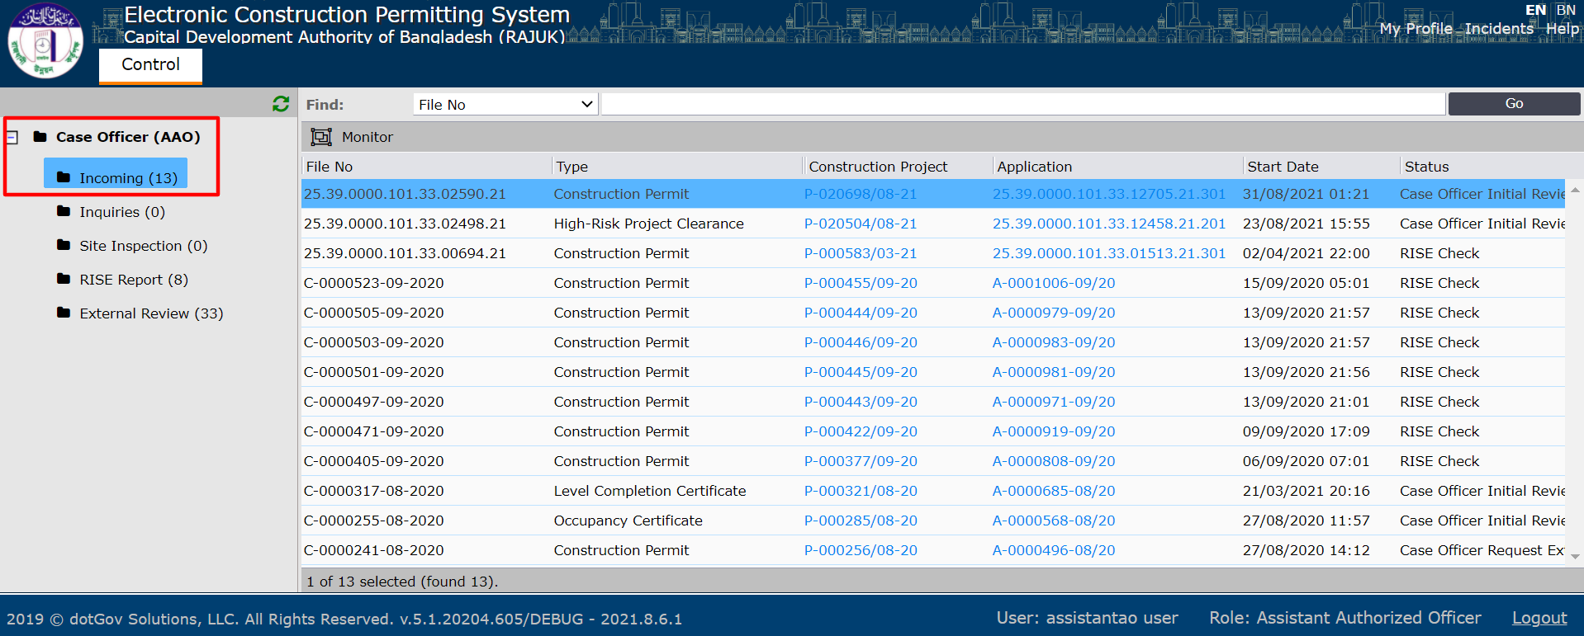
Figure 21

AAO user checks information in Assignments, Staff Reviews, Inspection, Comments/Attachments, Applicants’ Clarifications and History tabs as shown in Figure 22.
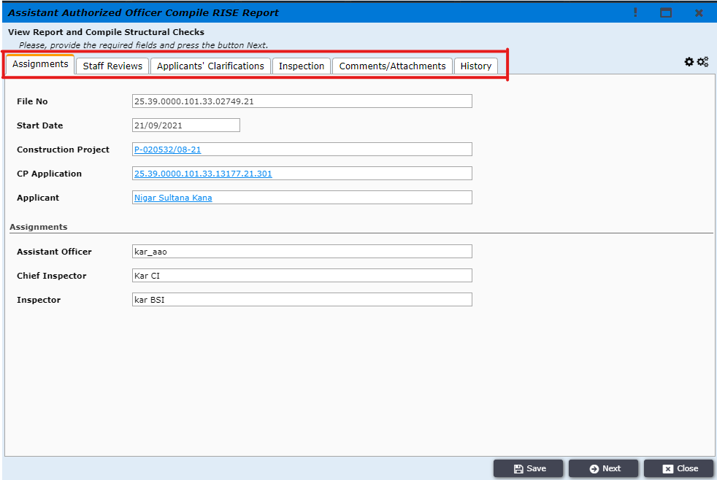
Figure 22

AAO user can check the history tab to see the application flow and timeframe (which officer take what amount of time) and also the total day spent for this file. as shown in figure 23.
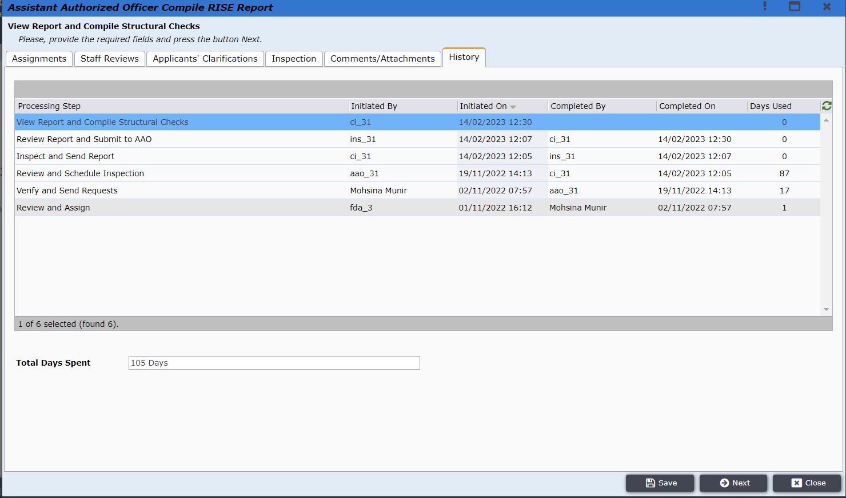
Figure 23

AAO user will click Next then and he will be taken to RISE-Risk and Structural Evaluation Tool page. The page contains Building Details, Floors Load, Columns, Shear Walls, Foundation, Architectural, Fire Protection and Checklist.
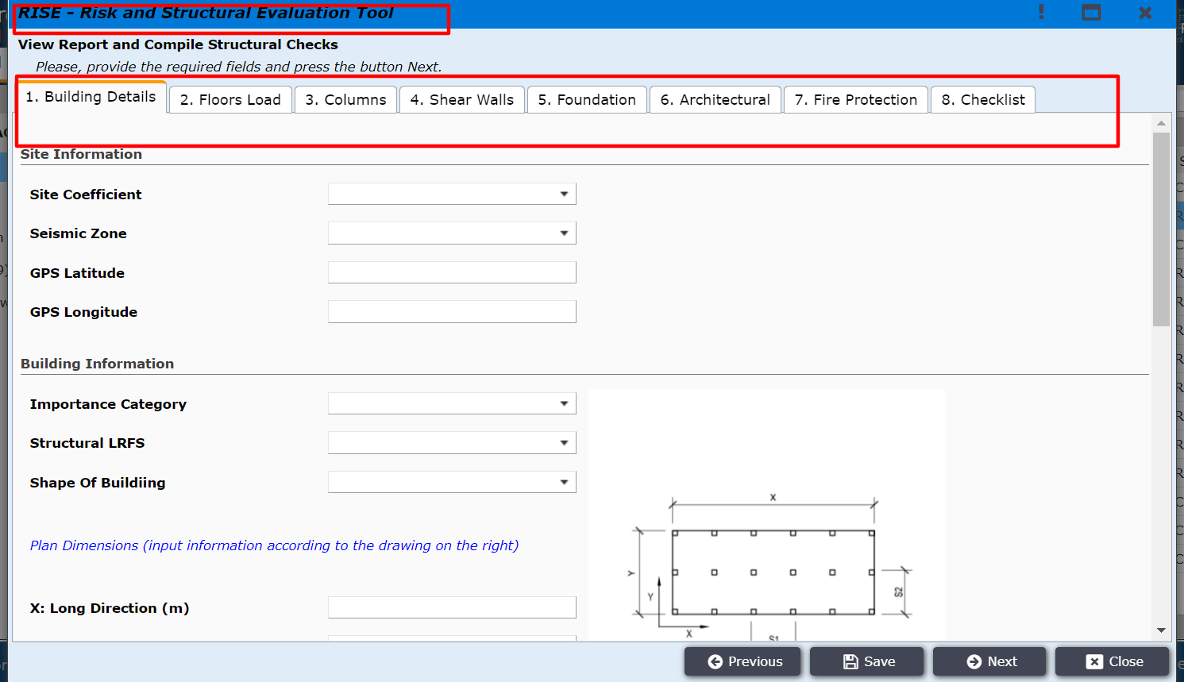
Figure 24
The rise tool information should be field in the tabs given in figure 24.1 to figure 24.8.
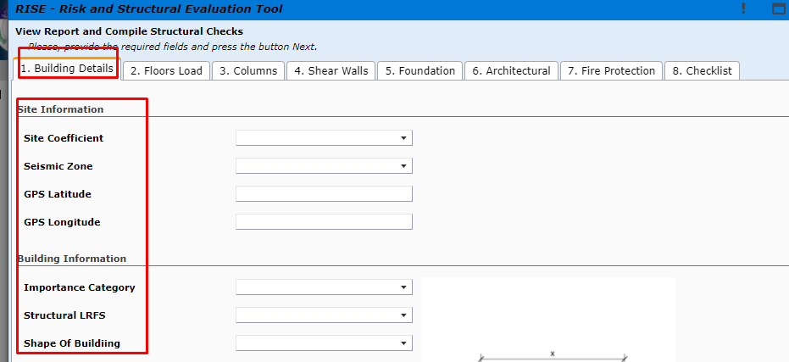
Figure 24.1
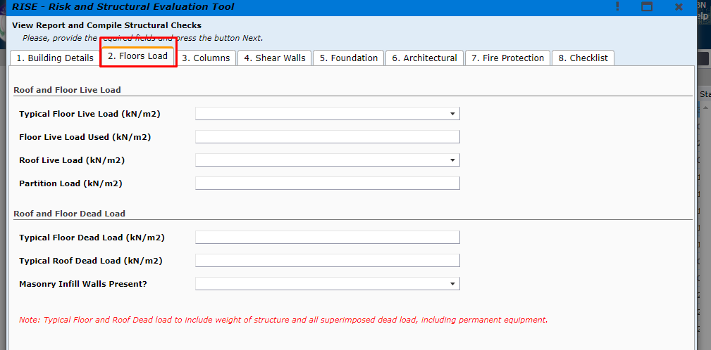
Figure 24.2

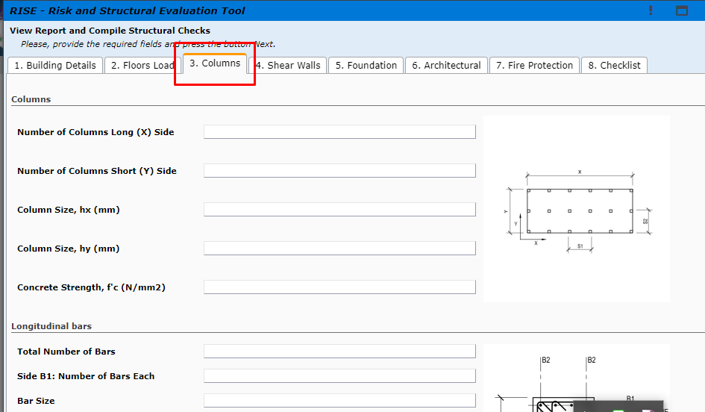
Figure 24.3

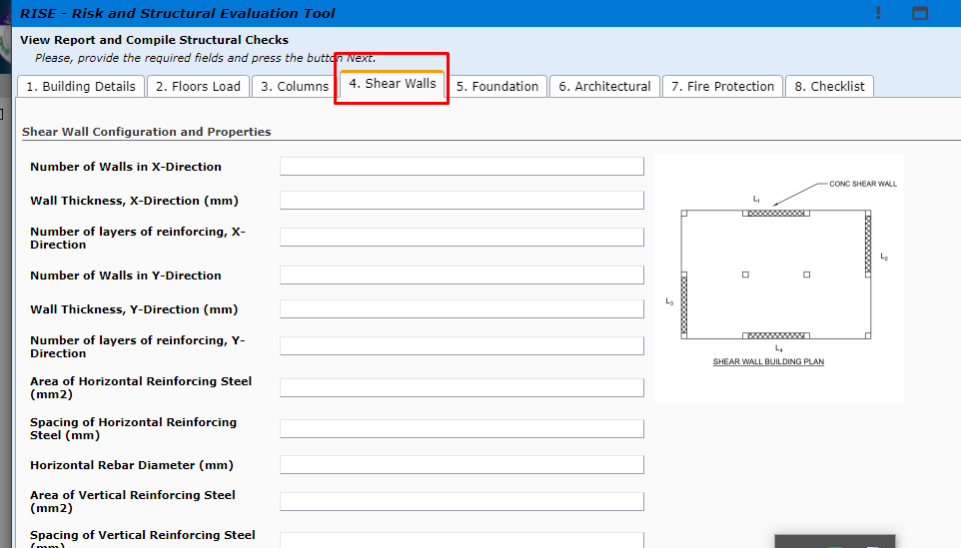
Figure 24.4

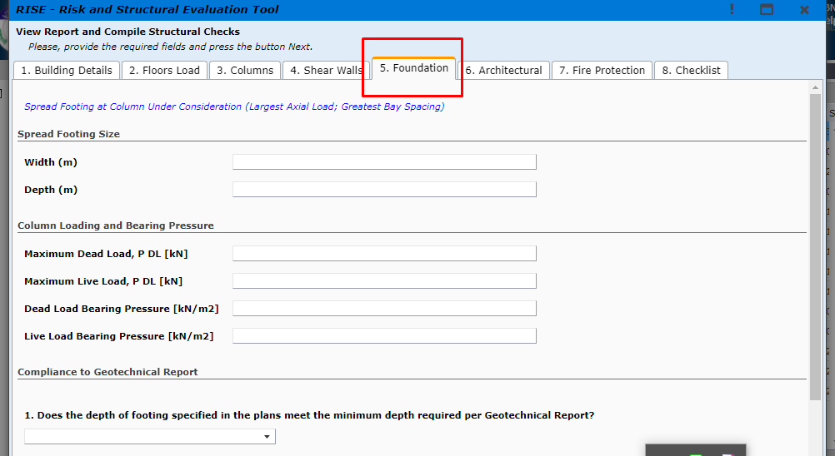
Figure 24.5

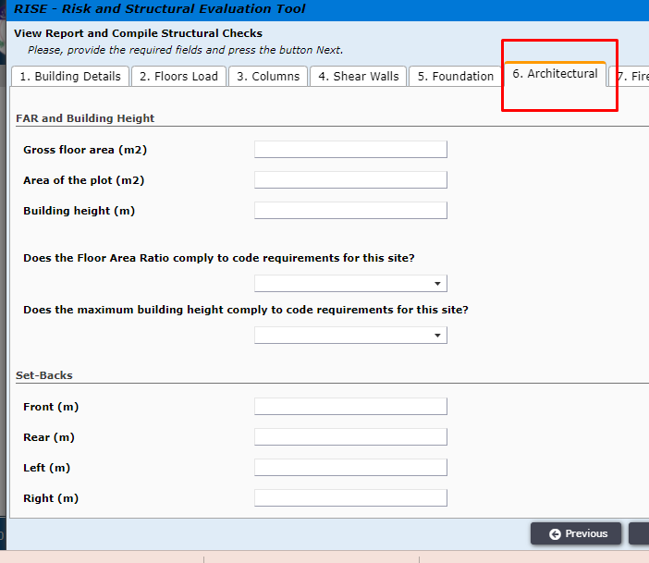
Figure 24.6

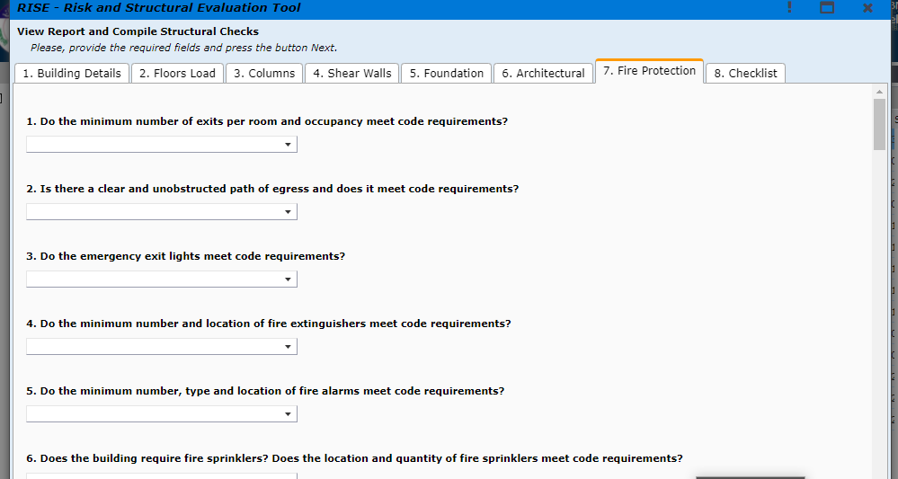
Figure 24.7

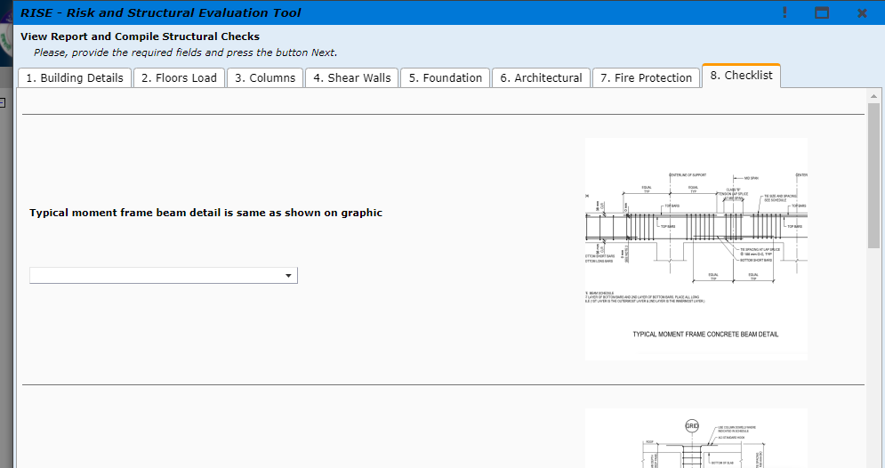
Figure 24.8

AAO user will click Next and will be taken to the preview window as shown in Figure 25.
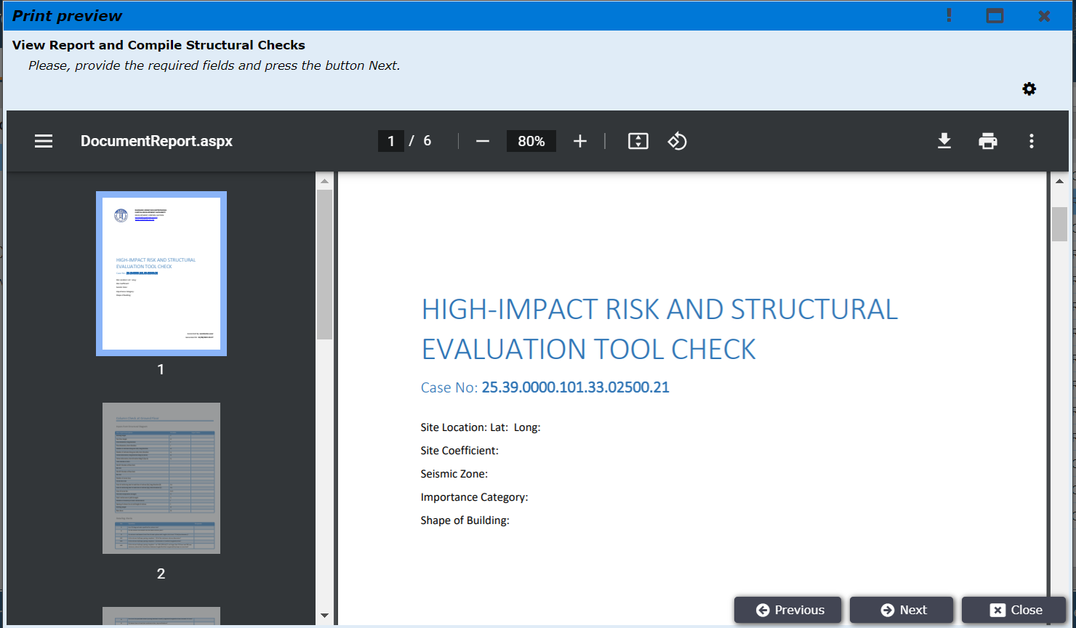
Figure 25

After clicking Next the Staff Review Tab will show like fig 25.1. AAO has to provide a final review and attachments about this file.

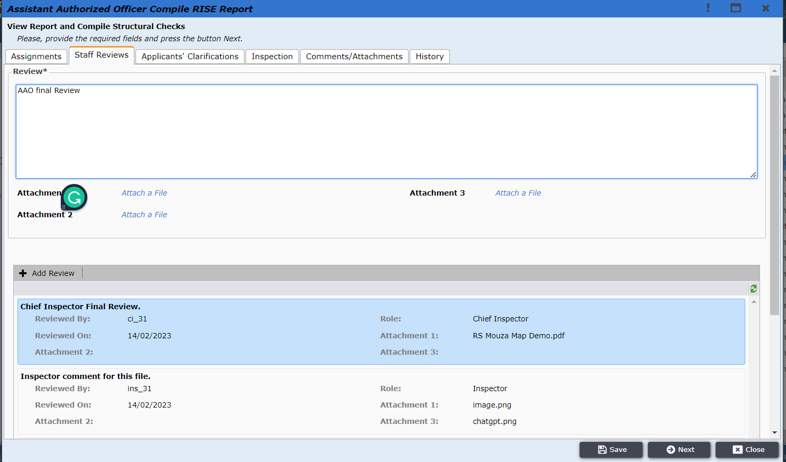
Figure 25.1
AAO user is taken to the window as shown in Figure 26. AAO will get two options: Request Report Correction and Send Report to AO. If Request Report Correction is clicked, then the application will be sent to Chief Inspector for the update. And if Send to AO is clicked then the application will be sent to AO.

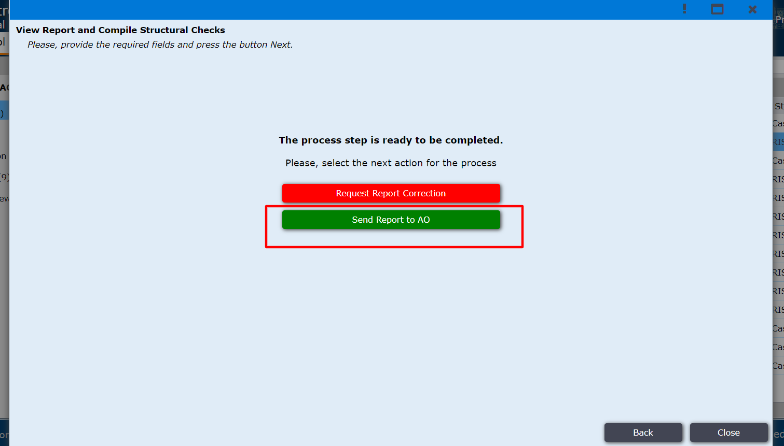
Figure 26

AO user logins to the system and finds the application under the Incoming folder and From AAO sub-folder as shown in Figure 27.

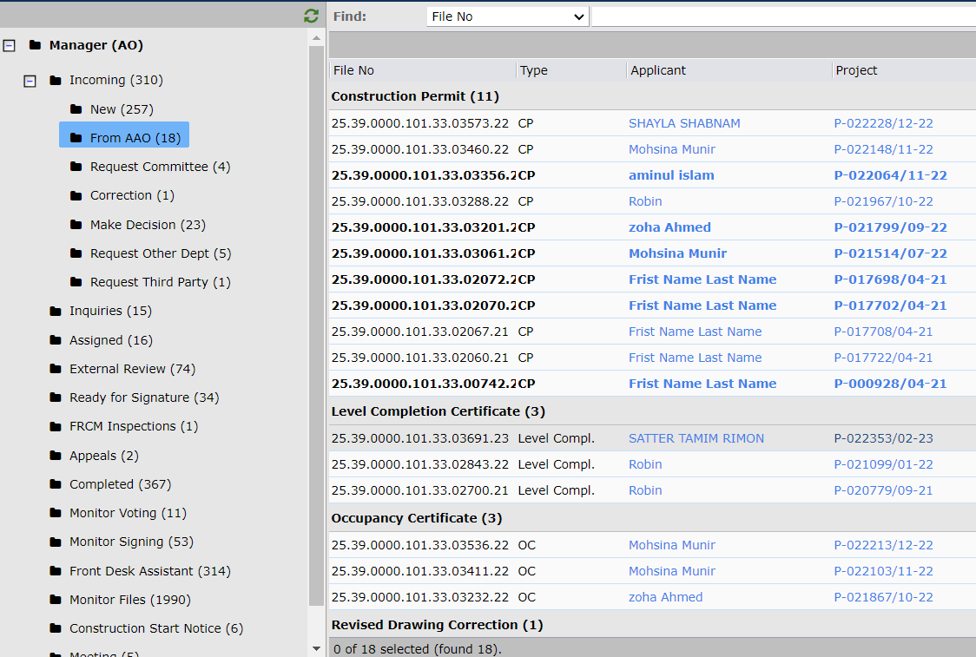
Figure 27
AO clicks on the application and Authorized Officer Final Review page is opened. AO reviews all the contents as shown in figure 28.
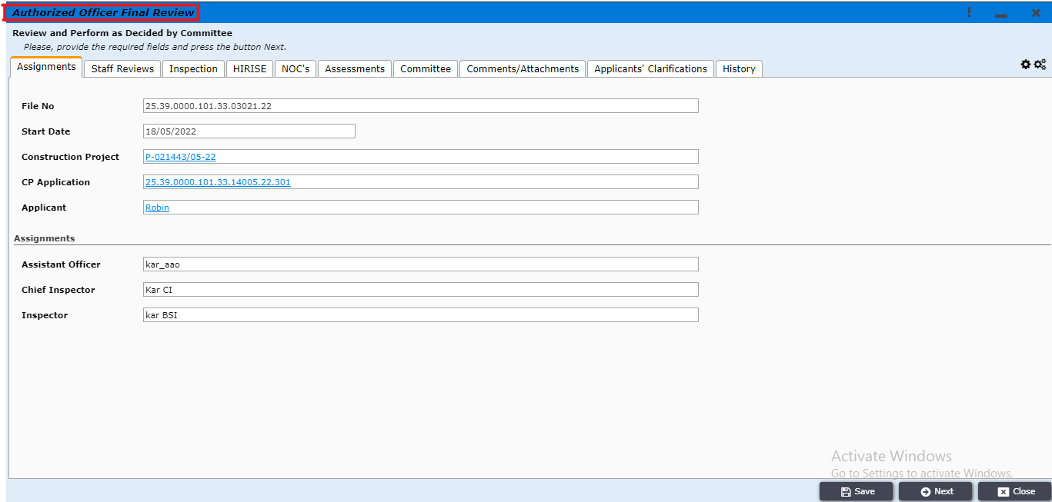
Figure 28
AO user clicks on the NOC’s tab to Request NOCs from desired departments. The departments are shown in Figure 29.1. In this case AO has selected department of environment for NOC. AO can select multiple departments or any other department for NOC. AO can leave a comment for NOC department in the NOC comment box. AO can also add attachments by clicking Add New button as shown in Figure 29.1 and 29.2.
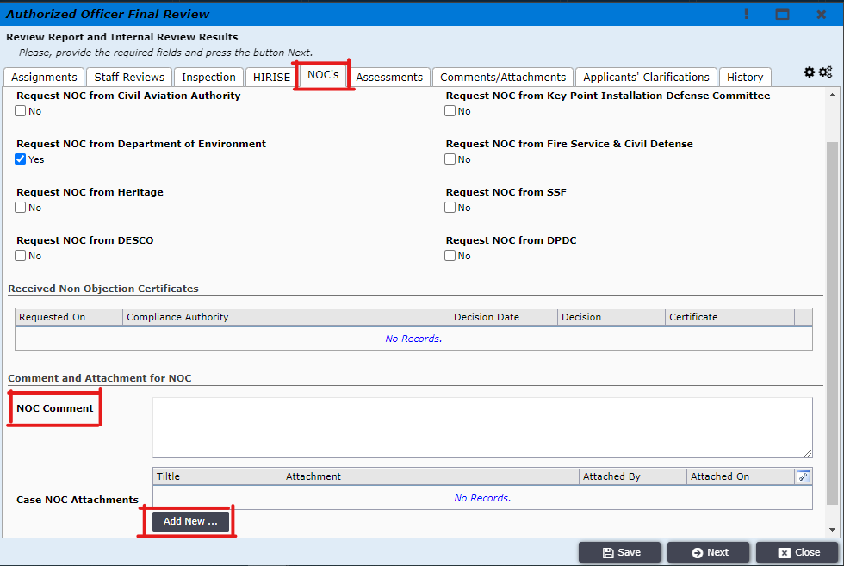
Figure 29.1
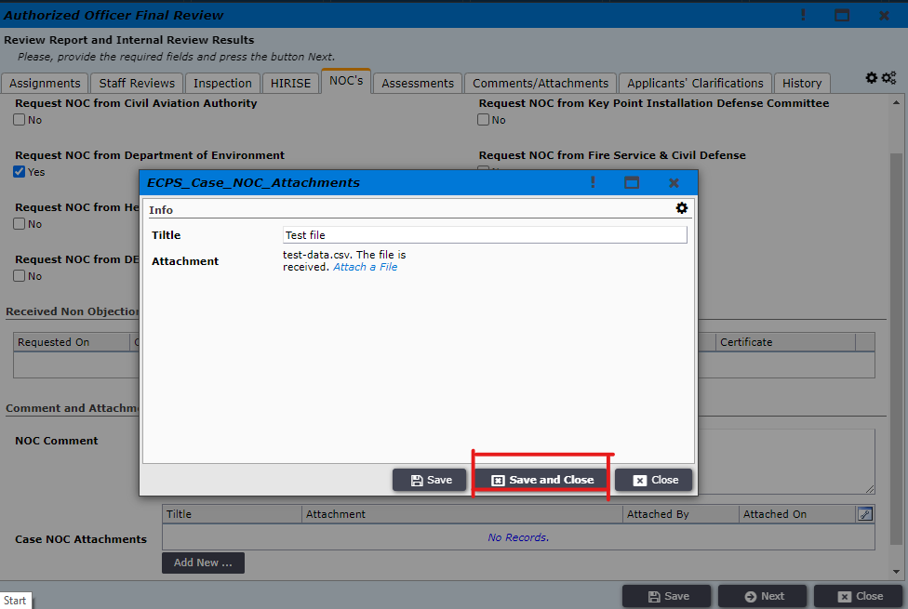
Figure 29.2
After clicking Save and Close and then Next, the window with options of review is opened as shown in Figure 30. And AO user clicks on the Request For NOC as NOCs are given via external review.
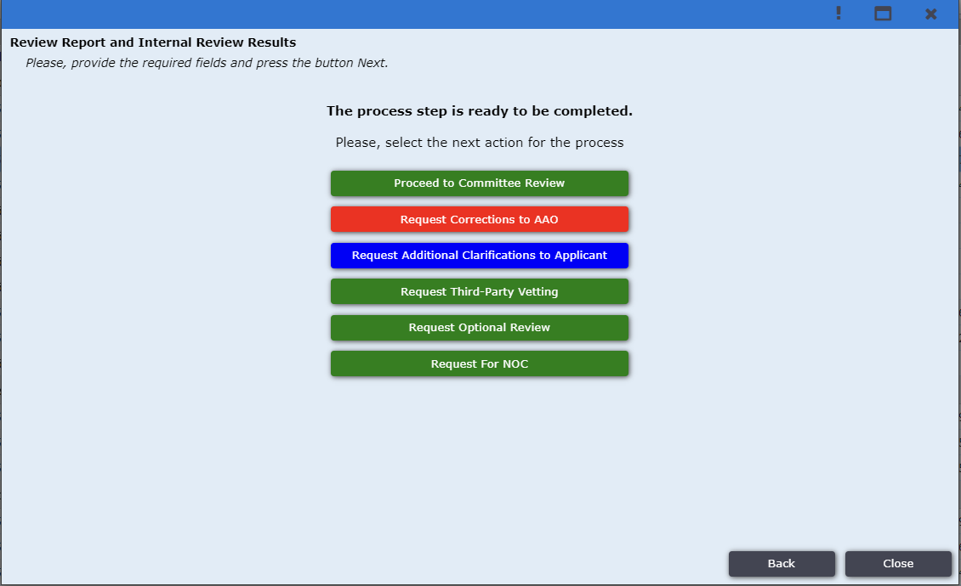Figure 30
After clicking this Button New form will come to review what organization AO selected. If AO didn’t select any Organization an error message is shown like fig 30.1. If AO selects at least one Organization then two buttons will come shown in fig 30.2. AO selects Request External Review for sending files the to external reviewer. If AO doesn’t want to send the file then he can get back the previous status by clicking Back to Internal Review.
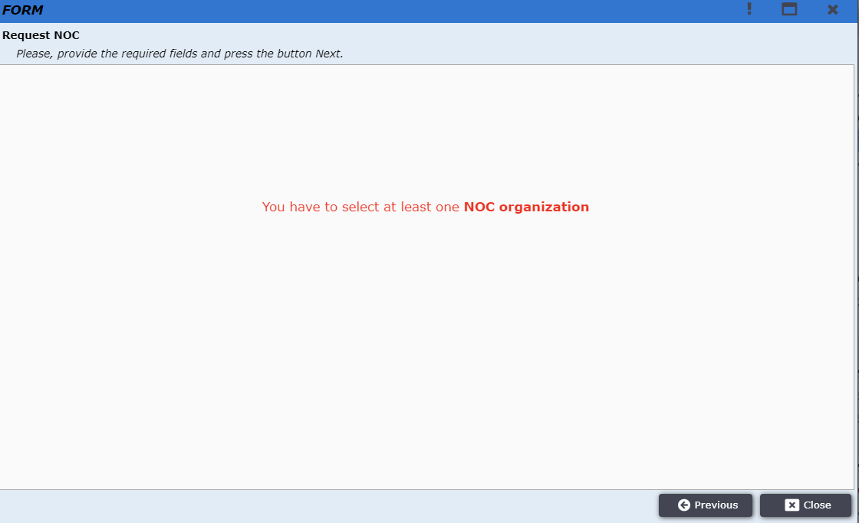
Figure 30.1
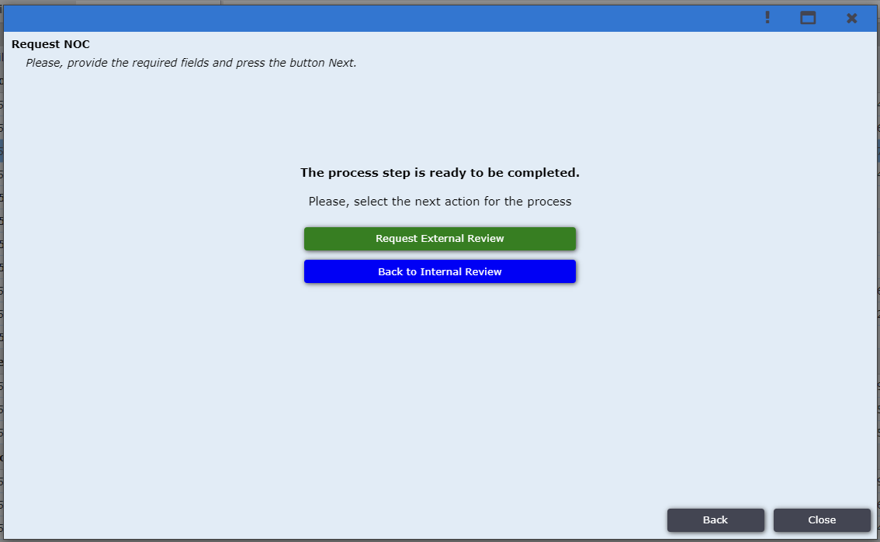
Figure 30.2

The application is then moved to the external review tab as shown in Figure 31.
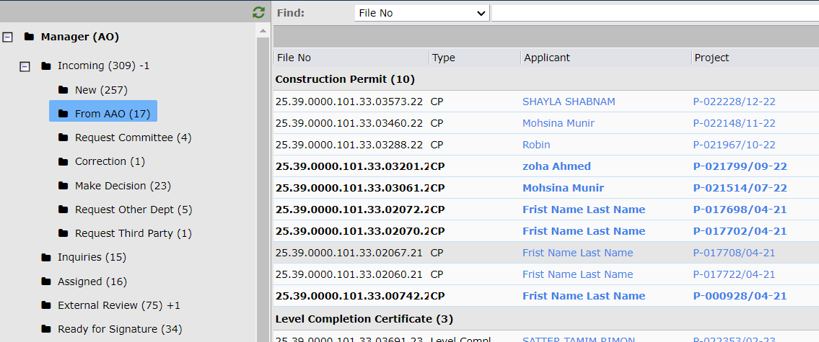
Figure 31

The application can be found under external application tab as shown in Figure 32.
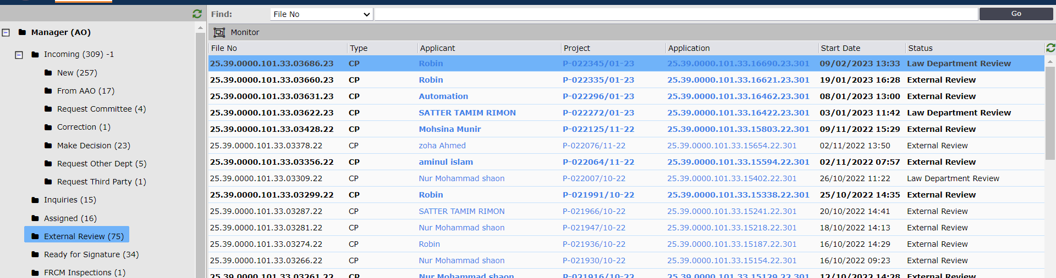
Figure 32
The user from Civil Aviation Authority will log in to the system and find the application under the External Review tab as shown figure 33.
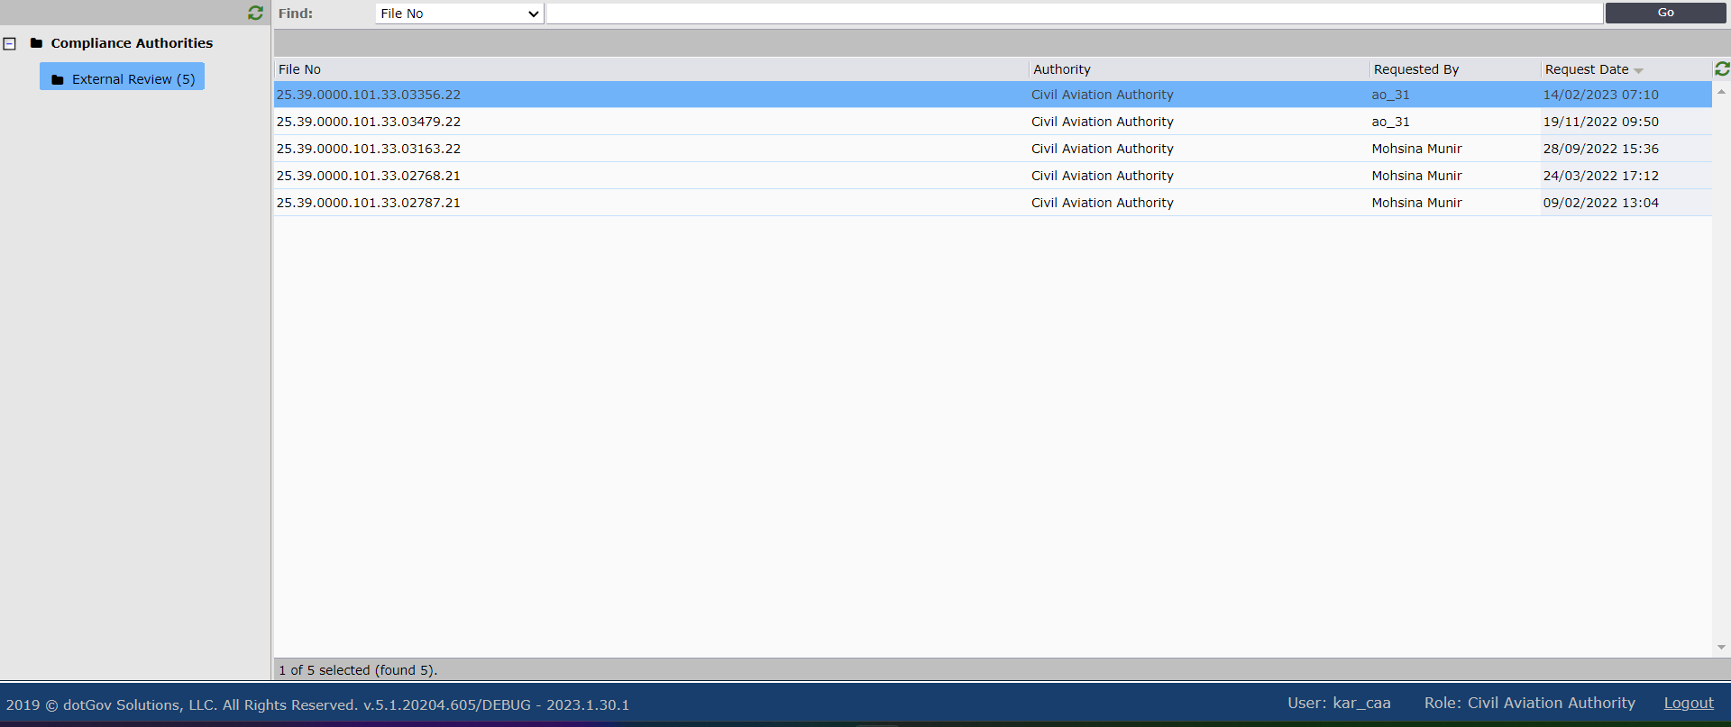
Figure 33

After clicking on the NOC request the window as shown in Figure 34 will be opened. The user will select Approved and write decision notes to send the NOC.
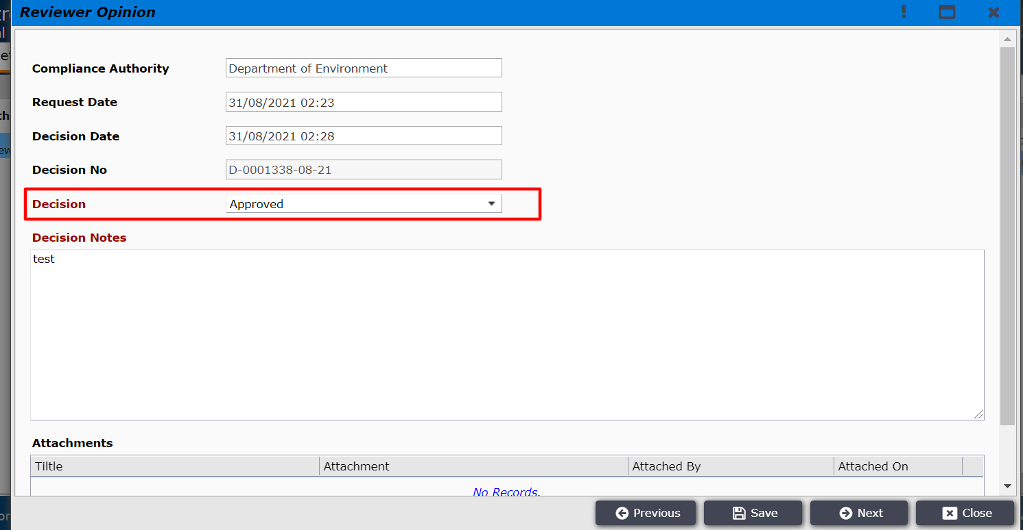
Figure 34
The user can also attach a document by clicking on Add New as shown in figure 35 and 36.
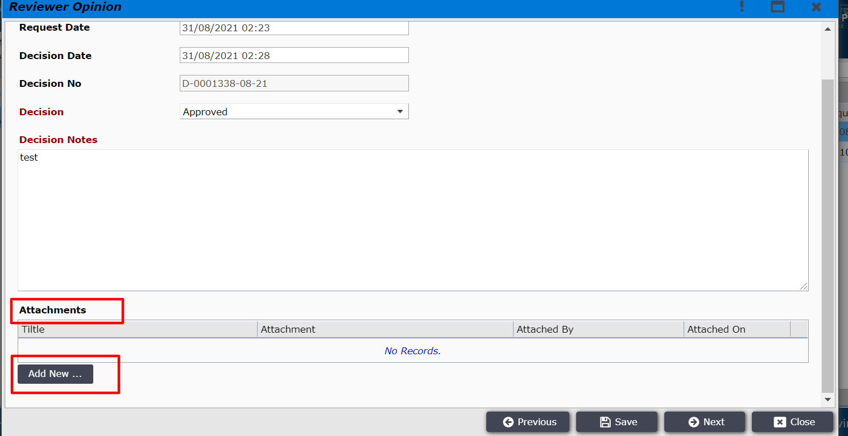
Figure 35

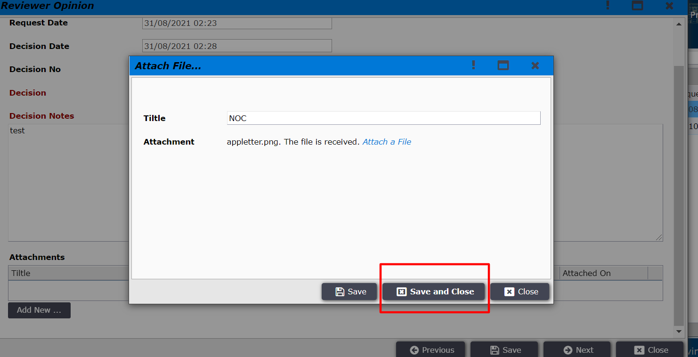
Figure 36
After clicking Save and Close the user will click Next as shown in Figure 37. After clicking Next, the approved NOC will be sent to AO. If the decision is rejected it will also be sent to AO.
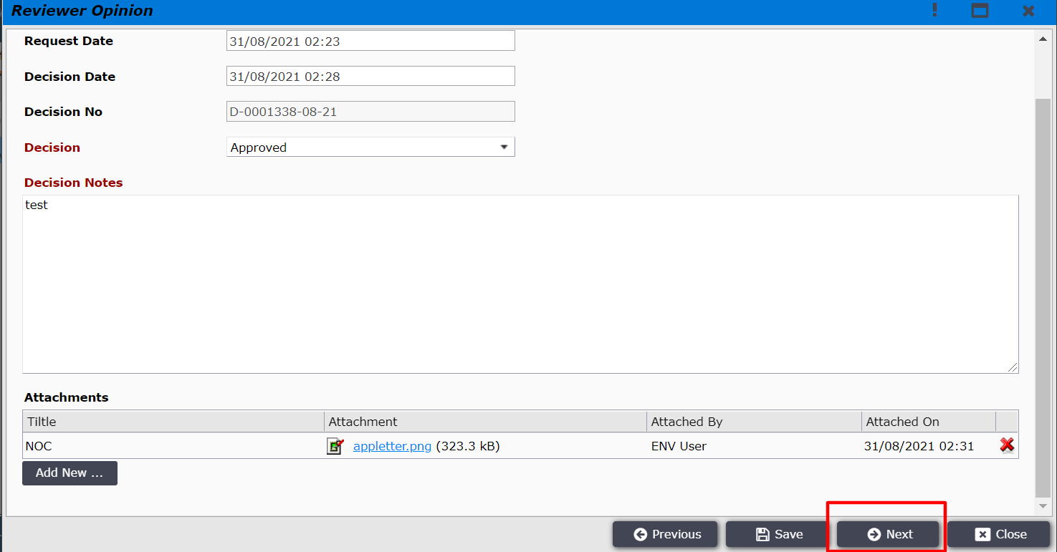
Figure 37

AO user logins to the system and the application are found under the Incoming folder and From AAO sub-folder as shown in Figure 37.
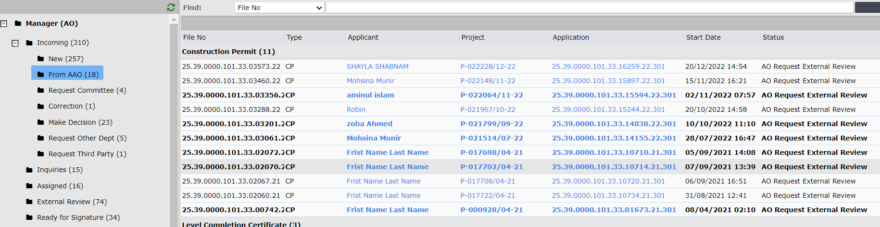
Figure 37
AO user will open the application as can find the NOC under the NOC’s tab and the decision can be seen there as shown in Figure 38.
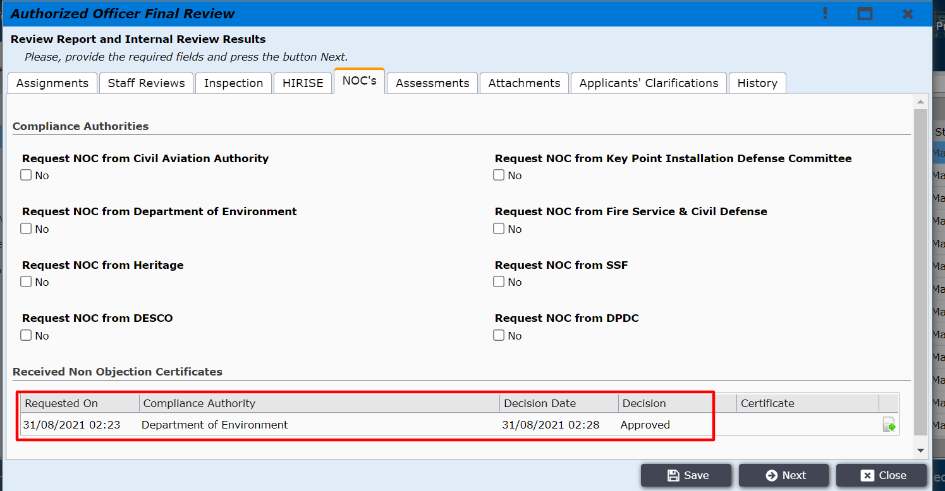
Figure 38

After clicking on the report icon the reviewer opinion window will be opened as shown in Figure 39.

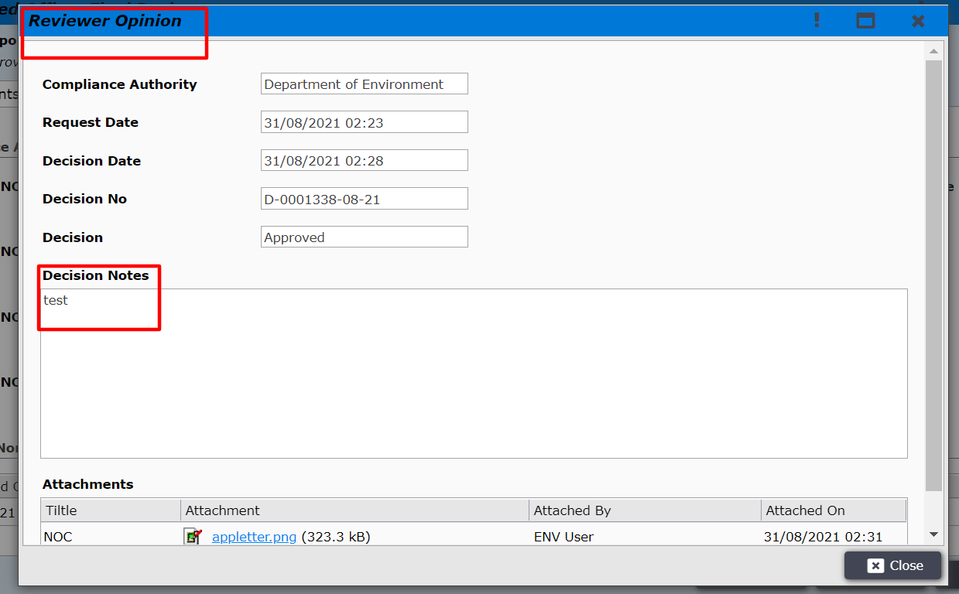
Figure 39

After reviewing the NOC the AO user will click on Next, AO user will get review options: Request External Review, Proceed to Committee Review, Request Corrections, Request Additional Clarifications, Request Third-Party Vetting and Request Optional Review. The AO user will click on Request Optional Review.
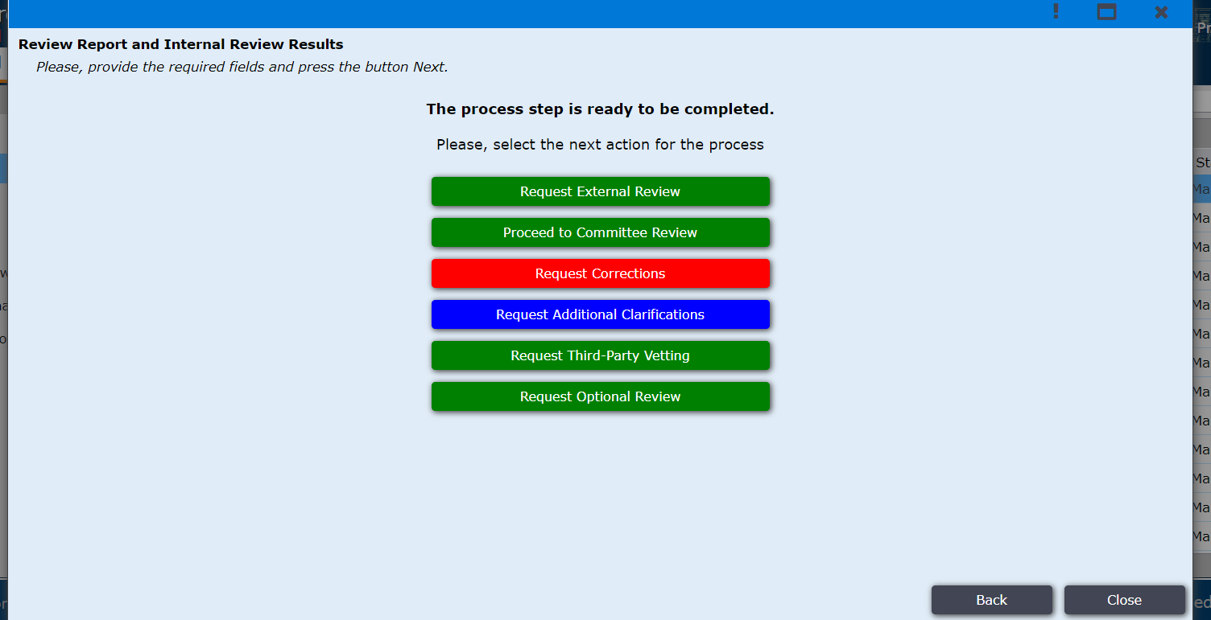
Figure 40

The AO user will be shown options of different departments for review. The departments are Law Department Review, Estate Department Review, Town Planning Review, Architectural Review, Management Review as shown Figure 41. There is also option Back to Internal Review Results by clicking on this option the AO user will be taken back to the window as shown in Figure 40.
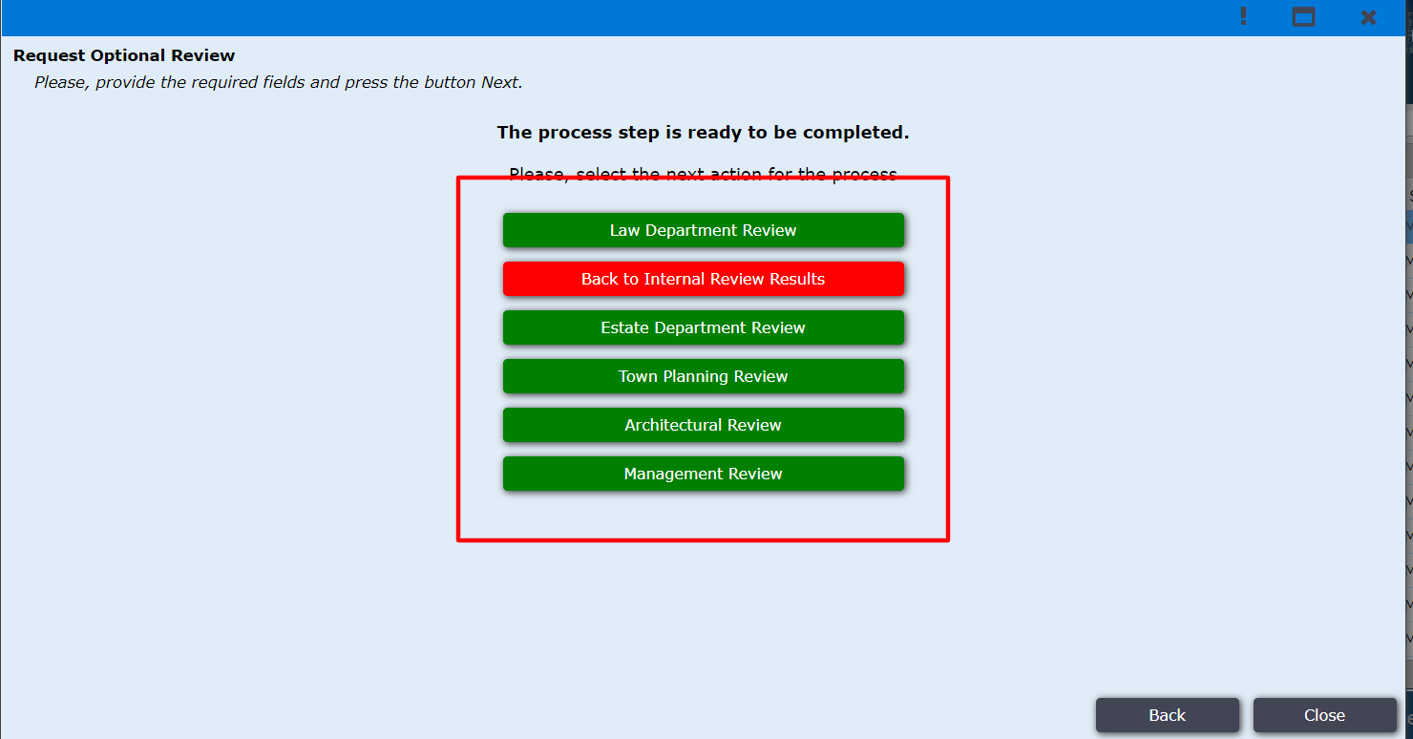
Figure 41

AO user now clicks on Law Department Review, then he/she have to provide a comment shown in fig 41.1
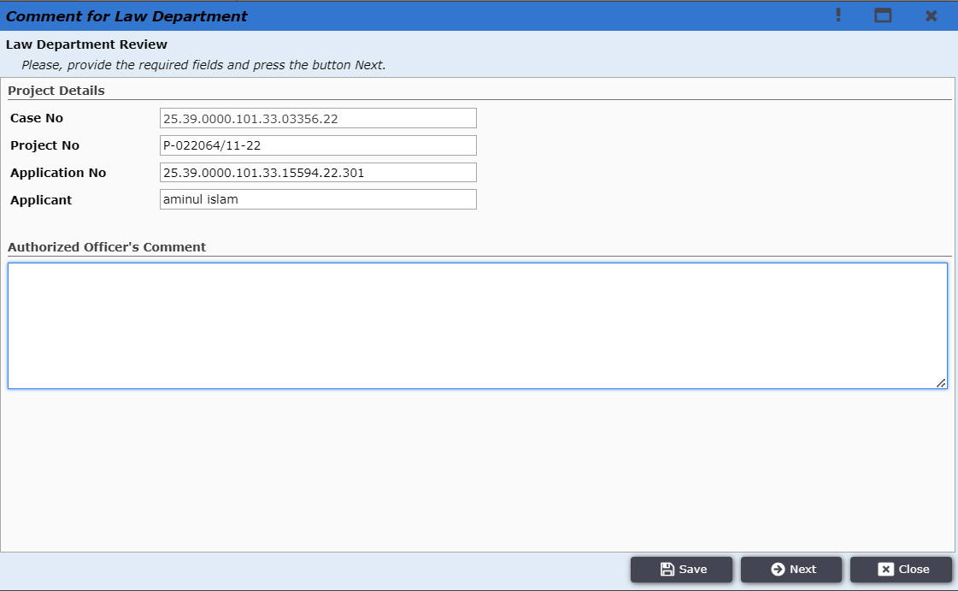
Figure 41.1

AO user now clicks on Next, the application is moved under External Review tab and the status is mention as Law Department Review. As shown in Figure 42. The other department reviews will also follow the same process.
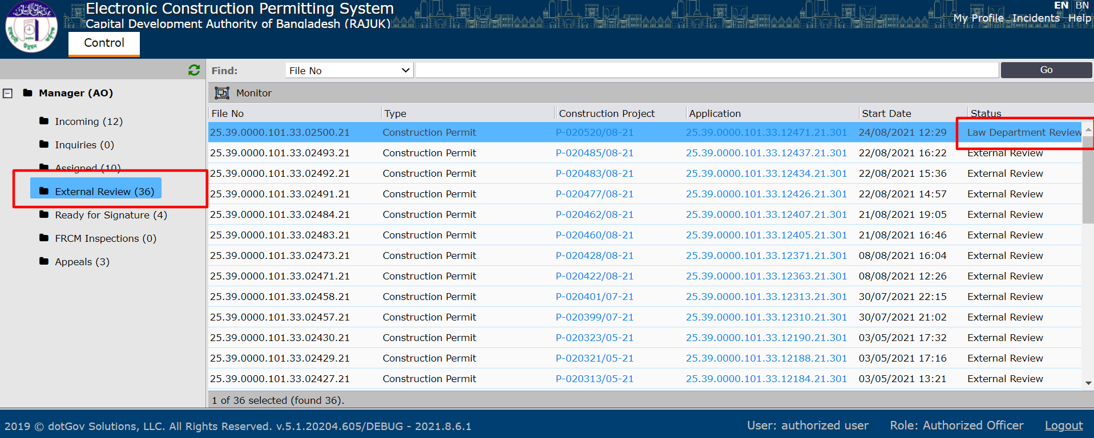
Figure 42
The law department users will receive the application for review. Figure 43

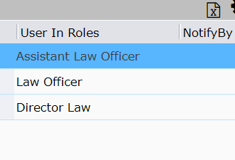
Figure 43

The Assistant Law Officer logs in to the system and finds the application under Case Review. As shown in Figure 44.
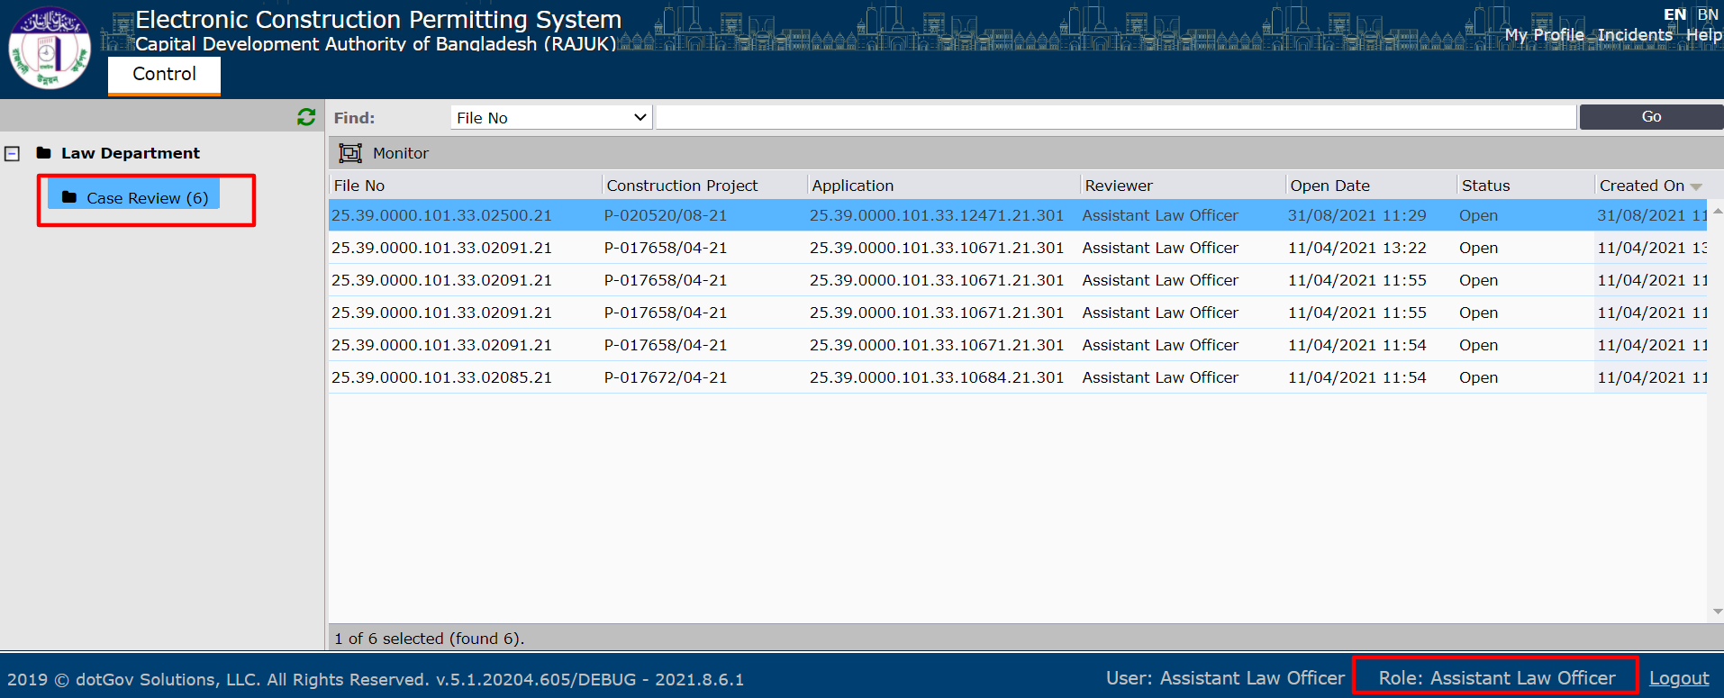
Figure 44

After clicking on the application the Assistant law officer will see the comment of AO and after clicking Next details of the application and click Next as shown in figure 45.1 and 45.2.
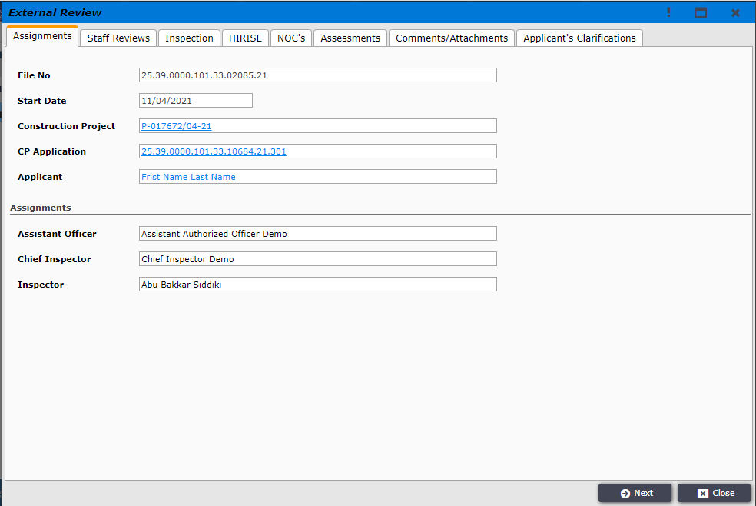
Figure 45.1

Figure 45.2

After clicking Next, the window as shown in Figure 46 will be opened. The Assistant Law Officer can select any option from Review Outcome options: Approved, Drawings Correction and Rejected as shown in Figure 46.
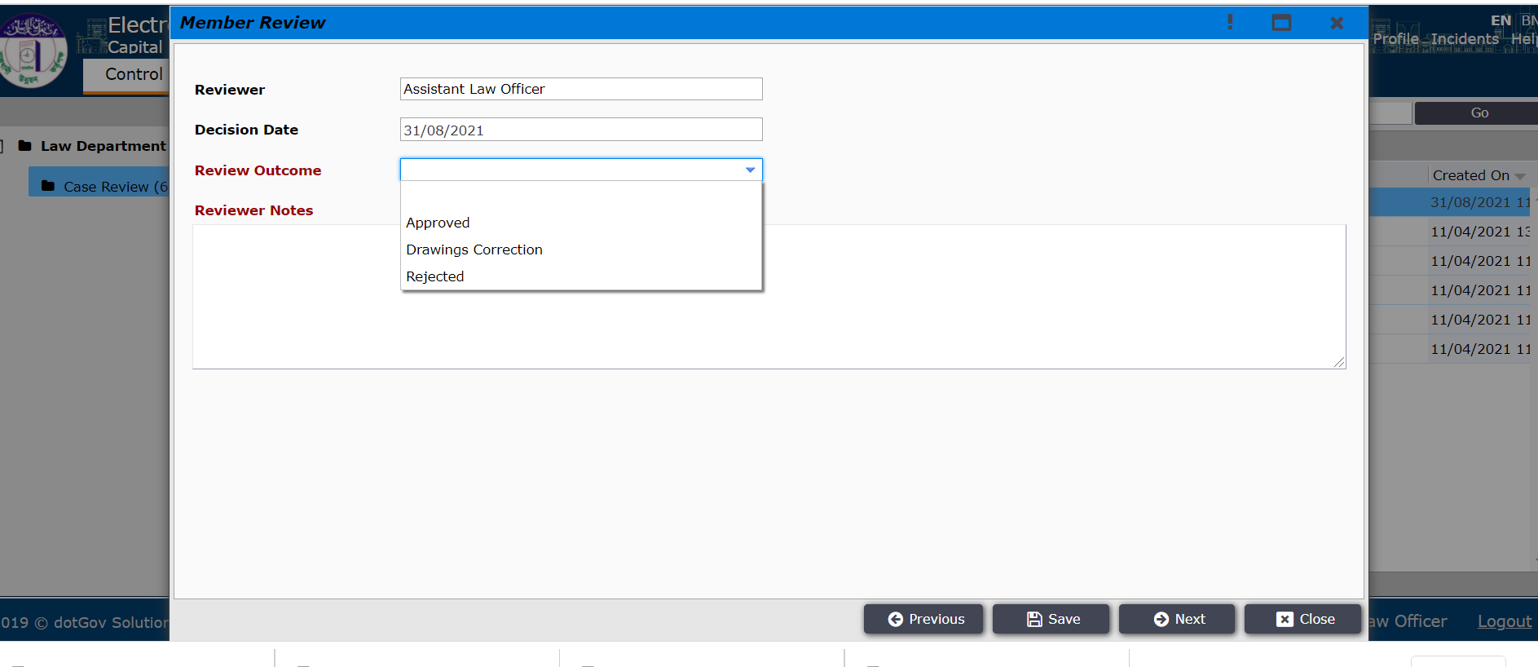
Figure 46

The Assistant Law Officer selects approved and write notes as shown in Figure 47. And then clicks on Next so the review will be completed.
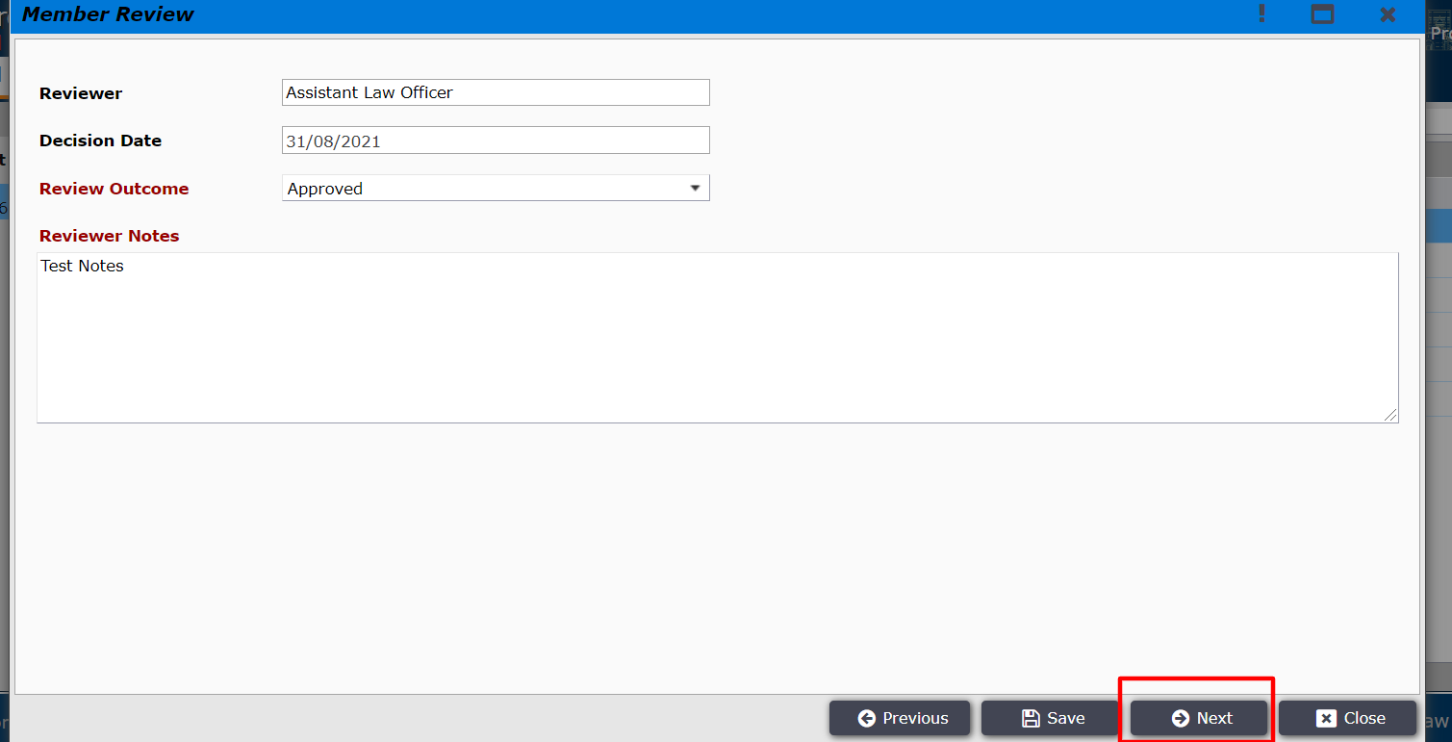
Figure 47
All the reviewer of Law Department such as Low officer and Director of Law will also follow the same process to complete Law Department Review. After all the reviewers completes reviewing then the application will be sent back to the AO.

AO logins in the system and the application is found under Incoming folder and Request Other Department sub folders. AO user clicks on the application as shown in Figure 48.
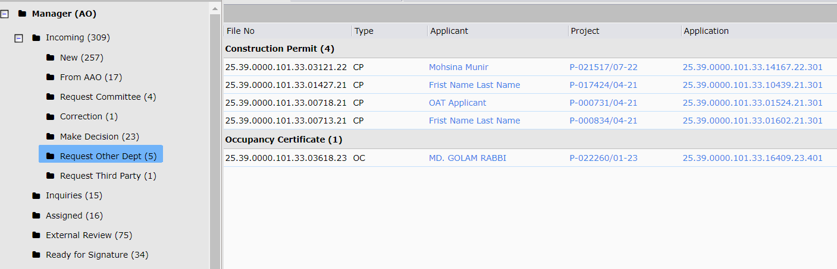
Figure 48
After clicking on the application the details in opened as shown in Figure 49.
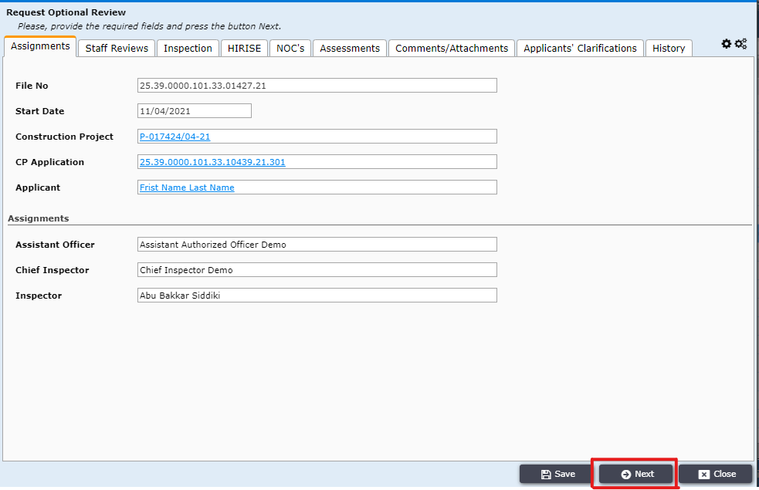
Figure 49

The authorized officer clicks on the Assessments tab, the law department review is shown as open status in Figure 50. The AO user will click on the review.
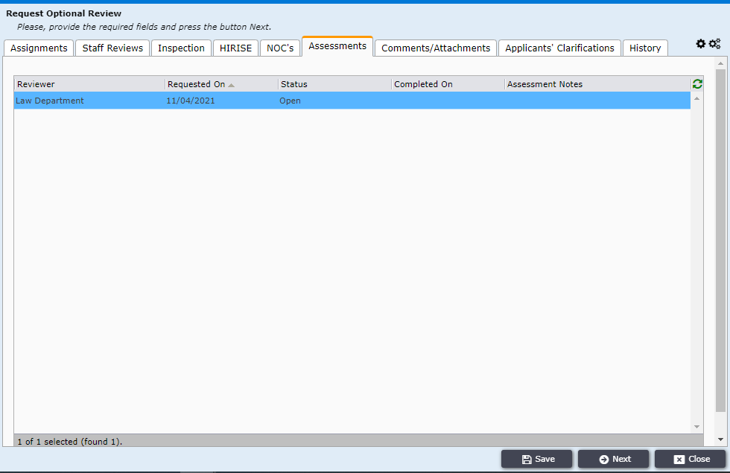
Figure 50

The Assessment Results window is opened with General and Assessments tab. The AO user will select close date and change status With one voice to close the assessment and write assessment notes. Then will click on Save and Close button as shown in Figure 51.
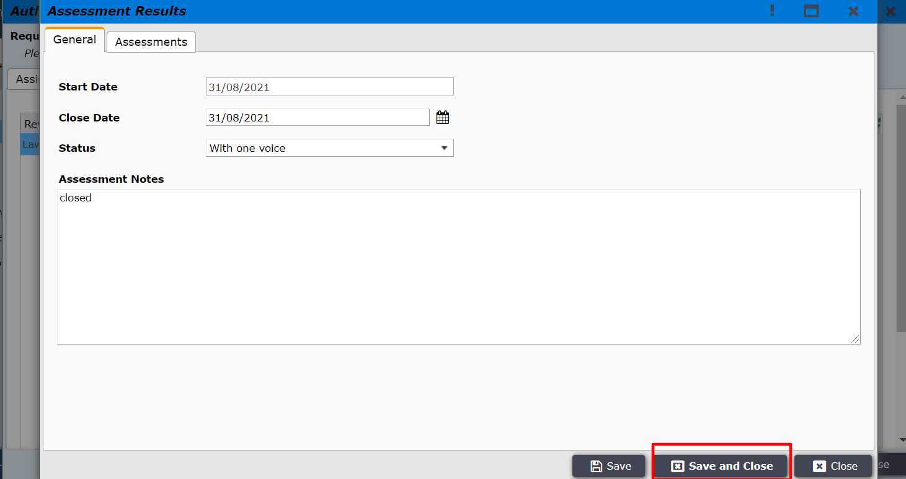
Figure 51

AO user will click on Assessments tab to check the reviewers of the law department as shown in Figure 52.
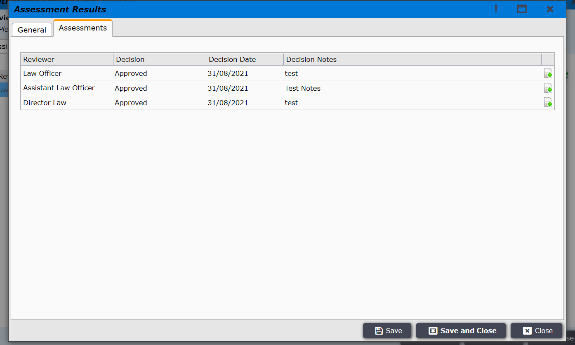
Figure 52

After clicking on Save and Close, the Assessments Notes is shown as closed. AO user clicks on Next.
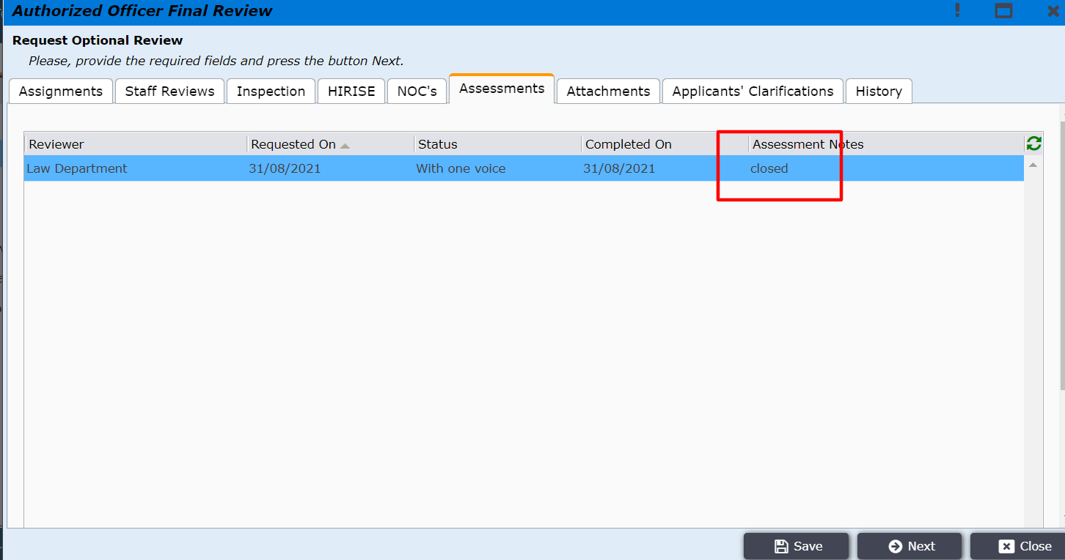
Figure 53
After clicking on Next the AO user is taken to the window as shown in Figure 54. AO user clicks on Back to Internal Review Results.
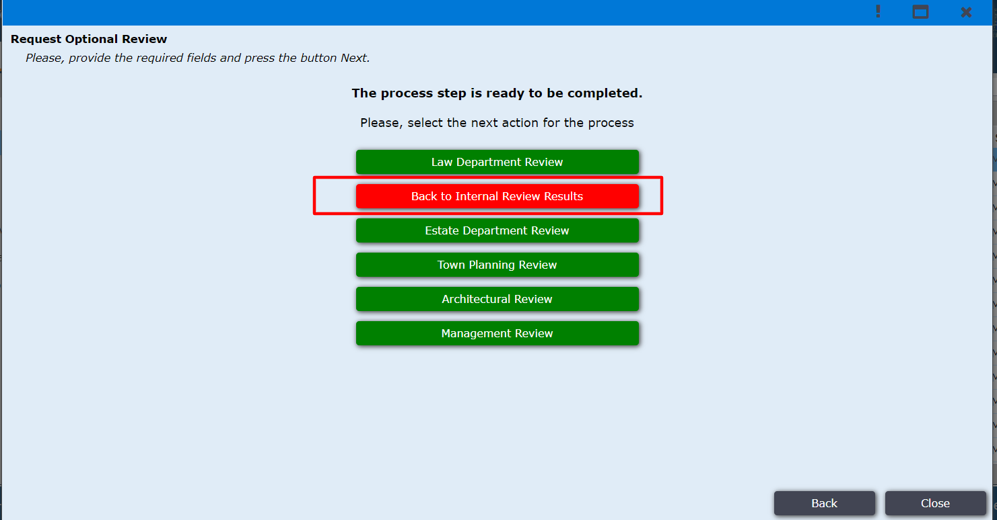
Figure 54

The AO user is taken back to the incoming folder and From AAO sub-folder as shown in Figure 55.

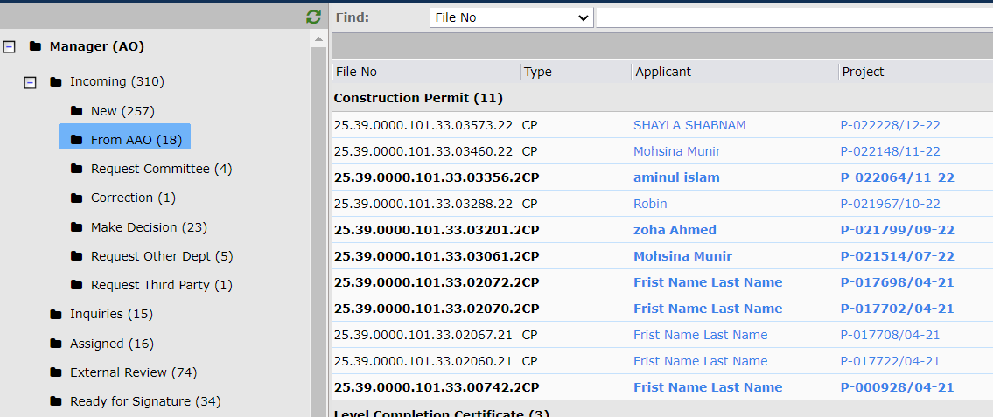
Figure 55

After opening this file and click Next many button comes shown in Figure 55.1. There is a button Request Additional Clarifications to Applicant.
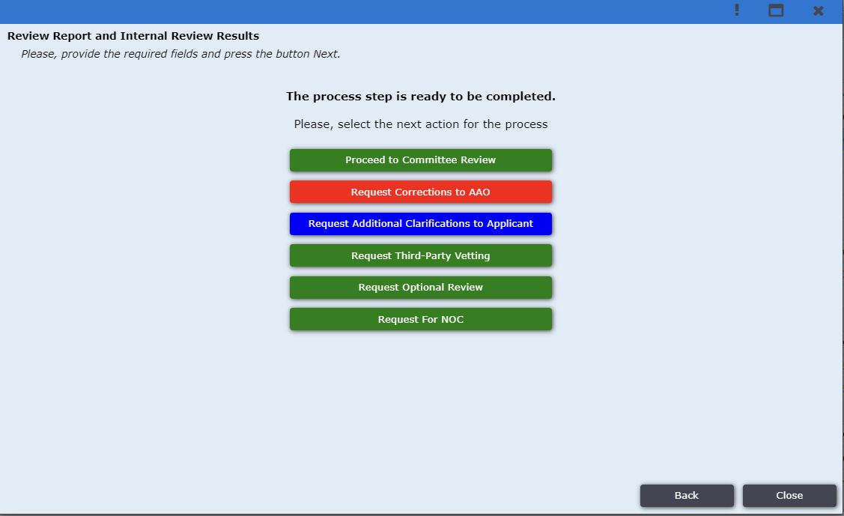
Figure 55
After clicking on this button new form will come shown in Figure 55.1. And then AO user click on “Yes” if Additional Payment is required. After clicking this new field pop up and have to give payment amount. Also he put some text what clarifications he need. After clicking Next file will go to applicant. If applicant send the clarifications and payment the file will come in FROM AAO sub folders.
Figure 55.1

Before sending the file to Committee AO user has to Create a meeting. For this AO will click on Meeting folder shown in fig 55.1.
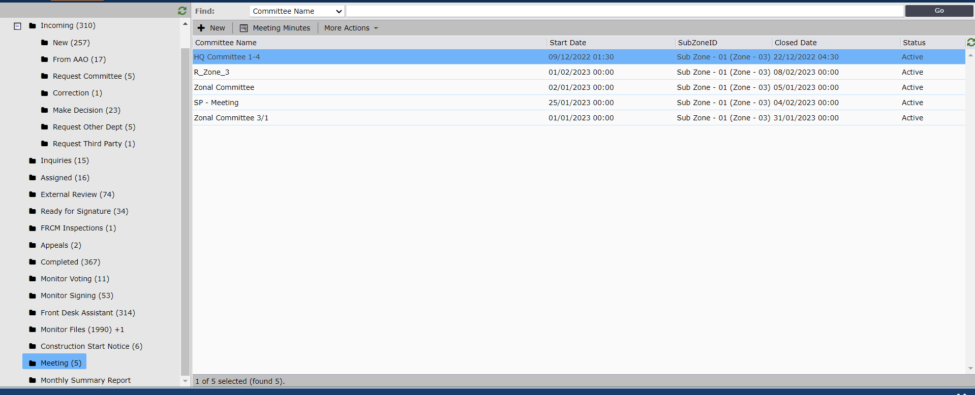
Figure 55.1
After that AO user click on New button to declare the meeting shown in fig 56.1. After clicking New button a new form come shown in fig 56.2 and the AO user provides all information about the meeting and save the meeting.
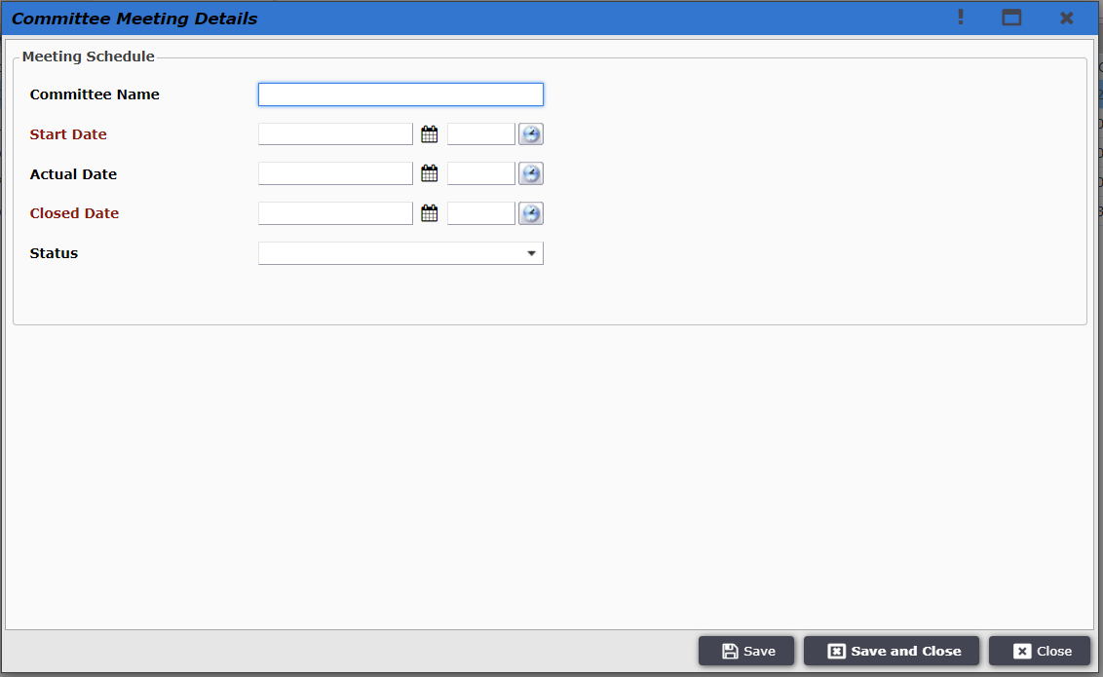
Figure 55.2

AO user clicks on the application and the window as shown in Figure 56. And clicks on Next.
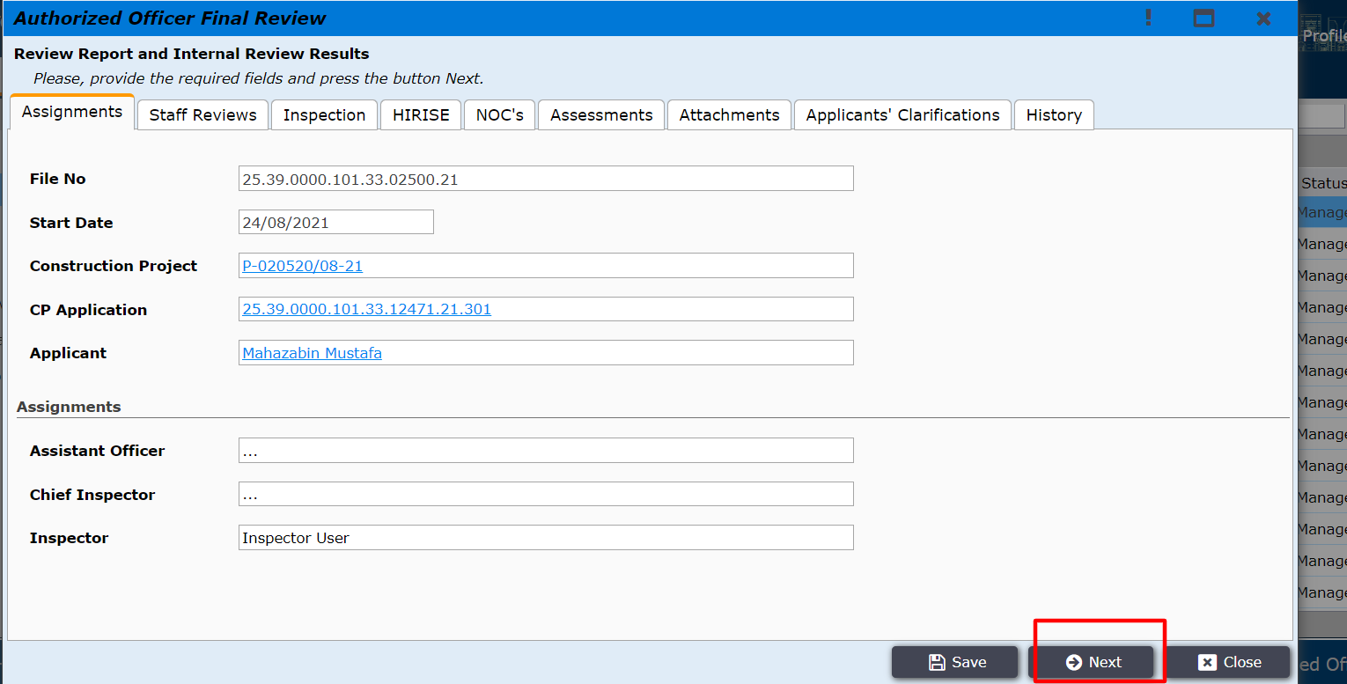
Figure 56
The AO user now clicks on Proceed to Committee Review as shown in Figure 57. And the user is taken back to the incoming page now in the Request Committee sub folder.
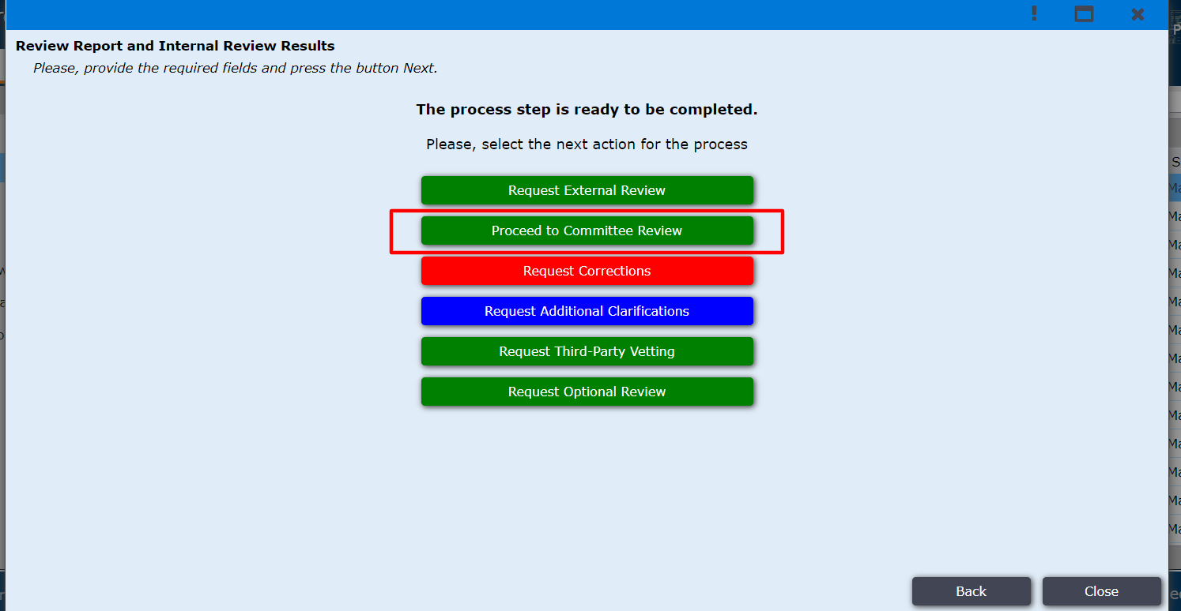
Figure 57

AO user clicks on the application and the window as shown in Figure 58 will be opened. And AO will click on Next.
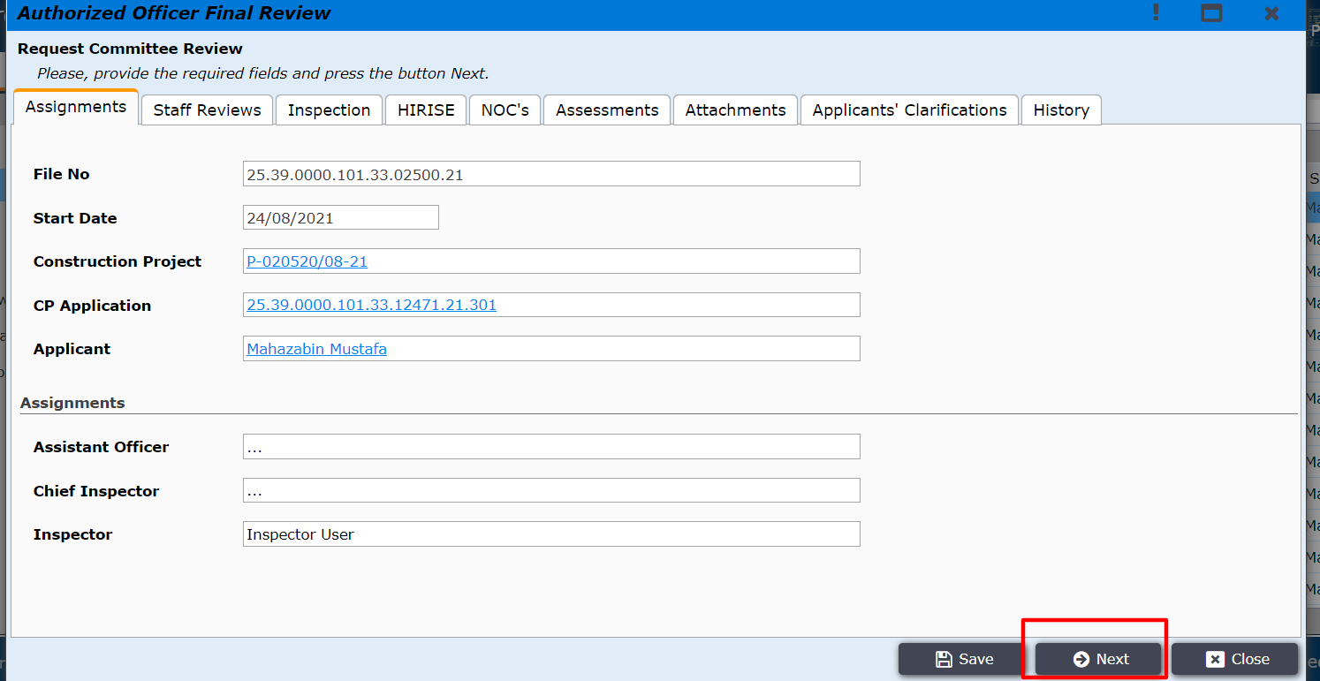
Figure 58
The AO user will be shown the option for Request Review and Make a Decision for Low Risk. AO will click on Request Review as shown in Figure 59. By clicking on Make a Decision for Low Risk, AO user can proceed this application without committee review.
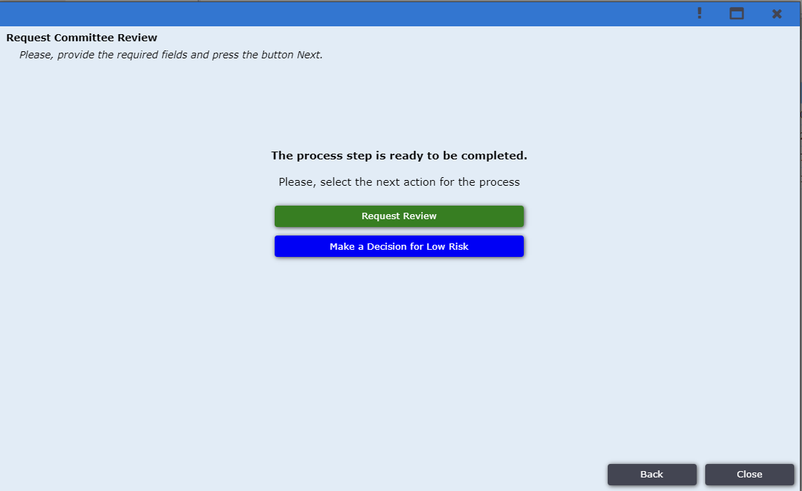
Figure 59
After clicking on Request Review a new form will come shown in fig 59.1. AO click on Active Meeting and get some active meeting. AO user selects one of the meetings shown in fig 59.2
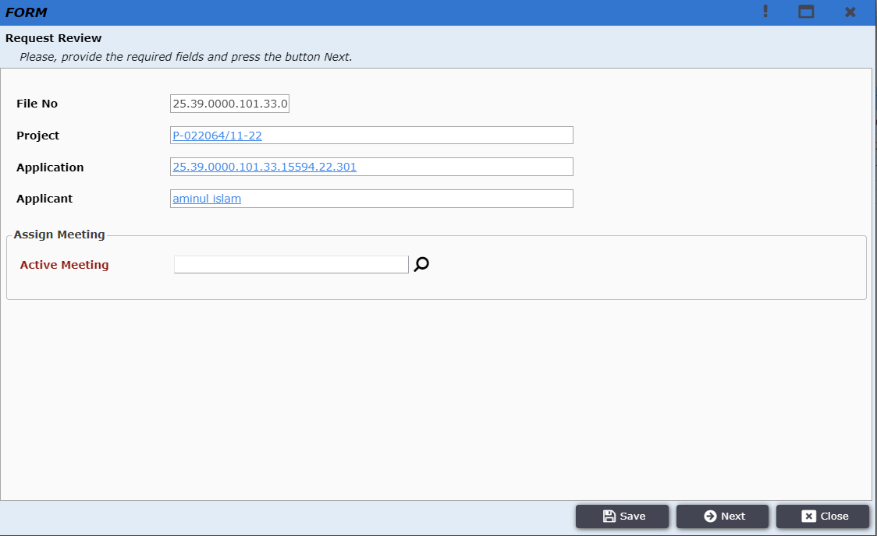
Figure 59.1

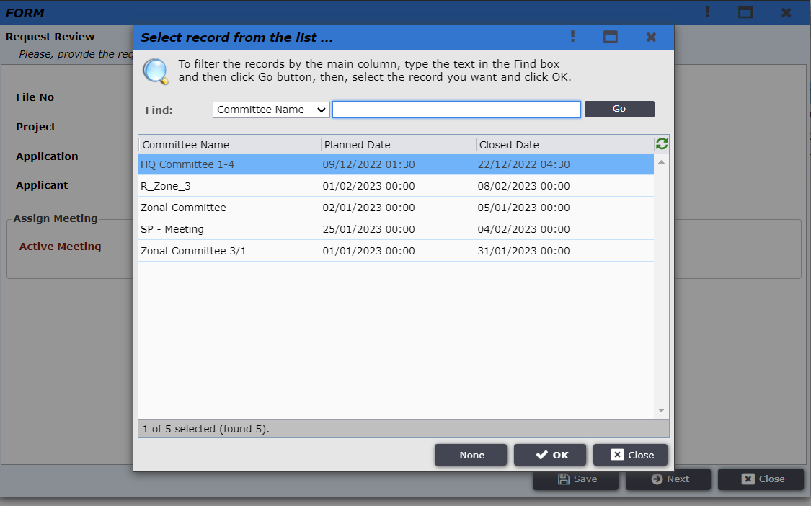
Figure 59.2

After selecting a meeting and clicking on Next AO user can see the basic details of the selected meeting.
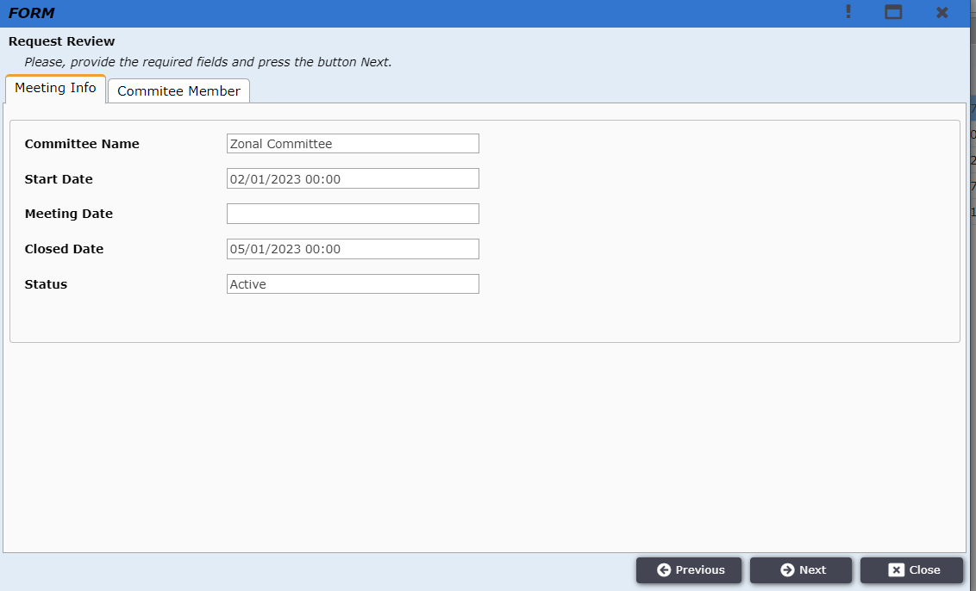
Figure 59.3

After clicking Next the application is moved under the Monitor Voting folder as shown in Figure 60.
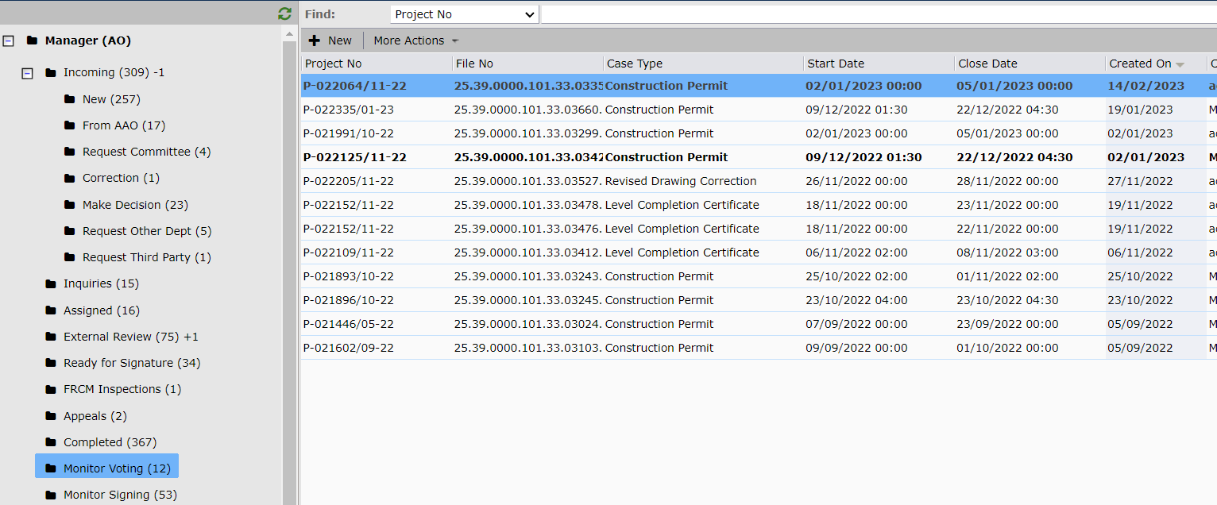
Figure 60

In this folder, AO user can monitor the voting progress. By Clicking on the file Basic information of file and the result of the voting process(All the committee members and their status on this file) will be shown in fig 60.1 and 60.2
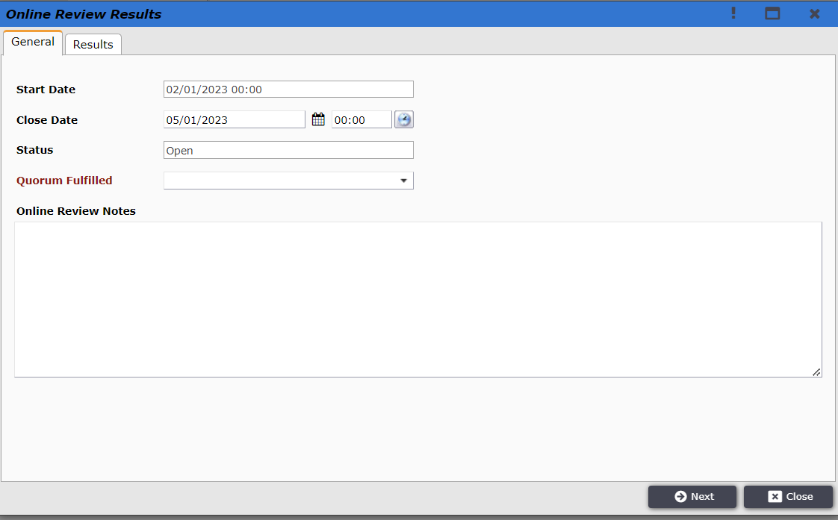
Figure 60.1
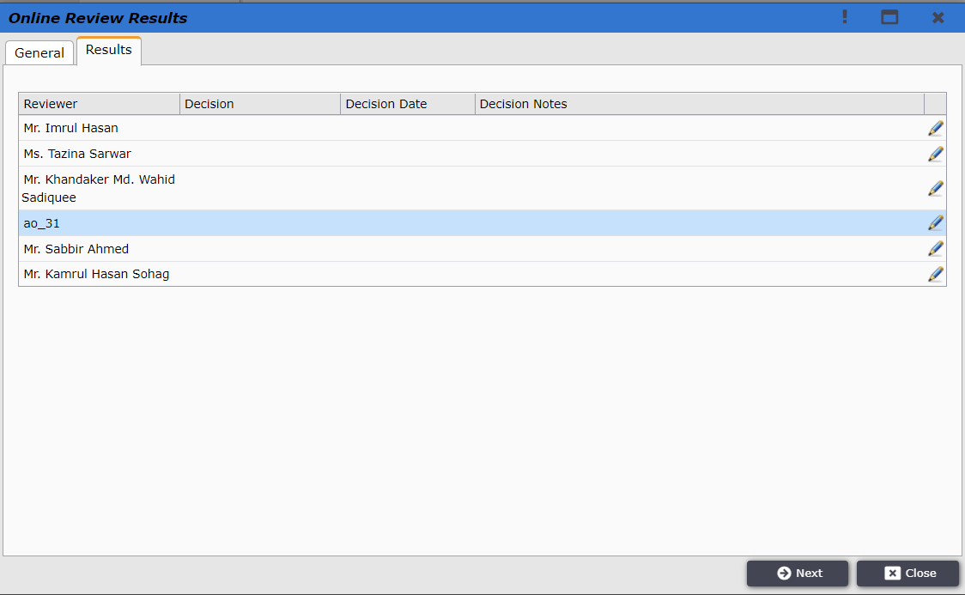
Figure 60.2

Committee reviewer member logins to the system and finds the application under the External Review tab as shown Figure 61.
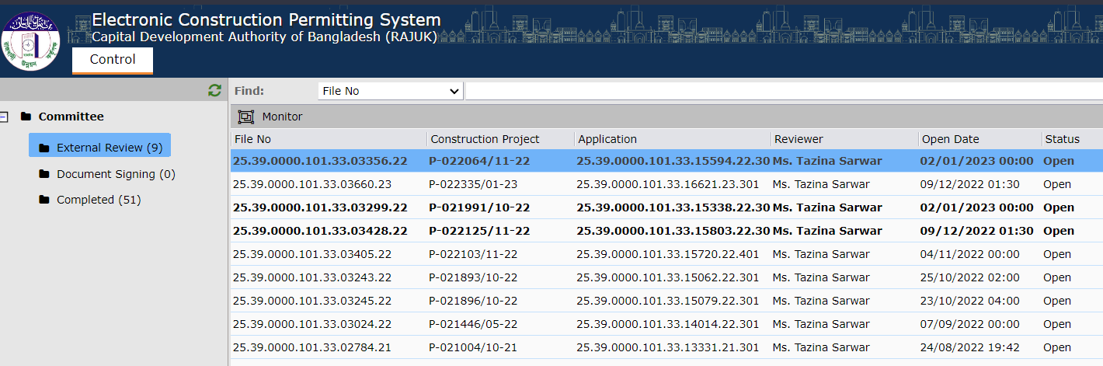
Figure 61

Reviewer clicks on the application and the window as shown in Figure 62 is opened. Review Outcome options are available as Approved, Drawings Correction and Rejected.
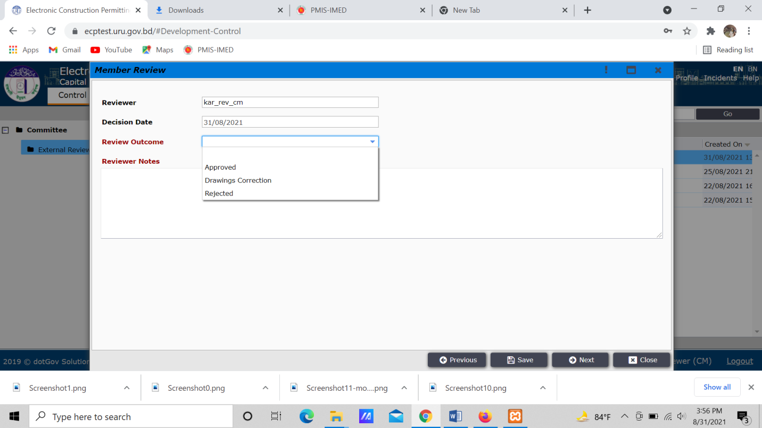
Figure 62

The reviewer selected Approved and wrote review notes and clicked on Next as shown in Figure 63.
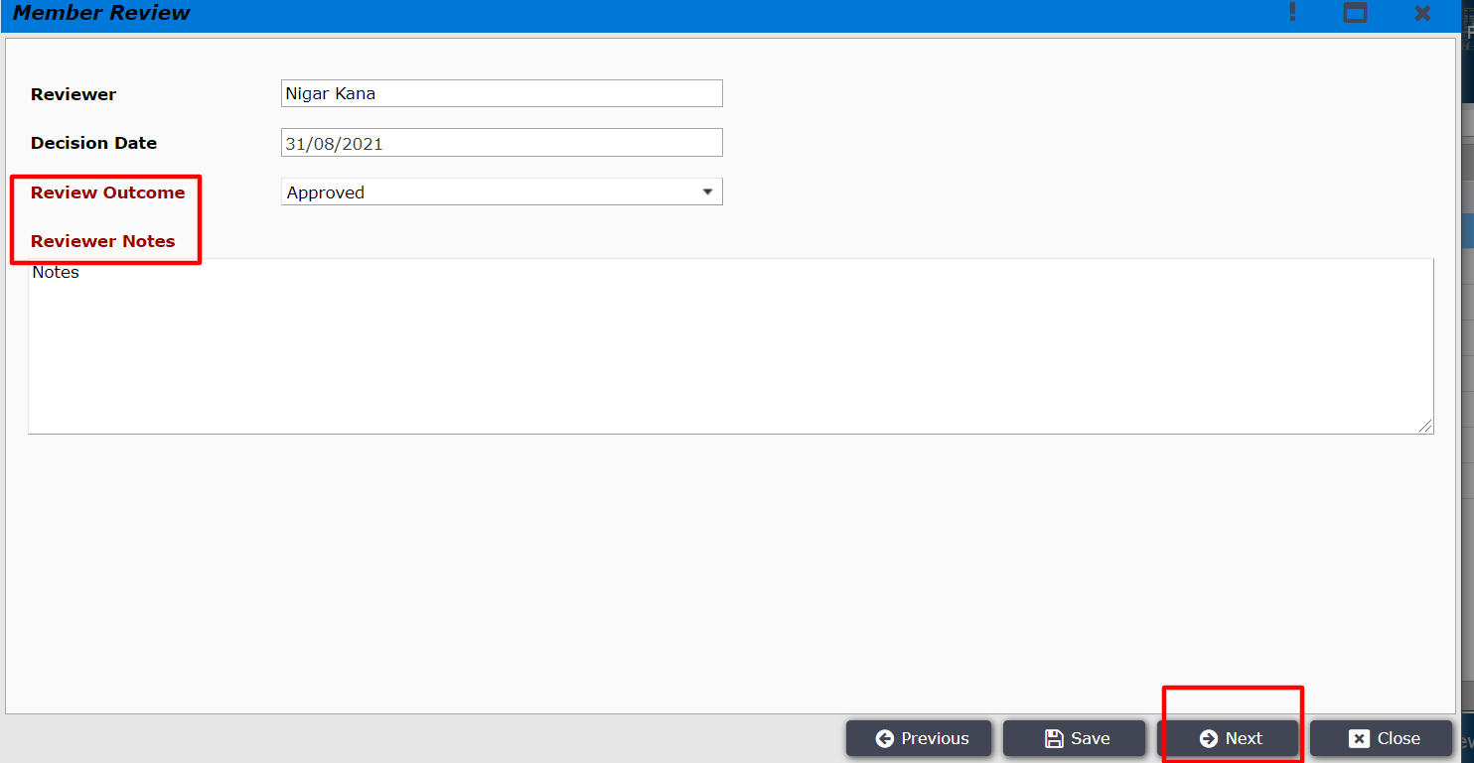
Figure 63
All the committee members for the review will follow the same process. After all the reviewers complete their online review the application is sent back to the AO.
AO user logins to the system and will find the reviewed application under Collect Signature sub folder tab as shown in Figure 64.
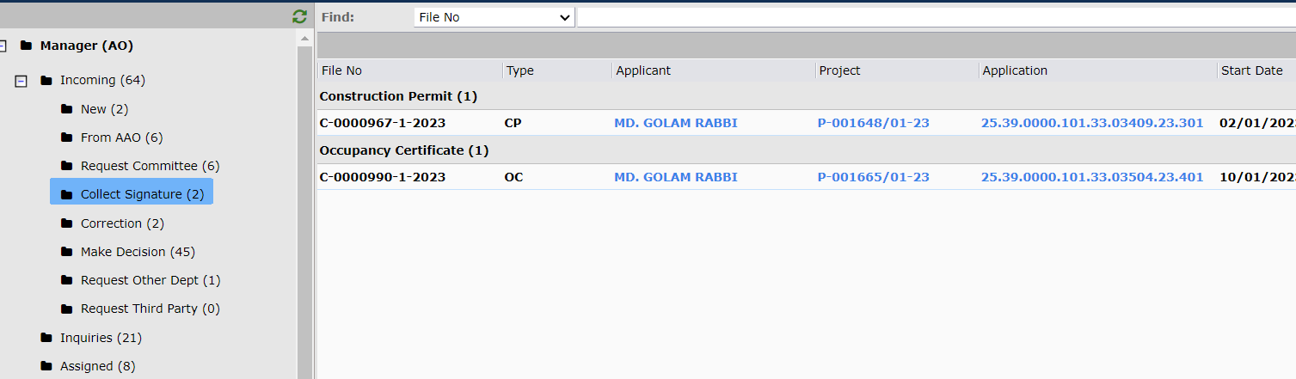
Figure 64
Also there is a possibility all the committee member is not present in this meeting. Then AO can end the meeting process. For ending the meeting process AO opens the file from monitor voting and select Quorum fulfill Yes and click next. There is a condition for ending the meeting process: AO must vote. Shown fig 64.1, 64.2
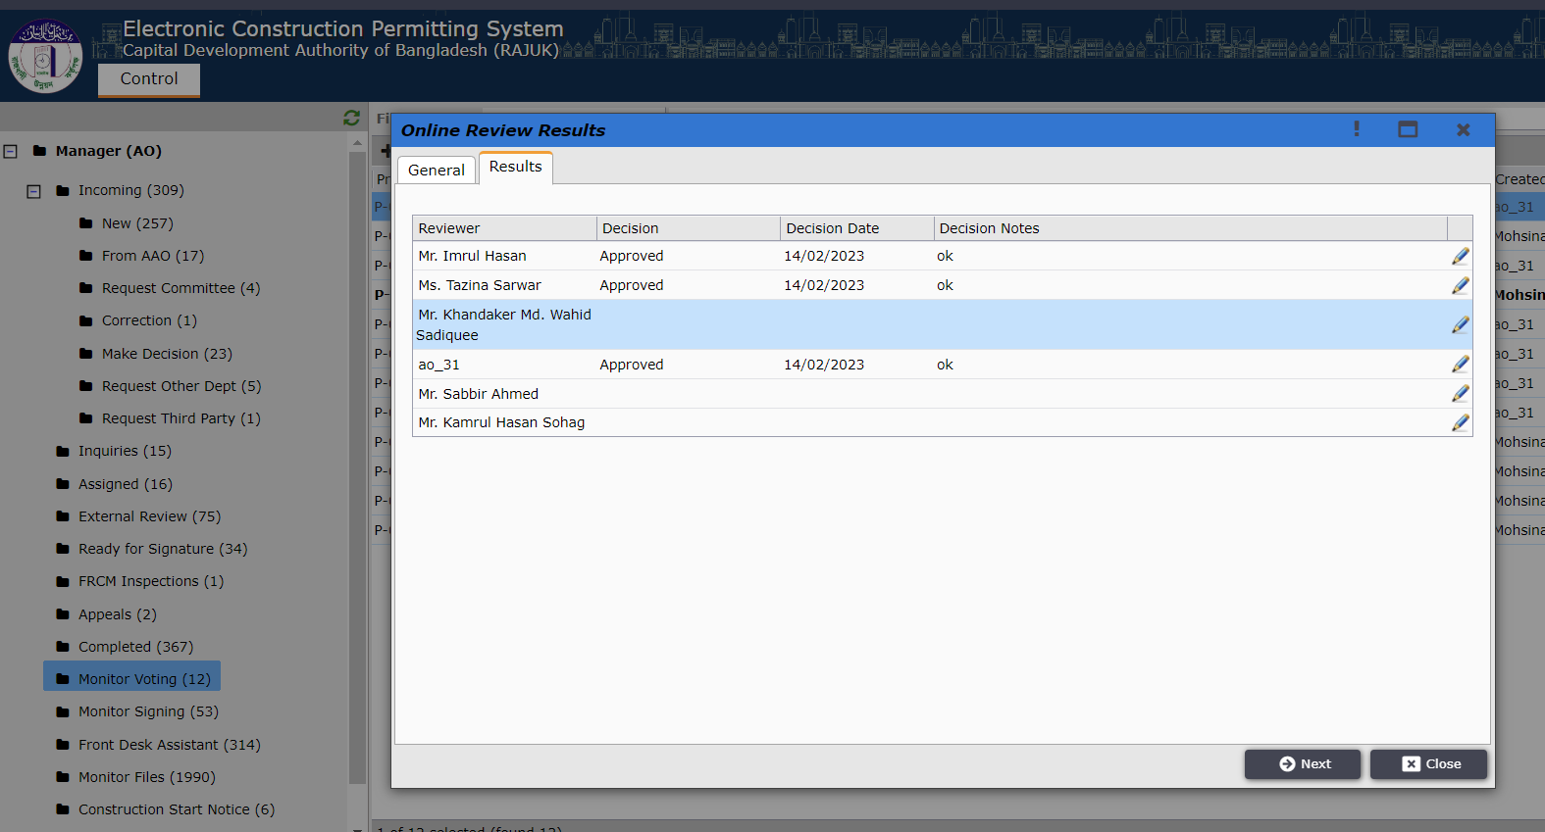
Figure 64.1
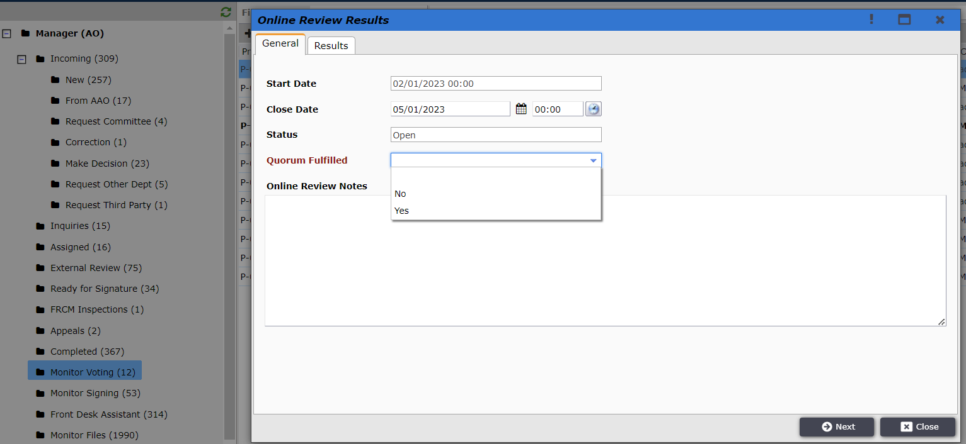
Figure 64.2

AO will find the reviewed application under the Collect Signature sub folder tab as shown in Figure 65.
Figure 65

After opening the file from the Collect Signature folder and clicking on Next the window shown in Figure 66 is opened.

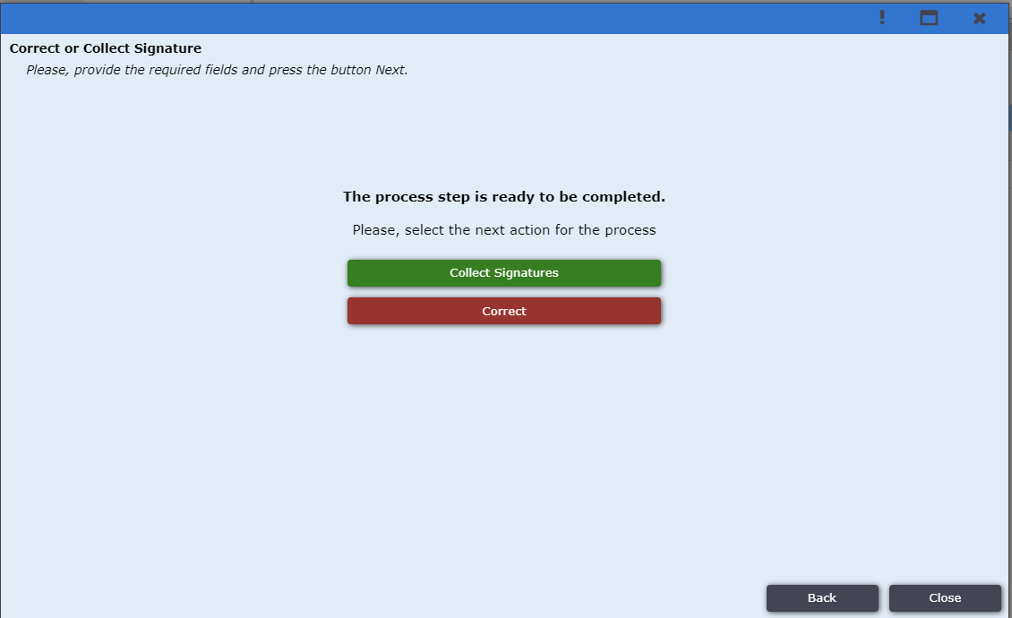
Figure 66

The button Correct in Figure 66. If AO user click on Correct he/she able to send file to applicants to correct their drawing then re-submit.
If AO user click on correct then he/she get file in Correction Subfolder shown in Figure 66.1
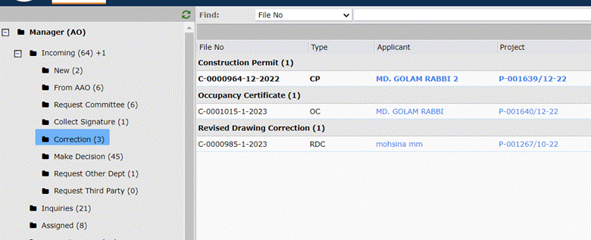
Figure 66.1
If AO user open the file and click Next, then a form shown in Figure 66.2. If Additional Payment need for this correction AO user click on Payment Required Yes then new field pop up to give payment amount.
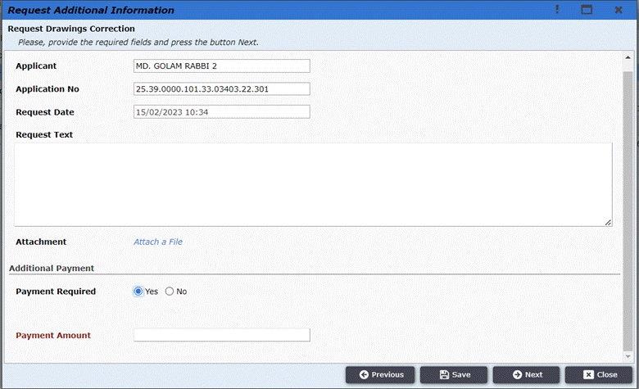
Figure 66.2
If AO user click on Next then new window pop up with a button Request Corrections shown in Figure 66.3 . If AO user click on this button the file go to applicant. When applicant re-submit the file it come in AO’s Request Committee Sub folder.
After that AO user send this file BC committee again.
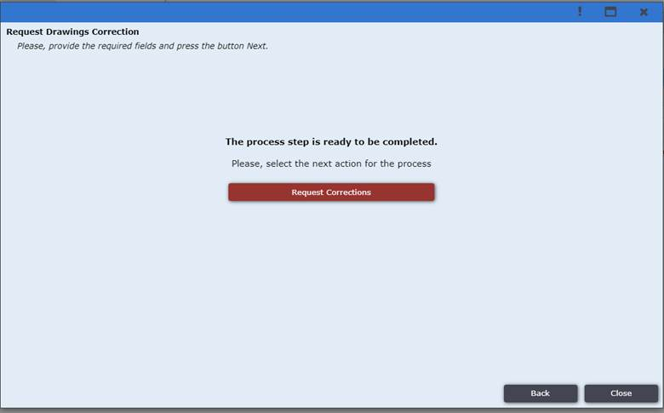
Figure 66.3

Then the another is button Collect Signature. After sending file for Collect Signature AO can monitor signing process from folder Monitor Signing. Shown in fig 66.1
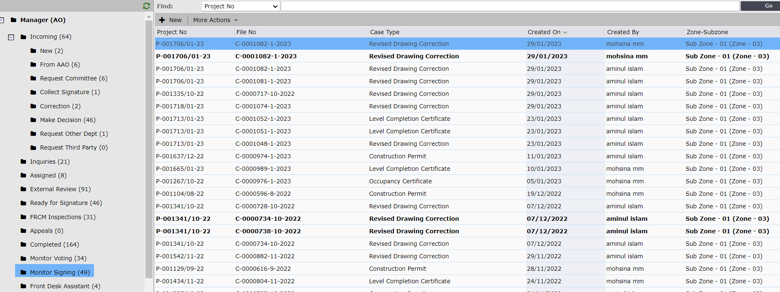
Figure 66.1
The committee member who participated in voting log in and see the file in the Document Signing folder.
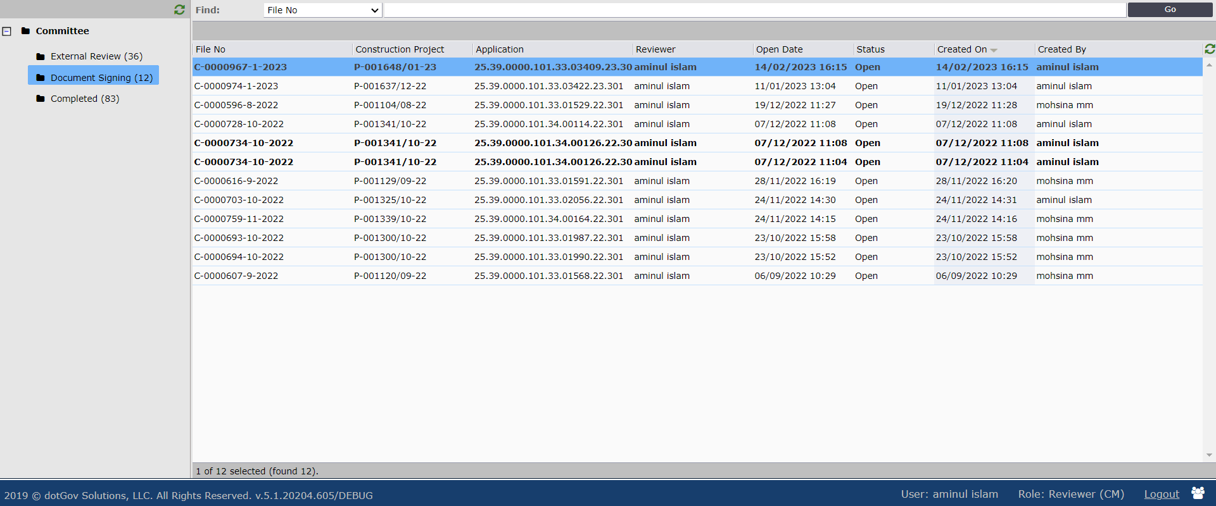
Figure 67
The committee member is needed to download every file in the attachment, apply his/her digital signature to it and attach it back to the form as shown in Figure 68, click Save and Close and then Next
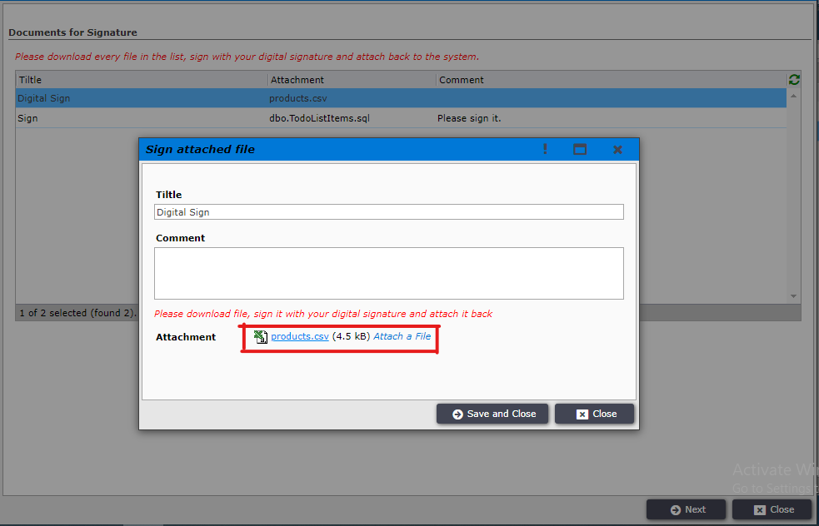
Figure 68

Once all the committee members sign the application, AO find the file in Make Decision sub folder. AO will open the file and able to Approve/Reject the application as in Figure 69
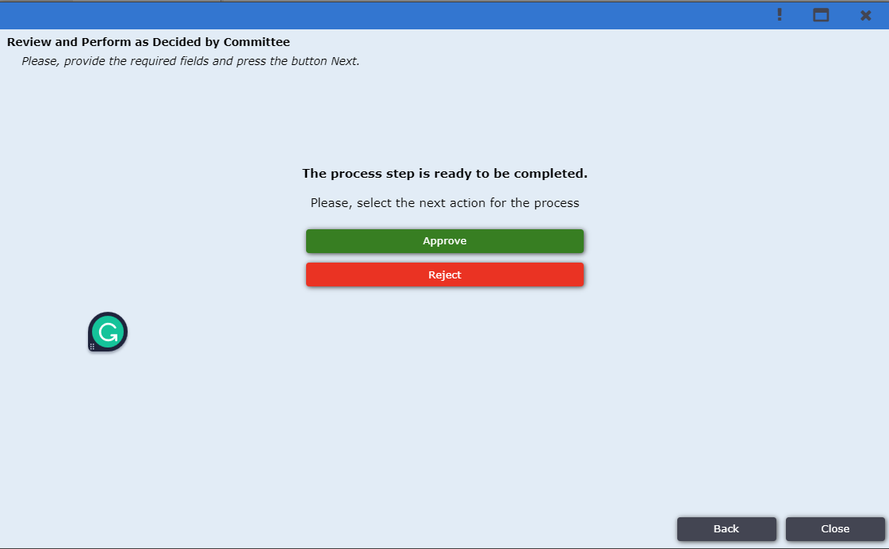
Figure 69

After clicking on Approve the application is sent under Ready for Signature tab as shown in Figure 70.
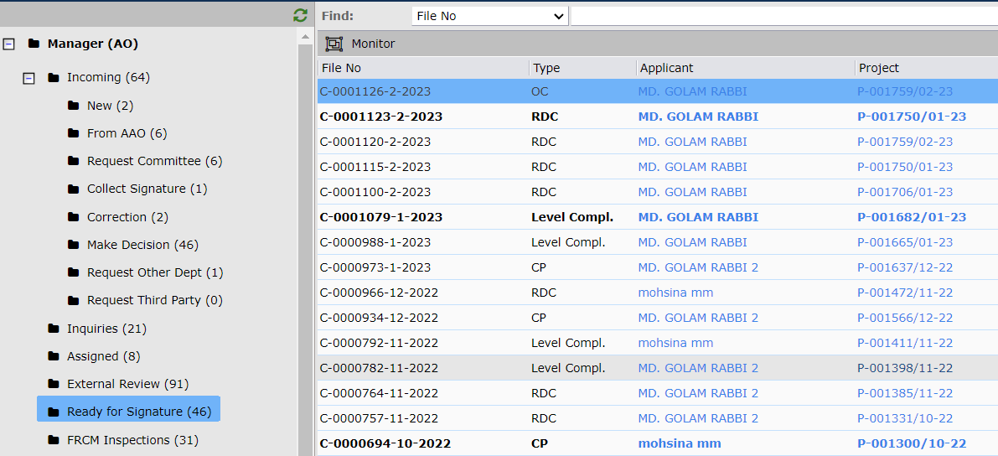
Figure 70

AO user opens the Construction Permit window and clicks on Next as shown in Figure 71.
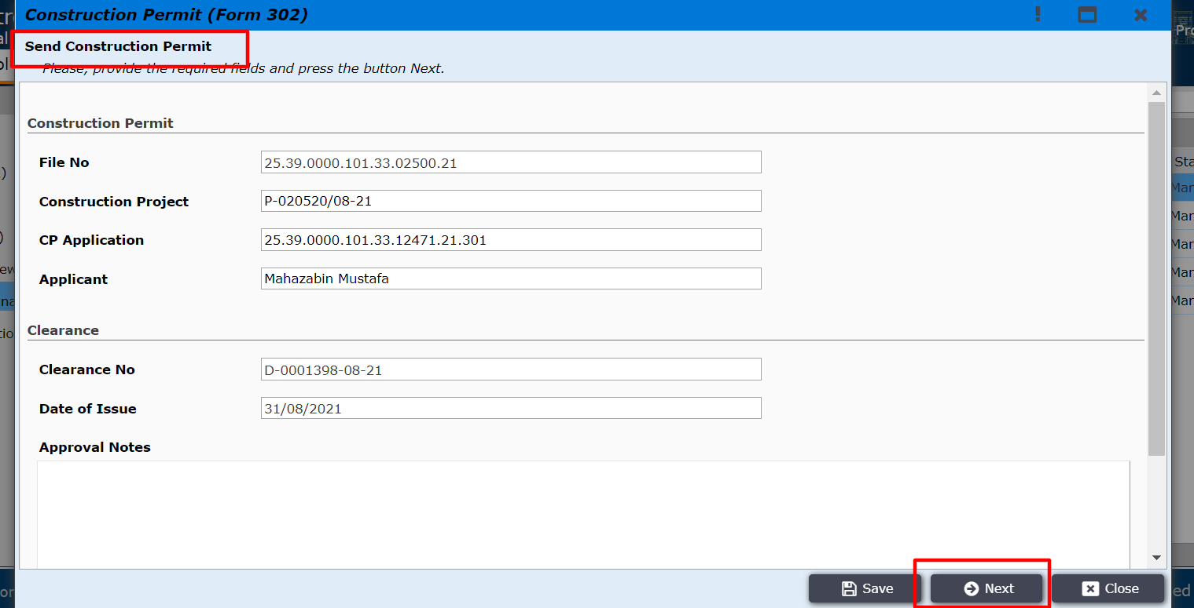
Figure 71

The construction permit print preview is shown as shown in Figure 72.
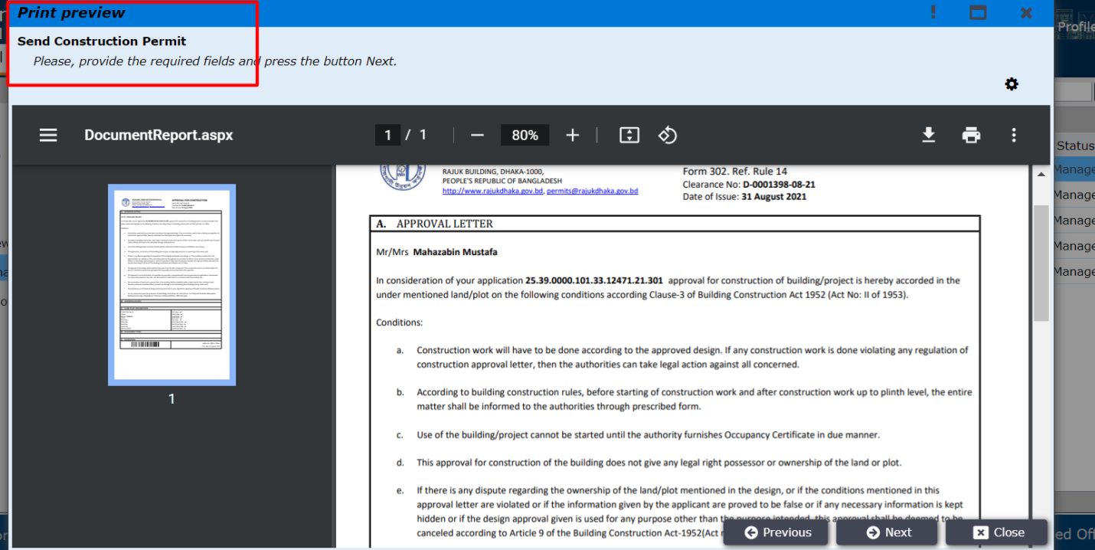
Figure 72

The e-Sign window is opened where AO users will download the file and Digitally signed and upload the signed documents as shown in Figure 73.
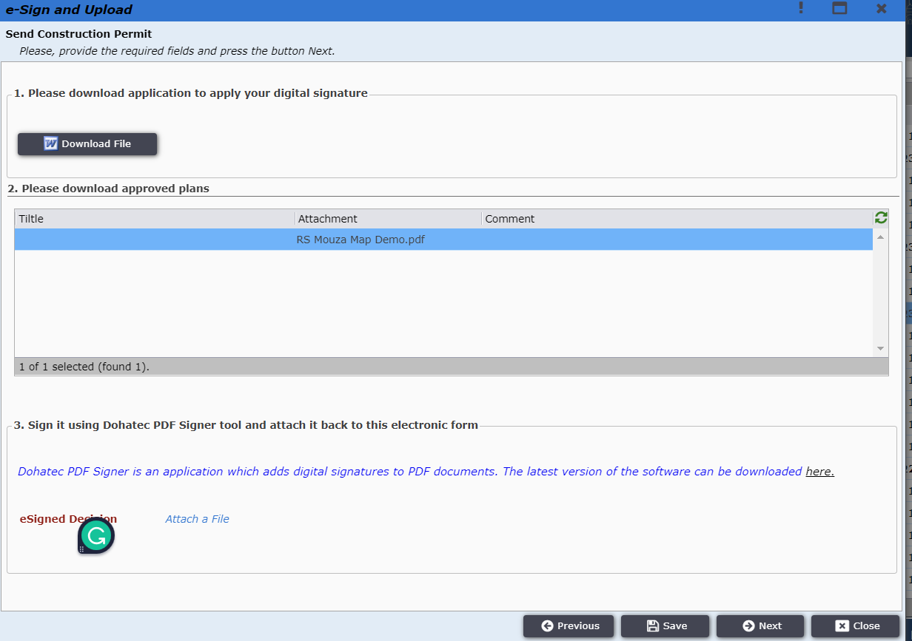
Figure 73
After clicking on the Next button, AO user gets the Send Official Response button. The AO user clicks on it and the Construction Permit is sent to the Applicant.
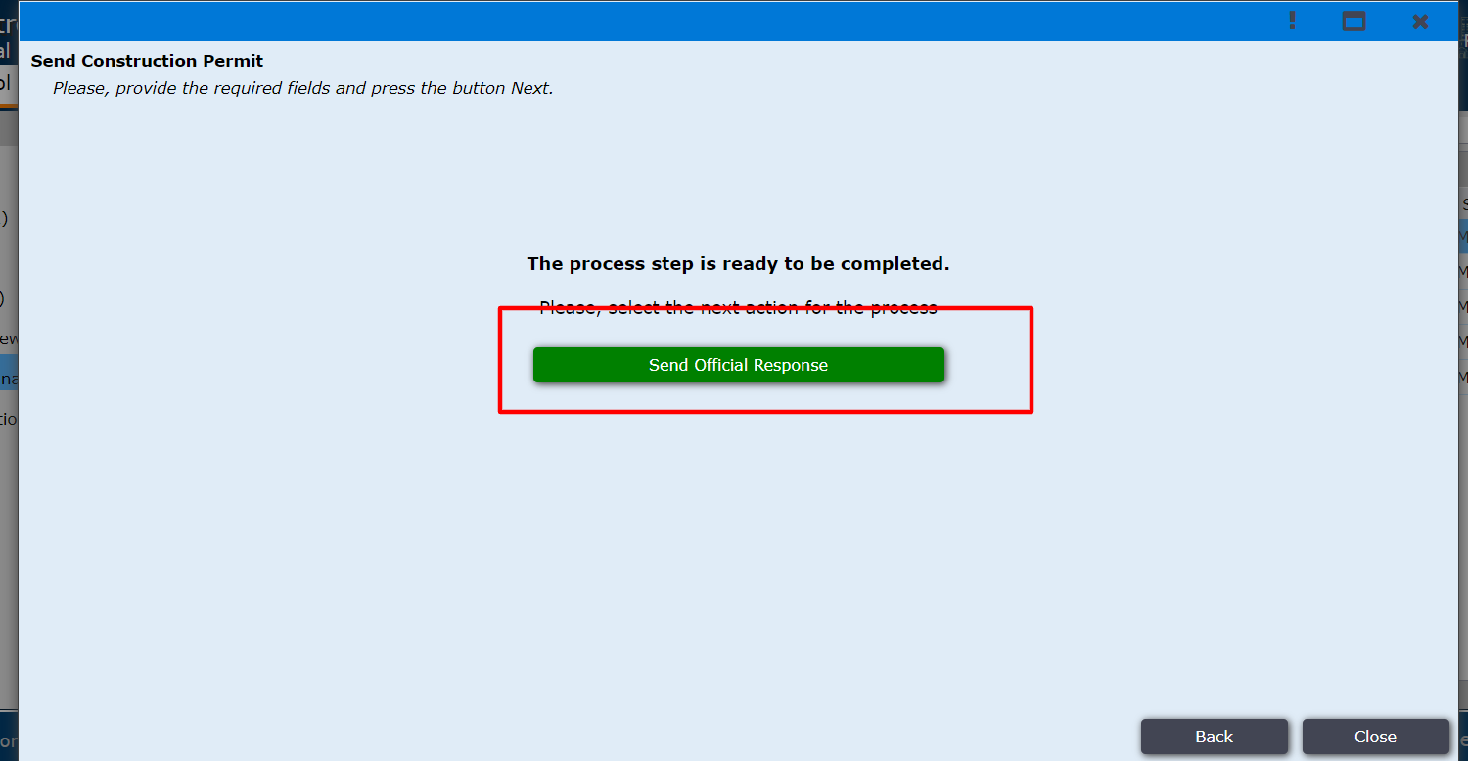
Figure 74

Applicant logins to the system and can find the permit under My Permits tab as shown in Figure 75.
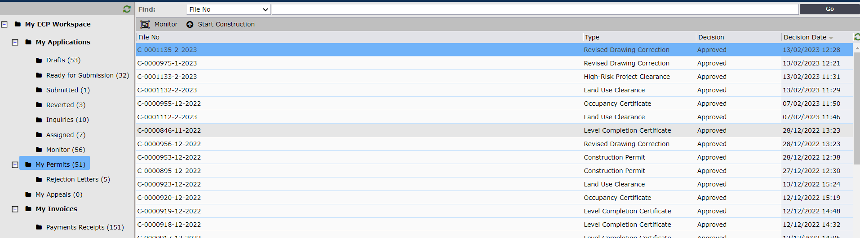
Figure 75
After clicking on the permit the window is opened to confirm receipt as shown in Figure 77. Applicant clicks on Next.
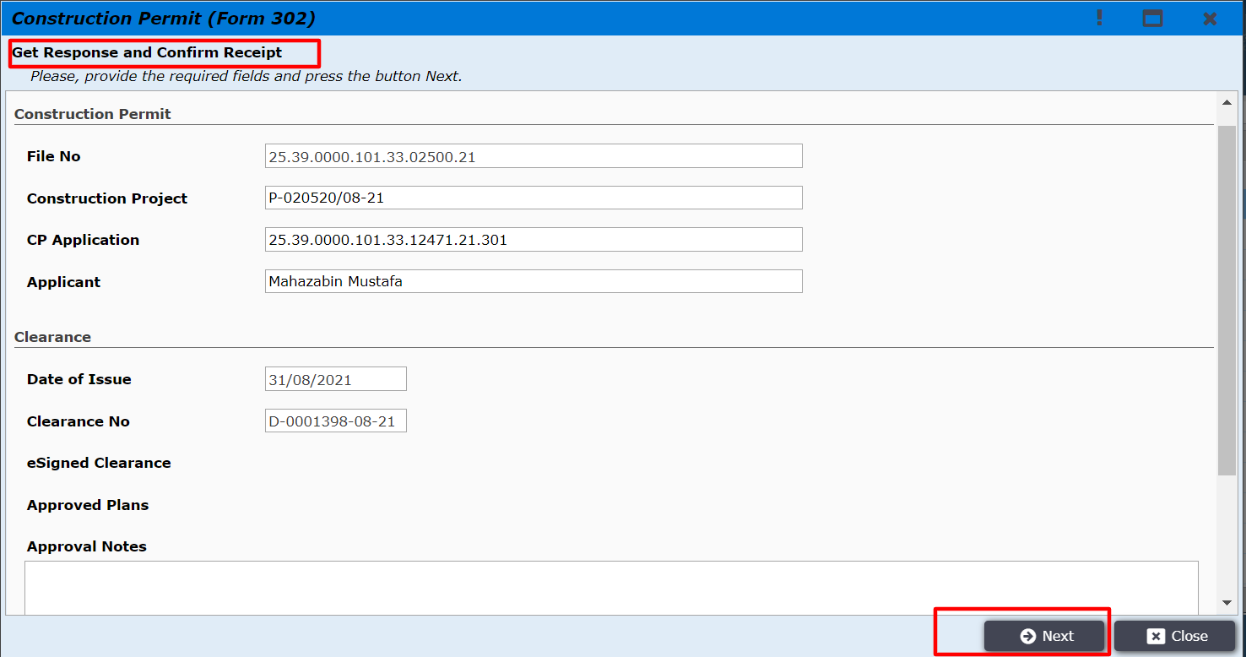
Figure 77

The window to confirm receipt is opened and the user clicks on Confirm Receipt button as shown in Figure 78.
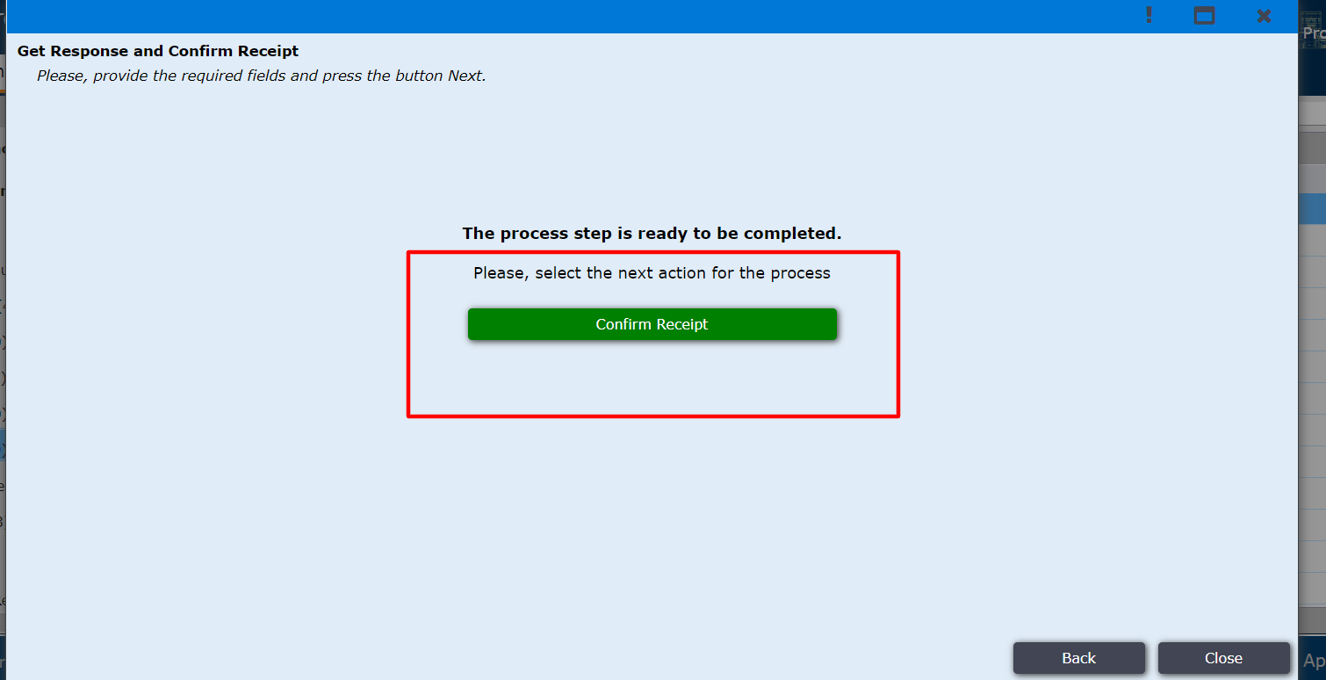
Figure 78
After clicking on it the Applicant gets the successful message as shown in Figure 79.
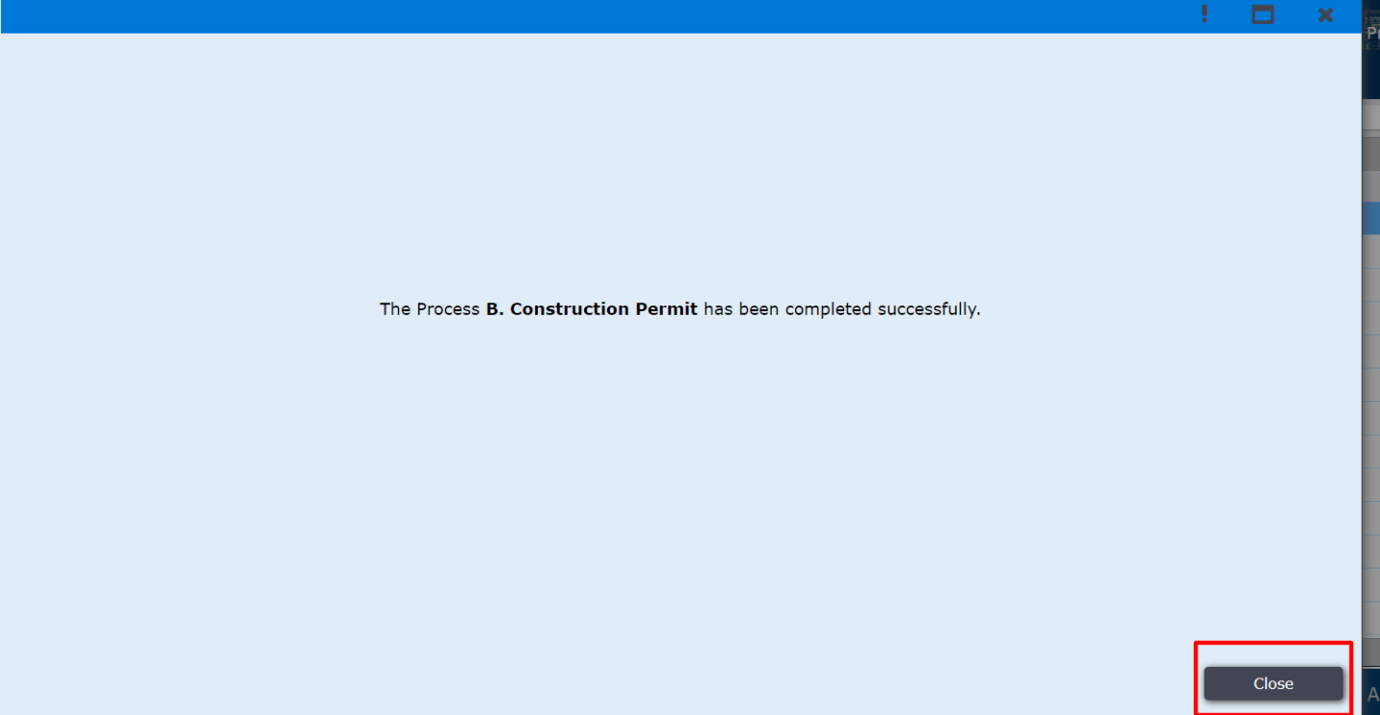
Figure 79

