**LUC Renewal Process**

**Town Planner (TP)** accesses the Electronic Construction Permitting System Portal using the URL

<https://ecp.uru.gov.bd> and providing his/her username and password. TP receives the application for Land Use Clearance Renewal when Front desk assistant accepts the application. TP will find the application in the ***Incoming*** section. Incoming files are sorted from Recent to Oldest. TP will have to click on the Application he wants to proceed with. As shown in ***Figure 1***

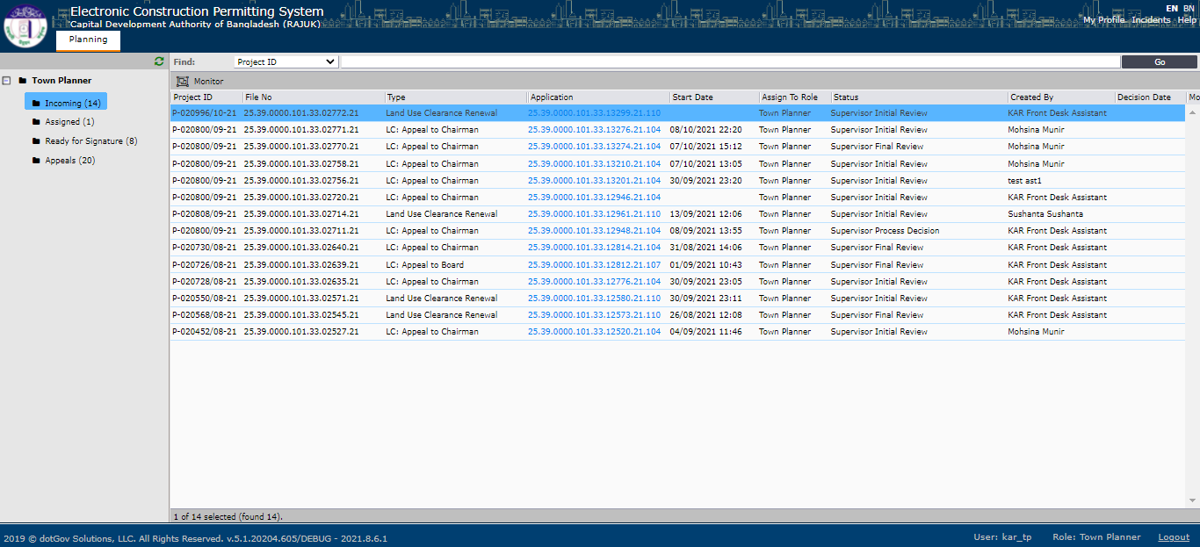

Figure 1

A new pop-up windows will appear when TP clicks on any incoming application. TP will have access to two different tabs ***Assignments and Initial Reviews.***  TP will check all the available information of the application by clicking on the Application number. As shown in ***Figure 2.***

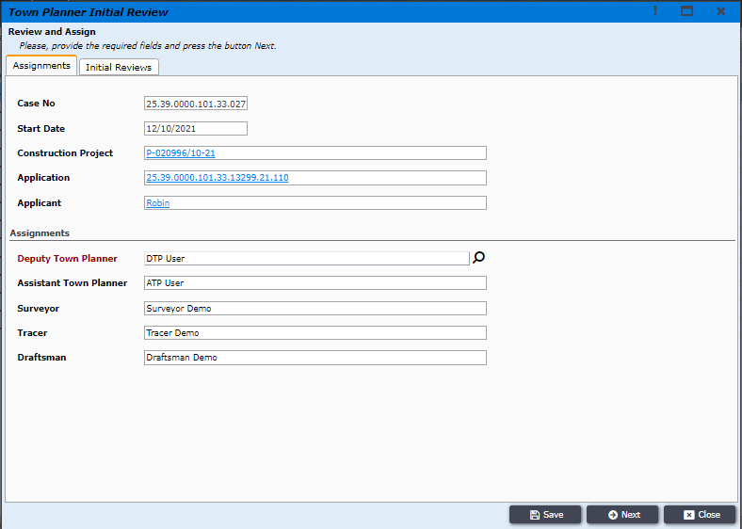

Figure 2

Town Planner should write his initial review comments after checking the application and click on next to proceed forward, as shown in ***Figure 3***

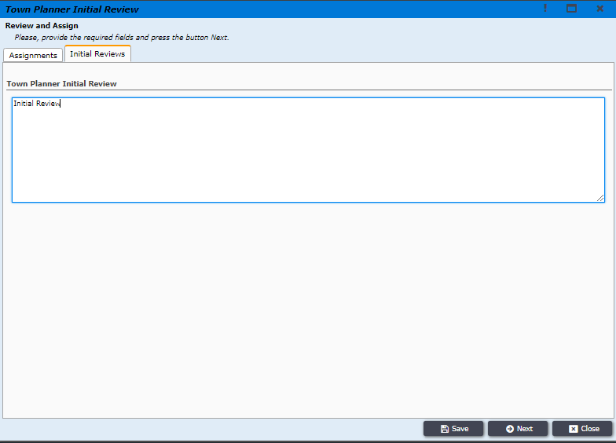

Figure 3

**TP** will then click on ***Assign to Deputy Town Planner*** to forward the application to ***Deputy Town Planner***, as shown in ***Figure 4.***

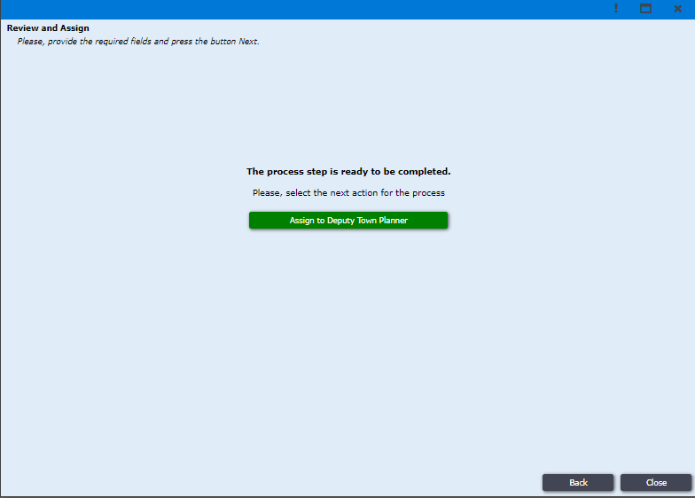

Figure 4

***Deputy Town Planner*** will login to the system with his login credentials and the system will take him to DTP dashboard’s ***Incoming*** section, where DTP will find all the application forwarded to him. There DTP will also find the LUC Renewal application forwarded by TP. DTP user will then click on the application, as shown in ***Figure 5.***

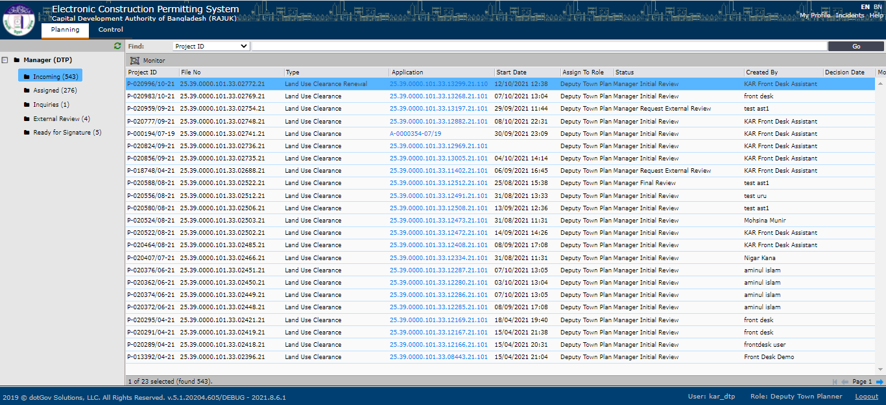

Figure 5

System will open a new window where DTP will have to click ***Assignments*** and click on ***Application*** to check all the available information of the application, as shown in ***Figure 6***.

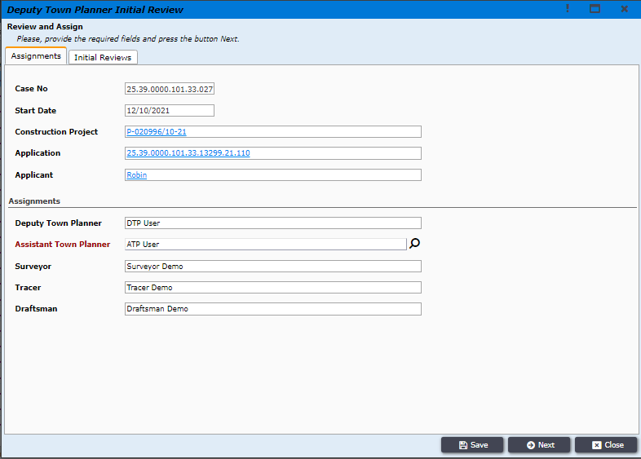

Figure 6

DTP user will then click on ***Initial Reviews*** tab and write his initial review,as shown in ***Figure 7.*** DTP user will then click on ***Next*** button at the bottom.

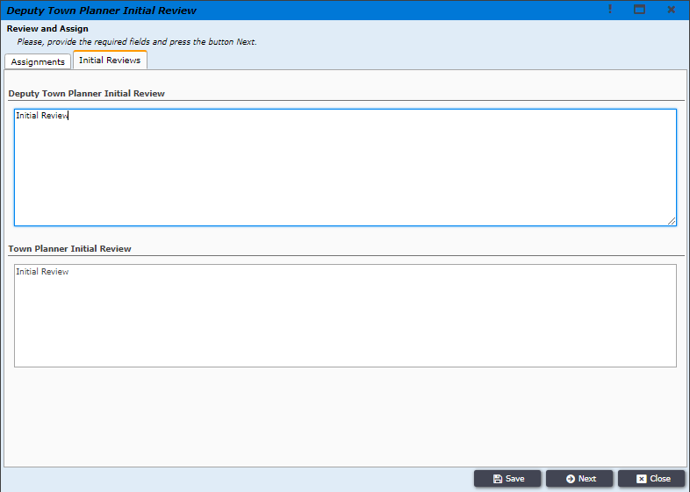

Figure 7

**DTP** will then click on ***Assign to Assistant Town Planner*** to forward the application to ***Assistant Town Planner***, as shown in ***Figure 8.***

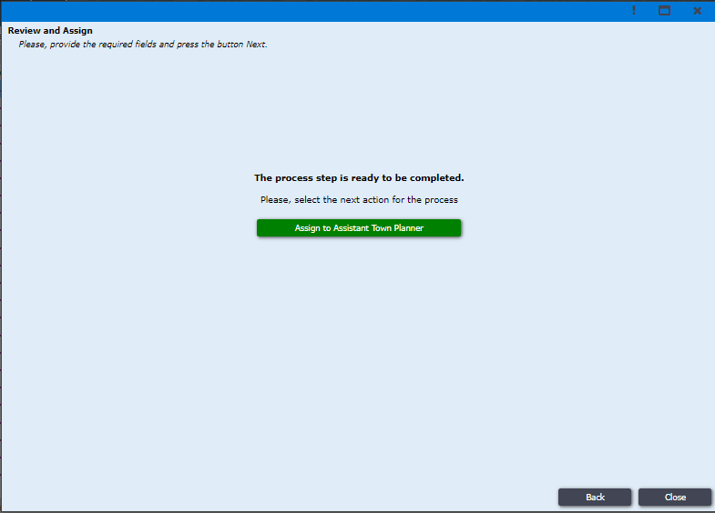

Figure 8

***Assistant Town Planner*** will login to the system with his login credentials and the system will take him to ATP dashboard’s ***Incoming*** section, where ATP will find all the application forwarded to him. There ATP user will also find the LUC Renewal application forwarded by DTP. ATP user will then click on the application, as shown in ***Figure 9.***

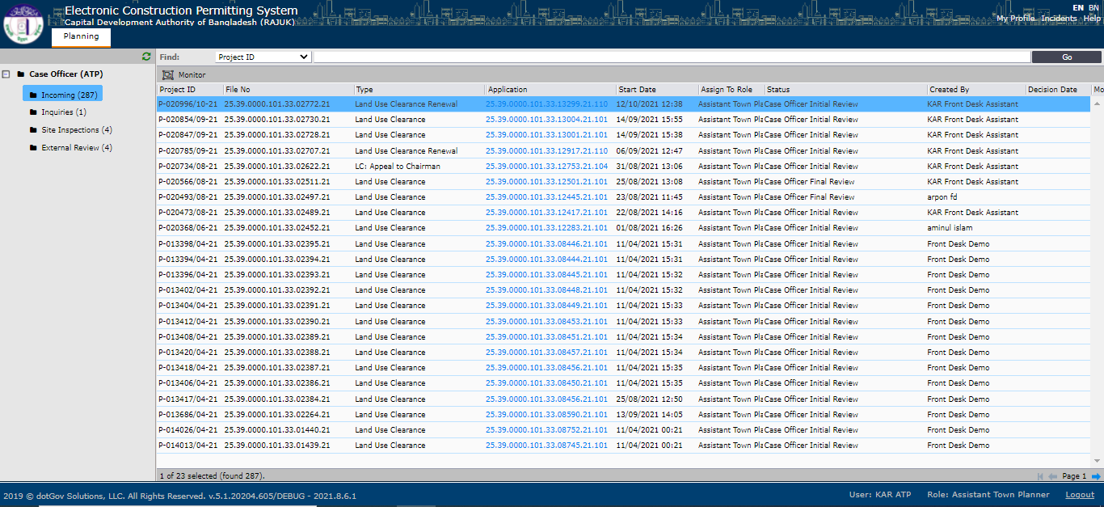

Figure 9

System will open a new window where ATP will have to click ***Assignments*** and click on ***Application*** to check all the available information of the application, as shown in ***Figure 10***.

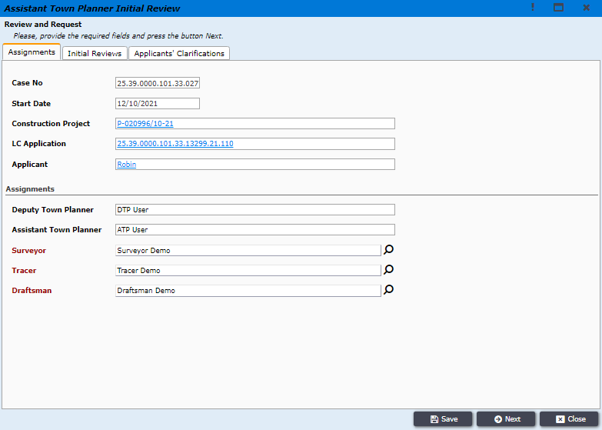

Figure 10

ATP user will then click on ***Initial Reviews*** tab and write his initial review,as shown in ***Figure 11.*** ATP user will then click on ***Next*** button at the bottom.

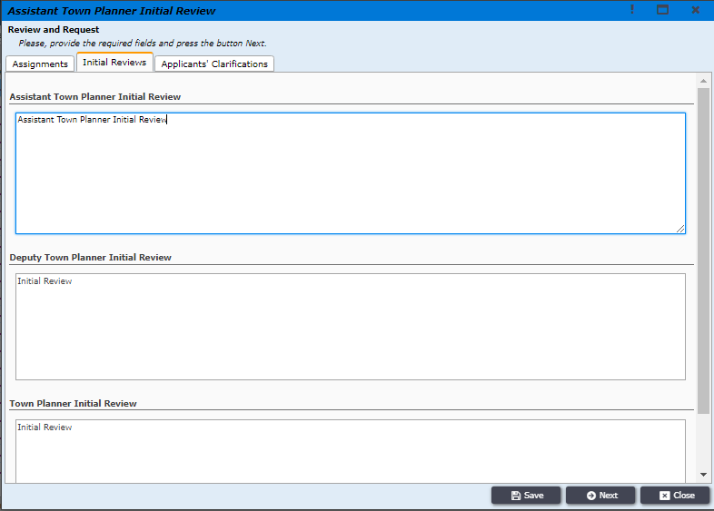

Figure 11

ATP user will then get a new window with two option **Request Site Survey** and  **Request Clarifications.** ATP user will click on **Request Clarifications** if he decide to request the applicant for some clarification or ATP user will click on  **Request Site Survey** if no clarification is needed from the applicant, then the application will be forwarded to the Surveyor for further proceedings, as shown in **Figure no 12.**

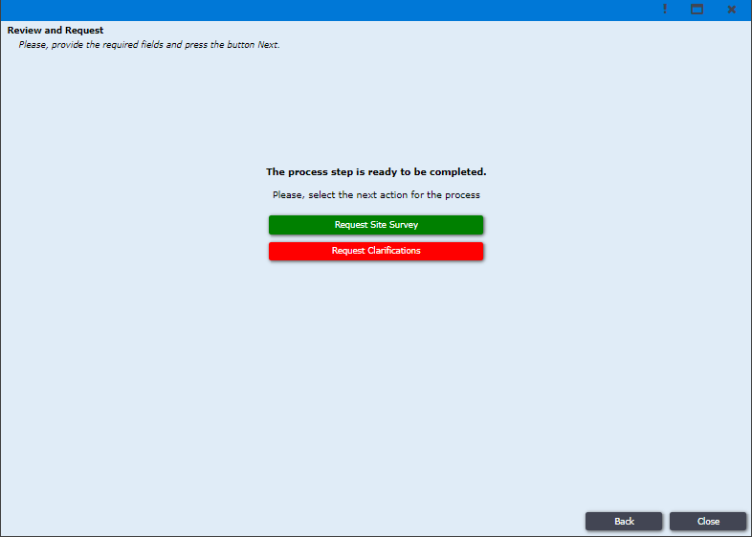

Figure 12

***Surveyor*** will login to the system with his login credentials and the system will take him to Surveyor dashboard’s ***Incoming*** section, where Surveyor will find all the application forwarded to him. There Surveyor user will also find the LUC Renewal application forwarded by ATP. Surveyor user will then click on the application, as shown in ***Figure 13.***

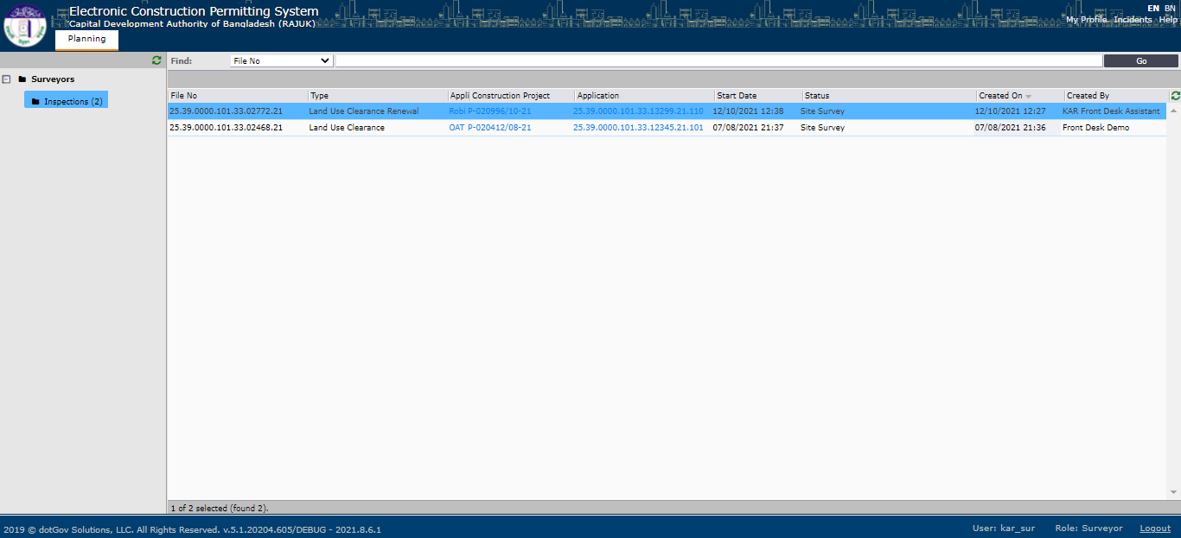

Figure 13

System will open a new window where Surveyor will have access to four different tabs ***Assignments, Initial Reviews, Survey Details*** and ***Applicants’ Clarifications. Initial Reviews*** tab will show all the initial review comments made by TP, DTP and ATP users. Surveyor user will then click on ***Assignments*** tab and then click on ***Application*** to check all the available information of the application, as shown in ***Figure 14***.

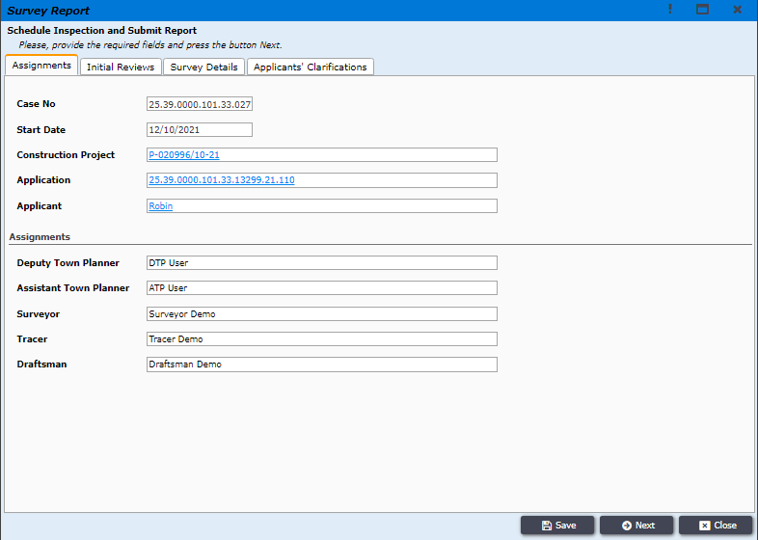

Figure

Surveyor user will then perform all the survey related work manually and prepare Survey report, Situational Map, Land Plot Plan and Setbacks and Roads, after completing these task Surveyor user will login to the system again and will upload all the docinets in ***Survey Details***  tab as shown ***Figure no 15.*** Surveyor user will then click on ***Next*** button to proceed forward.

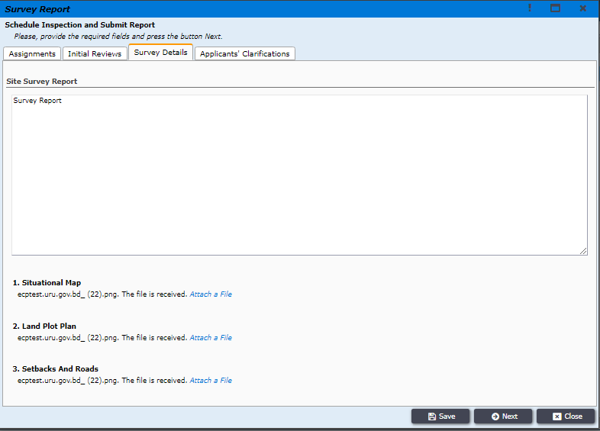

Figure

Surveyor user will then click on ***Send Survey Report*** to forward the application to ATP, as shown in ***Figure no 16.***

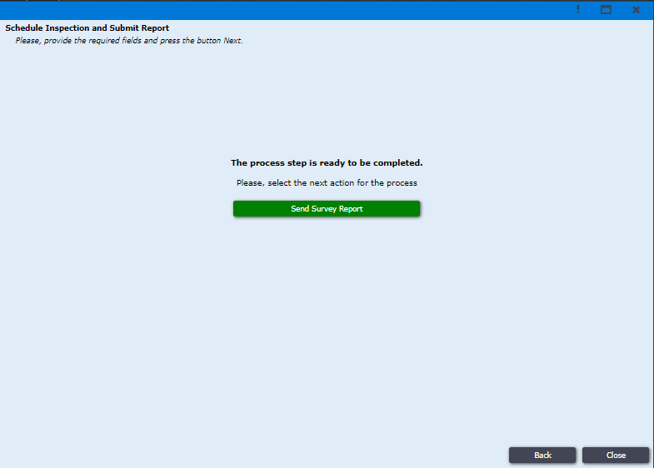

Figure

Assistant Town Planner will receive the applicantion sent from the surveyor. ATP user will then login to the system and find the application in the ***Incoming***  section, where the user will click on the applicaion, as shown in ***Figure no 17.***

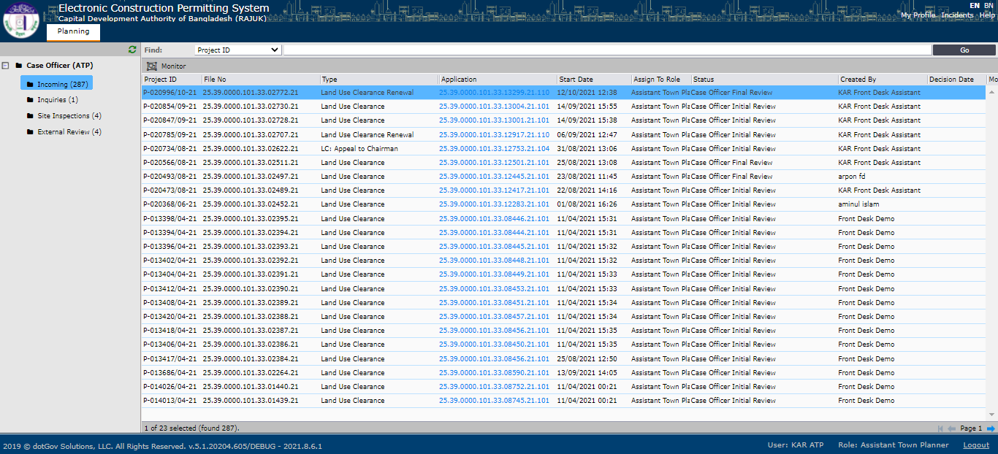

Figure

System will take the user toa new window where ATP user will find five different tabs (***Assignments, Initial Reviews, Survey Details, Final Comments and Applicants Clarifications***). ATP user will go to ***Survey Details*** ta to check the Survey Report, Situational Map and other documents attached by the surveyor, as shown in ***Figure no 18.***

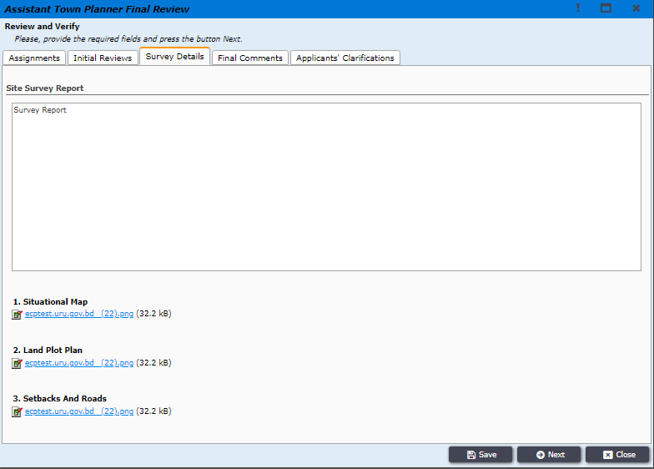

Figure

After checking all the document ATP user will go to the ***Final Comments*** tab and write his final comments and press ***Next,*** as shown in ***Figure no. 19.***

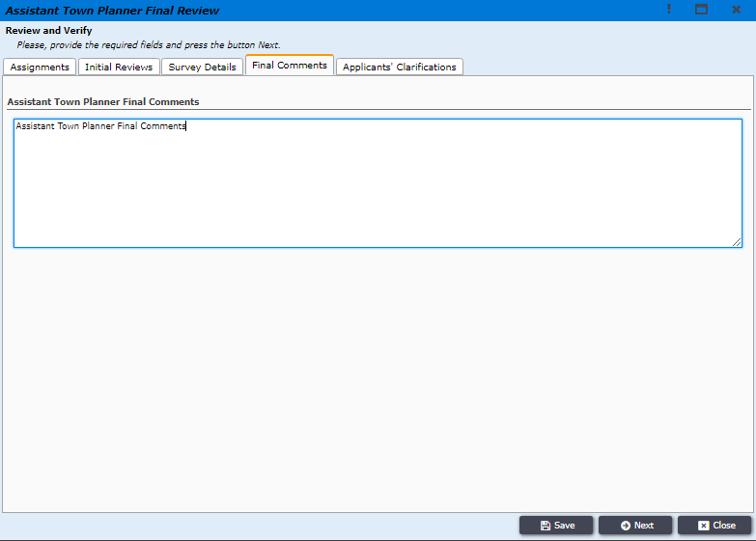

Figure

ATP user will then click on ***Submit to Deputy Town Planner*** button to forward the application to DTP, as shown in ***Figure no. 20.***

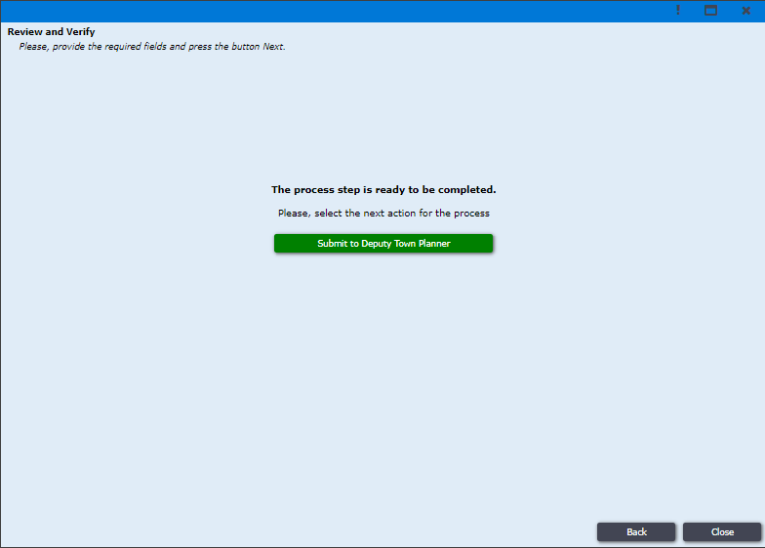

Figure

Deputy Town Planner will receive the applicantion sent from the Assistant Town Planner. DTP user will then login to the system and find the application in the ***Incoming***  section, where the user will click on the applicaion, as shown in ***Figure no 21.***

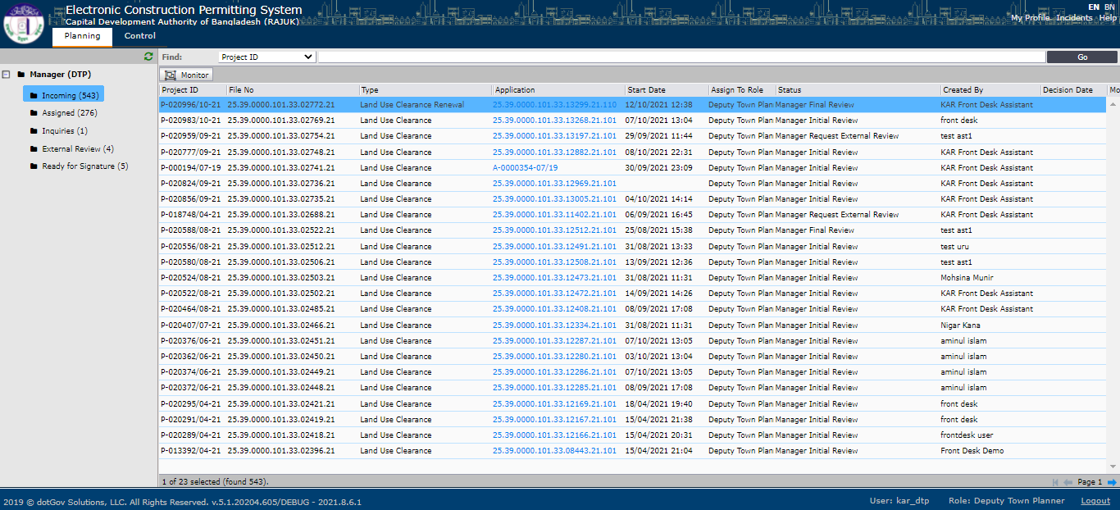

Figure

System will take the user to a new window where DTP user will find five different tabs (***Assignments, Initial Reviews, Survey Details, Final Comments and Applicants Clarifications***). DTP user will go to ***Survey Details*** ta to check the Survey Report, Situational Map and other documents attached by the surveyor, as shown in ***Figure no 22.***

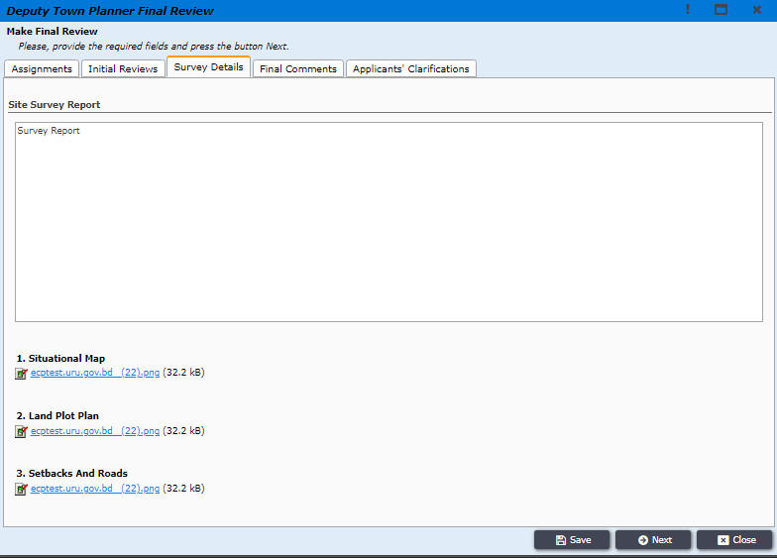

Figure

After checking all the document DTP user will go to the ***Final Comments*** tab to check the final comments made by the ATP user and write his final comments and press Next, as shown in ***Figure no. 23.***

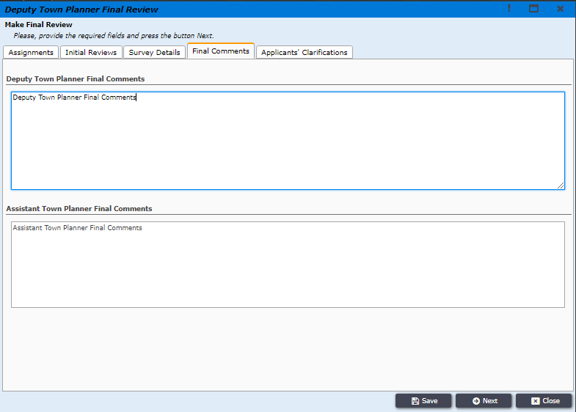

Figure

DTP user will then click on ***Submit to Town Planner*** button to forward the application to TP, as shown in ***Figure no. 24.***

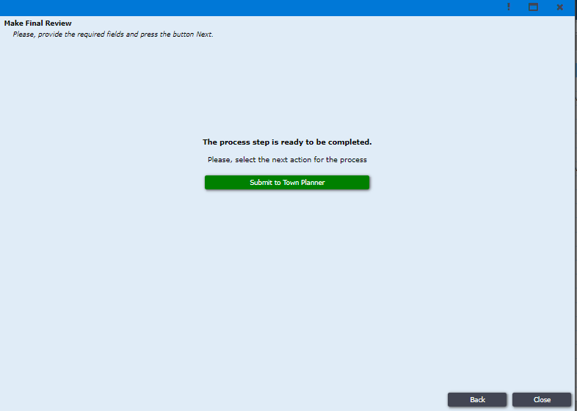

Figure

Town Planner will receive the applicantion sent from the Deputy Town Planner. TP user will then login to the system and find the application in the ***Incoming***  section, where the user will click on the applicaion, as shown in ***Figure no 25.***

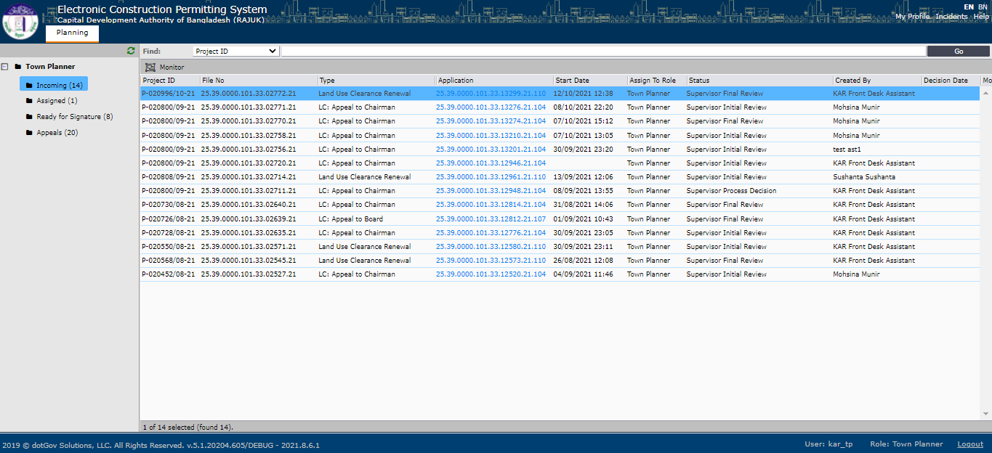

Figure

System will take the user to a new window where TP user will find five different tabs (***Assignments, Initial Reviews, Survey Details, Final Comments and Applicants Clarifications***), as shown in ***Figure no 26.***

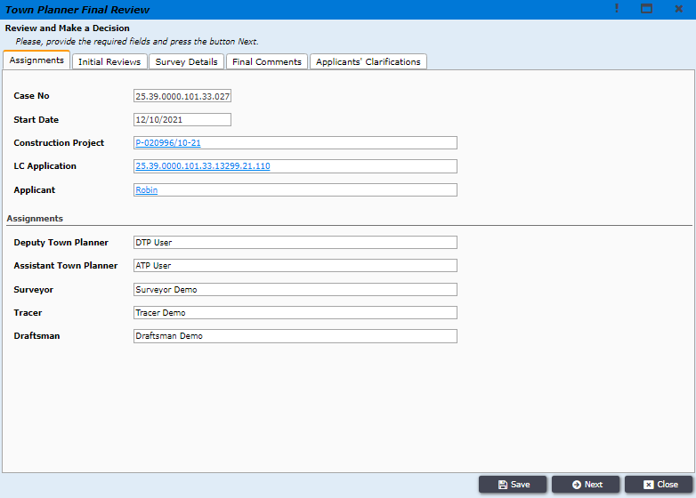

Figure

TP user will go to ***Survey Details*** ta to check the Survey Report, Situational Map and other documents attached by the surveyor, as shown in ***Figure no 27.***

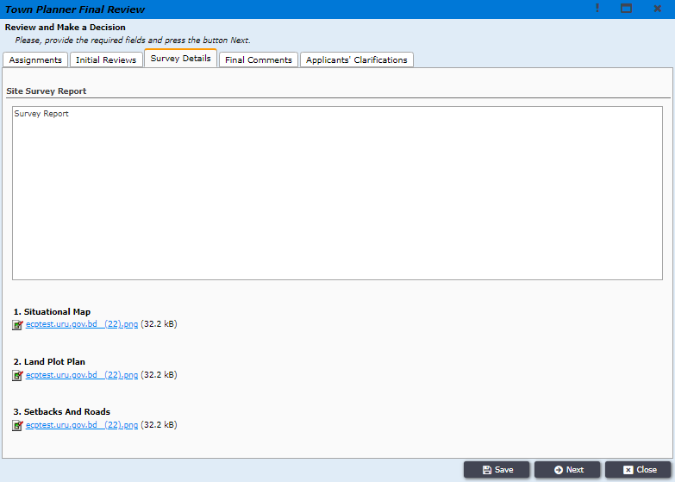

Figure

After checking all the document TP user will go to the ***Final Comments*** tab to check the final comments made by the ATP and DTP user and write his final comments and press Next, as shown in ***Figure no. 28.***

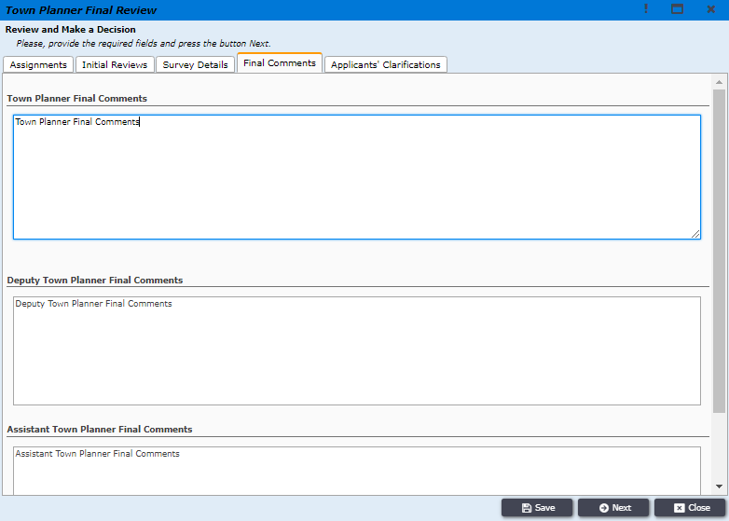

Figure

Town Planner will then take his decision about the application and click on ***Accept*** if the application is satisfactory or the user might click on ***Reject*** if the application is not acceptable, as shown in ***Figure no. 29.***

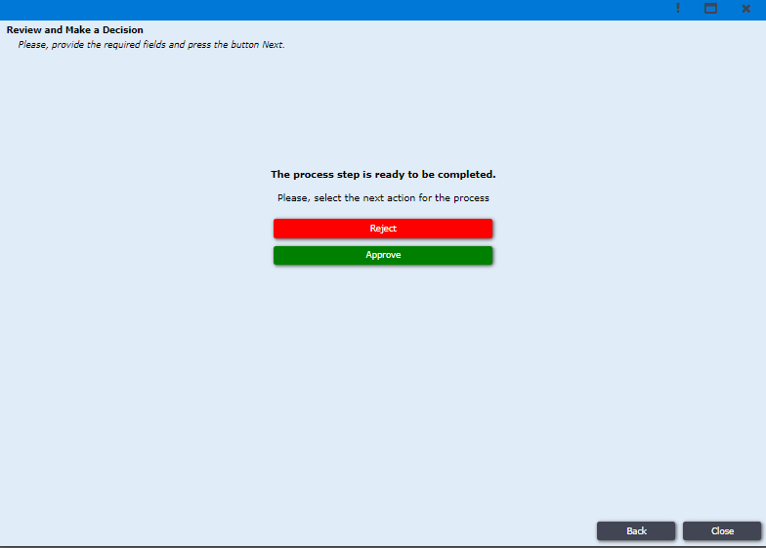

Figure

The application will be moved to ***Ready for Signature*** section after the decision from TP user, as shown in ***Figure no. 30.***

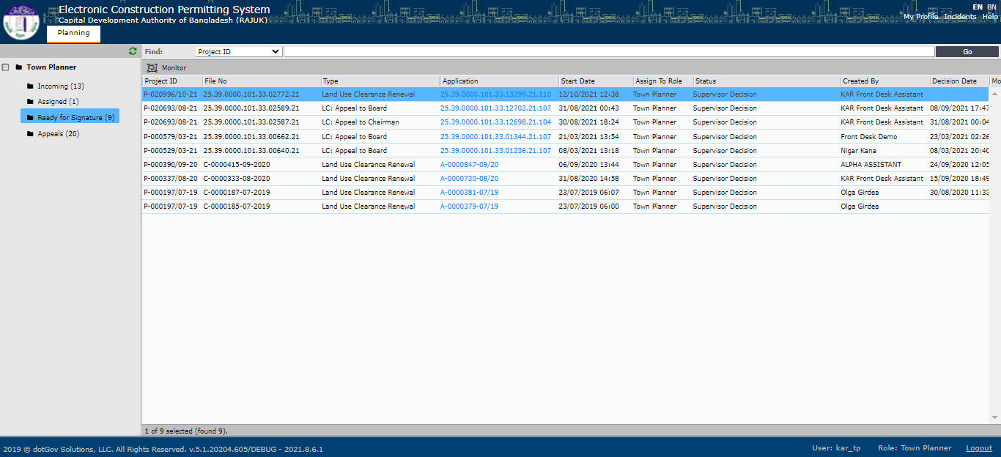

Figure

Then the Town Planner will have to click on the application and the system will take the user to a new window where the TP user will have to write his ***Aproval Notes,*** as shown in ***Figure no. 31.***

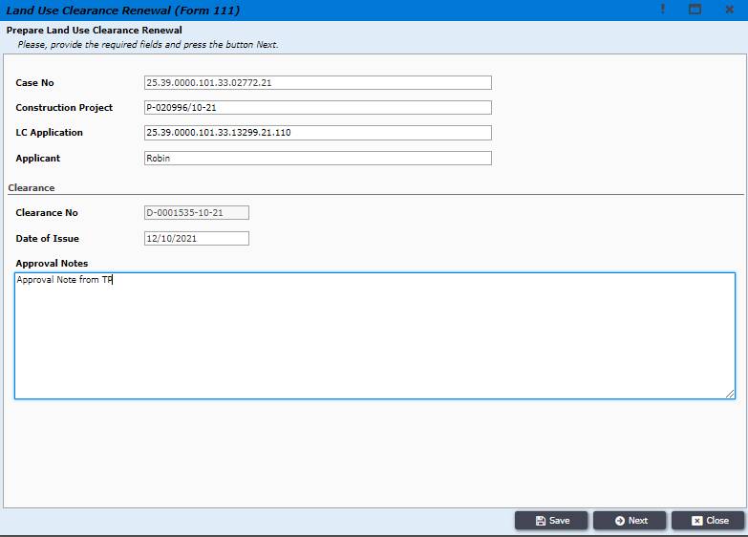

Figure

Then the system will show the approval letter generated by the system. Town planner will check the letter and click on ***Next*** button to proceed forward, as shown in ***Figure no 32.***

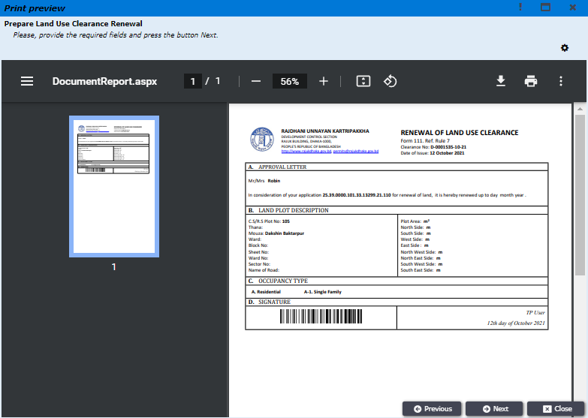

Figure

Town planner will the Download the approval letter by clicking on ***Download PDF*** button, as shown in ***Figure no. 33.***

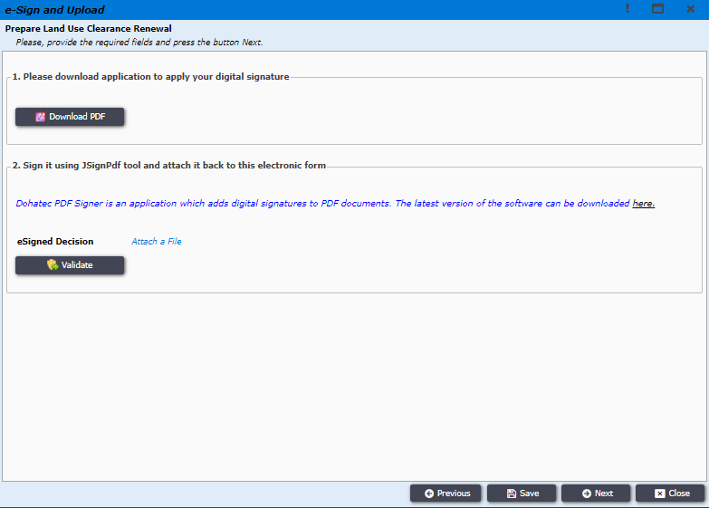

Figure

Later TP will digitally sign the pdf document and upload it by clicking on ***Attach a File*** and then click on ***Validate button,*** and click on ***Next*** button, as shown ***Figure no 34.***

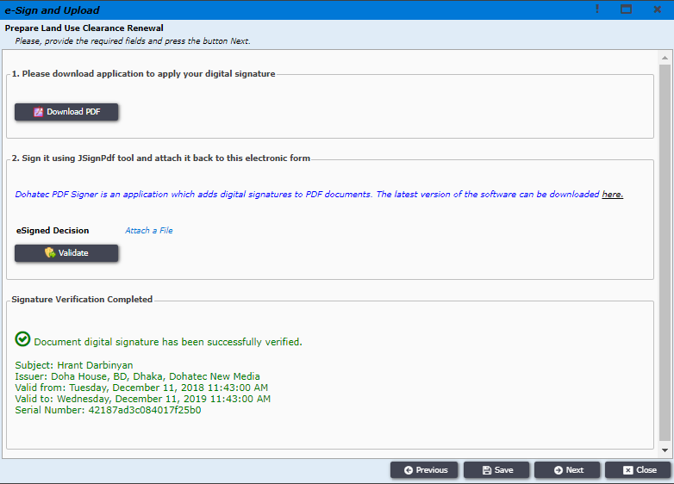

Figure

Town Planner will the click on ***Send Official Response*** button to the the response to the Applicant, as shown in ***Figure no 35.***

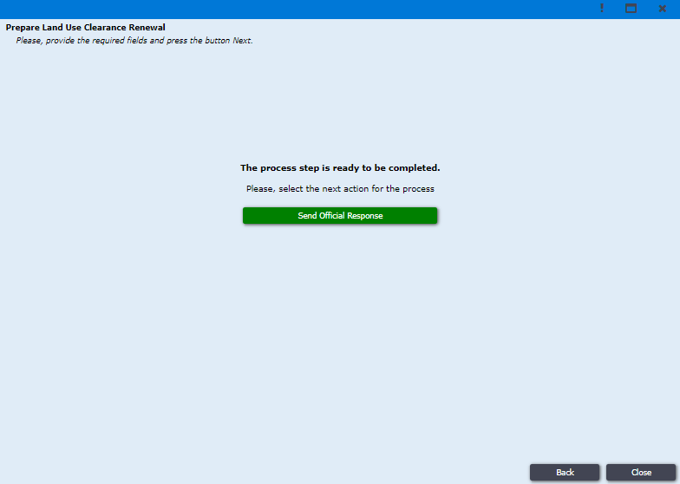

Figure